

**Small Business Identification (SBI) Tool**

INFORMATION SHEET 6

December 2024 202420242024



paymenttimes.gov.au

[support@paymenttimes.gov.au](mailto:support@paymenttimes.gov.au)

Page **1** of **4**

*This information sheet provides general guidance only and does not amount to legal advice. Entities are encouraged to seek independent legal advice to clarify their rights and obligations under the Act.*

# What is the Small Business Identification (SBI) Tool?

The Payment Times Reporting Small Business Identification (SBI) Tool identifies which of your suppliers are small businesses for payment times reporting.

The tool is available through the [Payment Times Reporting](https://portal.paymenttimes.gov.au/) [Portal](https://portal.paymenttimes.gov.au/) and must be used to identify small business suppliers for payment times reporting. You cannot use other data and information sources to identify small business suppliers.

The tool works by elimination. It contains a database of Australian Business Numbers (ABNs) that are:

* large businesses and medium sized businesses (income greater than A$10 million), and
* small businesses that have opted out of the tool.

To use the tool, you will need to upload a list of your suppliers’ ABNs and select a year. The tool compares your supplier ABN list to the ABNs in its database. ABNs that don't have a match in the SBI Tool’s database are small businesses for reporting purposes.

The tool returns a CSV output file listing the supplier ABNs that are small businesses for the selected year. You must use the correct year classification when preparing your payment times report.

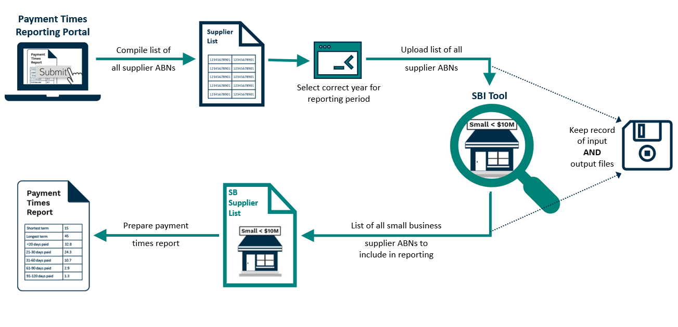

# Selecting the correct year

From January 2025, users will be required to select a year to run the SBI Tool.

Users should select the year the reporting period ended to identify small businesses for that period. The only exception to this is for reporting entities using a 52‑53-week financial year that should use the ordinary end date of the reporting period.

If you are reporting for a historical reporting period to remediate an instance of non-compliance, you should also follow this process.

|  |
| --- |
| **Example 1 – Conventional reporting period**  A reporting entity with a reporting period from 1 July 2024 to 31 December 2024 should select 2024.  **Example 2 – Unconventional reporting period**  A reporting entity with a reporting period from 1 October 2024 to 31 March 2025 should select 2025.  **Example 3 – 52-53-week financial years**  A reporting entity with a 52–53-week financial year has a reporting period from 1 July 2025 to 5 January 2026 should still select 2025 because the report is for the second half of 2025.  **Example 4 – Revising a payment times report**  A reporting entity that must re-run the SBI Tool to revise a report for a reporting period from 1 January 2024 to 30 June 2024 should select 2024. |

Classification of ABNs by year commenced in 2024. Before this, the SBI Tool provided point-in-time classification. For reporting periods ending before 2024, select 2024.

# When to use the SBI Tool

The SBI Tool is not publicly available – it is only available to entities registered in the portal. The tool can be accessed at any time and used in any manner that assists you in meeting your reporting obligations.

The Regulator may undertake compliance reviews to ensure you ran the tool after the end of a reporting period but before you submitted a report. If you have not run the tool in this period, it may indicate your report is inaccurate and potentially misleading.

# Appropriate use of the SBI Tool

If you use the SBI Tool selectively or inconsistently we may consider further investigation or action. Examples of SBI Tool use where we may investigate further include where:

* A reporting entity uses the SBI Tool when engaging a new supplier but does not confirm the classification of the supplier in each reporting period.
* A reporting entity modifies the SBI Tool output, classifying suppliers using other data sources.

The SBI Tool can only be used for purposes under the [*Payment Times Reporting Act*](https://www.legislation.gov.au/Series/C2020A00091) *2020* and in accordance with the tool’s [Terms of Use](https://paymenttimes.gov.au/terms-use).

If we identify unusual usage or approaches to the use of the SBI Tool, we may consider further investigation or action. Improper use may result in your access to the SBI Tool being restricted.

# Keeping SBI Tool records

You are required to keep records of information used to prepare your payment times report for at least 7 years. You must also keep copies of both the input file submitted to the SBI Tool and the output file you receive.

Failing to keep records, as required by the [*Payment Times Reporting Act 2020,*](https://www.legislation.gov.au/Series/C2020A00091)may result in civil penalty action with a penalty of 200 penalty units or a modified amount for body corporates.

# Updating and correcting the SBI Tool

We do a major update to the tool’s data in January each year for the coming calendar year and only make minor updates and corrections throughout the year.

The accuracy and reliability of SBI Tool data can be impacted by several factors including businesses delaying or being non-compliant with statutory reporting obligations, an absence of available data (particularly for newly established entities) and lack of readily available data sources for some organisation structures.

If you believe the SBI Tool output file incorrectly identifies a supplier as a small business, you can:

* Submit a form via the [Payment Times Reporting Portal](https://portal.paymenttimes.gov.au/) and provide documentary evidence (payment records or a statutory declaration) that you paid A$10 million or more to the supplier in a single income year.
* Request the supplier contact us to update its classification. The supplier will need to provide its registered business name, ABN and a statement that the contact person is authorised to request the classification update on behalf of the entity.

The Regulator is committed to updating the SBI Tool within 28 calendar days of appropriate documentary evidence being provided.

Where a reporting entity has identified an error and seeks to have the SBI Tool updated, it may:

* wait for the SBI Tool to be updated and re-run the tool for the relevant period, or
* use the SBI Tool output file with the error uncorrected to prepare its payment times report.

Waiting for the SBI Tool to be updated does not excuse a reporting entity from the obligation to submit a payment times report by the statutory due date.

# Opting out of the SBI Tool

Small business suppliers may choose not to be identified as a small business in the SBI Tool. To opt out of the SBI Tool, small businesses must register as users of the [Payment Times Reporting Portal.](https://portal.paymenttimes.gov.au/) Once registered and logged into the portal, small businesses can select the option to opt out of the SBI Tool.

If a small business opts out, you cannot include payments to that small business when preparing your report.

If a small business subsequently wishes to opt in, they can log into the reporting portal and change the opt out selection.

# Further information

For more information, please refer to the additional guidance notes and information sheets available in the [Guidance](https://paymenttimes.gov.au/guidance) section of the Payment Times Reporting Regulator’s [website.](https://paymenttimes.gov.au/)

**Document history**

This information sheet version was published in December 2024 based on the [*Payment Times Reporting Act 2020*](https://www.legislation.gov.au/C2020A00091/latest/text)and [Payment Times Reporting Rules 2024](https://www.legislation.gov.au/F2024L01148/asmade/text) as of that date.

|  |  |  |
| --- | --- | --- |
| **Date published** | **Status** | **Details of change** |
| 16/12/24 | Active | Updated to reflect IT upgrades to the tool and output file. |
| 11/12/23 | Superseded | Updated to reflect changes to the way entities can correct the SBI Tool. |
| 28/10/22 | Superseded | Original version |