Regulator’s update
August 2026

Regulator’s update
August 2026

In the spirit of reconciliation, the Regulator acknowledges the Traditional Custodians of country throughout Australia and their connections to land, sea and community.
We pay our respect to their Elders past and present and extend that respect to all Aboriginal and Torres Strait Islander peoples.

© Commonwealth of Australia 2026
ISBN: 978-1-923278-54-7
This publication is available for your use under a Creative Commons Attribution 4.0 International licence, with the exception of the Commonwealth Coat of Arms, the Treasury logo, photographs, images, third party materials, materials protected by a trademark, signatures and where otherwise stated. The full licence terms are available from creativecommons.org/licenses/by/4.0/legalcode.
Use of Treasury material under a Creative Commons Attribution 4.0 International licence requires you to attribute the work (but not in any way that suggests that the Treasury endorses you or your use of the work).
Treasury material used ‘as supplied’
Provided you have not modified or transformed Treasury material in any way including, for example, by changing the Treasury text; calculating percentage changes; graphing or charting data; or deriving new statistics from published Treasury statistics – then Treasury prefers the following attribution:
Source: The Commonwealth of Australia.
Derivative material
If you have modified or transformed Treasury material, or derived new material from those of the Treasury in any way, then Treasury prefers the following attribution:
Based on Commonwealth of Australia data.
Use of the Coat of Arms
The terms under which the Coat of Arms can be used are set out on the Department of the Prime Minister and Cabinet website (see www.pmc.gov.au/government/commonwealth-coat-arms).
Other uses
Enquiries regarding this licence and any other use of this document are welcome at:
Manager
Media Unit
The Treasury
Langton Crescent
Parkes ACT 2600
Email: media@treasury.gov.au

Contents
Letter from the Regulator 4
The Regulator’s 2026 priority areas 6
Engagement and education 7
Changes to the way we engage 8
Education 9
Research and intelligence 12
Data snapshot 13
Data insights 14
Industry insights 19
Spotlight: Regional series – Agriculture, Forestry and Fishing industry 25
Compliance and enforcement 28
Compliance and enforcement update 29
Compliance and enforcement priorities 2026–27 30
Spotlight: Compliance and enforcement action 32
Appendix A – Insights: methodology and assumptions 34
Appendix B – Data tables 36
Appendix C – Compendium 43


Letter from the Regulator
I am pleased to share with you the August 2026 Regulator’s Update, with insights from Reporting Cycle 10 (1 July 2025 to 30 December 2025).
Reporting Cycle 10 results show improvements across most key performance measures. Compared with Reporting Cycle 9, the proportion of invoices paid on time increased by 1.8 per cent and the all-industry average 95th percentile payment time reduced to 55 days. The proportion of invoices paid within 30 days increased to 69.8 per cent – a 6.6 percentage point improvement since the start of the Scheme. For small businesses, these results translate to better cashflow outcomes and increased payment reliability.
As the newly appointed Payment Times Reporting Regulator, I have been engaging with stakeholders to gain deeper insight into the challenges shaping current payment practices and behaviours in Australia. As we near the completion of the reform process, these challenges present important opportunities for the Scheme to shape the payment landscape and drive cultural change across Australian boardrooms.
The recent reforms to the Scheme have made it easier for reporting entities to comply with their reporting obligations and improve the transparency of the Scheme through the Payment Times Reports Register. The reforms also include a reputational framework to incentivise reporting entities to demonstrate leadership in payment times and improve payment performance. For those unfamiliar with the Scheme, these incentives allow for the identification and public disclosure of fast and slow small business payers.
In February 2026, the Fast Small Business Payer List was launched on the Payment Times Reports Register. The list currently recognises 96 reporting entities with exemplar payment performance. This achievement is no easy task and reflects entities who pay their small business suppliers within 20 days or less. More importantly, it reflects strong corporate leadership; an organisational-wide commitment to implementing effective systems and processes; and demonstrates the value these entities place on their small business supplier relationships.
The second component of the reputational framework, Slow Small Business Payer is also progressing with Cycle 10 data providing two reporting cycles to assess entity performance. Entities that meet the slow small business payer criteria may have their slow payer status published and the Minister or I, may issue a direction requiring them to disclose that status.
As part of the Scheme’s escalating approach to compliance and enforcement, there has been a strong focus on supporting entities to meet their reporting obligations while taking proportionate action where non-compliance persists. Following targeted engagement and education activities, 9 infringement notices for not reporting on time, with a combined value of $891,000, have been issued and paid by reporting entities. Details of these infringement notices are available on the public-facing Payment Times Reports Register and the Scheme website.
Under the Payment Times Reporting Act 2020, infringement notices may be issued for a range of contraventions, including failure to submit a report, providing false or misleading information, and failures to comply with an information gathering notice. It is the reporting entity’s responsibility to submit their reports on time and ensure that the report is accurate. Transparency is central to the Scheme.
Depending on the nature and seriousness of the breach, penalties can range from several thousand dollars to 0.6 per cent of the entity’s total income for an income year. Over the next 12 months, we will focus on entities that have reporting obligations but have not yet reported, and on reports that may be false or misleading. Further information on our focus areas is available in the 2026–27 compliance and enforcement priorities.
As explained on the Payment Times website, the Scheme has transitioned to an online-first service model. This decision reflects changes in how reporting entities and the public engage with the Scheme, including a decline in the use of the call centre service. As part of this transition, we are enhancing our website to improve user experience, accessibility and the utility of guidance material. We have also enhanced the contact form on our website and introduced a new contact form for reporting entities accessible via the Portal.
The Scheme’s ICT upgrade project concluded on 30 June 2026. The project has delivered improvements that streamline reporting and reduce regulatory burden for reporting entities. Enhancements include a new reporting portal with reduced reporting fields, the ability to navigate through reporting steps, functionality to save draft reports, and improved access to historical applications and reports. I would like to thank everyone who contributed to this process – your feedback has helped deliver a more efficient reporting experience.
As at Reporting Cycle 10, reporting entities have had up to 3 reporting periods to understand and embed reporting changes introduced in 2024 as part of the reforms to the Scheme. Timely payment to small business suppliers reflects strong leadership and good governance, underpinned by deliberate decisions on payment times and planning to embed effective internal processes and systems. I encourage all entities to take active steps to improve payment performance, embed a culture of prompt payment, and contribute to a more transparent, fair and resilient economy for small businesses.
Yours sincerely,
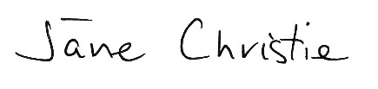
Jane Christie
Payment Times Reporting Regulator

The Regulator’s 2026 priority areas
Over the past 6 months, the Scheme has progressed the Regulator’s 2026 priority areas, shifting from awareness-raising to evidence-based engagement, and leveraging research insights to improve outcomes of the Scheme.

Regulator’s 2026 priority areas
  Engagement & education | Strategic stakeholder engagement and education  Continue strategic engagements with industry associations, professional bodies, professional service providers and small business advocates, leveraging the trusted relations established in 2025.  Extending on educational sessions held in 2025 and 2026 to provide fit-for-purpose educational resources and tools to help new entities understand and meet their obligations.

  Research & intelligence | Better understand drivers of payment practices and increase transparency  Using data to inform research projects that improve our understanding of poor payment and procurement practices, to better address these drivers.  Continue to increase transparency and comparability through progressive updates to the public Payment Times Reports Register, such as the recent publication of paid infringement notices and the launch of the Fast Small Business Payer list.

  Compliance & enforcement | Strengthening integrity and taking action  Continue to identify entities with reporting obligations who have not yet reported, including a focus on industries with elevated non-compliance.  Continue to strengthen the integrity of the Scheme by applying greater scrutiny to the completeness and quality of reports.  Take appropriate action where entities show patterns of non-compliance as part of our escalating approach to compliance, including giving infringement notices, with the aim to encourage entities to comply with the Act.

Engagement and education
Changes to the way we engage
Education

Changes to the way we engage
As part of our commitment to continuous improvement, we are updating some of our engagement pathways as the Scheme transitions into a mature regulatory phase. Over the next 12 months, we will implement incremental changes to our communication channels and some of our stakeholder supports. These changes will assist stakeholders to better understand their obligations, access relevant guidance and information, and engage more effectively with the Scheme.

New format for the January Regulator’s update
From January 2027, the January edition of the Regulator’s Update will adopt a refreshed format. The new format will present a more data-driven view of reporting entity and industry-level performance across the Scheme, with a focus on changes in key reporting measures, trends and updated data tables.

Technical workshops
We will transition in-depth technical content from the Regulator’s Update and Stakeholder Liaison Forum into targeted technical workshops delivered throughout the year. These technical workshops will provide tailored support to new entities entering the Scheme and help existing entities better understand and meet their reporting obligations. We will publish details of upcoming technical workshops on our website and in the Regulator’s Newsletter.

Transition to an online-first support service
From 1 July 2026, the Scheme replaced its live phone support service with an enhanced website contact form, shifting to an online-first support model. In the first instance, reporting entities can continue to access guidance and support through the resources available on the Scheme’s website. If you require further assistance, there is now an enhanced contact form available on the Scheme website or through the Portal for registered reporting entities. Before submitting an enquiry, users of the enhanced contact form will be directed to relevant guidance and information that may assist in resolving their enquiry.

Changes to our website
We are making it easier to find the information you need on the Scheme’s website to support the transition to an online-first service model. These changes include a more user-friendly format and more accessible guidance material.
To follow our progress, we encourage reporting entities to stay connected through updates in the Regulator’s Newsletter. Newsletters will continue to provide concise updates on key developments, helping users stay informed of important changes, messages and dates.
To sign up for our newsletter, please email engagement@paymenttimes.gov.au. Past newsletters are available on the News page of the Payment Times website.

Education

Tips to improve reporting and applications
The Regulator continues to identify errors in submitted reports, applications and entity information forms. These errors can result in reports being incomplete and may require revision or, in some cases, removal from the Payment Times Reports Register.
We also continue to identify issues with invalid or incomplete applications. In these cases, the Regulator may need to reject the application or seek further information, which can delay processing times.
To support entities to submit accurate reports the first time, we have outlined some of the most common errors below, along with guidance on how to avoid them.

Reports

Submitting a report using incorrect report type (AASB 8 vs Standard)
Selecting the wrong report type may result in submitting information that is false or misleading.
Reporting entities who are required to comply with Accounting Standard AASB 8 or an equivalent financial standard when preparing financial reports, must provide payment times information for each operating segment under section 14(4) of the Payment Times Reporting Rules 2024 (the Rules). These entities must select ‘Entity adopting AASB 8 in the preparation of financial reports’ as the type of report they need to submit instead of ‘Standard report’.

Common errors in entity information forms
A reporting entity or a reporting nominee is required to give entity information. Under section 10 of the Rules and section 10S of the Act, a payment times report must include a statement confirming the entity information and that it is correct as at the time the report is given to the Regulator.
Entities provide this information to the Regulator by submitting an Entity Information Form (EIF). The Regulator continues to identify issues with submitted EIFs.
Common errors include:
- listing the entity itself as the ultimate controlling entity
- identifying the wrong entity as the ultimate controlling entity
- recording a controlled entity as a controlling entity, and
- reporting subsidiary entities where the Regulator has made no subsidiary reporting entity determinations.
When completing the EIF, it is important to ensure all information is accurate and not false or misleading. If your entity becomes aware that information provided is materially incorrect, you must update it as soon as practicable.

SBI Tool – using correct year
We continue to observe that entities are selecting the wrong reporting year when using the SBI Tool. Under the Rules, specifically section 13(5), entities must use the SBI Tool each time they prepare a payment times report, to create a small business trade credit payments dataset for a reporting period. When running the tool, an entity must select the year in which the reporting period ends.
For example:
- if an entity’s reporting period ends on 31 December 2026, it must select 2026 on the SBI Tool, even if the report is prepared in 2027, or
- if an entity’s reporting period spans two years (for example, 1 September 2025 to 31 March 2026), it must select 2026 on the SBI Tool.
Where you identify the status of an entity in the SBI Tool may not be correct, you may make an ad hoc change by submitting a ‘Notification to Correct the SBI Tool’ form through the Portal. In the period 1 January to 30 June 2026, the Regulator processed 43 valid SBI Tool notice requests, reflecting an update in the SBI Tool, in an average of 4.2 calendar days.

Calculating 95th percentile payment time correctly
As defined under section 13(2)(d) of the Rules, the 95th percentile payment time must be expressed as a number of calendar days that is the 95th percentile of all payment times (ordered fastest to slowest) for all payments (that discharged an invoice or obligation in full) included in the small business trade credit payments dataset for the reporting period for the entity.
Entities must ensure that the 95th percentile payment time reflects an actual value from the small business trade credit payment dataset and is reported as a whole number. Entities should not calculate it using averaging or interpolation.
To do this in Microsoft Excel, start by sorting the dataset by payment times in ascending order (from fastest to slowest). Then, use functions such as PERCENTILE.INC, along with INDEX and MATCH, to identify the correct value.
Providing an incorrect value in this field may result in a report which is false or misleading.

Applications

Exempt entity (section 10Q of the Act)
The exemption mechanism under Division 6 of the Act is designed to address unintended or unusual situations. This may include cases where an entity inadvertently meets the reporting entity criteria under section 7 of the Act, where that entity is not intended to be a reporting entity. This may include a situation where an entity, that would not ordinarily satisfy the criteria, has a one-off sale of assets leading to its consolidated revenue being more than $100 million for that financial year and, therefore, becomes a reporting entity.
When submitting an exempt entity application, you should only apply:
- for reporting periods beginning on or after 1 July 2024
- when the circumstances are not part of the entity’s ordinary course of business, or
- when the entity inadvertently becomes a reporting entity due to circumstances outside of its control.

Notices

Ceasing to be a reporting entity (section 10H of the Act)
A common error in notices that an entity has ceased to be a reporting entity is the incorrect assumption that they cease to be a reporting entity from the date the change in circumstance has occurred. However, under section 10H of the Act, a notice can only take effect from the start of the reporting period in which it is given, even where the relevant qualifying circumstances to cease reporting arose at an earlier date. Importantly, those qualifying circumstances must have existed at the start of the reporting period in which that notice is given.
The Regulator reviews all notices for validity as a first step in our escalating approach to compliance.
Scenario
Company A and Company B are both reporting entities with a 30 June financial year end.
On 15 September 2025, Company B acquires Company A.
Key considerations
- Although Company A becomes controlled by another reporting entity on 15 September 2025, those circumstances did not exist at the start of Company A’s reporting period 1 July 2025 – 31 December 2025.
- Accordingly, Company A cannot give the Regulator notice to cease reporting until the beginning of its next reporting period (1 January 2026) and remains required to submit a report for the period 1 July 2025 – 31 December 2025.
Possible outcomes
- If Company A submits a notice before 1 January 2026, the notice would not be valid, and Company A would remain a reporting entity under the Act.
- If Company A submits a notice between 1 January 2026 and 30 June 2026, the notice would take effect from 1 January 2026. Company A would not be required to give payment times reports for reporting periods commencing from 1 January 2026.
- If Company A delays giving the notice until 5 July 2026 for example, the notice would instead take effect from 1 July 2026. Company A would therefore have an obligation to submit a report for the reporting period 1 January 2026 to 30 June 2026, because the notice would only take effect from the start of the reporting period in which it is given.

Research and intelligence
Data snapshot
Data insights
Industry insights
Spotlight: Regional series – Agriculture, Forestry and Fishing industry

Data snapshot
The data used in this Update reflects reported data for the reporting period 1 July 2025 to 31 December 2025 (Reporting Cycle 10). Data and analysis reflect payment times reports and revised reports for Reporting Cycle 10 received on or before 30 June 2026.
Figure 1: Key measures data snapshot
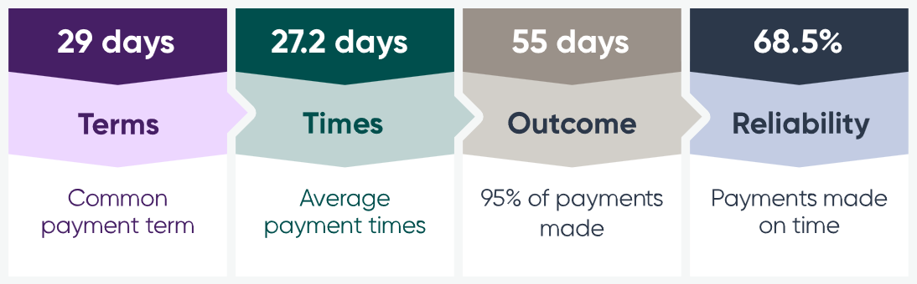
Figure 2: Industry data snapshot
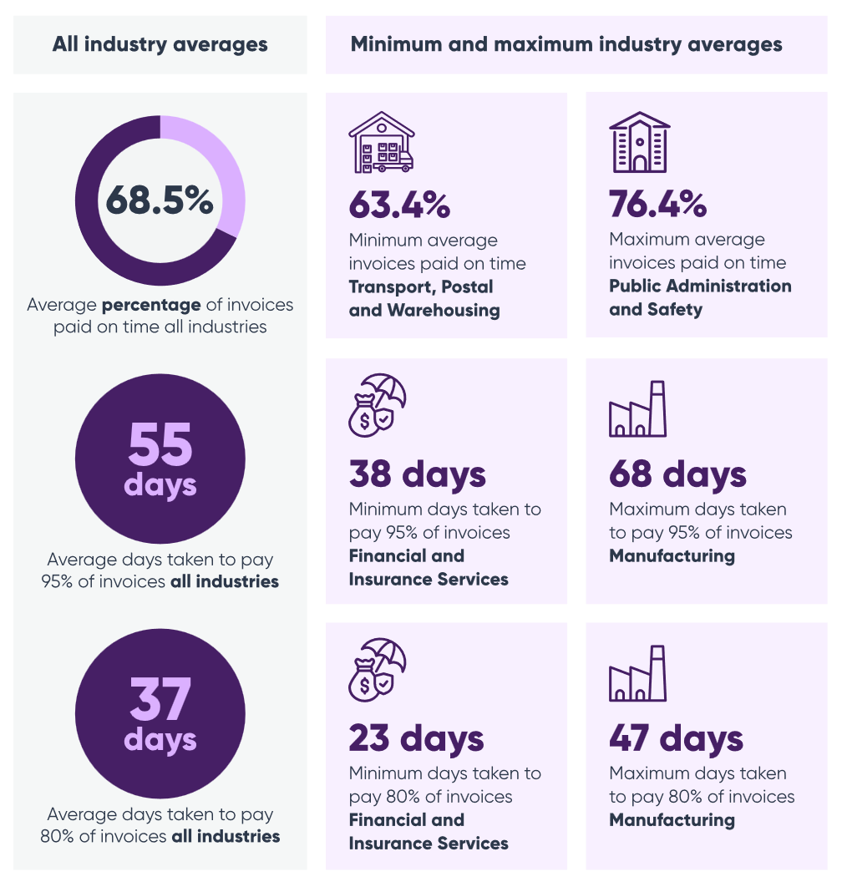
Note: Use caution when interpreting the data and insights in this Update. Some reporting measures introduced from 1 July 2024 are not directly comparable with data from Reporting Cycle 7 or earlier. For further information about the data in this Update, refer to Appendix A.

Data insights
In Reporting Cycle 10, performance improvements varied across key payment times reporting measures relative to Reporting Cycle 9. The most noticeable reported change occurred in the time taken to pay 95 per cent of small business invoices.
Compared with Reporting Cycle 9, the all-industry average common payment term remained unchanged at 29 days, while the reported average payment time reduced by a very modest 0.4 days to 27.2 days. The 95th percentile payment time decreased to 55 days, highlighting its importance in identifying fast and slow small business payers under the Scheme and the increased scrutiny reporting entities are placing on this key reporting measure.
These results indicate that, while typical terms and average payment times remained broadly stable, the reported time taken to pay the vast majority of invoices shortened materially in Reporting Cycle 10. This outcome suggests improved payment experiences for small business suppliers who previously faced the longest reported wait times. This trend is further supported by the improvement in the reported 80th percentile payment time, reducing from 38 days to 37 days.
Table 1: Comparison of key measures across Reporting Cycle 9 and Reporting Cycle 10 (all industries)
Measure | Reporting Cycle 9 | Reporting Cycle 10 | Change
Average common payment term (days) | 29 | 29 | 0.0
Average payment time (days) | 27.4 | 27.2 | -0.2
80th percentile payment time (days) | 38 | 37 | -1.4
95th percentile payment time (days) | 62 | 55 | -6.3
Invoices paid within 30 days (%) | 68.0 | 69.8 | +1.8
Invoices paid within 31–60 days (%) | 25.2 | 24.3 | -1.0
Invoices paid over 60 days (%) | 6.7 | 5.9 | -0.8
Paid on time (within terms) (%) | 66.7 | 68.5 | +1.9

Most small businesses can expect to wait almost double the agreed payment term to be paid
Although the average common payment term across all industries in Reporting Cycle 10 was 29 days, entities are often taking significantly longer to pay their small business suppliers.
On average, 80 per cent of small business invoices were paid within 37 days. However, to reach 95 per cent of small business invoices paid, it took 55 days.

It is taking almost double the average agreed payment term for the vast majority of small business invoices to be paid. These figures highlight the gap between stated payment terms and actual payment behaviour.
This means that for most small business invoices to be paid, small businesses have a wait time that is close to double the typical agreed payment term. This highlights the continuing gap between stated payment terms and actual payment behaviour, even as the tail of very late payments improved in Reporting Cycle 10.
Figure 3: Payment terms and times, Reporting Cycle 10
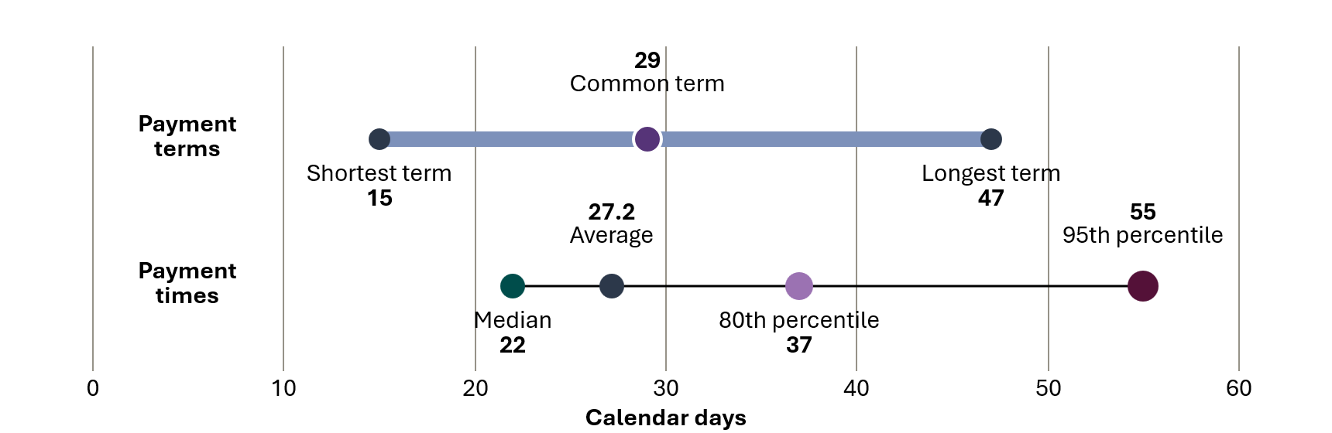

Small businesses are big players in the supply chain
In Reporting Cycle 10, 3,254 entities reported buying goods and services from small business suppliers. On average, they sourced around 29.4 per cent of their total procurement value from small businesses – a modest increase from 29.0 per cent in Reporting Cycle 9.
Trade with small business suppliers has remained significant across all sectors. In Reporting Cycle 10, the lowest reported share of small business procurement was in the Mining industry at 22.2 per cent, while the highest was in Education and Training at 43.8 per cent. Both the Agriculture, Forestry and Fishing and Construction industries also showed very high small business exposure, reporting 42.7 per cent and 43.5 per cent respectively.
These figures reinforce that small businesses remain deeply embedded in the supply chains of Australia’s largest businesses, and that improvements in payment outcomes deliver broad-based cashflow benefits given the scale of small business engagement.
Figure 4: Reported small business procurement share, Reporting Cycle 10
Average procurement value from small business
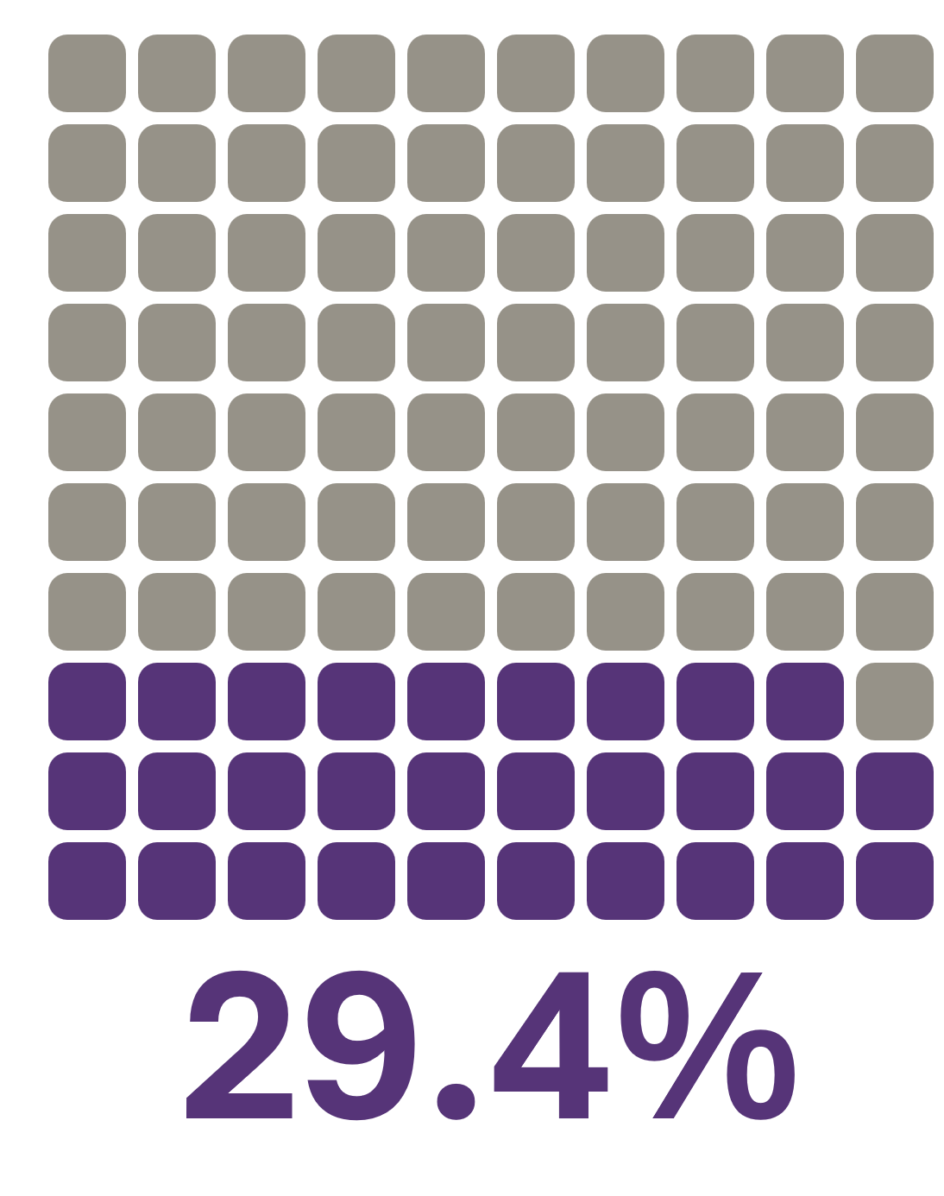

Entities paying in 20 days or less
In Reporting Cycle 10, 161 entities reported making 95 per cent of their payments to small business suppliers in 20 days or less. These entities may qualify as a Fast Small Business Payer if they continue this practice for 2 consecutive reporting periods.
These results demonstrate that making payments within 20 days is an achievable benchmark when organisations commit to better payment practices, supported by leadership, strong internal governance and processes.
Fast small business payers are publicly recognised on the Payment Times Reports Register. This recognition provides a credible, externally validated reputational incentive for achievement and offers stakeholders a clear and verifiable indicator of strong payment performance.
Figure 5: Number of entities paying 95 per cent of invoices in 20 days or less, 21-30 days and more than 30 days, Reporting Cycle 10
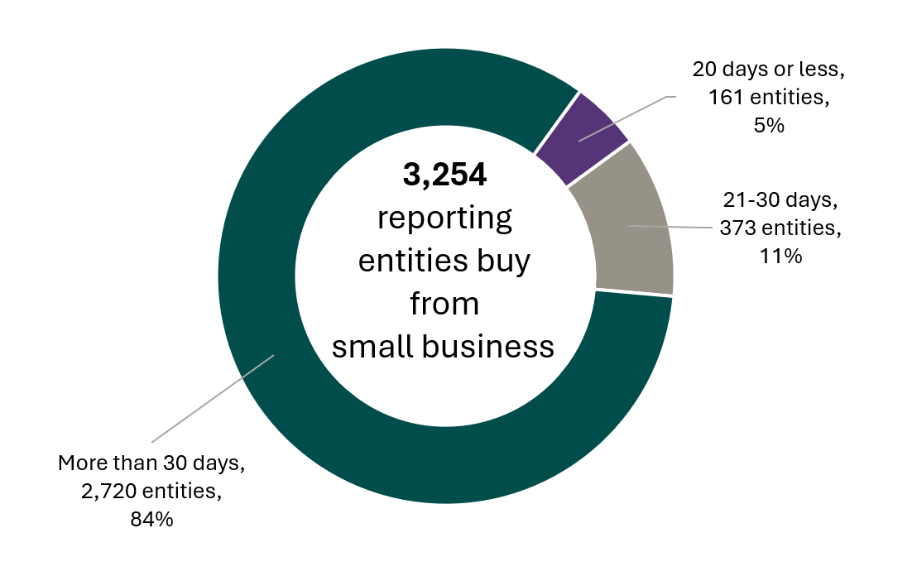

Invoices paid within 30 days
In Reporting Cycle 10, the average proportion of invoices paid within 30 days increased to 69.8 per cent, compared with 68.0 per cent in Reporting Cycle 9. This is the largest increase observed since Reporting Cycles 1 and 2.
Figure 6: Average invoices paid in 30 days, Reporting Cycles 1 to 10
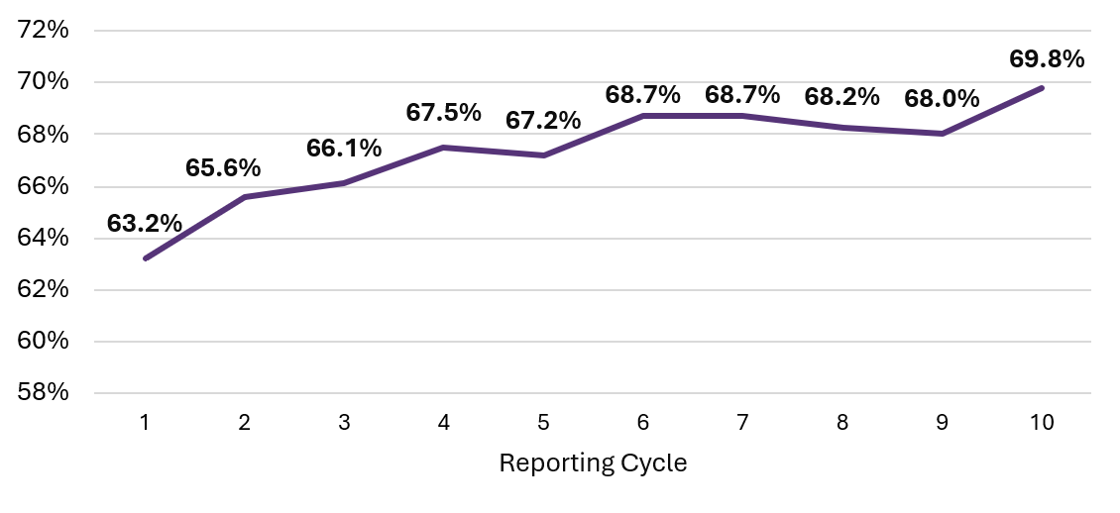
The proportion of invoices paid after 30 days declined, driving the observed improvement. The proportion of invoices paid within 31–60 days decreased from 25.2 per cent in Reporting Cycle 9 to 24.3 per cent in Reporting Cycle 10, and the proportion paid over 60 days decreased from 6.7 per cent in Reporting Cycle 9 to 5.9 per cent in Reporting Cycle 10 (see Table 6, Appendix B).
Taken together, the results for Reporting Cycle 10 suggest a broad shift towards faster payment practices, with a higher share of invoices being paid within 30 days, and fewer invoices being paid within 31–60 days and over 60 days.
Figure 7: Proportion of entities with average payment times in day ranges, Reporting Cycles 1 and 10
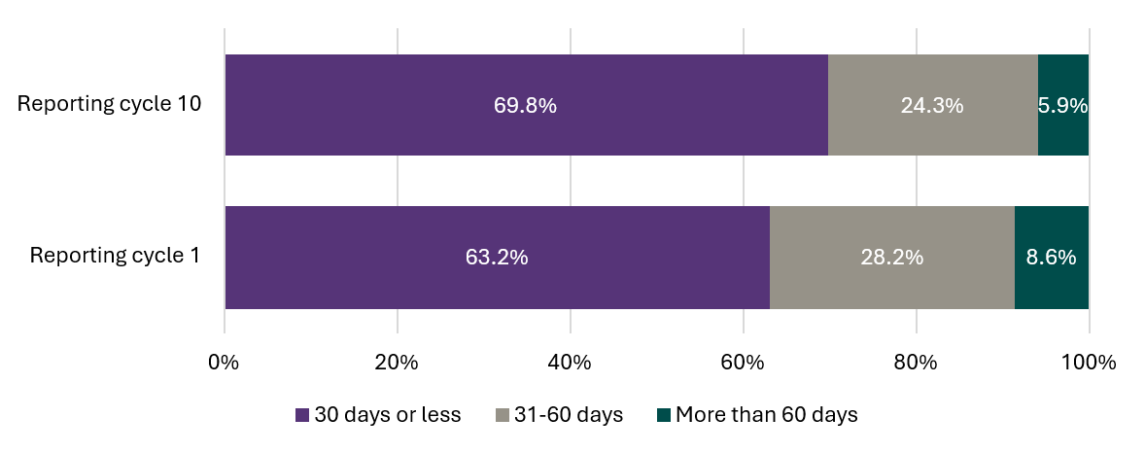

Most reporting entities report paying in more than 30 days
In Reporting Cycle 10, a majority of entities (2,720 or 84 per cent) reported taking more than 30 days to pay 95 per cent or more of their invoices, a 1 per cent reduction from Reporting Cycle 9 (see Figure 8).
Figure 8: Number and percentage of entities making 95 per cent of payments in 30 days or less, 31-60 days and more than 60 days, Reporting Cycle 10
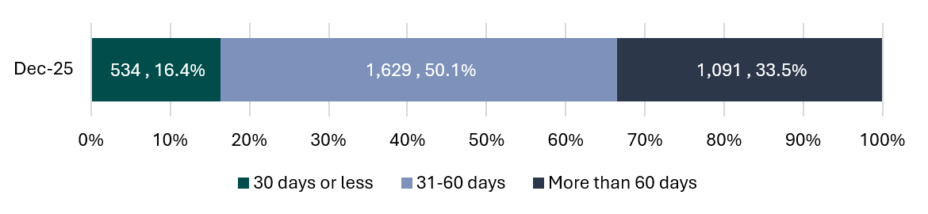
The Manufacturing and the Professional, Scientific and Technical Services industries offered small businesses average common payment terms of 35 days and 27 days respectively. Their average payment times were 33.3 days and 39.1 days respectively, suggesting the Manufacturing industry generally makes payments within agreed terms whereas the Professional, Scientific and Technical industries often do not.
Despite both industries offering terms of around 30 days, 95 per cent of small business invoices were paid in 68 days and 64 days respectively, more than double the agreed payment terms.
These extended periods can create significant cash flow challenges and increase costs for small business suppliers.
Figure 9: Average payment terms and times for reported data, Reporting Cycle 10 (for all industries, see Table 7, Appendix B)
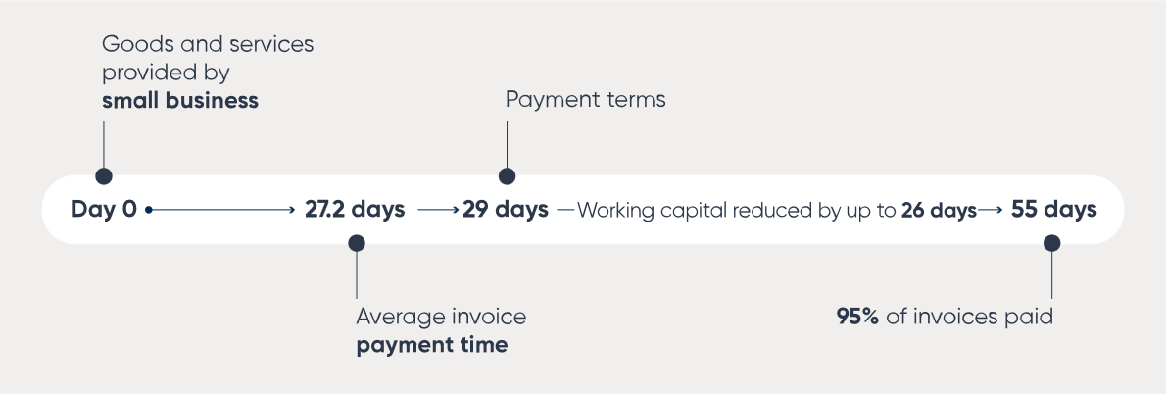

Industry insights

Payment times reporting applied to all industries
In Reporting Cycle 10, 3,254 reporting entities submitted reports across all 19 of the Australia and New Zealand Standard Industrial Classification (ANZSIC) Divisions (ANZSIC 2006 – ABS 2013).
Figure 10: Number of reporting entities by ANZSIC Division, Reporting Cycle 10
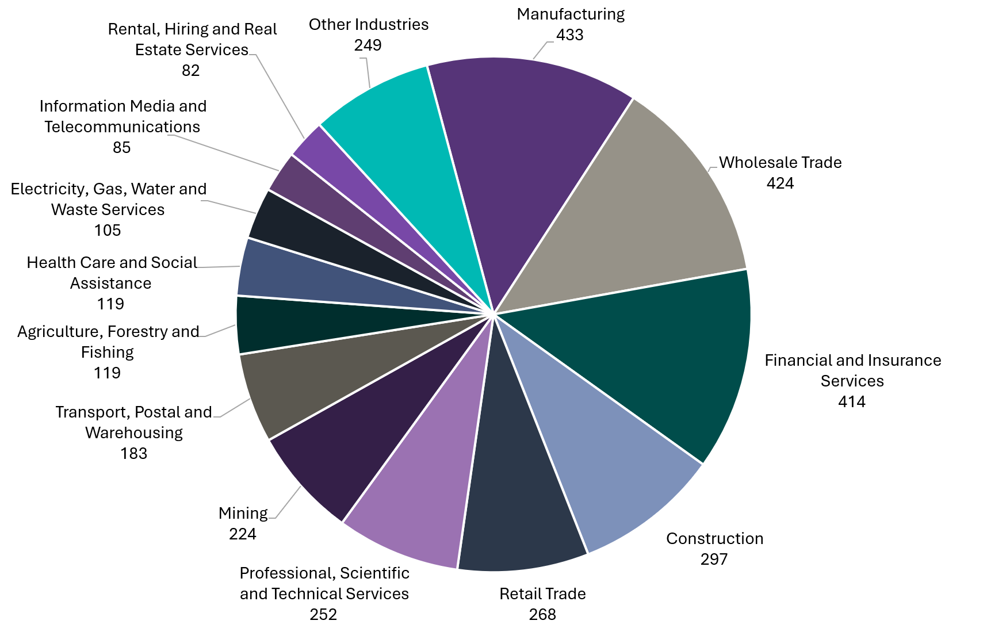
Notes:
- Industry insights for this cycle are based on the ANZSIC subdivision given by each reporting entity in the Entity Information form in the portal. The ANZSIC subdivision reflects the reporting entity’s self-assessed primary business activity.
- ‘Other industries’ include reporting entities where the industry proportion reflected less than 2 per cent.

Payment terms vary across industries
Across the Scheme, the reported average common payment term for Reporting Cycle 10 remained stable at 29 days when compared with Reporting Cycle 9. At an industry level, the average common payment term varied materially in Reporting Cycle 10 – ranging from 19 days in Education and Training to 35 days in Manufacturing. Differences in payment practices can be influenced by industry-specific factors, including contractual norms, commercial arrangements and operating environments, reinforcing the value of industry benchmarking when interpreting payment outcomes.
While industry benchmarking provides important context, industry-specific factors do not fully explain differences in payment terms. Reporting Cycle 10 data shows that, even within industries with comparatively longer average payment terms, many entities report shorter average common payment terms. Despite the Manufacturing industry reporting the longest average common payment term (35 days), 65.3 per cent of entities in the industry reported offering an average common payment term of 30 days or less, and 21.4 per cent reported terms of 20 days or less. This suggests that shorter payment terms are achievable for most entities within the industry, implying that longer payment terms cannot be attributed solely to industry-specific factors.
The availability of post-reform data across the last three reporting cycles has enhanced our ability to assess and understand industry payment practices as the Scheme matures. While the self-reported data does not directly identify the industry conditions, supply chain, or external factors that may contribute to longer payment times, these factors do not diminish an entity’s responsibility to improve its payment performance and reduce payment times to small business suppliers.


Figure 11: Average common payment term by industry in days, Reporting Cycle 10
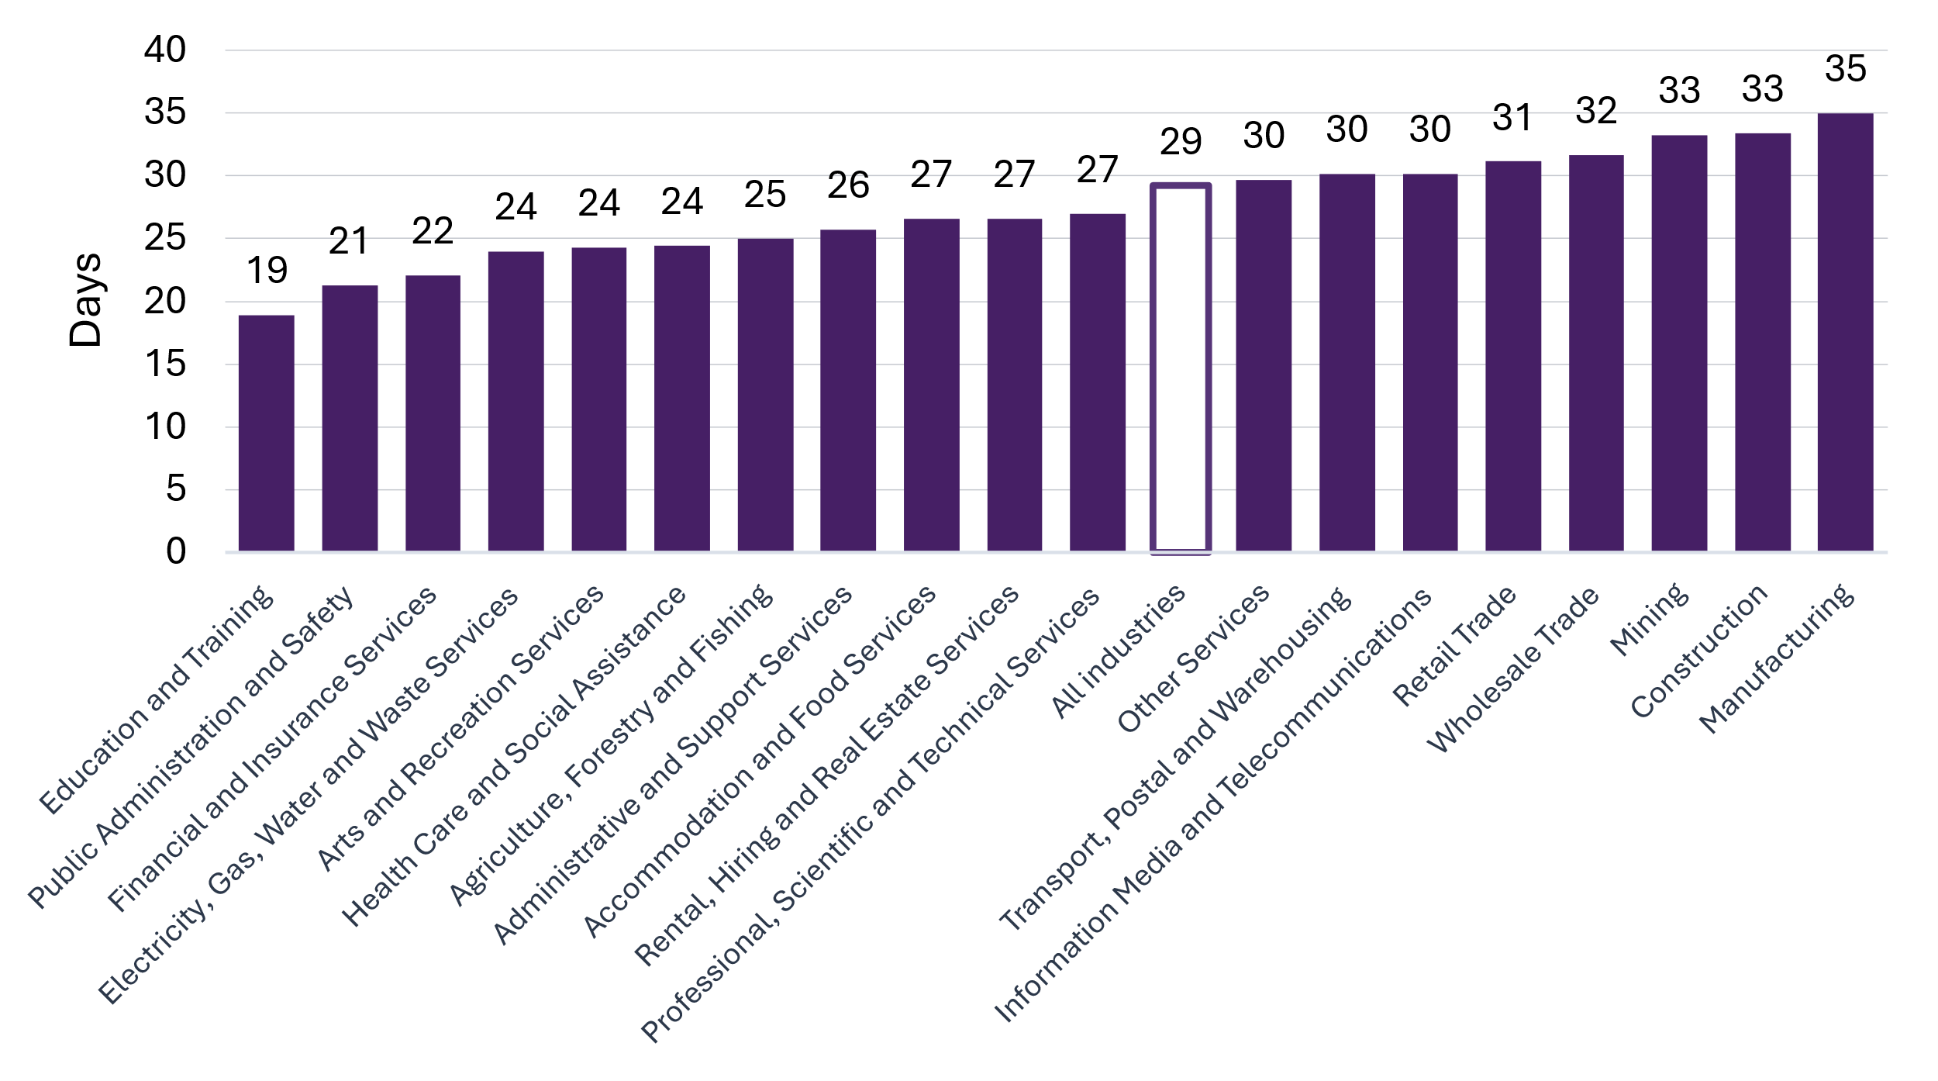

On-time payment performance by industry
In Reporting Cycle 10, the Public Administration and Safety industry reported the highest proportion of small business payments made on time at 76.4 per cent. The Financial and Insurance Services industry followed closely at 74.9 per cent. The Agriculture, Forestry and Fishing industry reported 74.4 per cent, while the Electricity, Gas, Water and Waste Services industry reported 73.1 per cent.
The Transport, Postal and Warehousing industry reported the lowest proportion of small business payments made on time at 63.4 per cent, with Health Care and Social Assistance and Manufacturing industries also among the least reliable industries reporting 63.8 per cent and 64.5 per cent respectively.
Across all industries, the average paid-on-time rate was 68.5 per cent in Reporting Cycle 10, compared with the all-industry average of 66.7 per cent in Reporting Cycle 9. This result indicates a marginal improvement in reliability against stated commitments.
Reporting Cycle 10


Reporting Cycle 9


In Reporting Cycle 10, 9 industries reported on-time payment rates above the all-industry average of 68.5 per cent (see Figure 12).
Figure 12: Proportion of payments paid on time by industry, Reporting Cycle 10
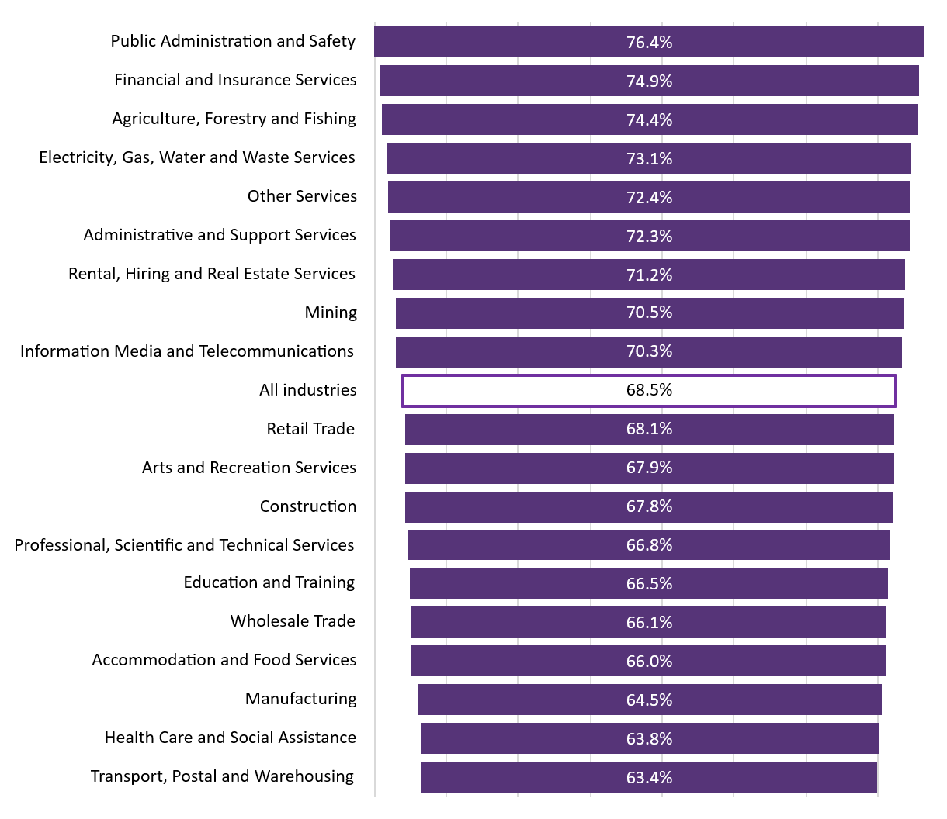

Improvement in payment performance by industry
Reported data shows a broad improvement in the share of invoices paid within 30 days between Reporting Cycle 9 and Reporting Cycle 10, with 18 out of 19 ANZSIC industries recording modest but consistent gains. Overall, the proportion of invoices paid within 30 days increased from 68.0 per cent to 69.8 per cent (a 1.8 percentage point improvement).
The strongest improvements were seen in Education and Training (+3.9 percentage points, to 81.9 per cent) and Public Administration and Safety (+3.7 points, to 84.7 per cent), followed by Construction (+3.2 points) and Rental, Hiring and Real Estate Services (+2.9 points). Mid-range gains of around 2 percentage points were recorded by the Electricity, Gas, Water and Waste Services, Retail Trade, and Arts and Recreation Services industries.
While most industries improved, the Information Media and Telecommunications industry reported a decline of 1.5 percentage points, from 72.7 per cent to 71.2 per cent.
Overall, these results indicate steady progress, with some observed variation across industries but a clear upward trend in payment timeliness.

Figure 13: Largest improvements paid within 30 days, Reporting Cycle 9 vs Reporting Cycle 10
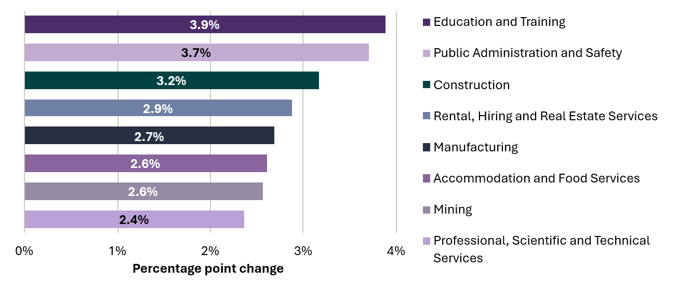

Commonwealth entities
Of the 91 Corporate Commonwealth entities and Commonwealth companies, 35 had reporting obligations under the Scheme in Reporting Cycle 10. All 35 entities submitted a payment times report to the Regulator, comprising 29 Corporate Commonwealth entities and 6 Commonwealth companies.
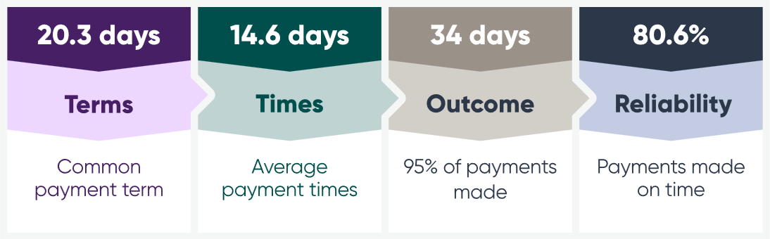
In Reporting Cycle 10, Commonwealth entities reported offering small business suppliers an average common payment term of 20.3 days, well under the all-industry average of 29 days. However, this result reflects a deterioration of 1 day since Reporting Cycle 9.
Despite this, Commonwealth entities reported improved payment performance in Reporting Cycle 10. Compared with Reporting Cycle 9, average payment times decreased to 14.6 days, and the time taken to pay 95 per cent of invoices reduced to 34 days – a reduction of 6 days.

Performance of Commonwealth entities remains a focus area for the Regulator
Commonwealth entities continue to be more reliable and pay their small business invoices on time.
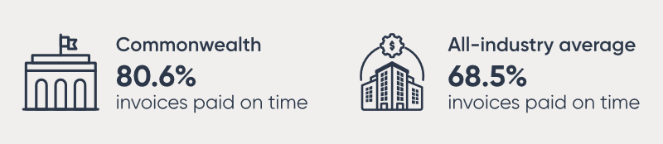
When it comes to being paid on time, small businesses can expect greater reliability from Commonwealth entities. In Reporting Cycle 10, Commonwealth entities have reported a significant improvement in invoices paid on time, up 6.3 percentage points from 74.3 per cent in Reporting Cycle 9.
Table 2: Comparison of key measures for Commonwealth entities across Reporting Cycles 9 and 10
Measure | Reporting Cycle 9 | Reporting Cycle 10
Average common payment term (days) | 19.6 | 20.3
Average payment time (days) | 16.4 | 14.6
Average 95th percentile payment time (days) | 40 | 34
Percentage of invoices paid on time (%) | 74.3 | 80.6
Although these results show some noteworthy performance improvements, the Australian Government expects Commonwealth entities to lead by example by paying small businesses promptly.

Spotlight: Regional series - Agriculture, Forestry and Fishing industry
The Agriculture, Forestry and Fishing industry highlights why large business payment practices matter to small businesses. Many suppliers operating in the industry provide seed, fertiliser, stock, fuel, transport, repairs, labour hire, machinery services and professional advice weeks or months before the value of that work is realised through the supply chain. Long production cycles, seasonal conditions and geographic distance can create cashflow pressures, making both prompt and predictable payment particularly important.
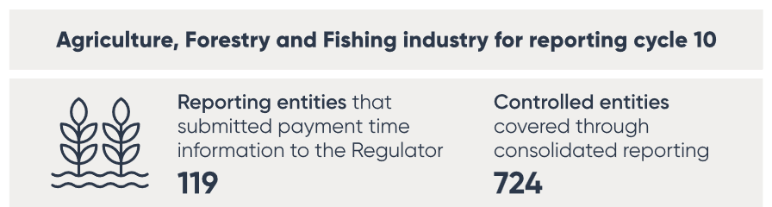
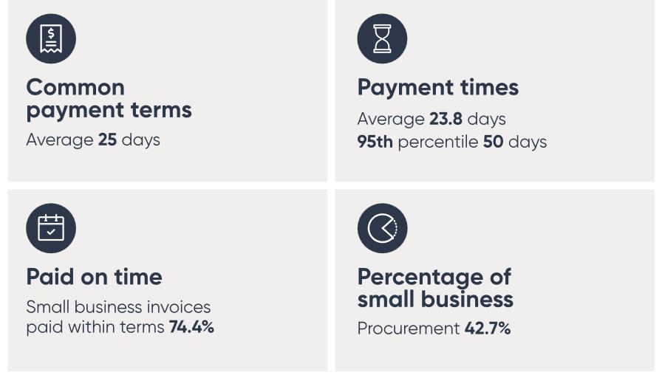
In 2024, reporting entities in the Agriculture, Forestry and Fishing industry engaged approximately 136,212 small business suppliers. As shown in Figure 14, 91.2 per cent of these suppliers were located in regional and remote Australia, compared with 31.5 per cent across all industries. This concentration highlights the industry’s important role in supporting regional business ecosystems, with many suppliers operating alongside their customers in communities where customer bases may be smaller, distances greater and alternative revenue sources more limited.
Figure 14: Small business suppliers in regional and remote areas (excluding major cities), industry comparison
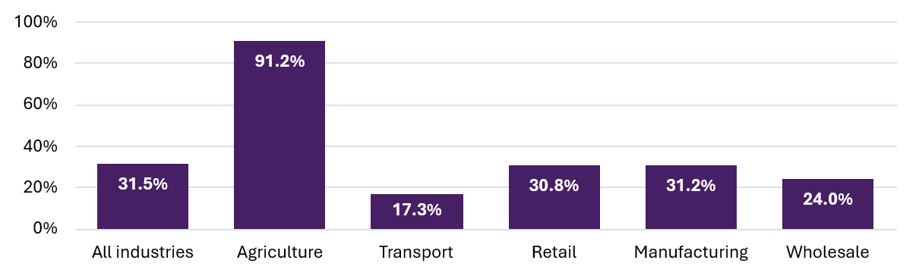
In Reporting Cycle 10, the industry reported strong results across most key payment measures when compared with the all-industry average (see Table 3). Reporting entities reported average payment times of 23.8 days, compared with 27.2 days across all industries; a 95th percentile payment time of 50 days, compared with 55 days; and 74.4 per cent of invoices paid within payment terms, compared with 68.5 per cent. The industry also reported a substantially higher share of procurement from small businesses, with 42.7 per cent of procurement by value directed to small business suppliers compared with 29.4 per cent across all industries.
Table 3: Comparison of reported key payment measures, Agriculture, Forestry and Fishing industry vs all industries, Reporting Cycle 10
Measure | Agriculture | All industries
Average common payment term (days) | 25 | 29
Average payment time (days) | 23.8 | 27.2
95th percentile payment time (days) | 50 | 55
Paid on time (within terms) (%) | 74.4 | 68.5
Invoices paid within 30 days (%) | 73.1 | 69.8
Small business procurement (value share) (%) | 42.7 | 29.4
Despite these positive results, some suppliers continue to experience longer payment delays. While the industry’s reported average payment time is better than the all-industry average, long tail payment times remain high, with 86.6 per cent of reporting entities paying 95 per cent of the small business supplier invoices in more than 30 days (see Figure 15). This indicates that some small businesses are waiting substantially longer to be paid than typical reporting measures would suggest.
Figure 15: Distribution of reported 95th percentile payment times for the Agriculture, Forestry and Fishing industry, Reporting Cycle 10
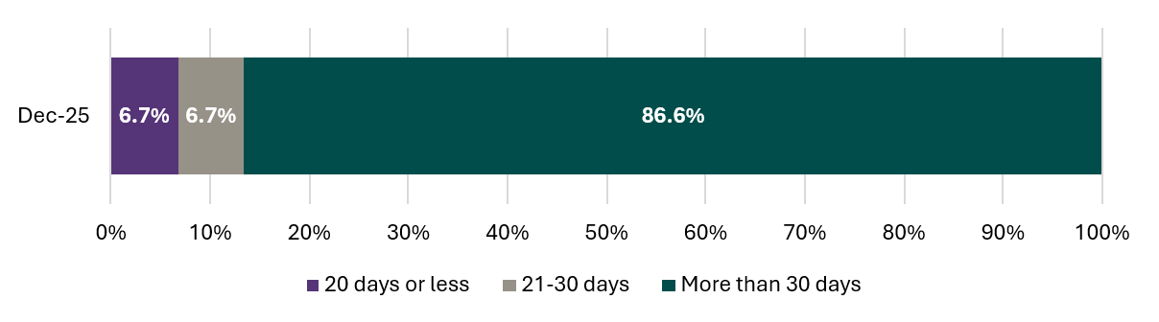
Overall, the Agriculture, Forestry and Fishing industry performed well across most key reporting measures, suggesting that many small business suppliers are benefitting from prompt and more reliable payment practices than those experienced across the broader Scheme. However, the gap between average payment time and 95th percentile payment time highlights an ongoing challenge: ensuring that payment performance is not only prompt on average, but also consistently reliable for the regional small businesses that underpin the industry’s supply chains.

Compliance and enforcement
Compliance and enforcement update
Compliance and enforcement priorities 2026–27
Spotlight: Compliance and enforcement action

Compliance and enforcement update
Since the reformed Scheme commenced in 2024, reporting entities have had up to 3 reporting periods to become familiar with their obligations and embed the systems and processes necessary to support compliance. For most reporting entities, Reporting Cycle 10 represents their third reporting cycle under the reformed framework.
The Regulator continues to support compliance through targeted engagement, education and guidance. This includes publishing information sheets and guidance materials, providing worked reporting examples, responding to enquiries, and delivering online education sessions to assist entities in understanding and meeting their obligations under the Act.
As the Scheme matures, the Regulator expects reporting entities to have effective governance arrangements and internal controls in place to ensure they submit reports accurately and on time.
Since publishing the 2025–26 compliance and enforcement priorities, the Regulator has focused on entities who have failed to report within legislated timeframes and entities who have provided information that is incomplete, inaccurate, false or misleading.
As a result of compliance and enforcement action undertaken, between 1 January and 30 June 2026:
 the Regulator published details of 9 paid infringement notices
 the Regulator published 38 instances of non-compliance relating to 13 entities
 337 warning letters were issued to entities who failed to comply with their reporting obligations
 139 entities submitted a report for the first time under the reformed Scheme
319 revised reports were submitted by entities to improve the accuracy and completeness of information published on the Payment Times Reports Register
 255 reports were removed from the Payment Times Reports Register due to not following consolidated reporting requirements under the Scheme.
Compliance actions reflect the Regulator’s continued focus on bringing entities into the Scheme, improving the quality of reports, and addressing non-compliance in a manner that supports the transparency objective of the Act.
Information about paid infringement notices is available on the Scheme’s website and the public-facing Payment Times Reports Register, which also contains notices with details of non-compliance.

Compliance and enforcement priorities 2026–27
The Regulator is maintaining its existing compliance and enforcement priorities for 2026‍–‍27 and will continue to apply an escalating approach to compliance and enforcement as outlined below:
Figure 16: Regulator’s escalating approach to compliance
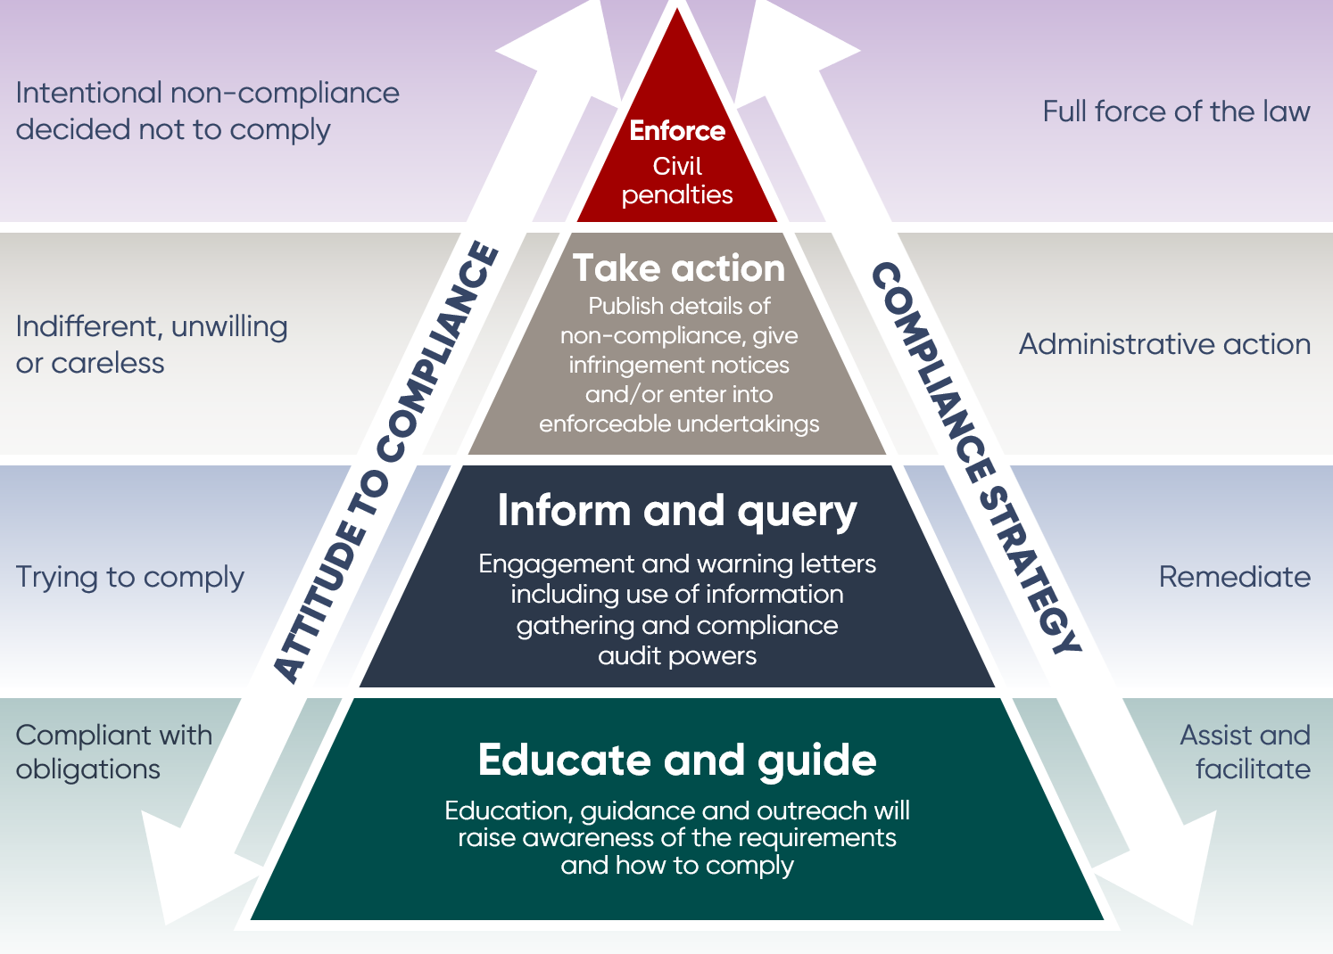
The primary focus remains on improving the completeness, accuracy and integrity of information available through the Payment Times Reports Register. This includes identifying entities who have reporting obligations but are not reporting, improving the quality of reports submitted under the Scheme, and addressing non-compliance where it occurs.
Where entities fail to take reasonable steps to comply, the Regulator will consider appropriate compliance and enforcement action.

Consistent with the existing compliance and enforcement priorities, the Regulator will continue to focus on:
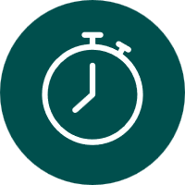 entities who are required to report but have not lodged reports
entities submitting reports outside legislated timeframes
 entities submitting reports which contain inaccuracies or appear false or misleading
entities who have failed to comply with consolidated reporting requirements
entities using incorrect report types, and
 using industry insights to target compliance activities on specific industry groups, including those with elevated levels of non-compliance.
Through these activities, the Regulator aims to strengthen confidence in the Scheme, improve transparency of payment practices, and support better payment outcomes for small business suppliers.

Spotlight: Compliance and enforcement action

Reasons for taking enforcement action
Transparency is central to the Scheme. The purpose of the Scheme is to improve the transparency of the payment practices of large businesses and certain government entities and, through transparency, encourage better payment outcomes for small business suppliers.
The effectiveness of the Scheme relies on information published on the Payment Times Reports Register being complete, accurate and available when stakeholders need it. When entities fail to report on time or provide inaccurate information, the integrity of the Payment Times Reports Register is diminished, and stakeholders are unable to access information to which they are entitled under the Act.
Late, incomplete or inaccurate reporting may:
- reduce transparency of payment practices across industries
- limit the ability of small businesses, investors and other stakeholders to make informed decisions
- reduce comparability between reporting entities, and/or
- undermine confidence in the Payment Times Reports Register and the Scheme more broadly.
While the Regulator is committed to supporting entities to understand and meet their obligations, reporting entities are responsible for ensuring their reports are complete, accurate and submitted on time.
When determining an appropriate regulatory response, the Regulator considers factors including:
- the nature and seriousness of the contravention
- the impact of the non-compliance
- the steps taken by the entity to address the issue
- whether the conduct is ongoing or repeated, and/or
- the entity’s compliance history.
Making information about an entity’s failure to comply with the Act publicly available enables small business suppliers and other stakeholders to take these matters into account when considering an entity’s performance and its approach to meeting its obligations. This information supports informed decision making when entering into a supply agreement or purchasing goods or services.
The Regulator takes a proportionate and escalating approach to compliance and enforcement. Enforcement action serves not only to address non-compliance but also to promote accountability, encourage future compliance and maintain the integrity of the Scheme.

Infringement notices and penalties
The Act provides a range of tools to address non-compliance. Infringement notices may be given for a range of alleged contraventions, including failure to report, providing false or misleading information, and failing to comply with information-gathering notices.
To date, the Regulator has published details of 9 paid infringement notices on its website and on the Payment Times Reports Register. Publication of compliance outcomes supports the transparency objectives of the Scheme and provides stakeholders with greater visibility of an entity’s compliance with its statutory reporting obligations.
The Payment Times Reporting legislative framework provides for significant penalties in appropriate circumstances. For a single alleged contravention of section 15(1) of the Act, the Regulator may issue an infringement notice with a maximum amount of 60 penalty units. An infringement notice relates to alleged contraventions and is an administrative alternative to court proceedings. If the matter proceeds to court, the court may impose a civil penalty that is 5 times that amount (300 penalty units), for a single contravention of subsection 15(1) of the Act. From 1 July 2026, the value of a penalty unit is $364. This means the maximum infringement notice amount for a single alleged contravention is $21,840, while the maximum court-imposed civil penalty for a single contravention is $109,200.
Importantly, non-compliance may lead to multiple contraventions. For example, each outstanding report may constitute a separate contravention and, in some circumstances, a failure to lodge a report may constitute a continuing contravention for each day the report remains outstanding.
Did you know?
Each day that your entity’s report is late is a separate alleged contravention.
For example, if an entity was up to 243 days late in submitting their report, the Regulator could give an infringement notice of up to $5,307,120. If this proceeded to court, the civil penalty could be up to $26,535,600.
Potential penalties can increase substantially where non-compliance is prolonged, repeated or affects multiple reporting periods. While the available penalties may be significant, the Regulator determines enforcement outcomes on a case-by-case basis, having regard to the particular circumstances of each matter. Relevant considerations may include the duration and seriousness of the non-compliance, whether the conduct is ongoing and/or repeated, the entity’s compliance history, and the extent to which the entity has engaged with the Regulator to resolve the matter.
For further information about the Regulator’s approach to compliance and enforcement, including infringement notices and civil penalties, refer to the Scheme’s website to view information sheets on ‘Our Approach to Regulation’ and ‘Our Regulatory Powers’.
The Regulator encourages entities to engage early where compliance issues are identified and to take proactive steps to rectify non-compliance before enforcement action becomes necessary.

Appendix A – Insights: methodology and assumptions

Reporting cycles
Reporting Cycle 1 | Reporting Cycle 2 | Reporting Cycle 3 |  | Reporting Cycle 10
1/01/2021–30/06/2021 | 1/07/2021–31/12/2021 | 1/01/2022–30/06/2022 | ⟶ | 1/07/2025–31/12/2025
Reports are assigned to a reporting cycle based on the reporting period end date. For example, reports with a reporting period end date of 15 March 2025 will be categorised as Reporting Cycle 9 for the purpose of payment times reporting.
Prior to December 2024, reports were assigned by the reporting period start date. This change has a minimal effect on the data and aligns the treatment of all reports submitted under the reformed Scheme.
Historic data may change when entities submit reports for previous reporting cycles, revise reports or when reports are withheld by the Regulator.

Insights are at a point in time
Data is subject to revision and reports are received on a continuous basis, including for historical reporting cycles. Previous reports can also be updated by submitting a revised report.
Insights provided in this Update are based on reports received on or before 30 June 2026 and subsequently published. These insights are subject to change as additional or revised reports are submitted and published after this date.
Note: Exercise caution when interpreting the data and insights in this Update, as the key reporting measures may not be directly comparable to measures from reporting cycles pre-July 2024. The July 2025 Regulator’s Update was the first publication to publish insights based on the new reporting measures.

Analysis on payment times
Reports received for Reporting Cycle 10 (1 July 2025 to 31 December 2025) contain reported payment terms and payment times data relating to payments made to small business suppliers. Reported data includes payment times expressed in days for average payment times, median payment times, the 80th percentile payment time, the 95th percentile payment time and percentage of invoices paid on time (within payment terms). Payments for invoices paid to small business suppliers are grouped into 3 separate day ranges (within 30 days, 31-60 days and more than 60 days).

Consolidated reporting
Consolidated reporting was introduced to the Scheme from 1 July 2024. Consolidation of entities using the AASB accounting standards provides a consistent and well understood framework for entities. It also reduces unnecessary administrative and compliance burden for individual entities in a group. Consolidated reporting allows a single report for a corporate group to be provided to the Regulator for publication to the Payment Times Reports Register.

Controlled entities
A controlled entity is an entity controlled by a reporting entity. Under the Act, a reporting entity must submit a single consolidated report which combines its own payment information with those of its corporate group. Data on controlled entities in this Update represents a count of reported business names. For the January 2026 Regulator’s Update, the number of controlled entities represents a count of reported Australian Business Numbers.

Commonwealth entities
A Commonwealth entity is considered a reporting entity if it is a Corporate Commonwealth entity or a Commonwealth company as defined by the Public Governance, Performance and Accountability Act 2013 and it meets the definition of a reporting entity in section 7 of the Payment Times Reporting Act 2020.

Assumptions
Unless otherwise stated, the following assumptions apply:

Included in the analysis
- Analysis is based on self-reported data from all reporting entities who make payments to small businesses (including volunteer entities).
- References to reporting entities include those who meet the definition of a reporting entity under section 7 of the Act, as well as volunteering entities, subsidiary reporting entities, and reporting nominees, as determined by the Regulator.
- Analysis for Reporting Cycle 10 is based on reports with reporting period end dates on or before 31 December 2025 and received by 30 June 2026. Therefore, data insights published in the Update are subject to revision.
- Reports submitted for Reporting Cycle 10 include key reporting measures, such as average payment times, median payment times, the 80th and 95th percentile payment times, and percentage of invoices paid on time.

Excluded from analysis
- Reports which indicate no procurement from small businesses are excluded from calculations for payment terms and payment times. A count of reports with no small business procurement is displayed in Table 2.
- Superseded reports are also excluded from calculations. A superseded report is an original report which has been replaced by a subsequent revised report. Only the most recent revised report is used for analysis. A count of superseded reports is displayed in Table 4.

Appendix B – Data tables
All data tables reflect payment times reports and revised reports received on or before 30 June 2026, reflecting small business payment activity up to and including Reporting Cycle 10. Reporting Cycle 11 is presented in Table 4 to give a complete picture of all reports received on or before 30 June 2026.
Time series data has been included in some tables below. Note: Following the reforms, time series data is not always comparable due to a number of reasons, including consolidated reporting or differences in reporting measures. In some instances, the Regulator has separated data for reporting period start dates before and after 1 July 2024.
Table 1: Share of small business procurement, Reporting Cycles 1 to 10
Reporting cycle | Cycle range | Proportion of total procurement value with small businesses - Before 1 July 2024 | Proportion of total procurement value with small businesses -  After 1 July 2024
Cycle 1 | 1 Jan 2021 - 30 Jun 2021 | 29.4%
Cycle 2 | 1 Jul 2021 - 31 Dec 2021 | 29.7%
Cycle 3 | 1 Jan 2022 - 30 Jun 2022 | 29.7%
Cycle 4 | 1 Jul 2022 - 31 Dec 2022 | 29.5%
Cycle 5 | 1 Jan 2023 - 30 Jun 2023 | 30.0%
Cycle 6 | 1 Jul 2023 - 31 Dec 2023 | 30.2%
Cycle 7 | 1 Jan 2024 - 30 Jun 2024 | 30.1%
Cycle 8 | 1 Jul 2024 - 31 Dec 2024 | 29.7% | 30.6%
Cycle 9 | 1 Jan 2025 - 30 Jun 2025 |  | 29.0%
Cycle 10 | 1 Jul 2025 - 31 Dec 2025 |  | 29.4%
Table 2: Report types, Reporting Cycle 10
Report Type | Total reports  (No. and %)
Standard | 2,983 (85.3%)
No small business procurement | 231 (6.6%)
External Administration | 5 (0.1%)
AASB8 | 277 (7.9%)
Has reporting nominee | 0 (0.0%)
Total reports on the Register (this cycle) | 3,496 (100%)

Table 3: Reporting entities with small business procurement by industry, Reporting Cycle 10
Industry  Ranked by alphabetical order | Reporting entities  (No. and %) | Controlled entities  (No.) | Average common payment terms  (days) | Proportion of total procurement value with small businesses  (%)
Accommodation and Food Services | 48 (1.5%) | 769 | 27 | 31.4%
Administrative and Support Services | 67 (2.1%) | 498 | 26 | 40.2%
Agriculture, Forestry and Fishing | 119 (3.7%) | 724 | 25 | 42.7%
Arts and Recreation Services | 54 (1.7%) | 540 | 24 | 36.7%
Construction | 297 (9.1%) | 3,517 | 33 | 43.5%
Education and Training | 16 (0.5%) | 312 | 19 | 43.8%
Electricity, Gas, Water and Waste Services | 105 (3.2%) | 1,334 | 24 | 22.9%
Financial and Insurance Services | 414 (12.7%) | 5,330 | 22 | 25.0%
Health Care and Social Assistance | 119 (3.7%) | 2,452 | 24 | 32.6%
Information Media and Telecommunications | 85 (2.6%) | 990 | 30 | 22.4%
Manufacturing | 433 (13.3%) | 1,928 | 35 | 28.3%
Mining | 224 (6.9%) | 2,251 | 33 | 22.2%
Other Services | 28 (0.9%) | 227 | 30 | 37.1%
Professional, Scientific and Technical Services | 252 (7.7%) | 1,880 | 27 | 32.3%
Public Administration and Safety | 36 (1.1%) | 83 | 21 | 26.7%
Rental, Hiring and Real Estate Services | 82 (2.5%) | 1,621 | 27 | 33.0%
Retail Trade | 268 (8.2%) | 3,102 | 31 | 26.0%
Transport, Postal and Warehousing | 183 (5.6%) | 1,193 | 30 | 25.6%
Wholesale Trade | 424 (13.0%) | 1,356 | 32 | 25.1%
All industries | 3,254 (100%) | 30,107 (100%) | 29 | 29.4%

Table 4: Payment times reports received by 30 June 2026, Reporting Cycles 1 to 11
Reporting Cycle | Cycle range | Number of reports  (No.) | Average standard payment terms  (days) | Average common payment terms  (days) | Average proportion of procurement value with small business  (%) | Average proportion of invoices paid within 30 days  (%)
Cycle 1 | 1 Jan 2021 - 30 Jun 2021 | 6,358 | 36.7 |  | 29.4% | 63.2%
Cycle 2 | 1 Jul 2021 - 31 Dec 2021 | 7,534 | 35.9 |  | 29.7% | 65.6%
Cycle 3 | 1 Jan 2022 - 30 Jun 2022 | 7,760 | 35.4 |  | 29.7% | 66.1%
Cycle 4 | 1 Jul 2022 - 31 Dec 2022 | 7,977 | 35.1 |  | 29.5% | 67.5%
Cycle 5 | 1 Jan 2023 - 30 Jun 2023 | 8,030 | 34.9 |  | 30.0% | 67.2%
Cycle 6 | 1 Jul 2023 - 31 Dec 2023 | 8,200 | 34.7 |  | 30.2% | 68.7%
Cycle 7 | 1 Jan 2024 - 30 Jun 2024 | 8,195 | 35.0 |  | 30.1% | 68.7%
Cycle 8 | 1 Jul 2024 - 31 Dec 2024 | 3,591 | 35.1 | 30 | 30.4% | 68.2%
Cycle 9 | 1 Jan 2025 - 30 Jun 2025 | 3,246 |  | 29 | 29.0% | 68.0%
Cycle 10 | 1 Jul 2025 - 31 Dec 2025 | 3,260 |  | 29 | 29.4% | 69.8%
Cycle 11 | 1 Jan 2026 – 30 Jun 2026 | 301
Total |  | 64,452
Superseded reports |  | 2,373
Total reports |  | 66,825
* The average standard payment terms reported since the Scheme began in 2021 has been replaced with the most common payment term.

Table 5: Payment terms and times for Commonwealth entities, Reporting Cycle 10
C'th Entity type | Commonwealth entity name  by alphabetical order | Common payment term  (days) | Median payment time  (days) | Average payment time  (days) | 80th percentile payment time  (days) | 95th percentile payment time  (days) | Average percentage paid on time  (%) | Proportion of total procurement value with small businesses (%)
CCE | Airservices Australia | 20 | 18 | 23.1 | 25 | 51 | 63.4% | 8.0%
CC | ASC Pty Ltd | 30 | 28 | 28.9 | 34 | 55 | 71.0% | 16.1%
CCE | Australian Broadcasting Corporation | 20 | 15 | 19.0 | 19 | 51 | 79.0% | 24.6%
CCE | Australian Digital Health Agency | 20 | 8 | 13.0 | 21 | 35 | 87.4% | 12.5%
CCE | Australian Hearing Services | 20 | 11 | 20.0 | 26 | 58 | 74.7% | 14.0%
CCE | Australian Institute of Health and Welfare | 9 | 10 | 14.0 | 16 | 36 | 87.8% | 24.0%
CCE | Australian Maritime Safety Authority | 30 | 16 | 21.9 | 28 | 41 | 79.7% | 20.3%
CC | Australian Naval Infrastructure Pty Ltd | 30 | 9 | 12.3 | 16 | 31 | 83.1% | 15.1%
CCE | Australian Nuclear Science and Technology Organisation | 30 | 14 | 15.0 | 23 | 29 | 90.0% | 34.1%
CCE | Australian Postal Corporation | 1 | 7 | 26.8 | 30 | 73 | 66.0% | 34.8%
CC | Australian Rail Track Corporation Limited | 20 | 23 | 27.9 | 29 | 60 | 72.3% | 15.2%
CCE | Australian Reinsurance Pool Corporation | 21 | 6 | 8.7 | 12 | 25 | 69.0% | 8.4%
CCE | Australian Renewable Energy Agency | 20 | 9 | 13.6 | 17 | 50 | 83.9% | 41.8%
CCE | Australian Sports Commission | 30 | 5 | 6.0 | 8 | 19 | 90.7% | 37.1%
CC | Australian Sports Foundation Limited | 14 | 10 | 11.3 | 14 | 21 | 78.4% | 23.5%
CC | CEA Technologies Pty Limited | 6 | 28 | 28.7 | 38 | 56 | 74.8% | 22.5%
CCE | Civil Aviation Safety Authority | 31 | 8 | 12.4 | 16 | 38 | 84.8% | 34.7%
CCE | Clean Energy Finance Corporation | 14 | 7 | 7.3 | 10 | 17 | 79.2% | 37.3%
CCE | Coal Mining Industry (Long Service Leave Funding) Corporation | 30 | 10 | 15.5 | 24 | 29 | 91.1% | 26.9%
CCE | Comcare Australia | 1 | 14 | 17.6 | 25 | 43 | 71.2% | 30.6%
Table 5: Payment terms and times for Commonwealth entities, Reporting Cycle 10 (continued)
C'th Entity type | Commonwealth entity name  by alphabetical order | Common payment term  (days) | Median payment time  (days) | Average payment time  (days) | 80th percentile payment time  (days) | 95th percentile payment time  (days) | Average percentage paid on time  (%) | Proportion of total procurement value with small businesses (%)
CCE | Commonwealth Scientific and Industrial Research Organisation | 14 | 5 | 6.4 | 8 | 15 | 88.1% | 26.9%
CCE | Commonwealth Superannuation Corporation | 20 | 6 | 7.3 | 10 | 20 | 95.5% | 18.8%
CCE | Creative Australia | 30 | 13 | 17.0 | 24 | 45 | 89.0% | 55.5%
CCE | Defence Housing Australia | 30 | 2 | 3.0 | 5 | 6 | 77.0% | 41.0%
CCE | Director of National Parks | 20 | 3 | 4.6 | 6 | 13 | 97.6% | 54.8%
CCE | Export Finance and Insurance Corp | 14 | 9 | 11.0 | 14 | 23 | 67.4% | 32.3%
CCE | Grains Research & Development Corporation | 30 | 13 | 17.0 | 23 | 49 | 87.5% | 20.0%
CCE | Housing Australia | 30 | 14 | 18.5 | 23 | 38 | 74.0% | 23.7%
CCE | Murray-Darling Basin Authority | 20 | 6 | 7.2 | 8 | 20 | 94.3% | 13.0%
CCE | National Disability Insurance Agency | 20 | 18 | 19.7 | 19 | 26 | 85.8% | 11.4%
CCE | National Gallery of Australia | 20 | 0 | 2.6 | 3 | 10 | 94.4% | 32.1%
CC | NBN Co Limited | 20 | 18 | 19.7 | 21 | 45 | 84.0% | 2.2%
CCE | Reserve Bank of Australia | 20 | 5 | 7.2 | 11 | 23 | 92.6% | 6.2%
CC | Snowy Hydro Limited | 7 | 7 | 11.5 | 22 | 29 | 78.3% | 2.9%
CCE | Special Broadcasting Service Corporation | 7 | 8 | 12.4 | 16 | 30 | 47.3% | 0.2%
CCE | Tourism Australia | 30 | 14 | 16.0 | 22 | 30 | 72.0% | 26.5%
 | All Commonwealth Entities | 20.3 | 10 | 14.6 | 19 | 34 | 80.6% | 23.6%
 | All industry Averages | 29 | 22 | 27.2 | 37 | 55 | 68.5% | 29.4%
CCE: Corporate Commonwealth entity – a Commonwealth entity that is a body corporate
CC: Commonwealth company – a Corporations Act 2001 company that the Commonwealth controls

Table 6: Average payment times with day ranges, Reporting Cycles 1 to 10
Reporting Cycle | Cycle range | Proportion of entities with average payment times within 30 days (%) | Proportion of entities with average payment times within 31-60 days (%) | Proportion of entities with average payment times greater than 60 days (%)
Cycle 1 | 1 Jan 2021 - 30 Jun 2021 | 63.2% | 28.2% | 8.6%
Cycle 2 | 1 Jul 2021 - 31 Dec 2021 | 65.6% | 26.6% | 7.8%
Cycle 3 | 1 Jan 2022 - 30 Jun 2022 | 66.1% | 25.8% | 8.1%
Cycle 4 | 1 Jul 2022 - 31 Dec 2022 | 67.5% | 24.8% | 7.7%
Cycle 5 | 1 Jan 2023 - 30 Jun 2023 | 67.2% | 24.8% | 8.0%
Cycle 6 | 1 Jul 2023 - 31 Dec 2023 | 68.7% | 24.2% | 7.1%
Cycle 7 | 1 Jan 2024 - 30 Jun 2024 | 68.7% | 24.0% | 7.3%
Cycle 8 | 1 Jul 2024 - 31 Dec 2024 | 68.0% | 25.4% | 6.7%
Cycle 9 | 1 Jan 2025 - 30 Jun 2025 | 68.0% | 25.2% | 6.7%
Cycle 10 | 1 Jul 2025 - 31 Dec 2025 | 69.8% | 24.3% | 5.9%
Table 7: Payment times and terms in days, Reporting Cycle 10
Common payment term | Median payment time | Average payment time | 80th percentile payment time | 95th percentile payment time
29 | 22.0 | 27.2 | 37 | 55
Table 8: Average percentage of payments within 30 days by industry, Reporting Cycle 10
Industry  Ranked by alphabetical order | Reporting Cycle 10  1 Jul 2025 to 31 Dec 2025  (%)
Accommodation and Food Services | 78.2%
Administrative and Support Services | 76.2%
Agriculture, Forestry and Fishing | 73.1%
Arts and Recreation Services | 82.6%
Construction | 57.4%
Education and Training | 81.9%
Electricity, Gas, Water and Waste Services | 80.3%
Financial and Insurance Services | 88.9%
Health Care and Social Assistance | 73.7%
Information Media and Telecommunications | 71.2%
Manufacturing | 56.6%
Mining | 66.3%
Other Services | 66.4%
Professional, Scientific and Technical Services | 72.6%
Public Administration and Safety | 84.7%
Rental, Hiring and Real Estate Services | 77.6%
Retail Trade | 66.7%
Transport, Postal and Warehousing | 67.8%
Wholesale Trade | 64.9%
All industries | 69.8%

Table 9: Payment terms and times measures by industry, Reporting Cycle 10
Industry (No. reporting entities)  Ranked by alphabetical order | Average common payment term (days) | Average payment time (days) | 80th percentile payment time (days) | 95th percentile payment time (days) | Average percentage paid on time  (%)
Accommodation & Food Services (48) | 27 | 25.1 | 33 | 50 | 66.0%
Administrative & Support Services (67) | 26 | 21.3 | 31 | 46 | 72.3%
Agriculture, Forestry & Fishing (119) | 25 | 23.8 | 33 | 50 | 74.4%
Arts & Recreation Services (54) | 24 | 20.0 | 28 | 45 | 67.9%
Construction (297) | 33 | 30.9 | 43 | 62 | 67.8%
Education & Training (16) | 19 | 20.7 | 30 | 49 | 66.5%
Electricity, Gas, Water & Waste Services (105) | 24 | 21.2 | 28 | 43 | 73.1%
Financial & Insurance Services (414) | 22 | 16.0 | 23 | 38 | 74.9%
Health Care & Social Assistance (119) | 24 | 25.8 | 37 | 57 | 63.8%
Information Media & Telecommunications (85) | 30 | 26.8 | 37 | 56 | 70.3%
Manufacturing (433) | 35 | 33.3 | 47 | 68 | 64.5%
Mining (224) | 33 | 28.2 | 37 | 53 | 70.5%
Other Services (28) | 30 | 25.9 | 35 | 48 | 72.4%
Professional, Scientific & Technical Services (252) | 27 | 39.1 | 36 | 64 | 66.8%
Public Administration & Safety (36) | 21 | 20.4 | 26 | 42 | 76.4%
Rental, Hiring & Real Estate Services (82) | 27 | 24.2 | 32 | 51 | 71.2%
Retail Trade (268) | 31 | 27.4 | 40 | 56 | 68.1%
Transport, Postal & Warehousing (183) | 30 | 26.6 | 37 | 56 | 63.4%
Wholesale Trade (424) | 32 | 28.3 | 40 | 60 | 66.1%
All Industries (3,254) | 29 | 27.2 | 37 | 55 | 68.5%

Appendix C – Compendium

Key payment times reporting measures
Measures introduced from 1 July 2024 improve the clarity and granularity of reported data to give both the Regulator and the community a more detailed and accurate view of large businesses’ payment practices. They provide greater transparency and context to users of the reports in the Payment Times Reports Register. These measures support the assessments for the payment incentives and provide insights on payment discipline and reliability, by showing how consistently a business meets its own commitments to pay on time.

80th percentile payment time (in days)
The 80th percentile indicates the number of days it took for a reporting entity to make 80 per cent of all small business trade credit payments in the reporting period. It offers a practical midpoint between average and extreme values by providing insight into whether slower payments by the entity are outliers, or representative of a more systemic practice of the entity. It is particularly useful for assessing general payment culture and tracking improvements over time.

95th percentile payment time (in days)
This measure indicates the number of days it took to make 95 per cent of all small business trade credit payments in the reporting period. This measure is key for assessing the payment incentives. It identifies the time it takes for an entity to pay the majority of invoices, excluding outliers and one-offs. This figure removes the slowest payment times of an entity, but more accurately reflects when a small business will be paid due to the removal of extreme outliers.
The 80th and 95th percentile metrics indicate the number of days at which 80 per cent and 95 per cent of small business invoices are paid. Both measures are important for understanding the midpoint and extremes of payment behaviour.
Example
If the 80th percentile payment time is 45 days and the 95th percentile payment time is 60 days for an entity, small businesses can anticipate the majority of payments being made within 45 days, with some taking up to 60 days and a small portion taking longer than 60 days. This information helps small businesses prepare for potential delays and manage their cash flow more effectively.

Average payment time (in days)
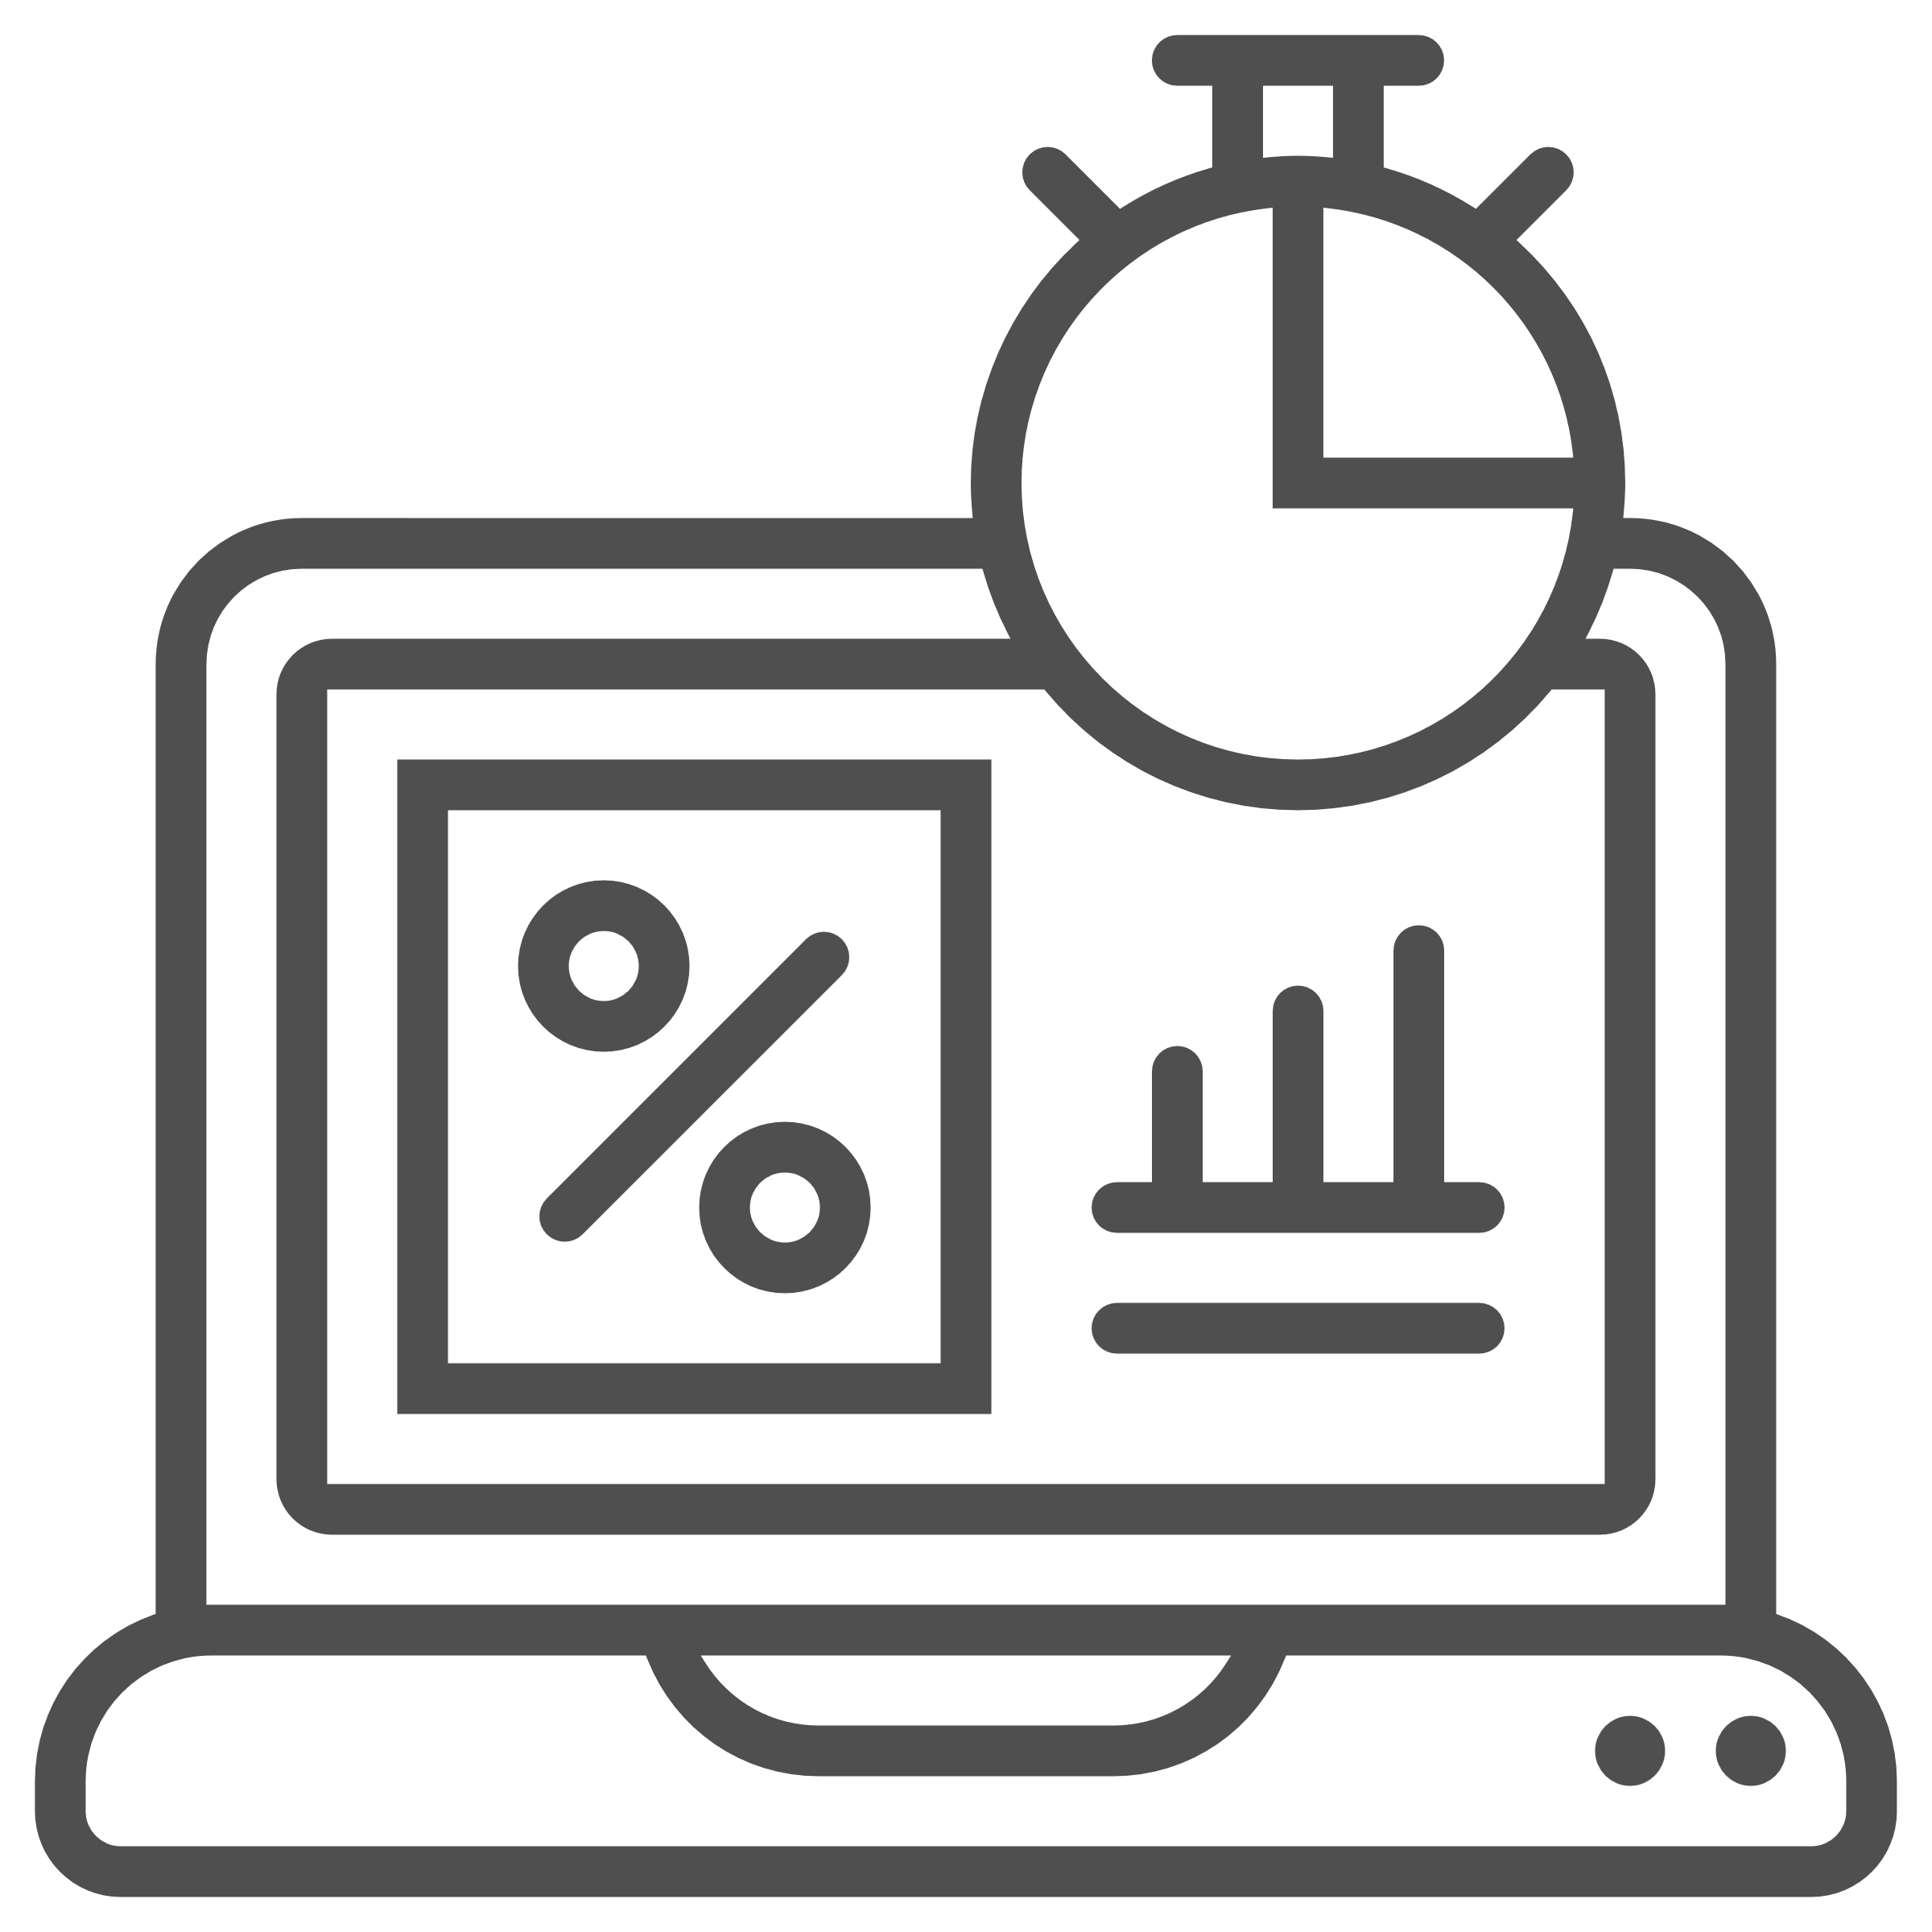
Both average and median payment times measures are included in the data collected, as payment times to small businesses do not necessarily follow a symmetrical distribution. The average payment time represents the statistical mean of the payment times calculated for all payments in the small business trade credit payments dataset.
The average payment time metric provides a clear, comparable indicator of payment performance across reporting entities and gives small businesses an awareness of when invoices are likely to be paid. It’s a useful tool for forecasting cashflow and planning working capital.
Example
If the average payment time for a large business is 32 days, but the 95th percentile is 60 days, it suggests most invoices are paid in 32 days, but a few are significantly delayed.


Common payment terms (in days)
Reporting the most frequently used payment terms helps to distinguish whether prolonged payments are due to non-compliance or permissive contractual arrangements. It also supports benchmarking across entities and industries regarding payment expectations. This measure replaces the average standard payment terms reported since the Scheme began in 2021.
Common payment terms allow terms to be compared with payment times to judge reliability.
Example
If a business has 60-day payment terms but consistently pays in 45 days, that is better than a business with 30-day payment terms but an average payment time of 60 days.

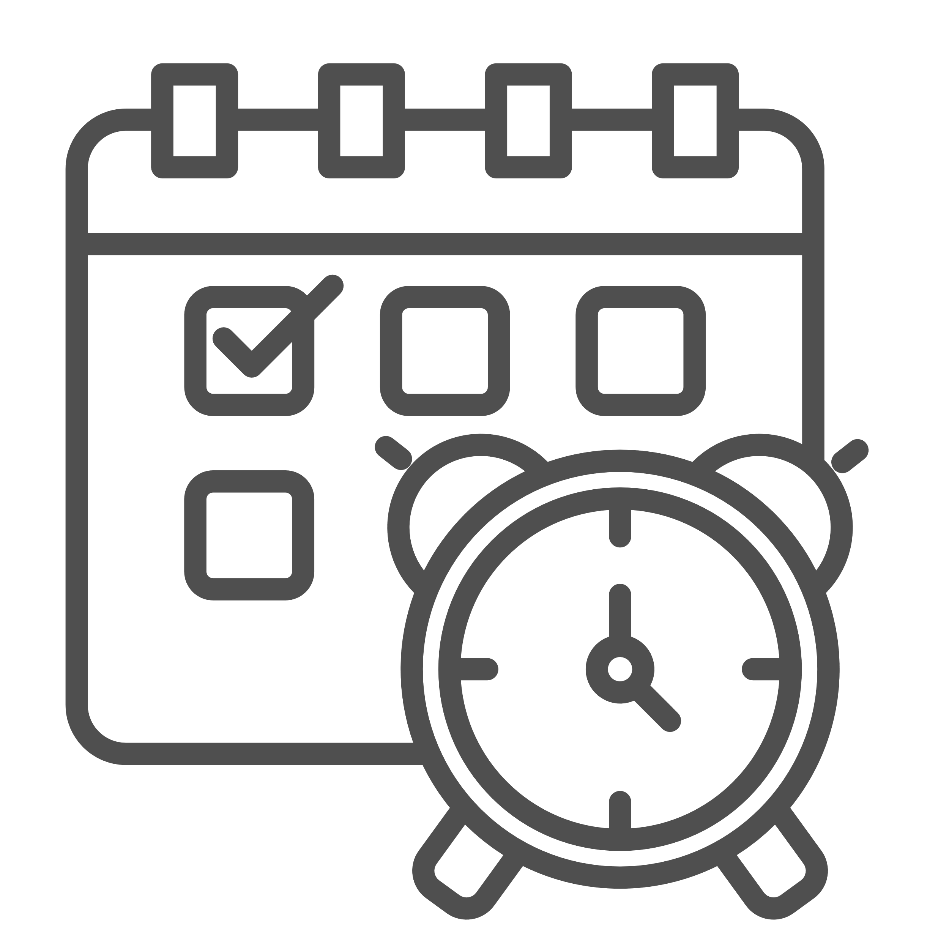
Percentage of invoices paid on time (within payment terms)
This field provides a compliance-based view, measuring how often large businesses meet their agreed payment terms for small business suppliers. It is a critical indicator of responsible procurement practices and enables targeted monitoring and public accountability.
This metric provides a measure of reliability by showing how often a business meets its own payment commitments. It is a strong indicator of payment discipline. A higher percentage means the business is more likely to pay on time.



Payment Times Reporting Regulator, How to Identify Small Business Suppliers (SBI Tool) (n.d.).
Australian Bureau of Statistics, Australian Statistical Geography Standard (ASGS): Volume 5 – Remoteness Structure, July 2011, cat. no. 1270.0.55.005 (ABS, 2011).
Australian Bureau of Statistics (ABS), Census of Population and Housing, 2021, TableBuilder, customised data extract.

