User Guide: View or revise a report
This guide outlines the steps in the portal to revise a submitted payment times report.
You can revise any report type. When you select a report to revise, the portal pre-fills the information from your original report so you can make the required changes.
For information about payment times reporting, visit the Guidance resources on the website.
To access the portal you need a Digital ID and authorisation from your entity in Relationship Authorisation Manager to act on its behalf for payment times reporting.
For more information, see Help and support to use the portal on the Regulator’s website.
Version 1.0

Revision history
Version | Date | Description
1.0 | 16 Feb 2026 | Initial version with release of new portal.

Contents
Navigate to Submit and view payment times reports 2
View or revise a report 3
Step 1: Type of report 4
Step 2: Report details 6
Step 3: Description of changes 7

Navigate to Submit and view payment times reports
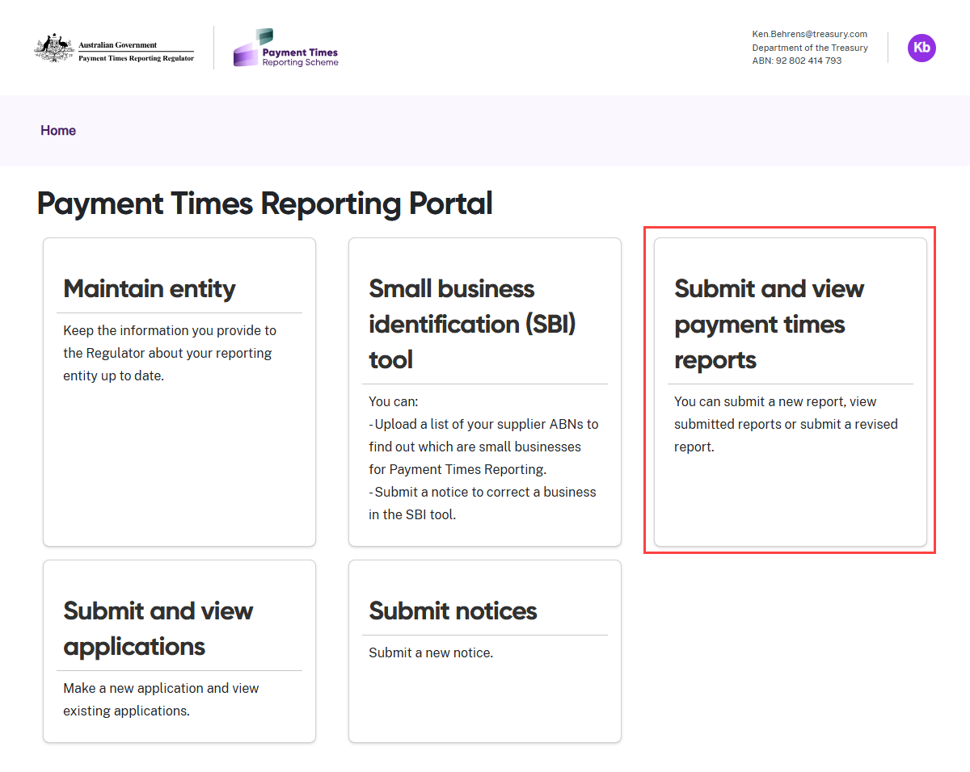
- Select the Submit and view payment times reports tile from the Home screen.

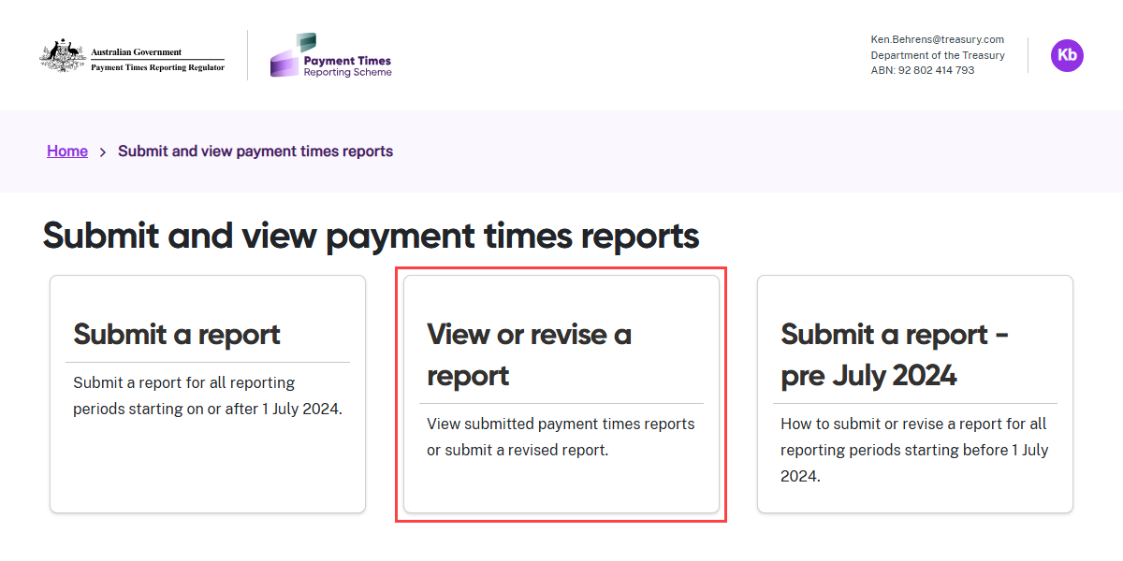
- Select the View or revise a report tile.

View or revise a report
View submitted reports
The portal displays a list of your entity’s submitted reports, including revised reports, for each reporting period beginning on 1 July 2024 or later. You can revise only the most recently submitted report for a reporting period.
You can view the list of submitted reports for reporting periods commencing prior to 1 July 2024 (i.e. on 30 June 2024 or earlier), but you cannot revise these reports through the portal.
Read about reporting for pre-1 July 2024 reporting periods in the Guidance archive section of the Regulator’s website.

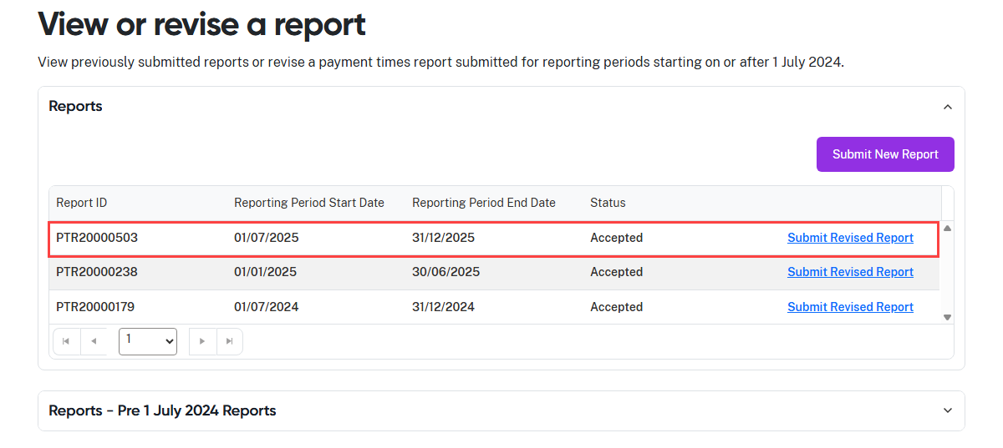
- You are able to start a new original report from this screen. Select Submit New Report to
launch this process.
 | You may find it helpful to read this User Guide alongside these resources:  - User Guide: Submit a standard report  - User Guide: Submit an AASB 8 report  - User Guide: Submit a report for nil small business payments  - User Guide: Submit a report for an entity in external administration

Revise a report
The portal displays a Submit Revised Report link next to reports that you can revise.
- Identify the report you want to revise.
- Click the Submit Revised Report link for that report.

Step 1: Type of report
In this step, select the type of payment times report you want to submit as a revised report.
 | Read the information on this page carefully and check you have selected the correct report number to revise.  If you change the report type as part of your revision, the portal will not pre-fill information from the last submitted report if it is not relevant to the revised report type.

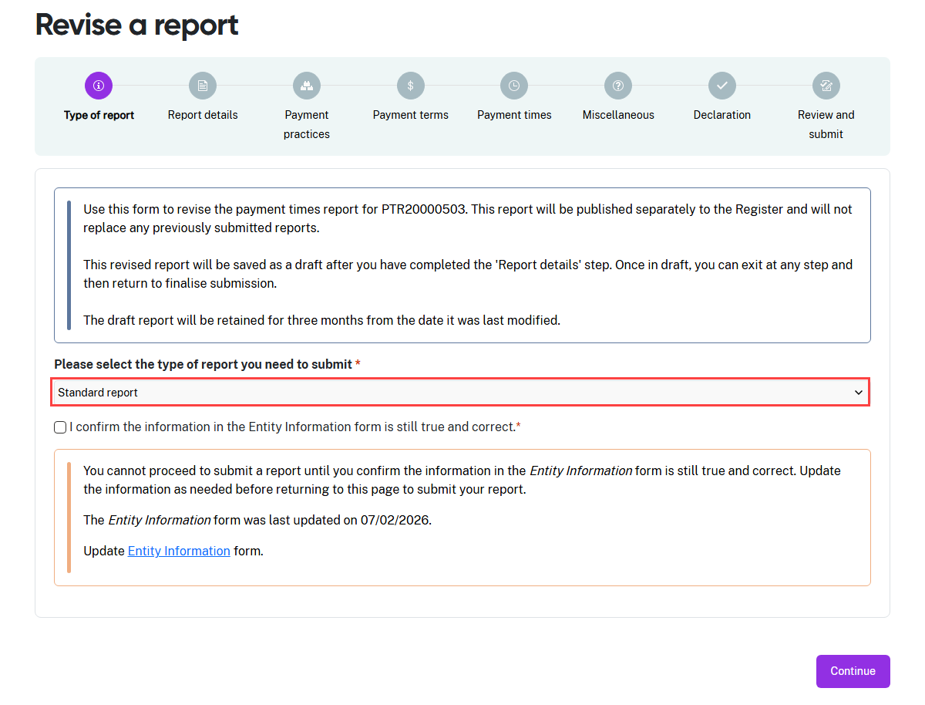
- From the drop-down menu, select the type of report to submit as a revised report.

In this User Guide, we are showing the steps to revise a standard report.
The process for revising a report is the same as the process for entering and submitting that report type.

- The progress guide now shows the sections required for a Standard report. Use the progress guide to track your progress as you complete each section.
- The portal displays a warning message reminding you to confirm the content in the
Entity information form is still true and correct. This message also shows the date
this form was last updated.
- If you need to review this content for accuracy, click the Entity Information link in
the message to go to the form. Refer to the User Guide: Entity information for help
to manage this process.

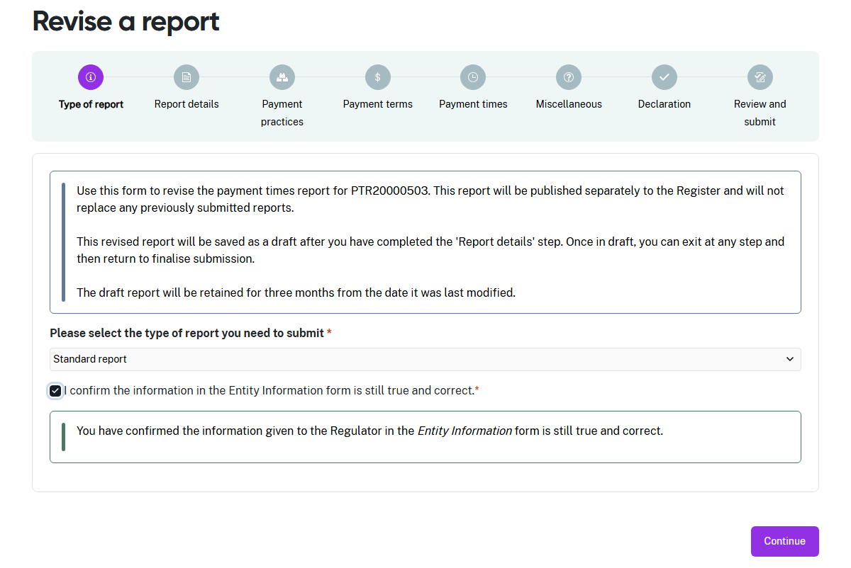
- When your Entity information is correct, check the box to confirm this is the case.
This is a mandatory field and is marked with a red asterisk. It cannot be left blank.
- Select Continue to move to the next step.

Step 2: Report details
This step pre-fills the Entity details and reporting period information from the latest
submitted report.
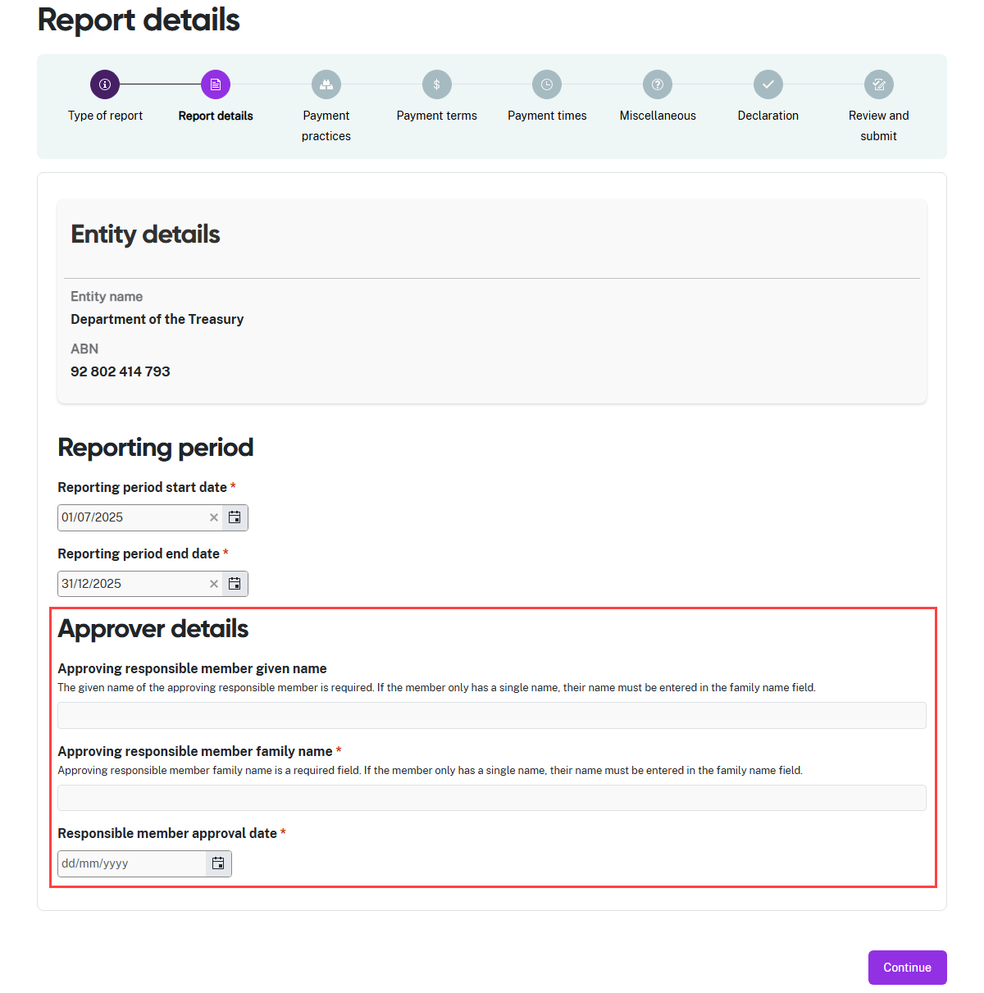
- Enter the Given name and Family name of the responsible member who approved
the revised information for this report.
- Enter the date the responsible member approved the revised information for this
report.
- Select Continue to move to the next step. If you have not changed the report type,
the portal will pre-fill this form with the information from the report you are revising. Review this information and edit it as needed.
- You can follow the standard reporting steps and see the field information in
User Guide: Submit a standard report.

Step 3: Description of changes
The Miscellaneous step of the report form captures a description of the revisions to
the report.
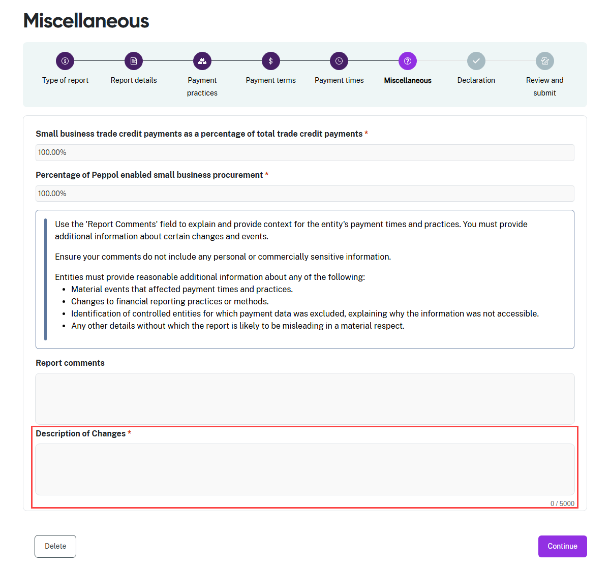
- Enter a description of the amendments you made to the submitted report in the Description of Changes field. This is a mandatory field and is marked with a red
asterisk. It cannot be left blank.
- Select Continue to move to the Declaration and Review and submit steps.
- These steps to finalise and submit the revised report are the same as in
User Guide: Submit a standard report.

