User Guide: Using the SBI Tool
This guide explains how to use the Small Business Identification Tool (SBI Tool) in the portal.
Before preparing a payment times report, a reporting entity must use the SBI Tool to identify the ABNs of the small businesses they paid during the reporting period. The SBI Tool distinguishes the small business ABNs from the ABNs of all businesses an entity paid in a reporting period.
Include all payments to businesses the SBI Tool identified as small businesses when preparing the payment times report.
Read more about using the SBI Tool in Information sheet 6: Small Business Identification Tool.
The SBI Tool is only available through the portal. To access the portal you need a Digital ID and authorisation from your entity in Relationship Authorisation Manager to act on its behalf for payment times reporting.
For more information, see Help and support to use the portal on the Regulator’s website.
Version 1.0

Revision history
Version | Date | Description
1.0 | 16 Feb 2026 | Initial version with release of new portal.

Contents
Navigate to the SBI tool 2
Step 1: Select the year 3
Step 2: Enter ABN information and run the SBI Tool 4

Navigate to the SBI tool
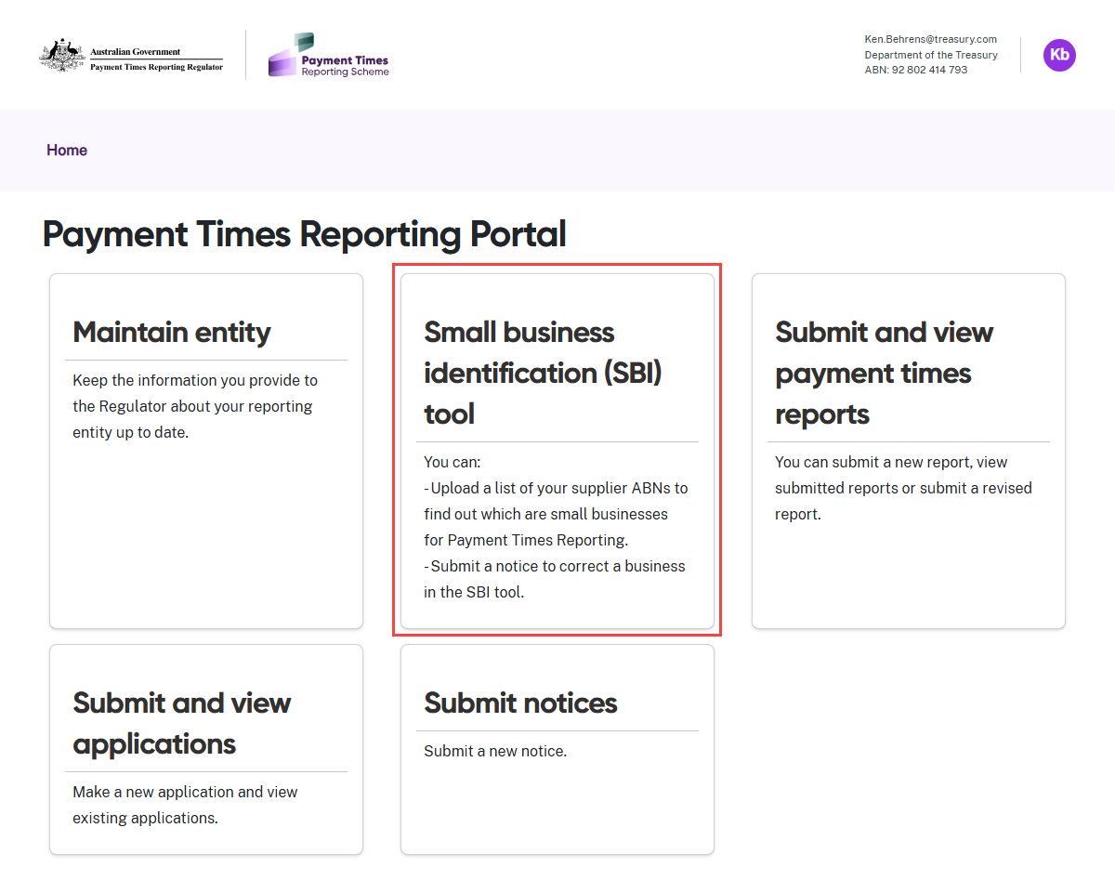
- Select the Small Business Identification (SBI) Tool tile from the Home screen.
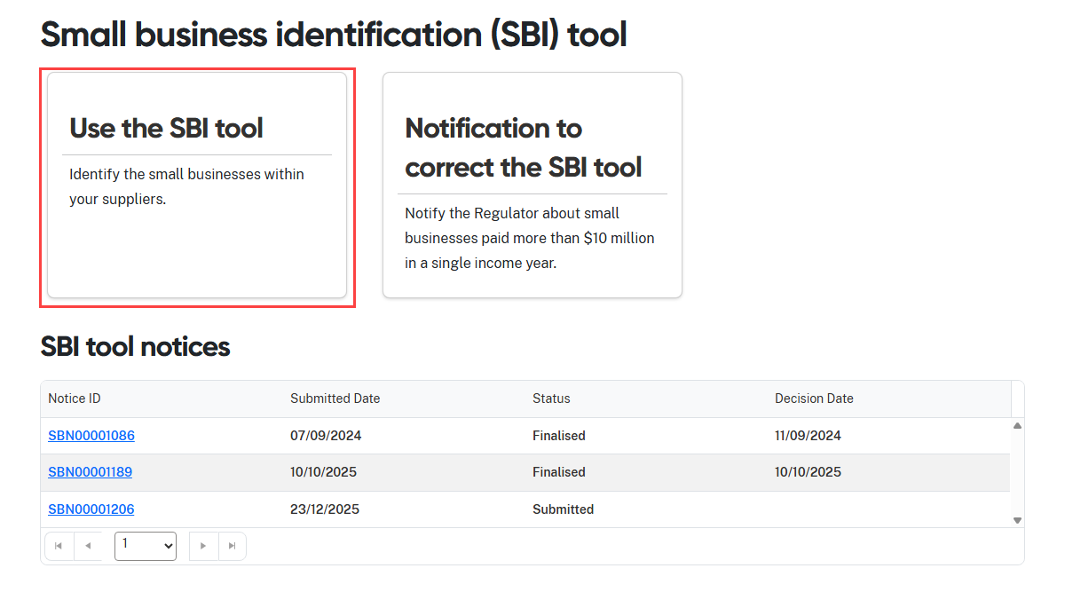
- Select the Use the SBI Tool tile.

Step 1: Select the year
 | Read the instructions carefully to select the correct ABN year.

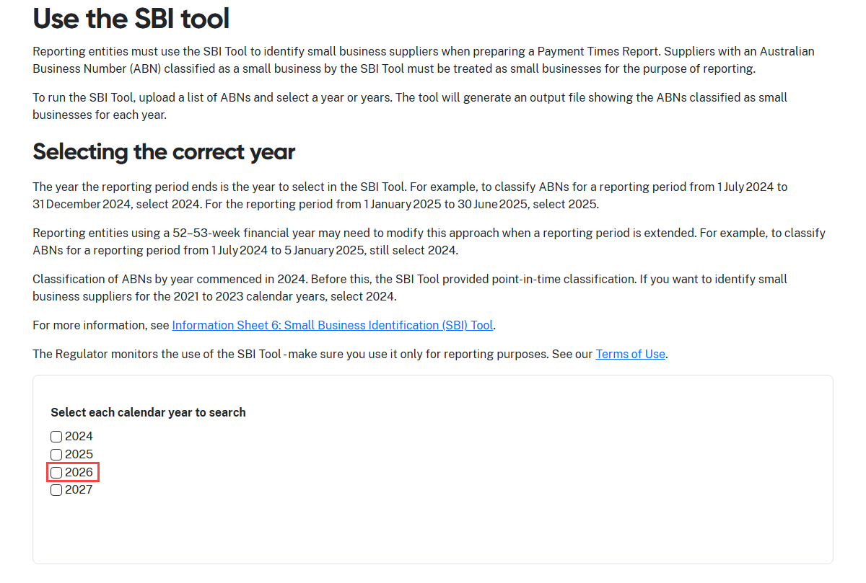
- Select the calendar year of ABN entries to check your ABN list against.
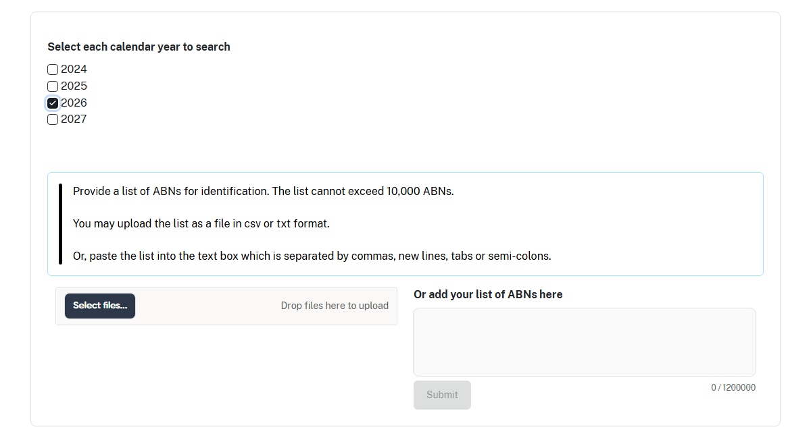
- The portal will display the input section of the screen.

Step 2: Enter ABN information and run the SBI Tool
You can enter ABN information into the SBI Tool in two ways:
1. upload or drop a file into the Select files field, or
2. copy and paste the ABNs into the free text field.
Upload or drop a file
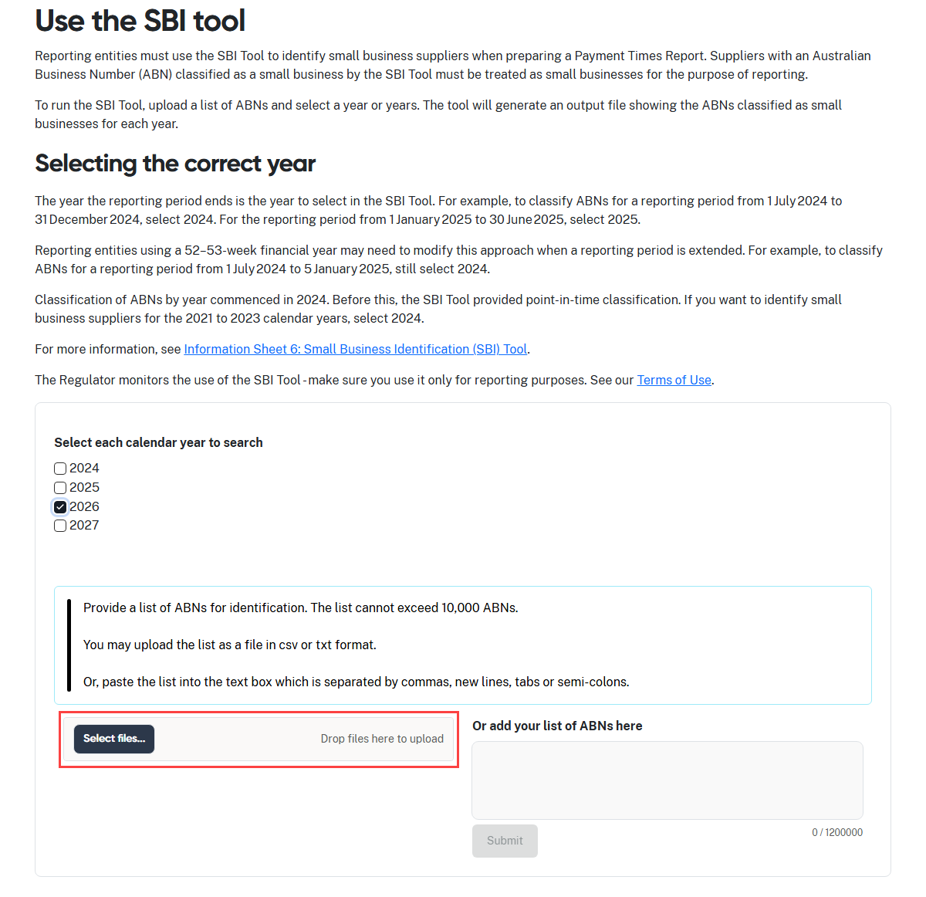
- Click Select files… to launch your file directory.

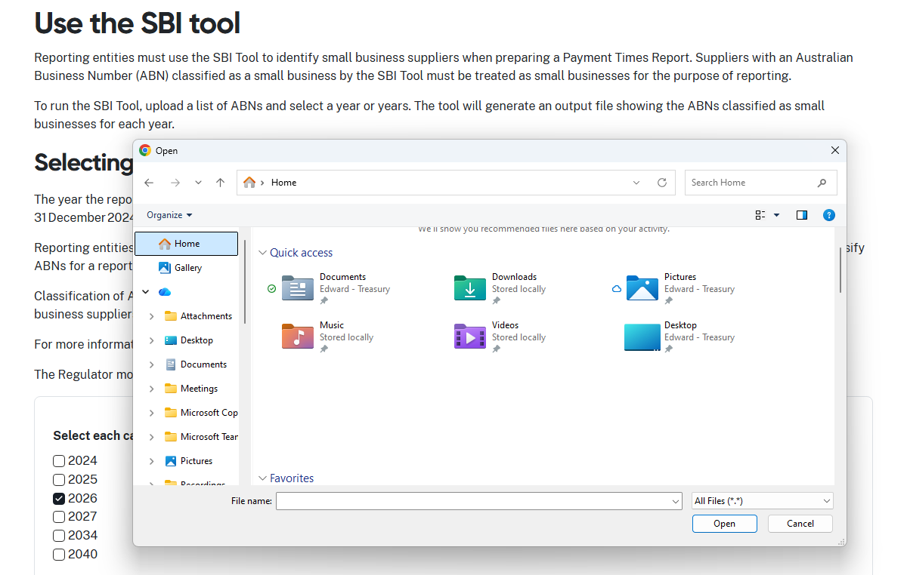
- Navigate through your folder structure to find your file.

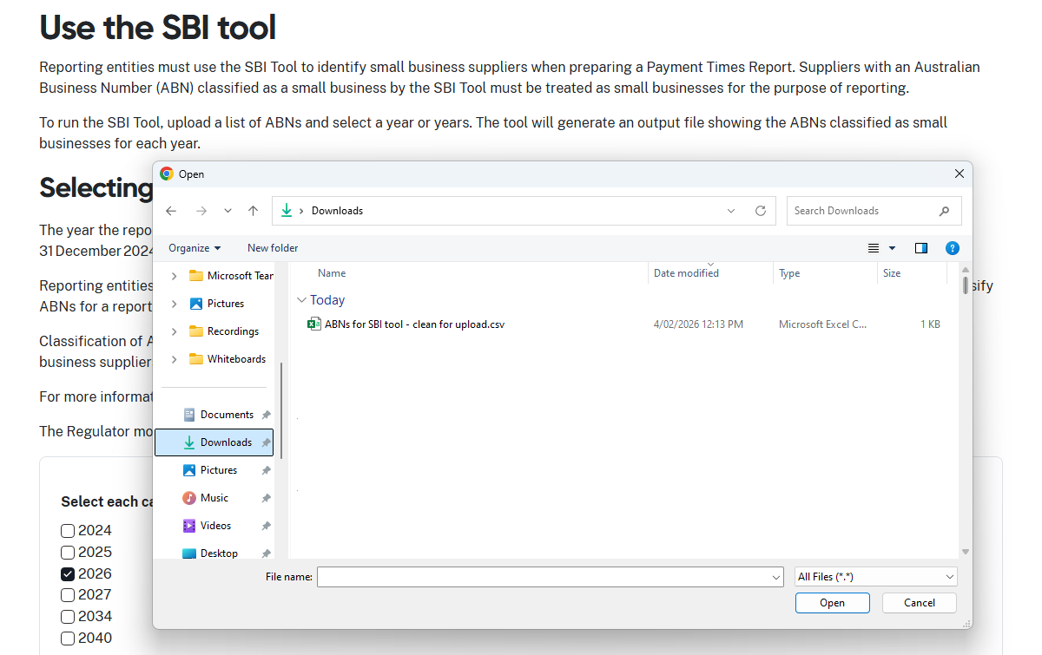
- Choose your .csv or .txt file and select Open to upload the document.
- The SBI Tool will automatically process the ABNs in the uploaded document and
generate an output file with the results of your search.

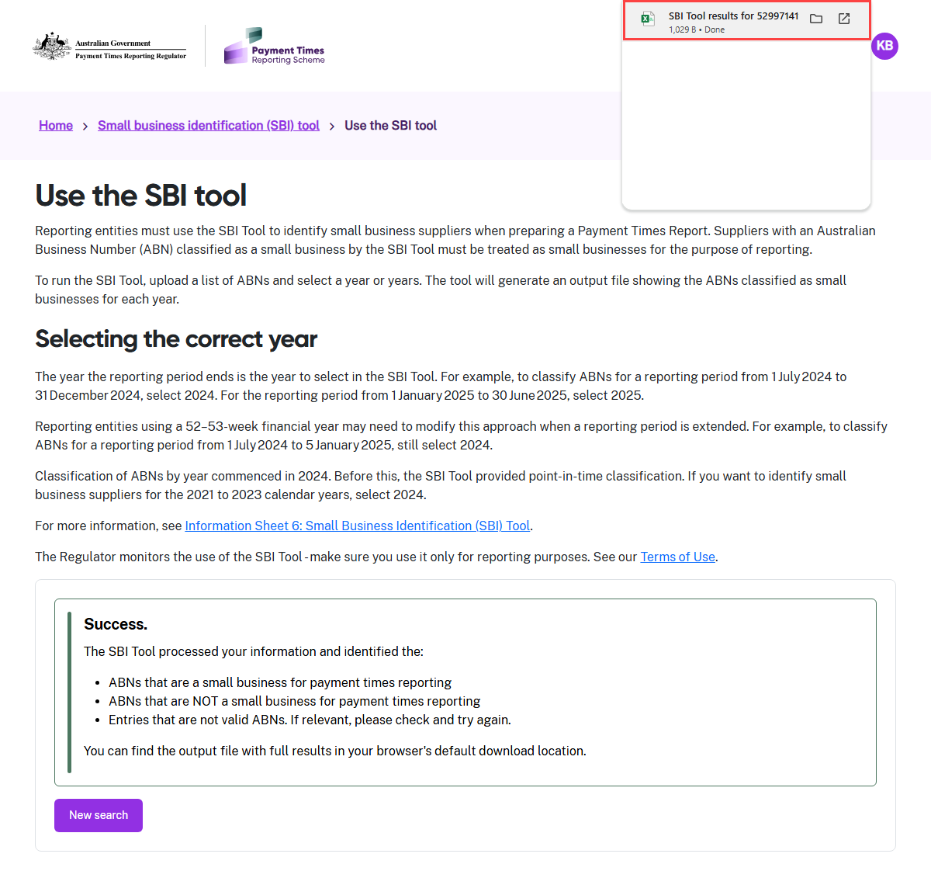
- The portal displays a confirmation message when the SBI Tool runs successfully.
- The message tells you that the output file is available in your browser’s default
download location.
- In this case, the file appears at the top right hand side of the screen.

Copy and paste ABNs into the free text field
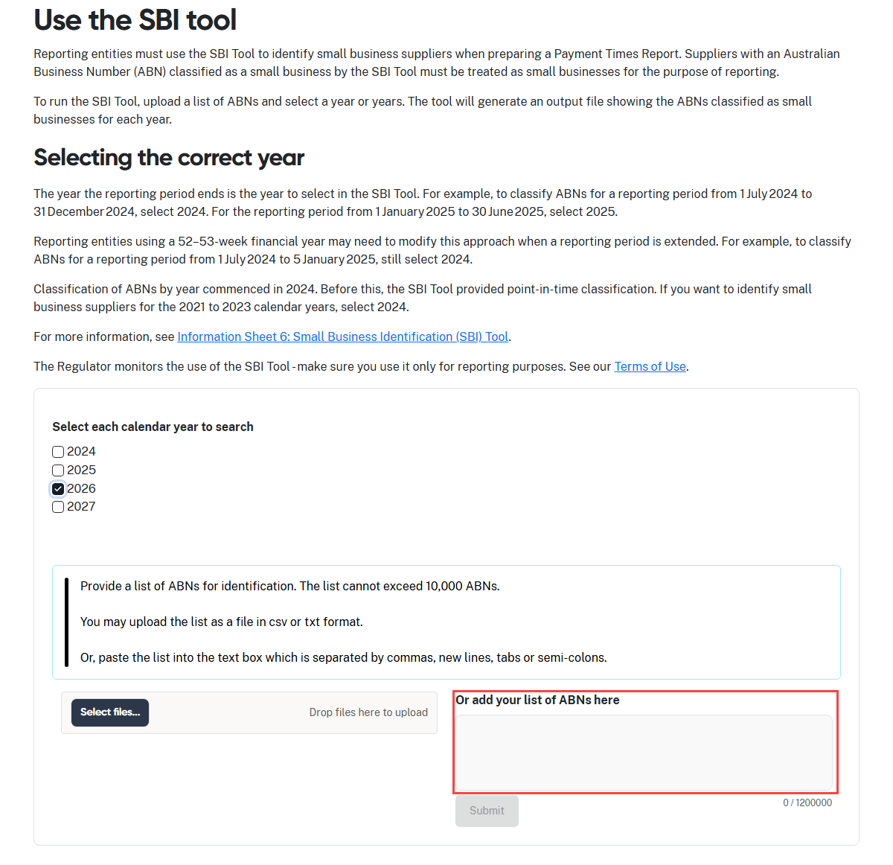
- To submit ABNs manually, copy and paste the list into the free-text field.
- Select Submit to start the SBI Tool processing the ABN list.
- The portal displays a confirmation message when the SBI Tool runs successfully.
- The message tells you that the output file is available in your browser’s default
download location.
- In this case, the file appears at the top right hand side of the screen.

