User Guide: Submit a report for an entity in external administration
This guide outlines the step-by-step process in the portal for an entity in external administration to enter and submit a report to the Regulator.
For information about payment times reporting, visit the Guidance resources on the website.
To access the portal you need a Digital ID and authorisation from your entity in Relationship Authorisation Manager to act on its behalf for payment times reporting.
For more information, see Help and support to use the portal on the Regulator’s website.
Version 1.0

Revision history
Version | Date | Description
1.0 | 16 Feb 2026 | Initial version with release of new portal.

Contents
Navigate to Submit and view payment times reports 2
Step 1: Type of report. 3
Step 2: Report details 5
Step 3: External administration 6
Step 4: Miscellaneous 7
Step 5: Declaration 8
Step 6: Review and submit 9

Navigate to Submit and view payment times reports
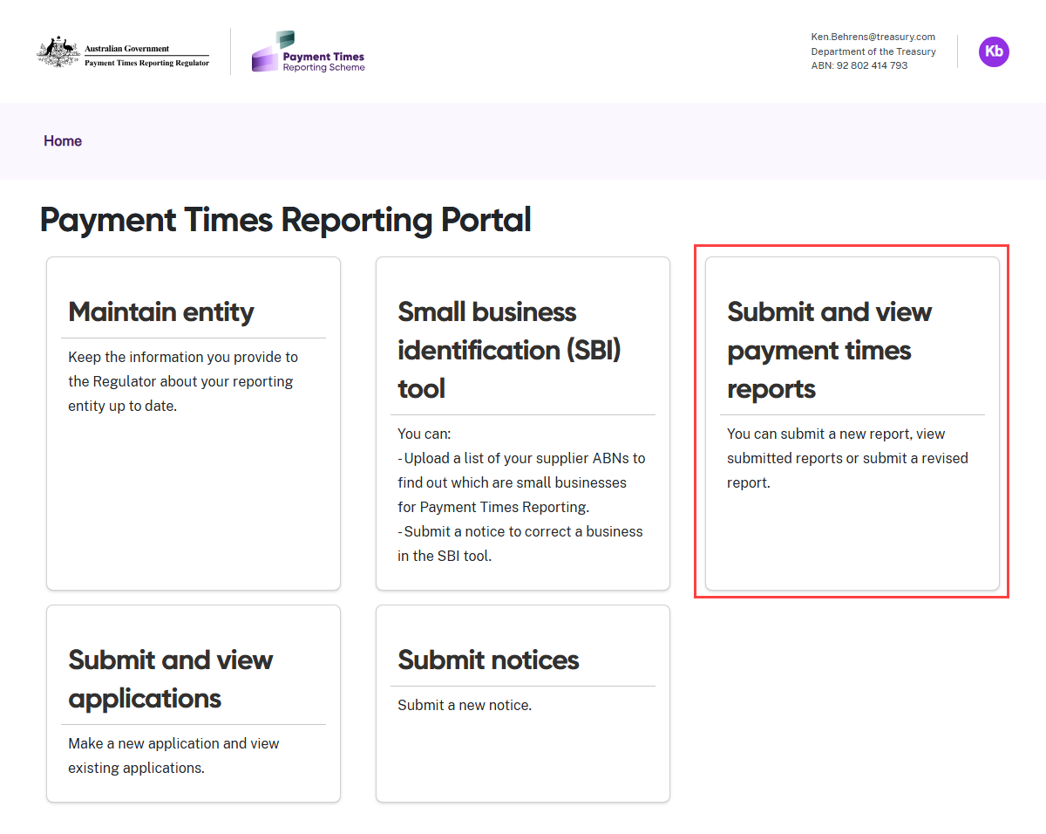
- Select the Submit and view payment times reports tile from the Home screen.

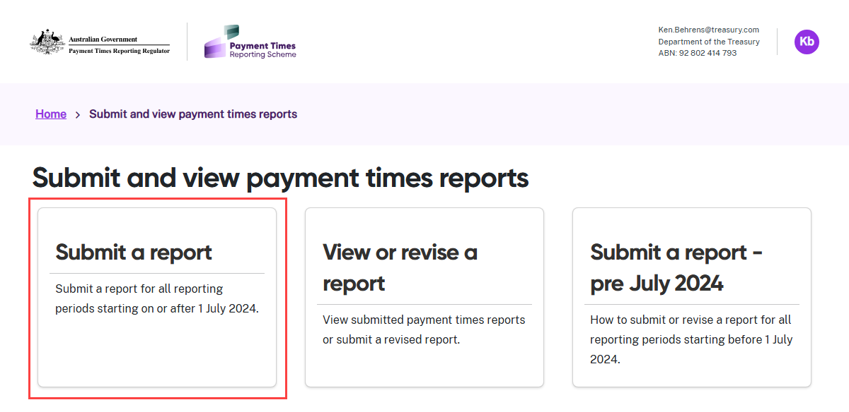
- Select the Submit a report tile.

Step 1: Type of report.
In this step, choose the type of payment times report you are entering. Ensure the selected report type matches the report you intend to complete and submit.
Your selection will determine the information required in the following steps.
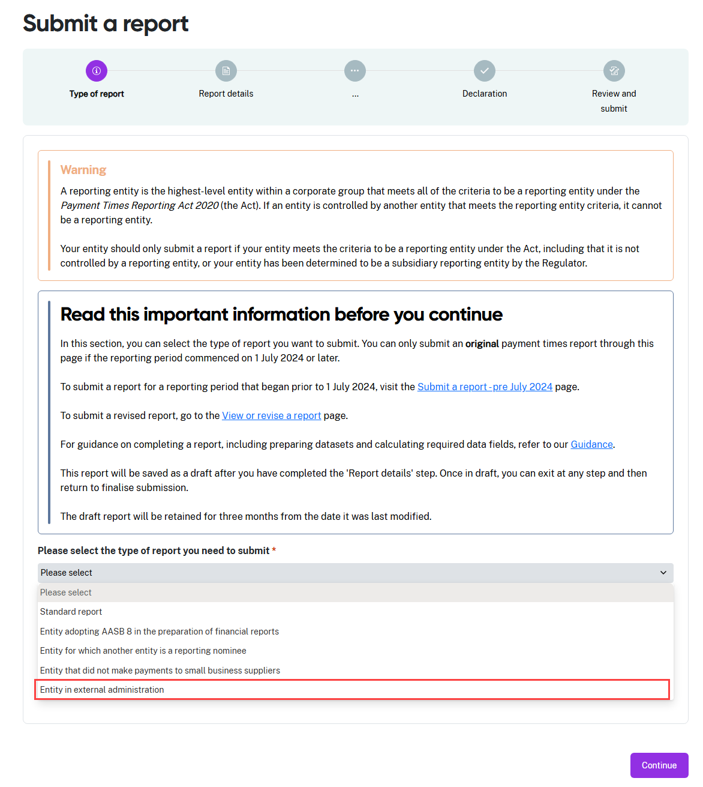
- From the drop down menu, select Entity in external administration as the report type.
- Before you enter your report information, you should confirm the information about your entity in the portal is up to date and correct.

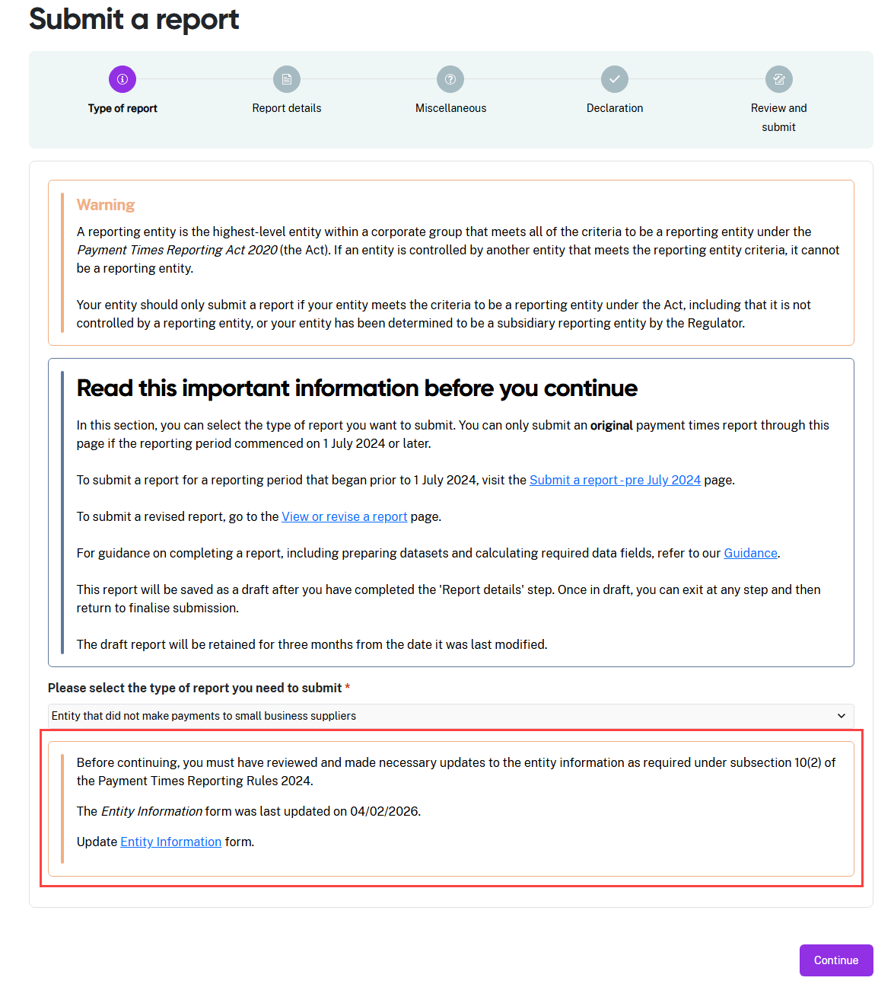
- The progress guide now shows the sections required for a report for an entity in external administration. Use the progress guide to track your progress as you complete each section.
- The portal displays a warning message reminding you to confirm the content in the Entity information form is still true and correct. This message also shows the date this form was last updated.
- If you need to review this content for accuracy, click the Entity Information link in the message to go to the form. Refer to the User Guide: Entity information for help to manage this process.
- If the Entity information is correct, select Continue to move to the next step.

Step 2: Report details
This step captures the reporting period for the report and the details of the entity’s responsible member. This is the person with authority to approve the information for a payment times report.
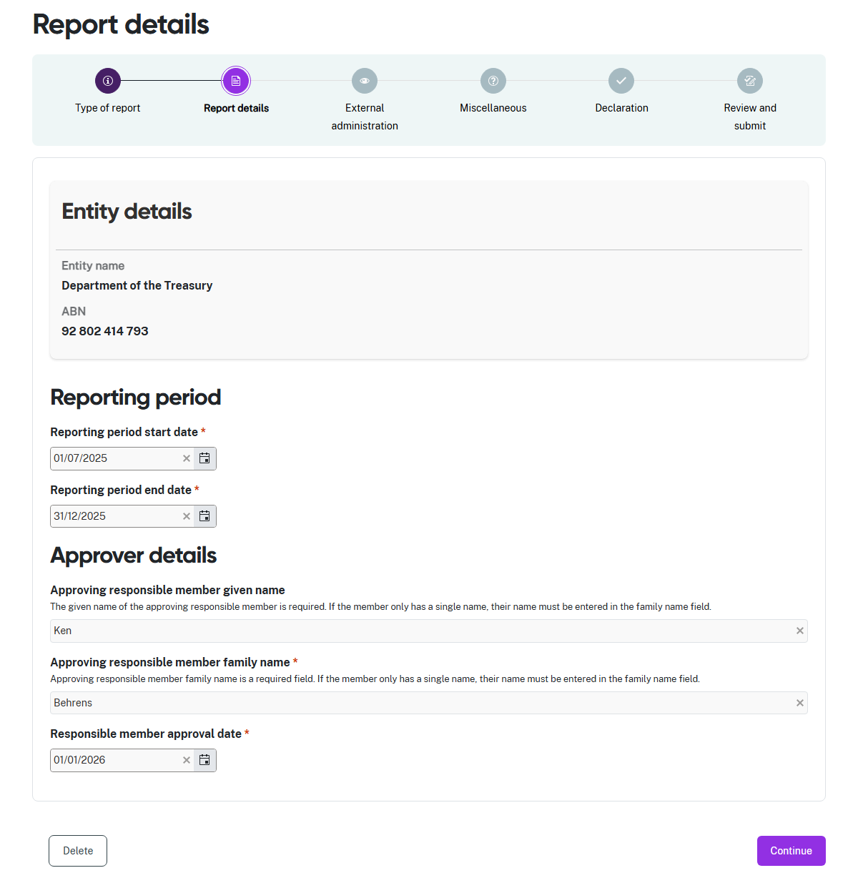
- Enter the start date and the end date of the reporting period in the Reporting period fields.
- Enter the Given name and Family name of the responsible member who approved the information for this report.
- Enter the date the responsible member approved the information for this report.
- Select Continue to move to the next step.

Step 3: External administration
This step captures details of the entity’s external administration arrangements.
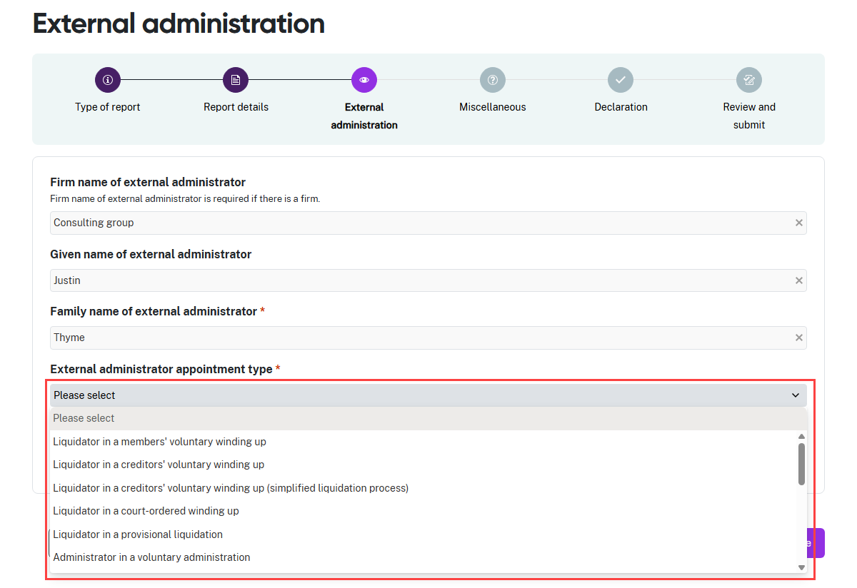
- Enter the name of the firm managing the external administration of the entity.
- Enter the Given name and Family name of the external administrator appointed.
- Select the External administrator appointment type from the drop-down list.
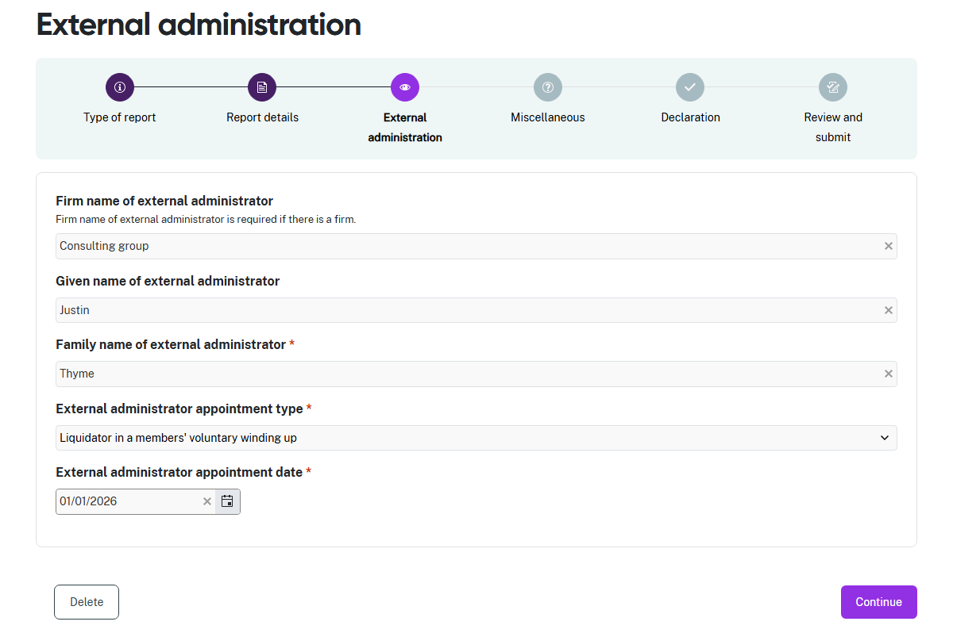
- Add the date the External administrator was appointed, then select Continue.

Step 4: Miscellaneous
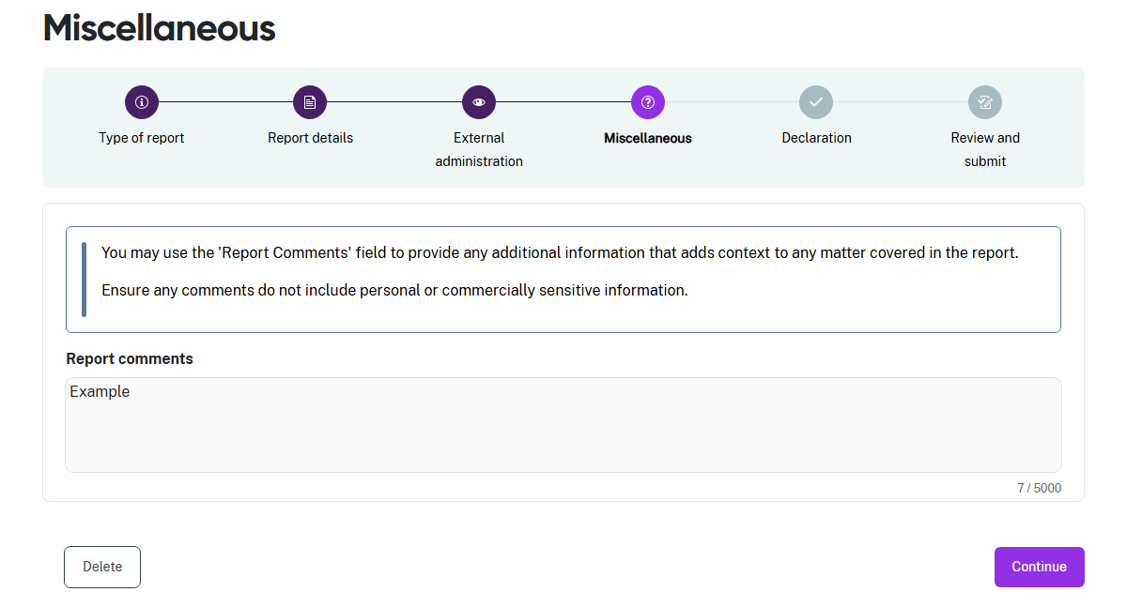
- The Report comments field displays and you have the option to add further information about your report here.
- Select Continue after you have entered any report comments.

Step 5: Declaration
The declaration links to the Digital ID credentials you use to log in to the portal.
 | Read this declaration carefully. You are making a statement that may lead to regulatory action if the information in this form is not true and correct.

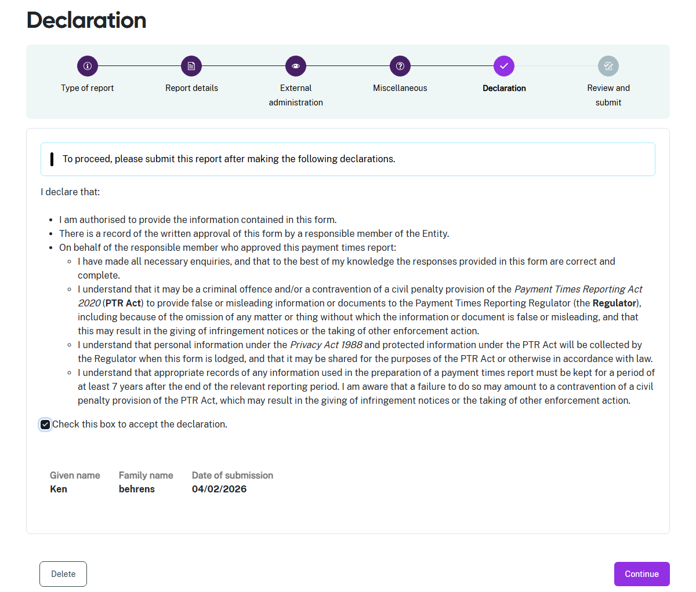
- If you think there may be an error earlier in the report, you can click a circle icon in the progress guide to return to that section of the report.
 | You do not need to provide a signed Responsible Member declaration with your report for reporting periods beginning on 1 July 2024 or later.  In the Declaration above, you are confirming that a written record of the Responsible Member’s approval of the report content exists.
- Check the declaration box when you are satisfied the information in this report is correct and complete.
- Select Continue to proceed to Step 6: Review and submit.

Step 6: Review and submit
This step lets you review all the information in the report before you submit it to the Regulator.
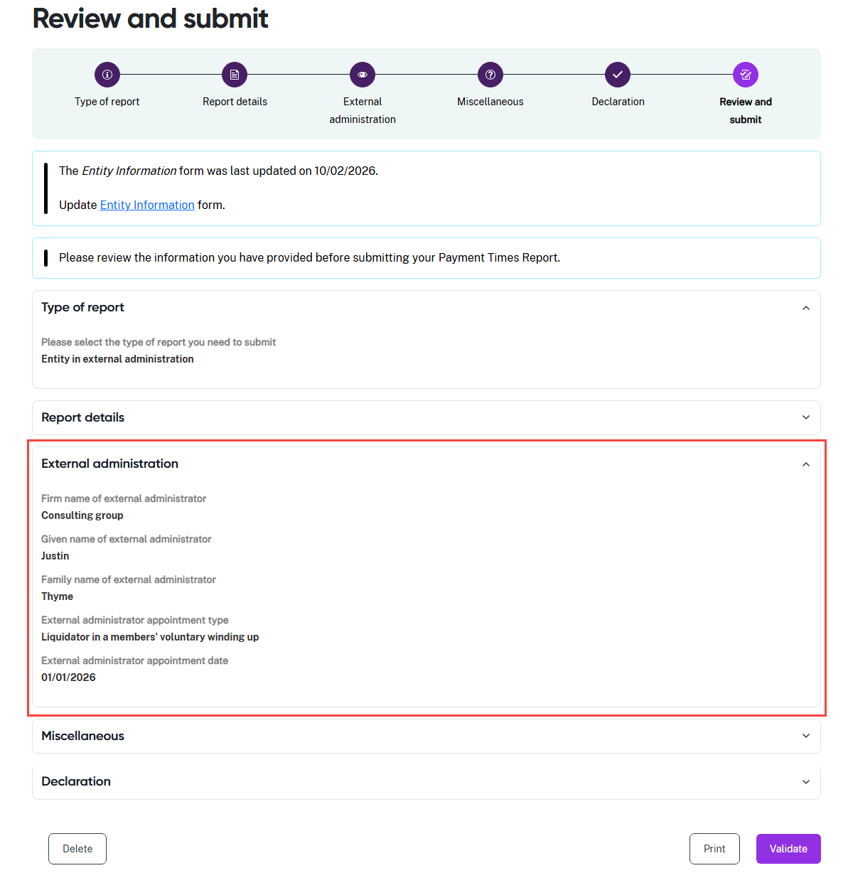
- Review the information in a section by clicking on the down arrow at the right hand side of the section name. In this example, the Type of report and External administration sections are expanded to show the summary details displayed by the portal.
- Collapse the view of the section by clicking the up arrow.
- Click a circle icon in the progress guide to return to that section of the form if you need to update information.

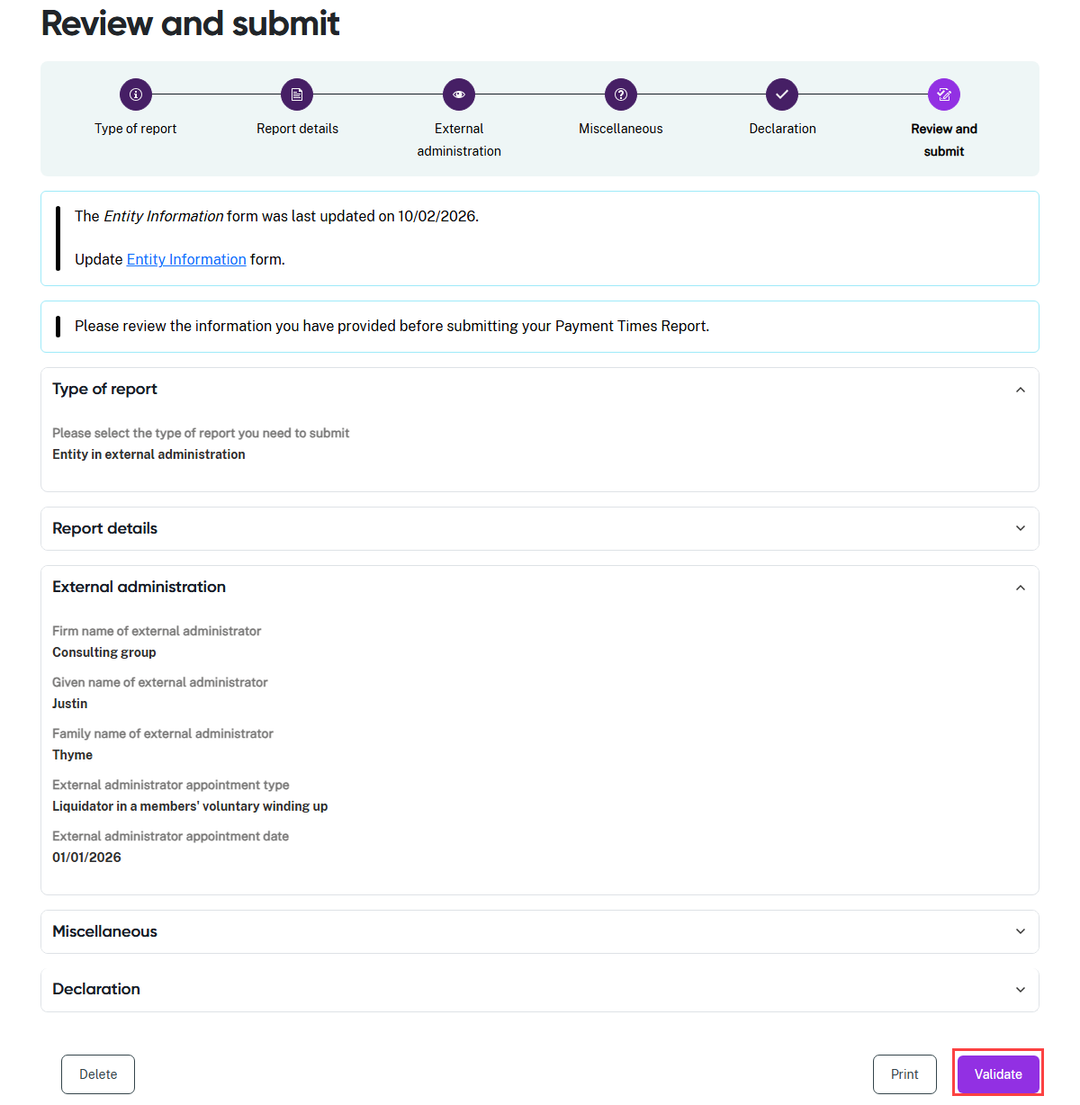
- Select Validate when the report information is final.
- The portal runs a series of validation checks to surface technical errors in the report.
- The portal will return a message with any validation errors it finds. You can return to the step in the process with the error to correct the information.

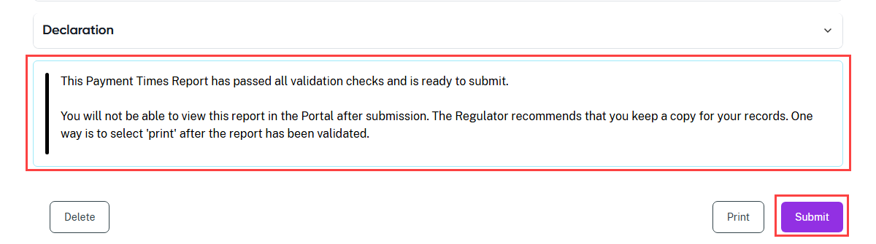
- If you have not printed your report, select Print to print a paper copy of the report using a connected printer, or to save a copy as a PDF. The form prints with all sections expanded to show all details.
- Select Submit to provide your payment times report to the Regulator.

