User Guide: Submit an AASB 8 report
This guide outlines the step-by-step process in the portal to enter and submit a payment
times report for an entity adopting AASB 8 in the preparation of its financial reports
(an AASB 8 report) to the Regulator.
For information about payment times reporting, visit the Guidance resources on the website.
To access the portal you need a Digital ID and authorisation from your entity in Relationship Authorisation Manager to act on its behalf for payment times reporting.
For more information, see Help and support to use the portal on the Regulator’s website.
Version 1.0

Revision history
Version | Date | Description
1.0 | 16 Feb 2026 | Initial version with release of new portal.

Contents
Navigate to Submit and view payment times reports 2
Step 1: Type of report 3
Step 2: Report details 6
Step 3: Payment practices 7
Step 4: Payment terms 8
Step 5: Payment times 10
Step 6: Operating segments 11
Step 7: Miscellaneous 14
Step 8: Declaration 15
Step 9: Review and submit 16

Navigate to Submit and view payment times reports
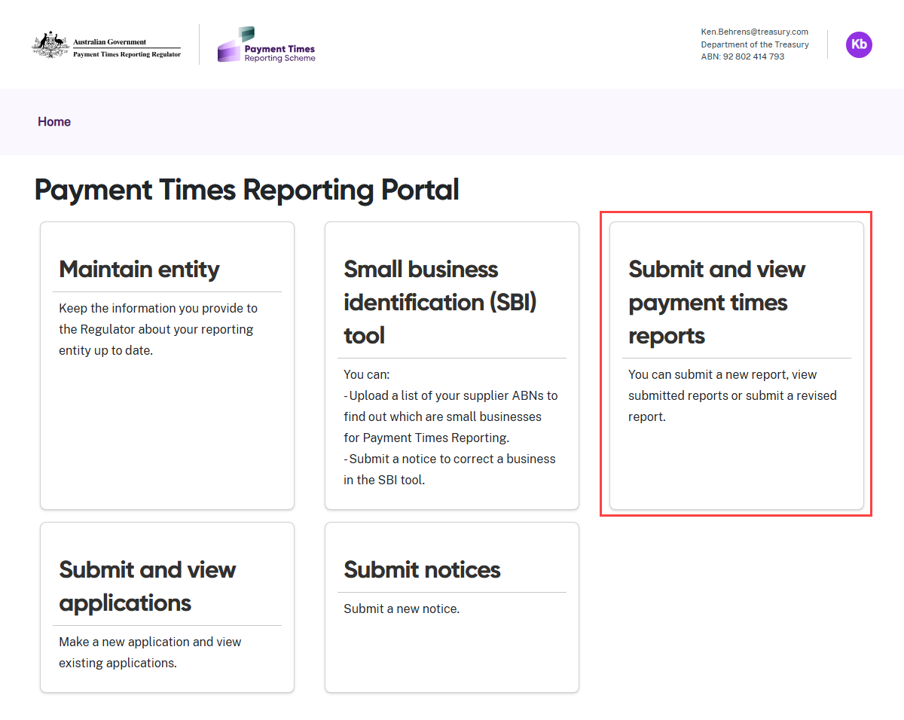
- Select the Submit and view payment times reports tile from the Home screen.

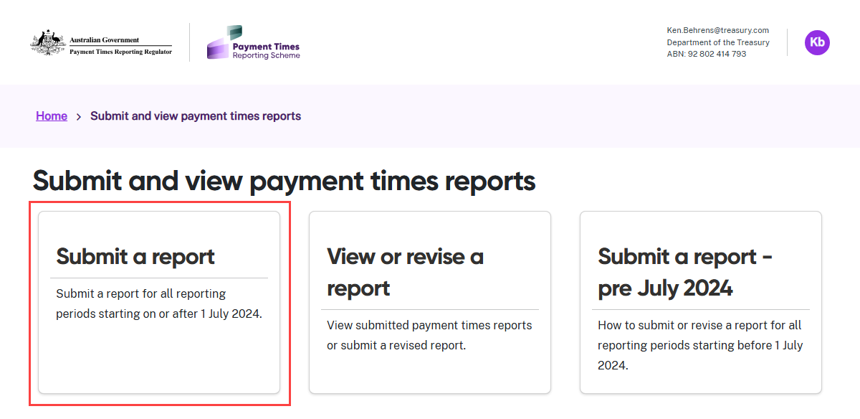
- Select the Submit a report tile.

Step 1: Type of report
In this step, choose the type of payment times report you are entering. Ensure the selected report type matches the report you intend to complete and submit.
Your selection will determine the information required in the following steps.
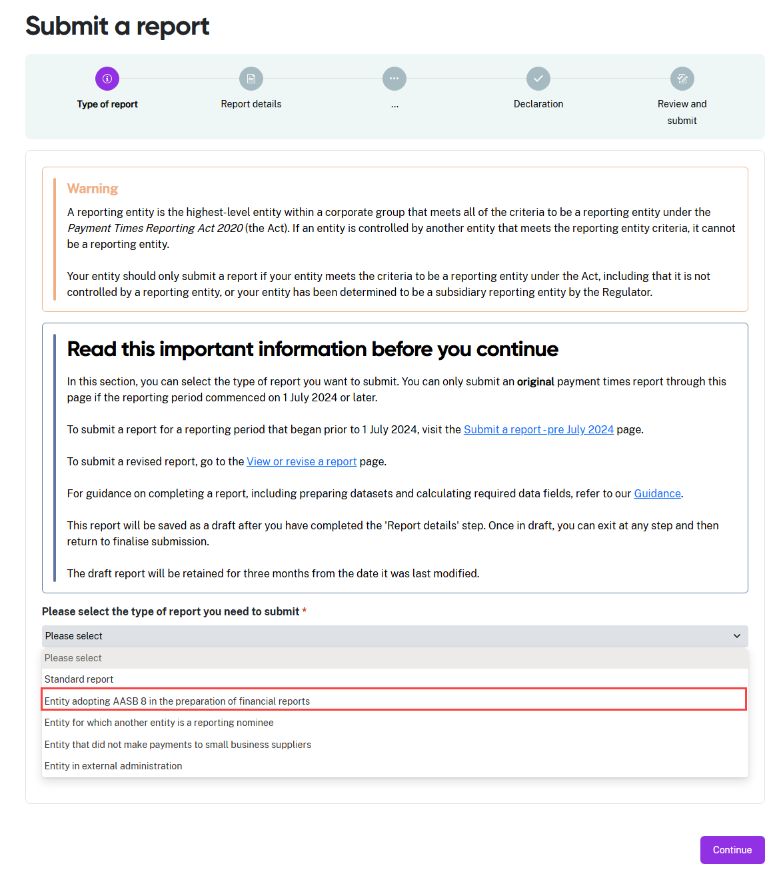
- From the drop down menu, select Entity adopting AASB 8 in the preparation of financial reports as the type of report.
- Before you enter your report information, you must confirm the information about your entity is up to date and correct.

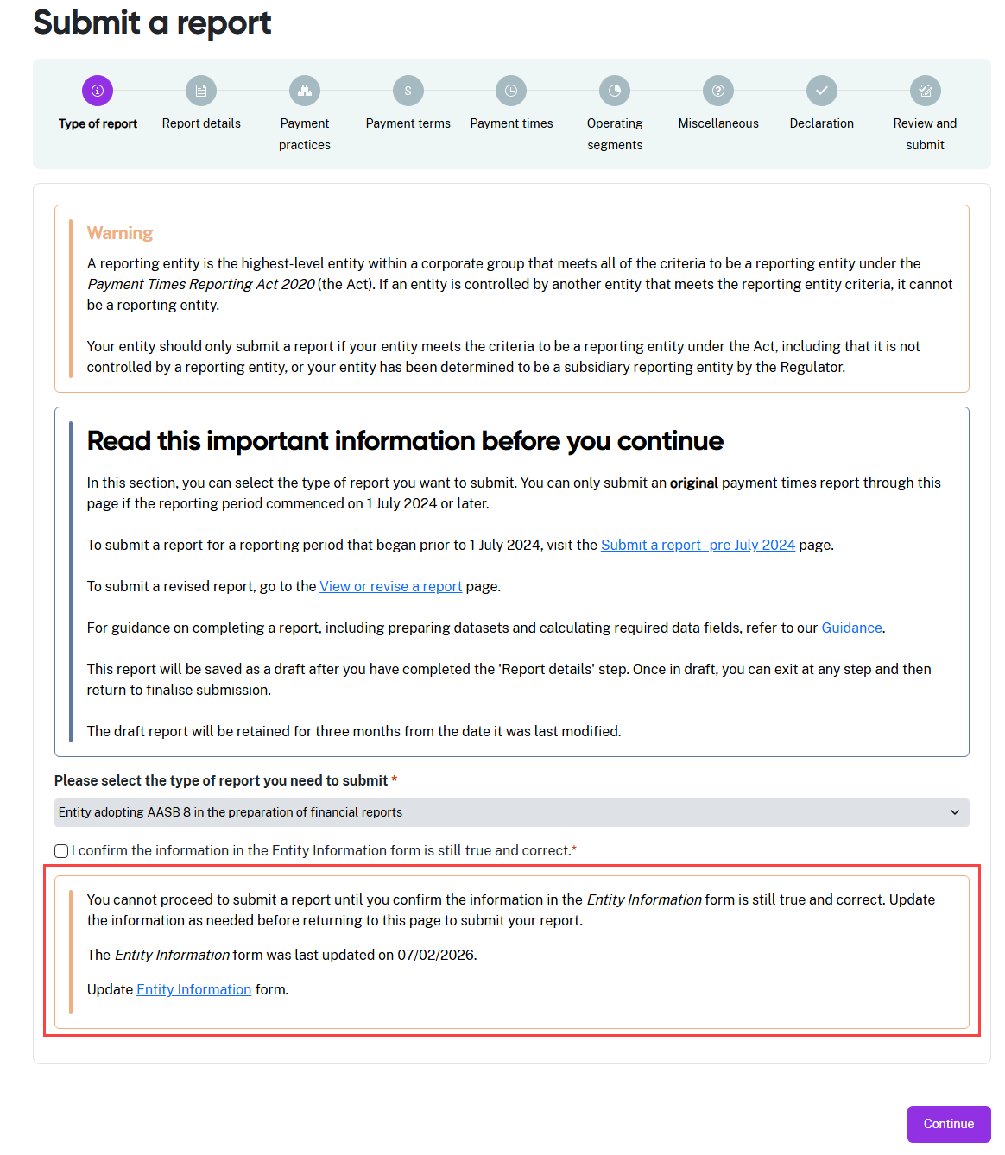
- The progress guide now shows the sections required for an AASB 8 report. Use the progress guide to track your progress as you complete each section.
- The portal displays a warning message reminding you to confirm the content in the Entity information form is still true and correct. This message also shows the date this form was last updated.
- If you need to review this content for accuracy, click the Entity Information link in the message to go to the form. Refer to the User Guide: Entity information for help to manage this process.

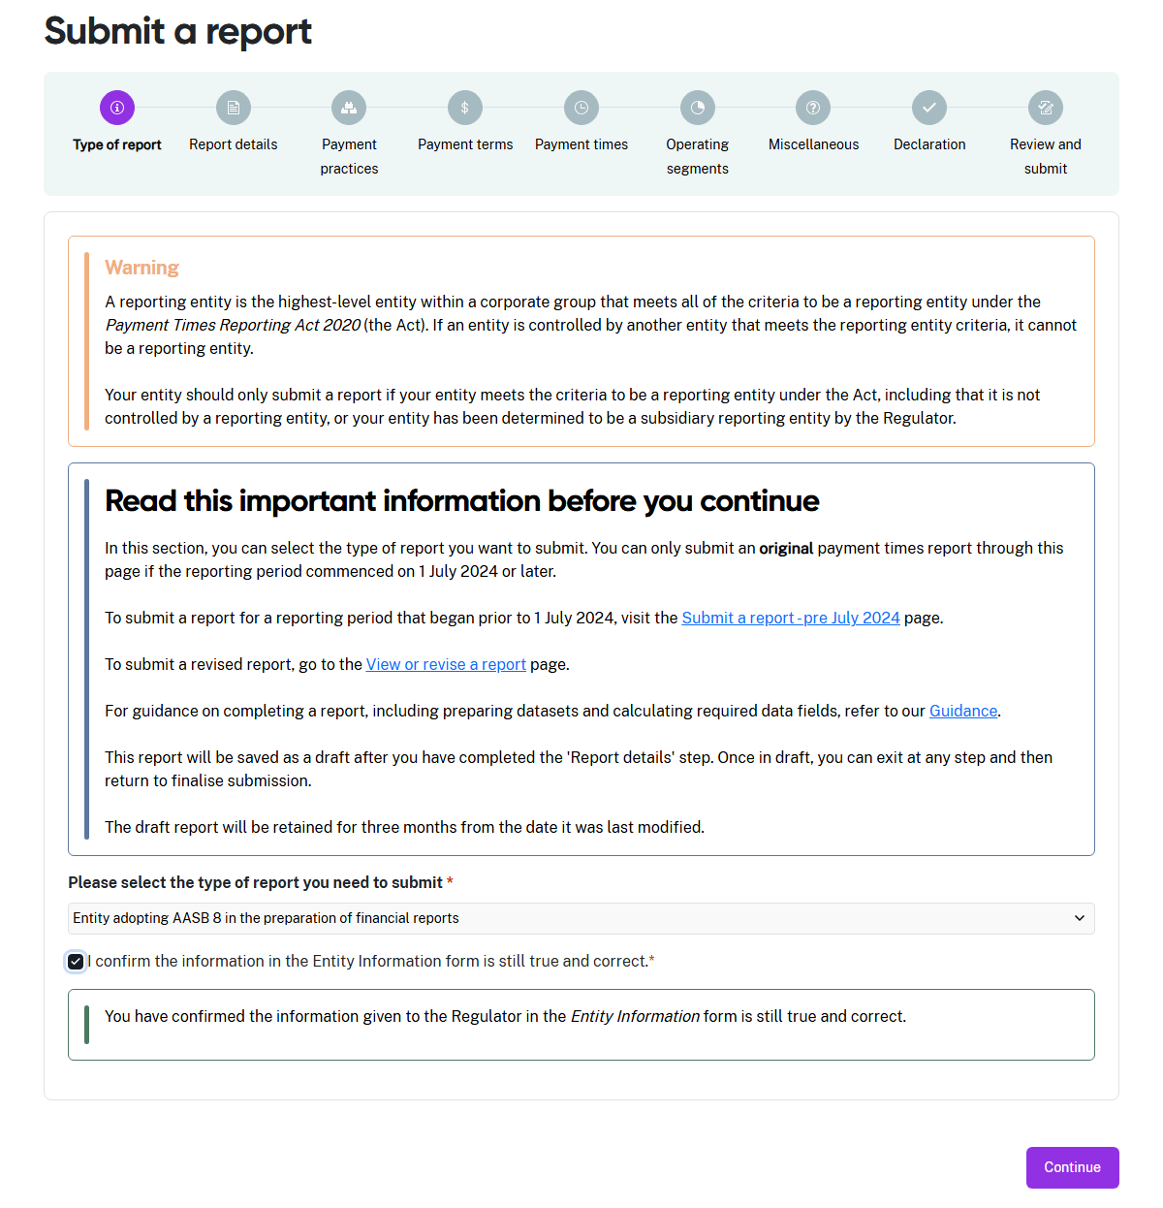
- When your Entity information is correct, check the box to confirm this is the case. This is a mandatory field and is marked with a red asterisk. It cannot be left blank.
- Select Continue to move to the next step.
Draft reports
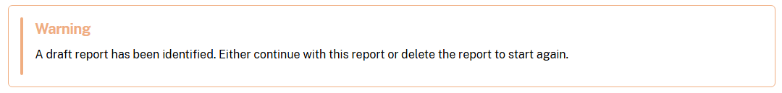
The portal saves your unsubmitted reports as drafts. If you have a draft report, you will see this message at the top of the Submit a report step.
- Selecting Continue will open the draft to continue with the report.
- Selecting Delete will erase all information and delete the draft report.

Step 2: Report details
This step captures the reporting period for the report and the details of the entity’s responsible member. This is the person with authority to approve the information for a payment times report.
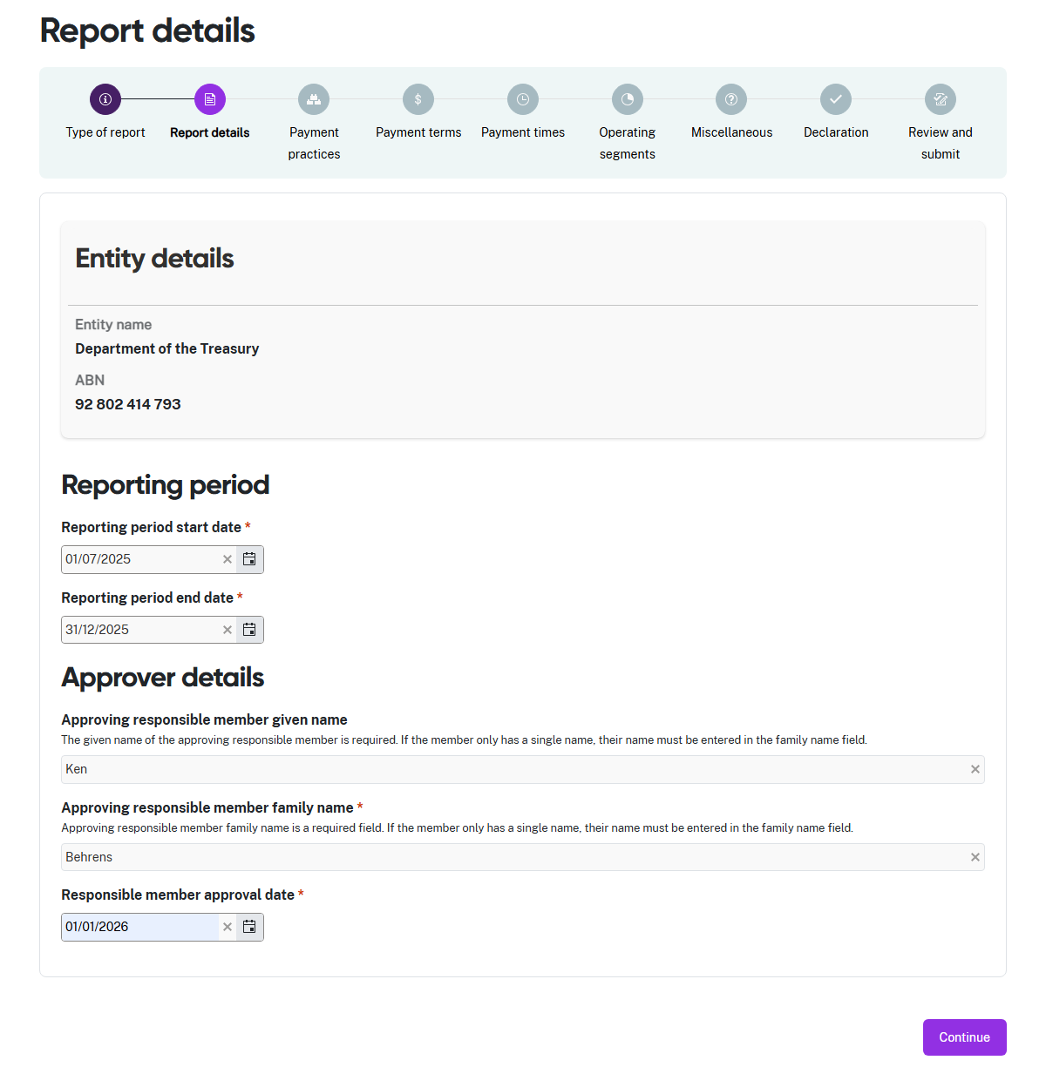
- Enter the start date and the end date of the reporting period in the Reporting period fields.
- Enter the Given name and Family name of the responsible member who approved the information for this report.
- Enter the date the responsible member approved the information for this report.
- Select Continue to move to the next step.

Step 3: Payment practices
This step collects information about your entity’s payment practices.
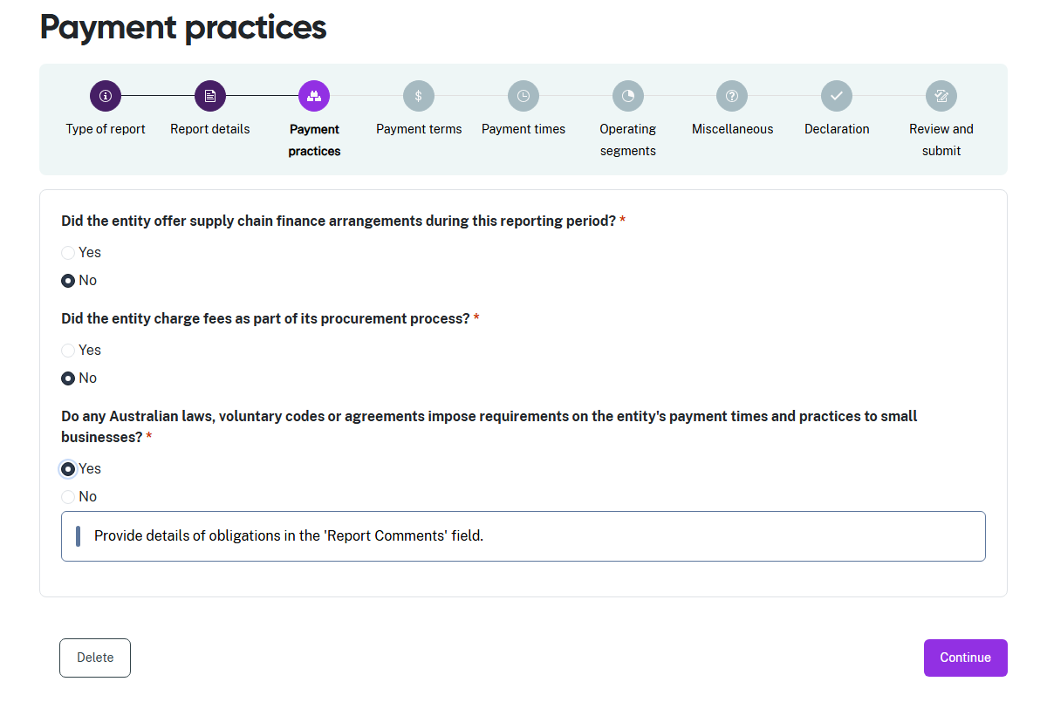
- Read the 3 questions in this step carefully before answering.
- These are mandatory fields and are marked with a red asterisk. They cannot be left blank.
- For each question, select Yes if your entity applied this payment practice during the reporting period. When you select Yes, the portal will prompt you to enter details about the relevant payment practice in the Miscellaneous step of the report.
- Answer No if your entity did not apply this payment practice during the reporting period.
- Select Continue when you have answered every question.

Step 4: Payment terms
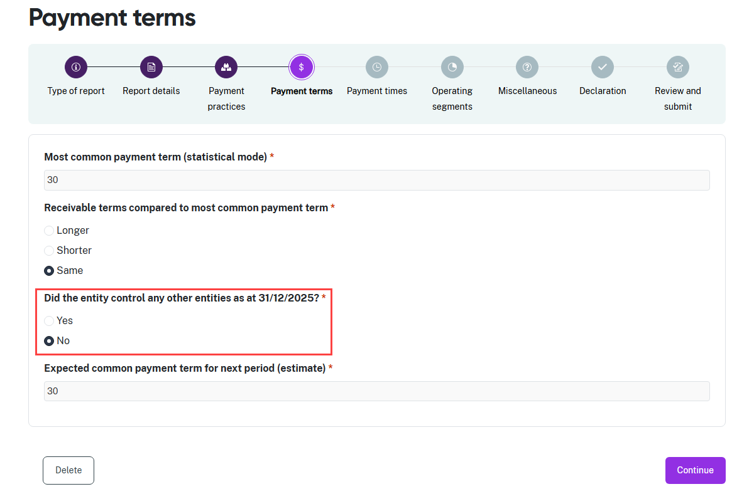
- All fields in this step are mandatory fields and are marked with a red asterisk. They cannot be left blank.
- Enter the most common payment term as a whole number of days.
- Indicate if the receivable terms are Longer, Shorter or the Same when compared to the most common payment term.
- The portal asks whether your entity controlled any other entities at the end of the reporting period.
 | The report cross-checks controlled entity details in the Entity Information form.  If you have controlled entities but answer No in this step, the portal will show a validation error in the Review and submit stage.
- Select No if your entity did not control any other entities at the end of the reporting period.
- If you answered No to having controlled entities, enter an estimate of the Expected common payment term for the next reporting period, as a whole number of days.
- Select Yes if your entity did control other entities at this time. The portal will display additional fields to collect reporting information.

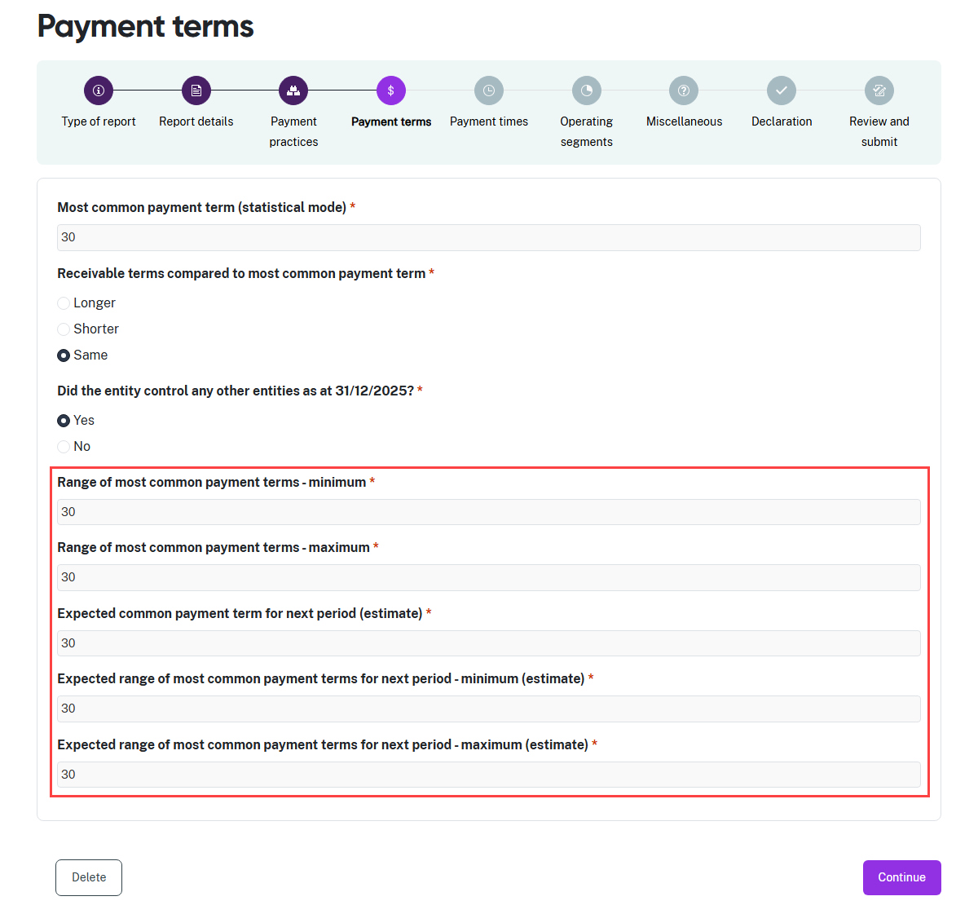
- All fields in this step are mandatory fields and are marked with a red asterisk. They cannot be left blank.
- In the 5 reporting fields that appear on a Yes response:
  - Enter the minimum mode payment term for the reporting group, as a whole number of days.
  - Enter the maximum mode payment term for the reporting group, as a whole number of days.
  - Enter an estimate of the expected common payment term for the next reporting period, as a whole number of days.
  - Enter an estimate for the minimum value in the expected range of most common payment terms for the next reporting period.
  - Enter an estimate for the maximum value in the expected range of most common payment terms for the next reporting period.
- Select Continue when you have answered every question and completed every reporting field.
- You may see a message if your information triggers any validation checks.

Step 5: Payment times
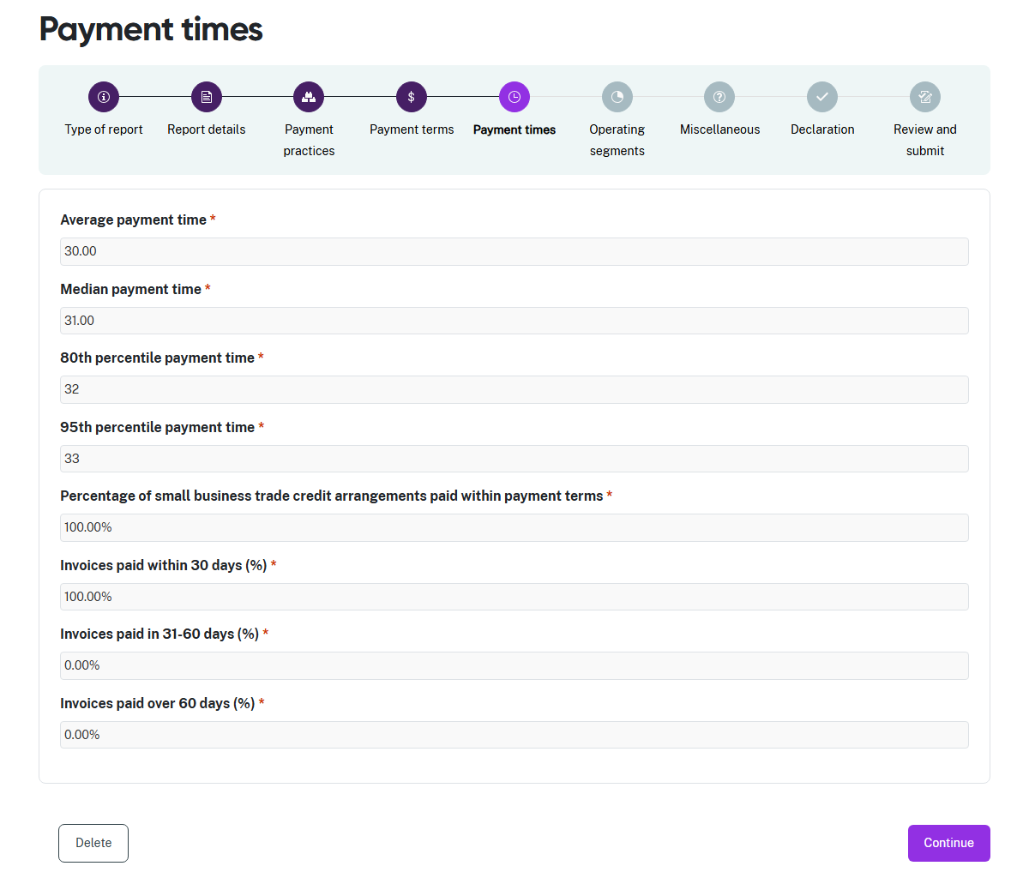
- All fields in this step are mandatory fields and are marked with a red asterisk. They cannot be left blank.
- For the first 5 fields in this step:
  - Enter the Average payment time in days, as a number to 2 decimal places.
  - Enter the Median payment time in days, as a number to 2 decimal places.
  - Enter the 80th percentile payment time in days, as a whole number.
  - Enter the 95th percentile payment time in days, as a whole number.
  - Enter the Percentage of small business trade credit arrangements paid with the agreed payment terms, as a number to 2 decimal places.
- For the final 3 fields in this step relating to Invoices paid…, ensure the total of all percentages equals 100% (the system allows a very small rounding variance).
  - Enter the percentage of Invoices paid within 30 days, as a number to 2 decimal places.
  - Enter the percentage of Invoices paid in 31-60 days, as a number to 2 decimal places.
  - Enter the percentage of Invoices paid over 60 days, as a number to 2 decimal places.
- Select Continue when you have completed every field.
- You may see a message if your information triggers any validation checks.

Step 6: Operating segments
You will need to add your operating segments to report their payment times information if your entity is making an AASB 8 report.
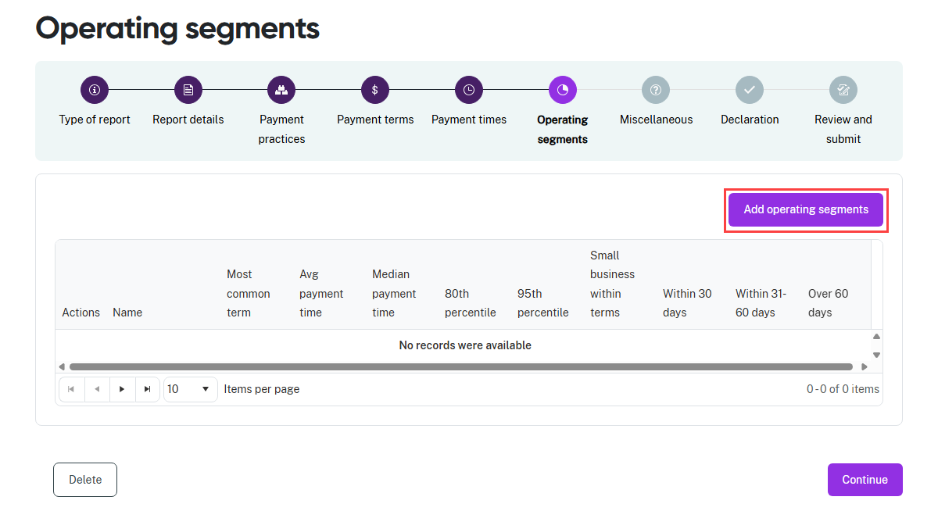
- Select Add operating segments. A screen with the reporting fields for one segment will slide into view from the right hand side of the screen.
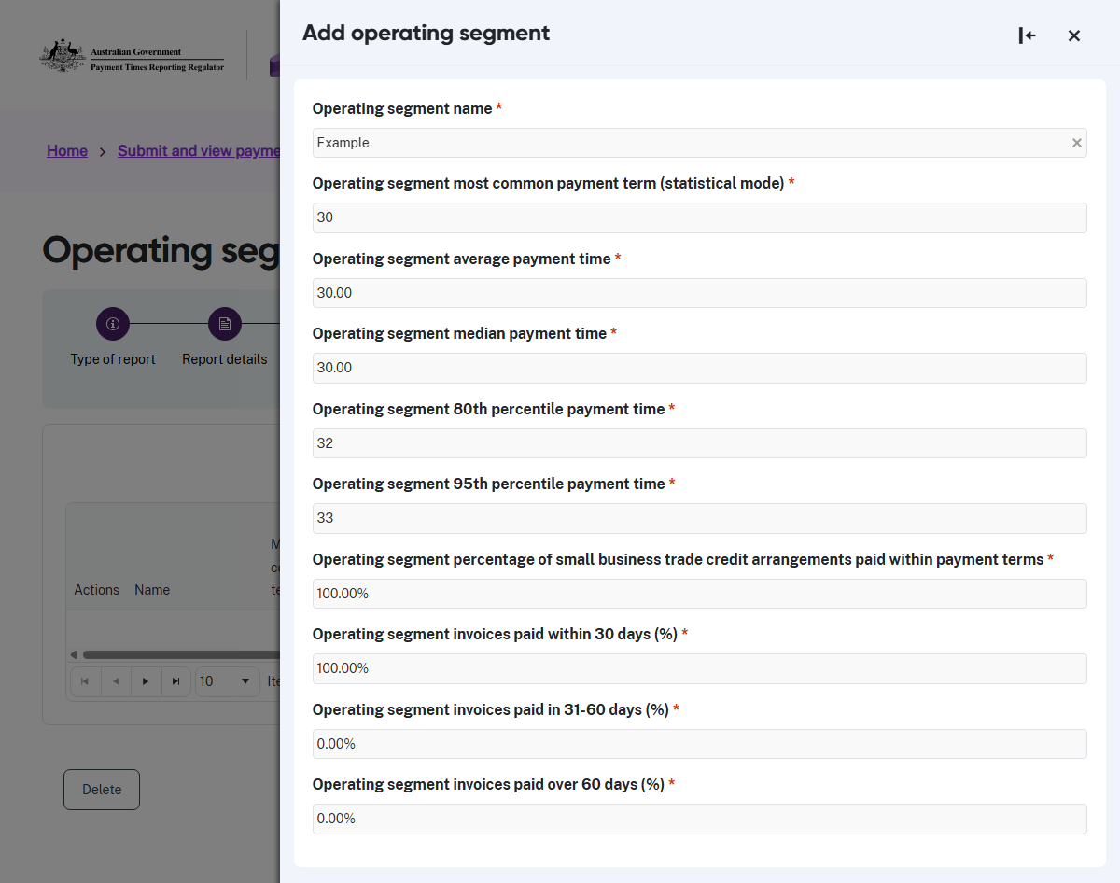

- All fields in this step are mandatory fields and are marked with a red asterisk. They cannot be left blank.
- Enter the name of this operating segment.
- For this operating segment:
  - Enter the Most common payment term as a whole number of days.
  - Enter the Average payment time in days, as a number to 2 decimal places.
  - Enter the Median payment time in days, as a number to 2 decimal places.
  - Enter the 80th percentile payment time in days, as a whole number.
  - Enter the 95th percentile payment time in days, as a whole number.
  - Enter the Percentage of small business trade credit arrangements paid with the agreed payment terms, as a number to 2 decimal places.
- For the final 3 fields in this step relating to Invoices paid… for this operating segment, ensure the total of all percentages equals 100% (the system allows a very small rounding variance).
  - Enter the percentage of Invoices paid within 30 days, as a number to 2 decimal places.
  - Enter the percentage of Invoices paid in 31-60 days, as a number to 2 decimal places.
  - Enter the percentage of Invoices paid over 60 days, as a number to 2 decimal places.
- Select Continue when you have completed every field.

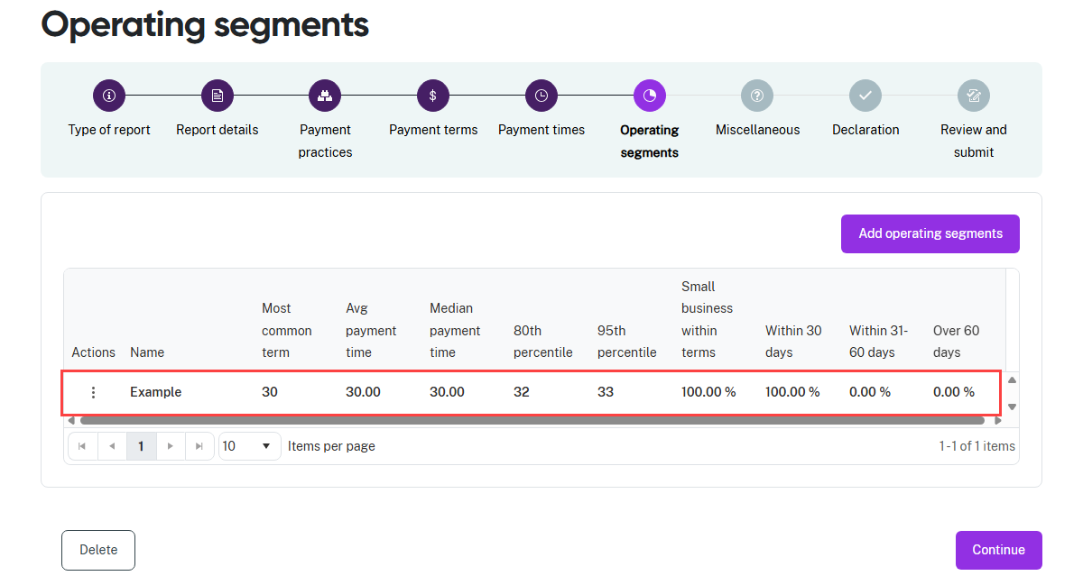
- The portal displays the report information you entered for the operating segment.

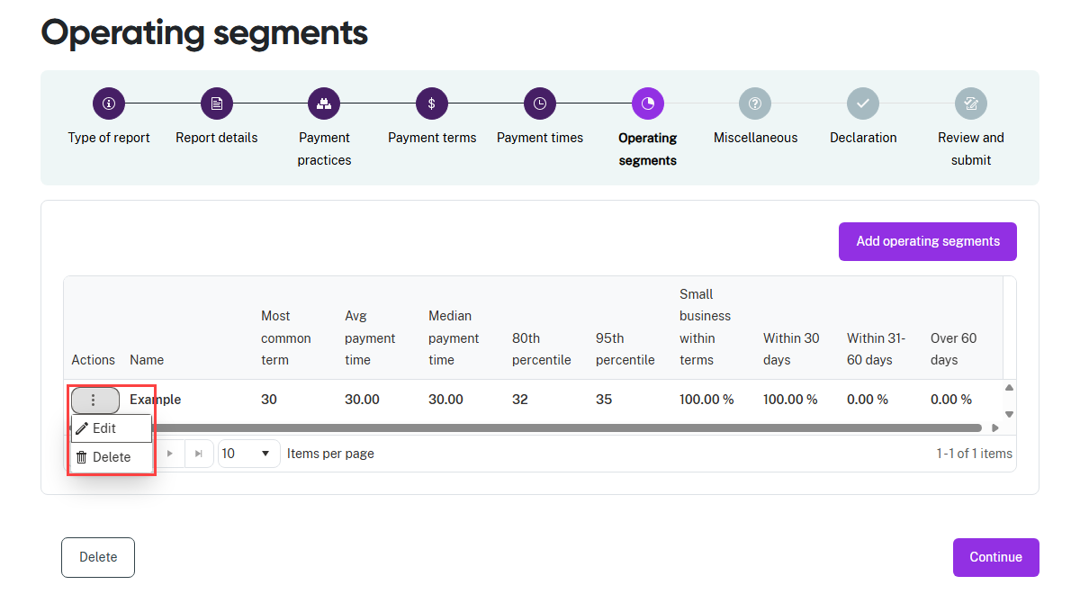
- If you add an operating segment in error or need to edit the report information, click on
the stacked dots under Actions.
- Select Edit to update the report information for the operating segment.
- Select Delete to remove the entire operating segment and its report information.

- To add further operating segments, select Add operating segments.
- Repeat the process from the beginning of this step.
- Select Continue when you have entered payment information for every operating segment.

Step 7: Miscellaneous
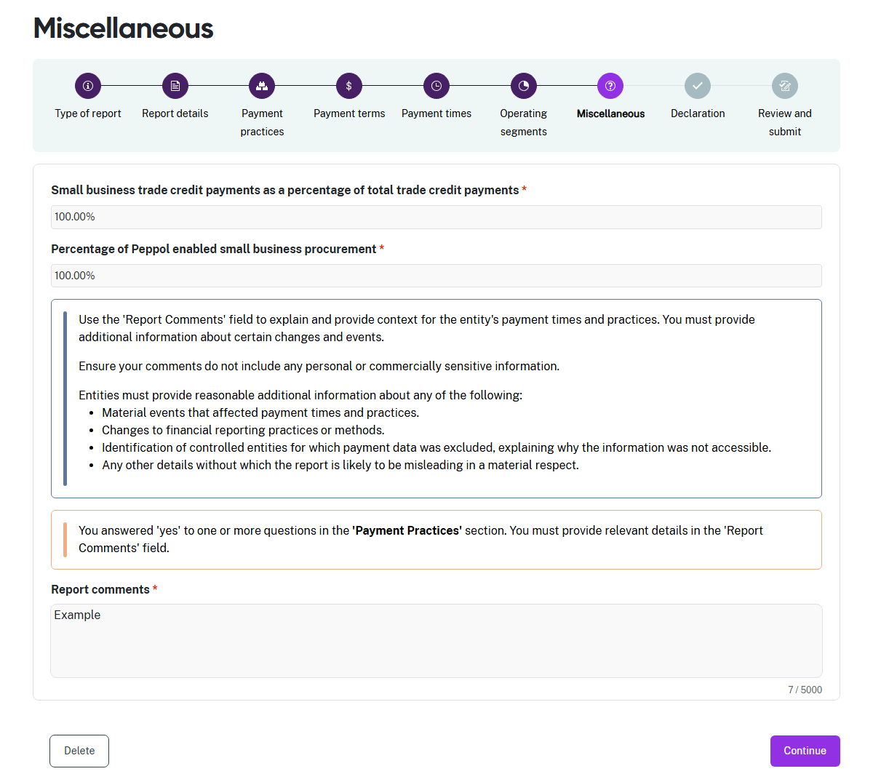
- Enter the Percentage of total trade credit payments made to small businesses, based on value. This field is a numeric value to 2 decimal places.
- Enter the Percentage of small business payments that were made using Peppol enabled systems. This field is a numeric value to 2 decimal places.
- Select Continue when you have completed every field.

Note: the Yes response in Step 3: Payment practices caused the Report comments field to become a mandatory field and be marked with a red asterisk.

Step 8: Declaration
The declaration links to the Digital ID credentials you use to log in to the portal.
Read this declaration carefully. You are making a statement that may lead to regulatory action if the information in this form is not true and correct.

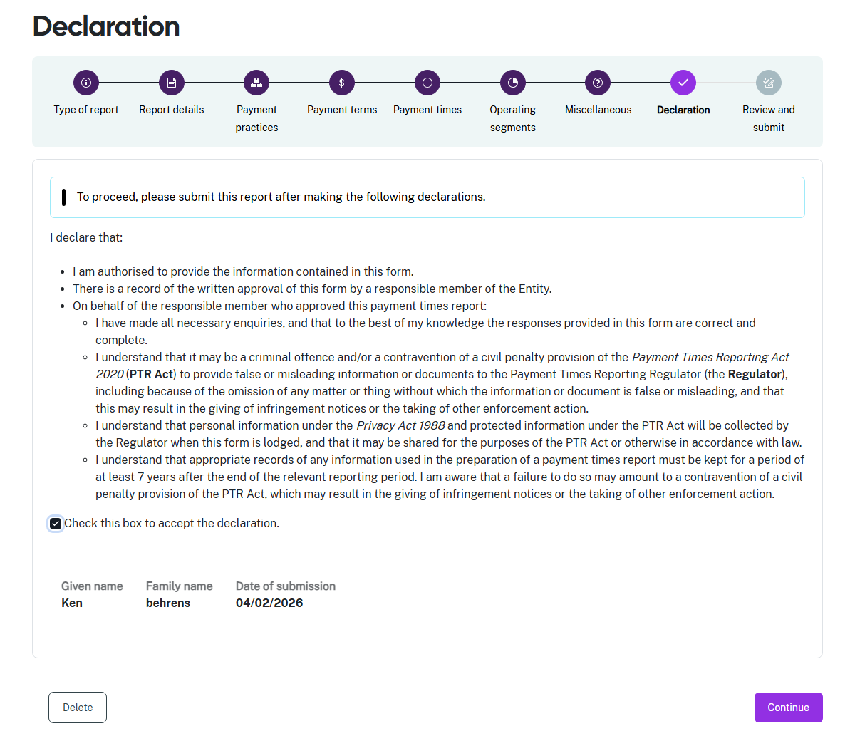
- If you think there may be an error earlier in the report, you can click a circle icon in the progress guide to return to that section of the report.
 | You do not need to provide a signed Responsible Member declaration with your report for reporting periods beginning on 1 July 2024 or later.  In the Declaration above, you are confirming that a written record of the Responsible Member’s approval of the report content exists.
- Check the declaration box when you are satisfied the information in this report is correct and complete.
- Select Continue to proceed to Step 8: Review and submit.

Step 9: Review and submit
This step lets you review all the information in the report before you submit it to the Regulator.
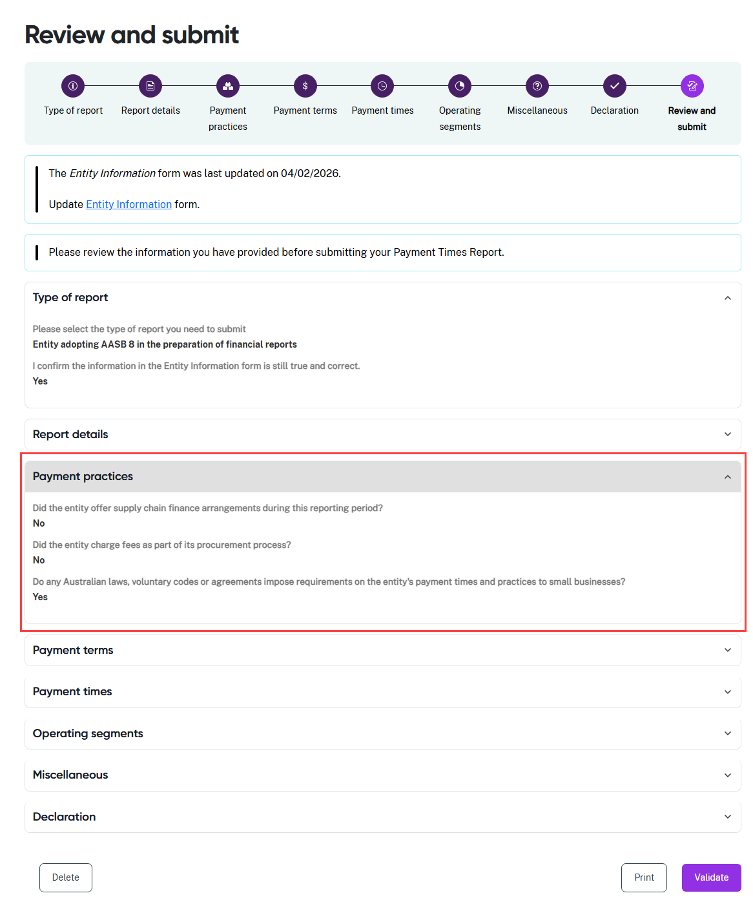
- Review the information in a section by clicking on the down arrow at the right hand side of the section name. In this example, the Type of report and Payment practices sections are expanded to show the summary details displayed by the portal.
- Collapse the view of the section by clicking the up arrow.
- Click a circle icon in the progress guide to return to that section of the form if you need to update information.

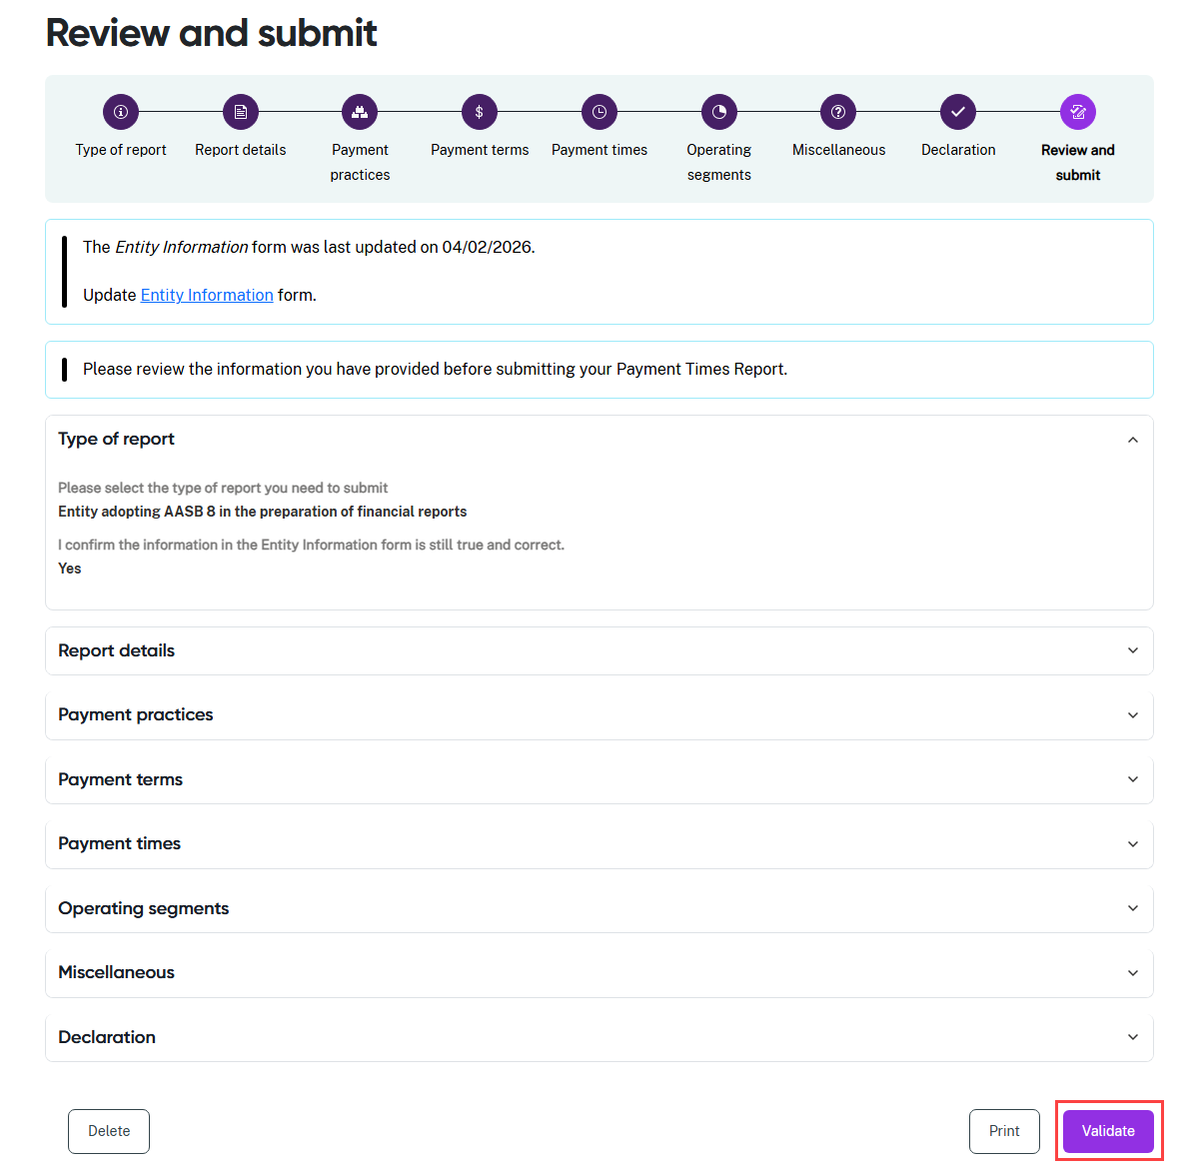
- Select Validate when the report information is final.
- The portal runs a series of validation checks to surface technical errors in the report.
- The portal will return a message with any validation errors it finds. You can return to the step in the process with the error to correct the information.
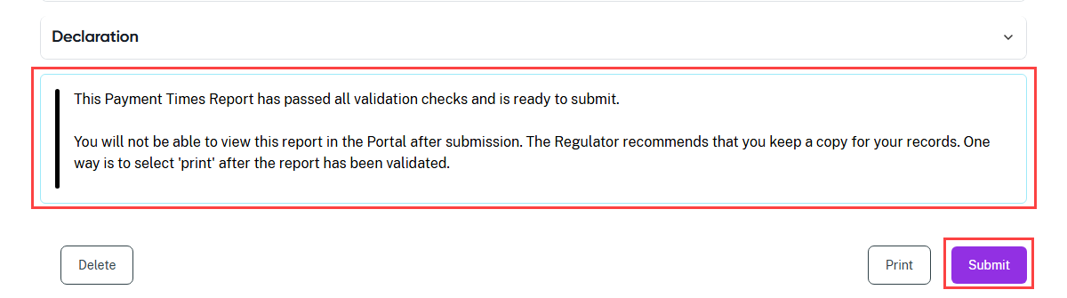
- If you have not printed your report, select Print to print a paper copy of the report using a connected printer, or to save a copy as a PDF. The form prints with all sections expanded to show all details.
- Select Submit to provide your payment times report to the Regulator.

