User Guide: Getting started in the portal
This guide explains the step-by-step process to successfully log in to the new Payment Times Reporting Portal (portal) for the first time and complete your set-up details.
To access the portal you need a Digital ID and authorisation from your entity in Relationship Authorisation Manager to act on its behalf for payment times reporting.
If your Digital ID is already linked to your entity in RAM, skip to Step 3 – Log in to the portal.
For more information, see Help and support to use the portal on the Regulator’s website.
Version 1.0

Revision history
Version | Date | Description
1.0 | 16 Feb 2026 | Initial version with release of new portal.

Contents
Portal access and log in 2
Step 1: Establish your Digital ID 2
Step 2: Link your Digital ID to your entity in RAM 3
Step 3: Log in to the portal 4
Self-assessment questionnaire 8
Step 1: Type of registration 8
Step 2: Questions 9
Step 3: Declaration 10
Step 4: Review and submit 11

Portal access and log in

Step 1: Establish your Digital ID
Your Digital ID allows you to prove your identity when you log in to Australian Government services. Because this portal is a government service, you must use a Digital ID to access it.
The Australian Government provides the myID app to create your Digital ID. You’ll need to use this app to set up your Digital ID for the portal.

 | The Regulator updates the information in this User Guide from time to time to reflect the support material available online for:  - myID at https://www.myid.gov.au  - Relationship Authorisation Manager at https://info.authorisationmanager.gov.au  You should check the source to make sure you have the latest information.

How to set up myID
Your myID is unique to you and can't be shared. As it's your personal Digital ID, you should set this up using a personal email address – don't use a shared or work email address.

Before you start
To set up your myID, you need:
- a smart device – the myID app is compatible with most smart devices, such as smart phones, and is only available from the Apple App Store or Google Play
- a personal email address – as it’s your personal Digital ID, your ID documents will be linked to the email you choose. It should not be a shared or work email address
- to be 15 years or older – age restrictions may also apply to use some government online services.

Three steps to set up myID
- Download the myID app on your smart device
External Link External Link
Only download the myID app from the official app stores listed above.
If you:
- are setting up your myID for the first time, continue to step 2
- have set up your myID before, select ‘I am an existing user’ and follow the prompts. See Setting up your myID again.
- Enter your details
Open the myID app on your smart device and follow the prompts to:
- enter your email address – choose a personal email you have ongoing access to
- create a password
- enter your full name and date of birth.
- Choose your identity strength
You can set up a Basic, Standard or Strong myID. After entering your details you will have a Basic identity strength.

 | Your identity strength must be Standard or Strong to access the portal.

Increasing your identity strength will better protect your Digital ID and allow you to access more services.
Once set up, you can use myID as your Digital ID to prove who you are when accessing government online services.

Step 2: Link your Digital ID to your entity in RAM
Relationship Authorisation Manager (RAM) helps businesses control who can access government services on their behalf. Through RAM, a business representative can authorise others to act for the business when using these services.

If you need to carry out regulatory tasks in the portal, your entity must use RAM to authorise you, using your myID Digital ID.

Acting on behalf of an entity
If you need to act on behalf of your entity to meet its reporting obligations under the Payment Times Reporting Scheme, the entity must authorise you to do so.
Receive an authorisation request
A principal authority or authorisation administrator needs to create the right level of authorisation for you in RAM.
Once they do, you will receive an authorisation request including details of the authorisation and an authorisation code via email. You will need to accept the authorisation in RAM using your authorisation code within 7 days.
Read about the process to accept an authorisation, including help with accepting the authorisation.
Once you’ve accepted, you can log in to the portal and act on behalf of your entity.

Step 3: Log in to the portal
The Payment Times Reporting Regulator continues to host the portal on its website. If you bookmarked the previous portal, your saved link will take you to the new portal.
If you used the previous portal to complete regulatory tasks for your entity, you can use your existing login details to access the new portal. You do not need to take any further action.

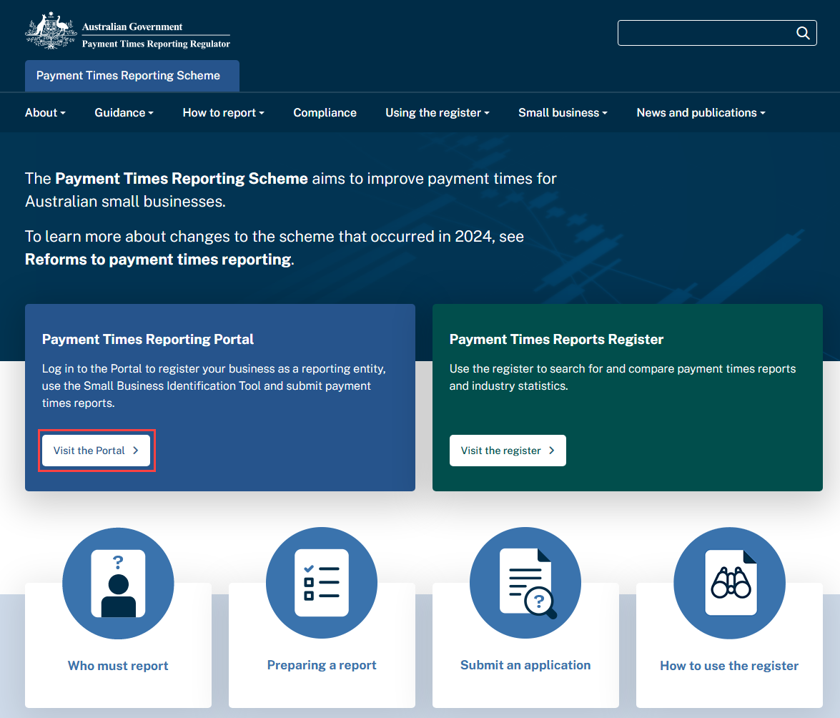
- Go to the website and select Visit the Portal.

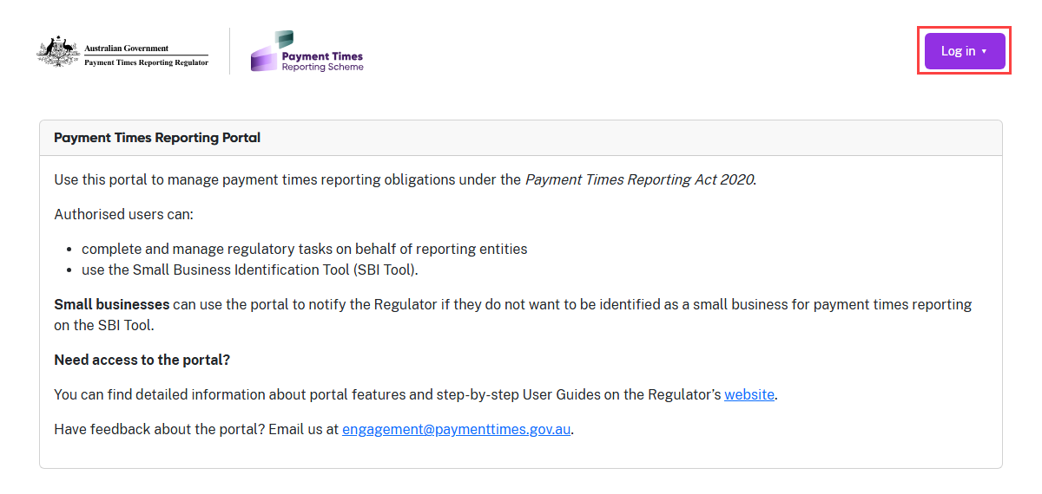
- Select Log in.

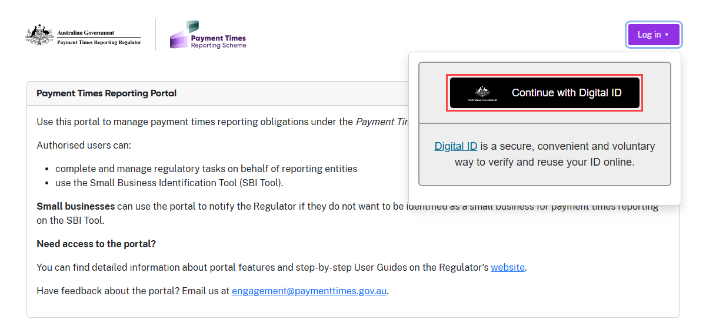
- Select Continue with Digital ID.

Terms of Use
The Regulator has revised the Terms of Use for the portal to reflect the introduction of draft reports.

Read the Terms of Use carefully. You are agreeing to be legally bound by these terms and if you are representing an entity, you are agreeing for it to be bound also.

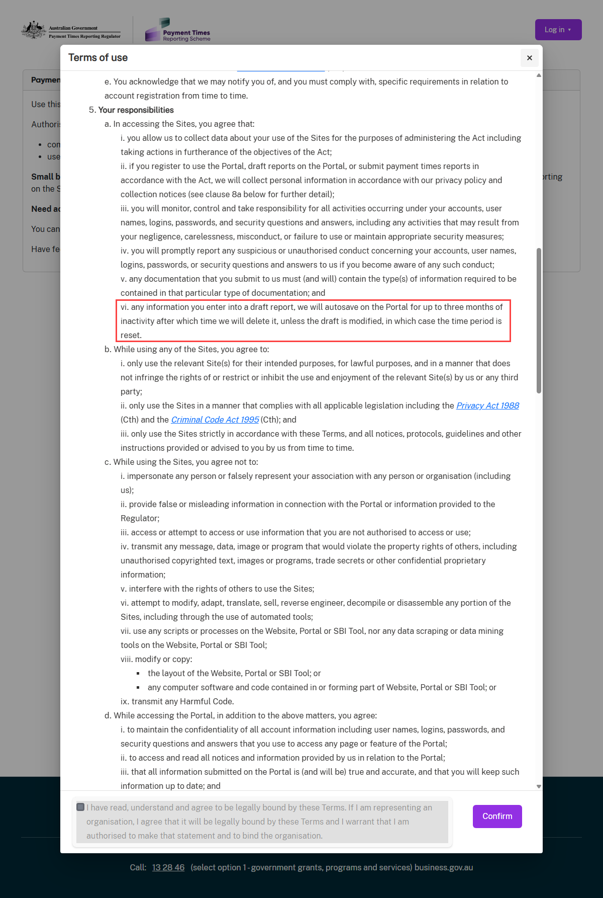
- Note the additional clause about the portal retaining unsubmitted report information as a draft for a period of time.

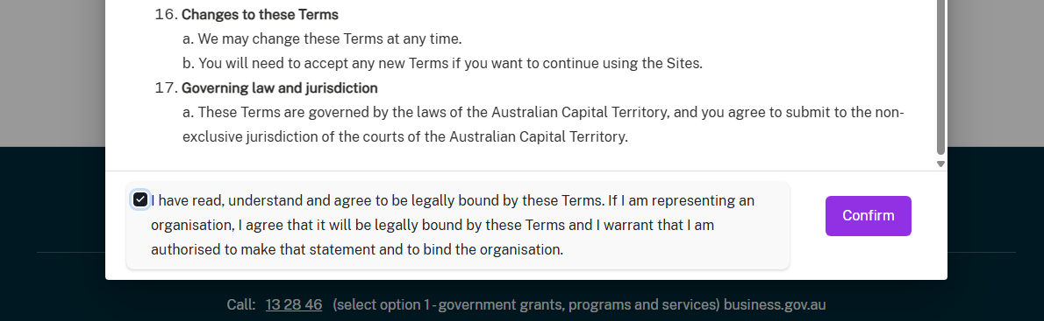
- When you have read and accepted the Terms of Use, check the box to record your agreement.
- Select Confirm to continue.
- The Portal will direct you to the myID login page.
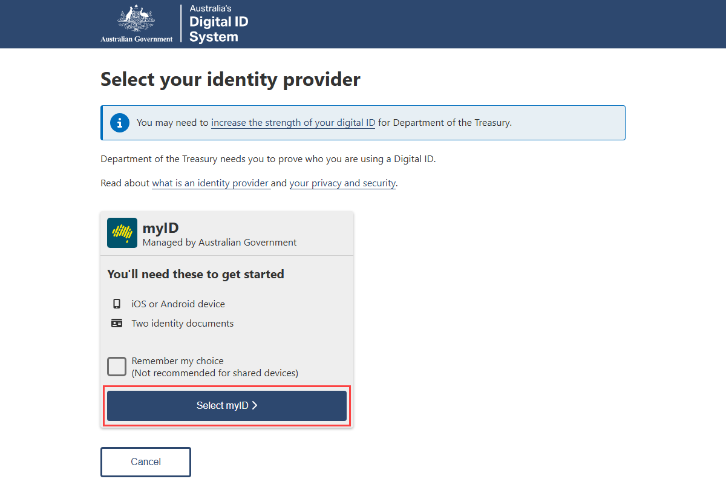
- Follow the instructions on this page and use the login details you set up in Step 1: Establish your Digital ID section of this User Guide.
The myID login process uses two-factor authentication for security and you will need to confirm a code through a separate device, like a mobile phone.
It’s helpful to have your device handy for this process.

Self-assessment questionnaire
Complete this questionnaire to create your entity’s profile and set up access to the features your entity needs in the portal. Your responses determine which tiles appear in your portal view.
Note: If you registered your entity in the previous portal, you do not need to complete this questionnaire again. The new portal carries over your entity’s existing access.
If you need to retake the questionnaire for your entity but cannot access it under the
‘Maintain Entity’ tile, contact the Regulator by email to support@paymenttimes.gov.au.

Step 1: Type of registration
- Read the information on this screen carefully, then select the action your entity
wants to take from the drop-down list.
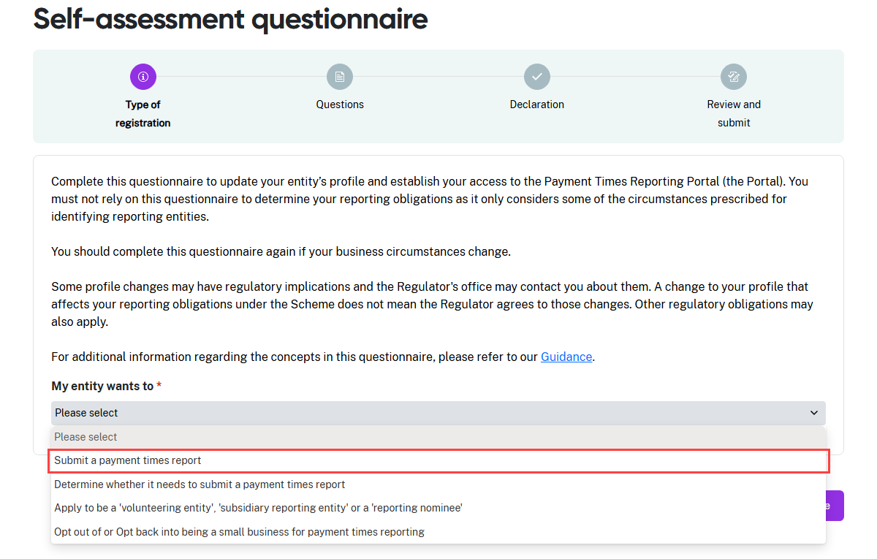
- In this example, the entity wants to Submit a payment times report.
- Select Continue to move to the next step and begin the Questions.

Depending on your responses to the questionnaire, the portal will guide you through a series of questions, or take you directly to the Declaration.

Step 2: Questions
This screen shot shows a combination of responses for our fictitious entity. The responses you provide for your entity must reflect its actual circumstances.
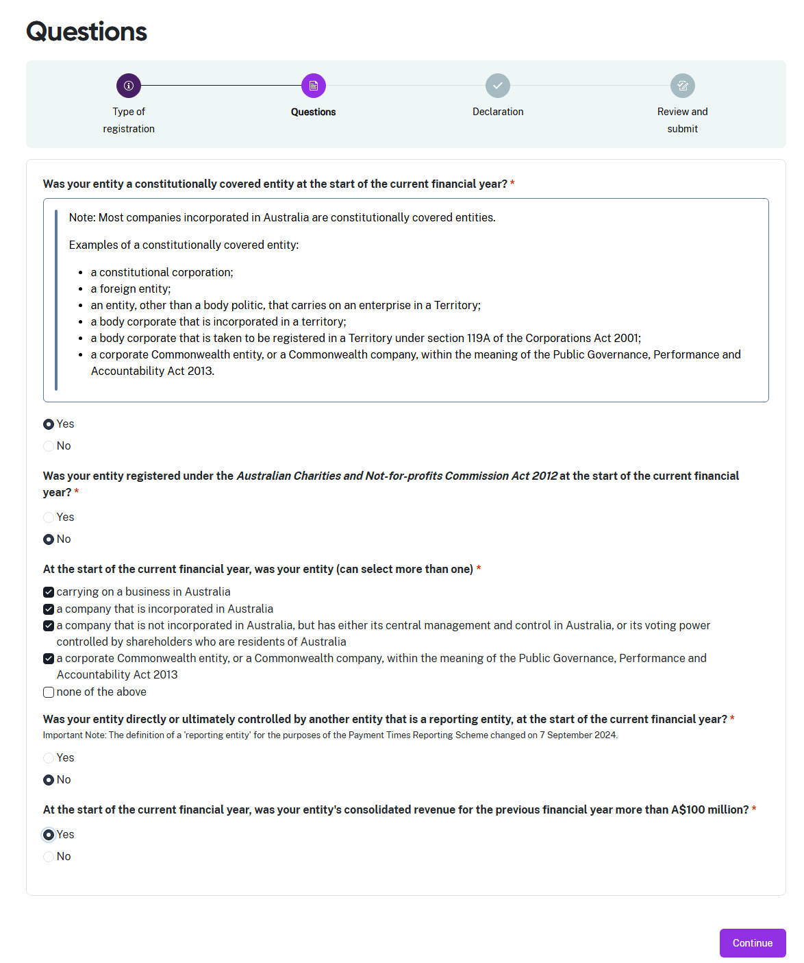

- Select Continue when you have responded to all questions the portal displays on this screen.

Step 3: Declaration
The declaration links to the Digital ID credentials you use to log in to the portal.
Read this declaration carefully. You are making a statement that may lead to regulatory action if the information in this form is not true and correct.

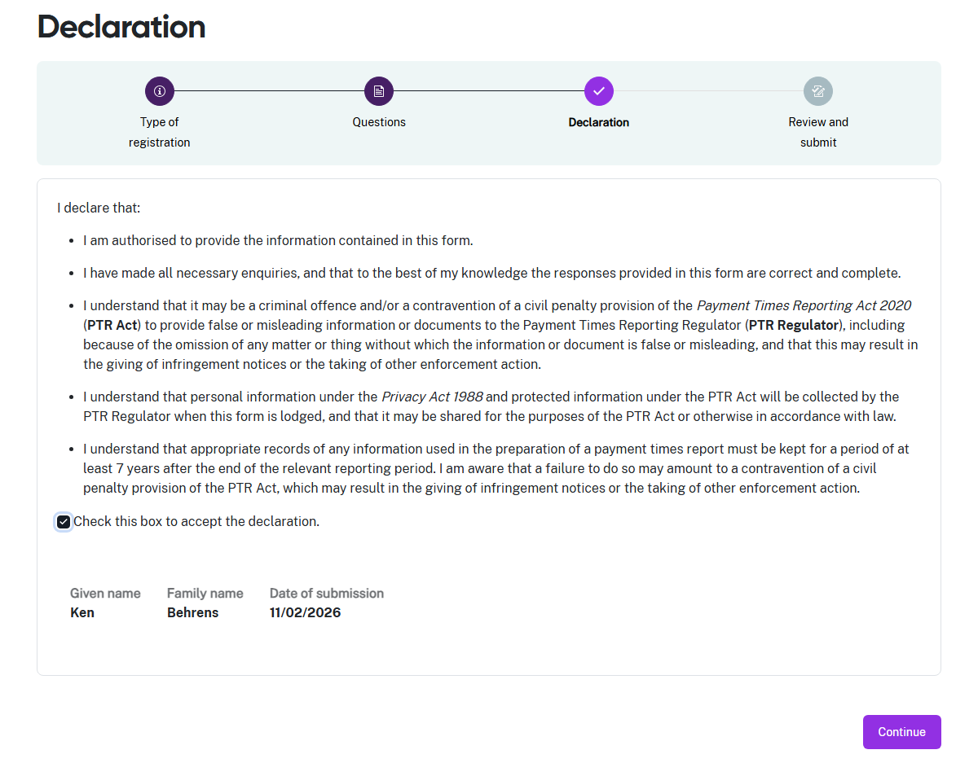
- If you think you may have answered a question incorrectly, you can click the circle icon in the progress guide to return to the Questions.
- Check the declaration box when you are satisfied the information in this questionnaire is correct and complete.
- Select Continue to proceed to Step 4: Review and submit.

Step 4: Review and submit
This step lets you review the information in the questionnaire before you submit it.
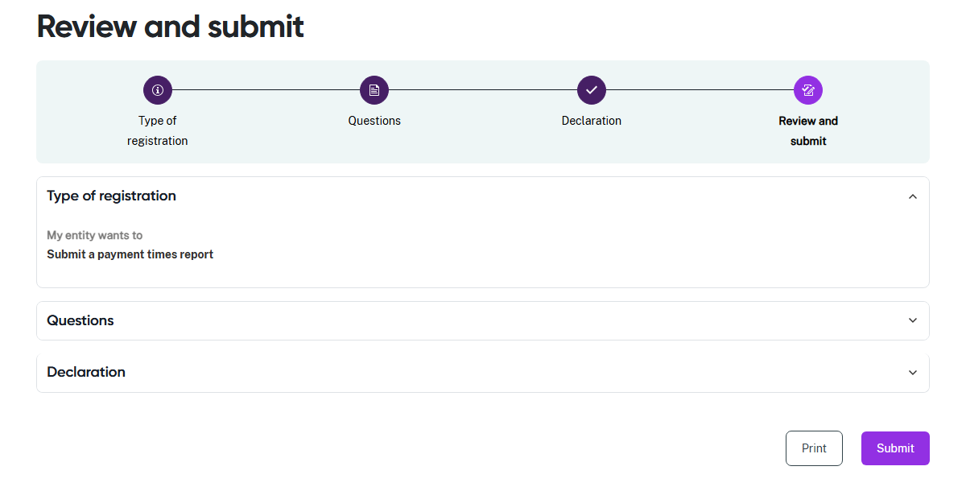
- Review the information in a section by clicking on the down arrow at the right hand side of the section name. In this example, the Type of registration section is expanded to show the summary details displayed by the portal.
- Collapse the view of the section by clicking the up arrow.
- Click a circle icon in the progress guide to return to that section of the questionnaire if you need to update information.
- Select Print to print a paper copy of the questionnaire using a connected printer, or to save a copy as a PDF. This form prints with all sections expanded to show all details.
- Select Submit to lodge your questionnaire and view the outcome.
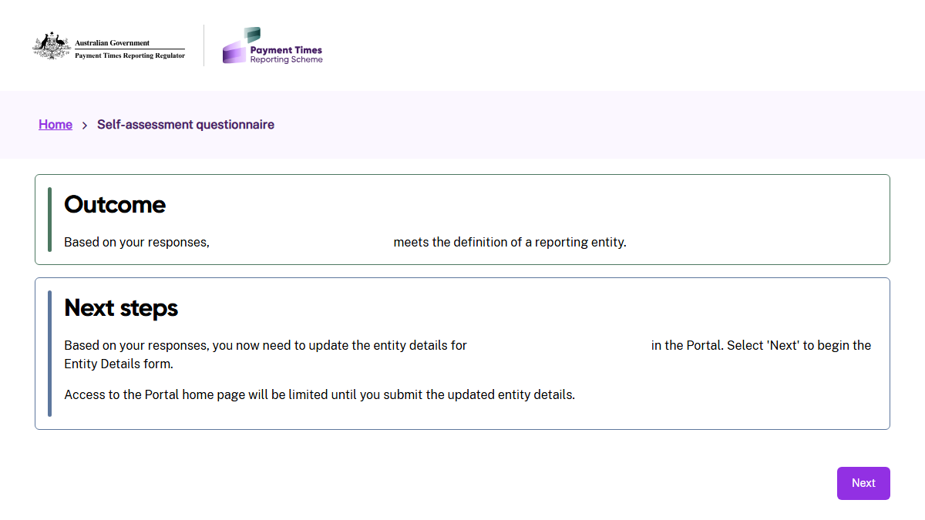
- Select Next to update the Entity details for your entity.
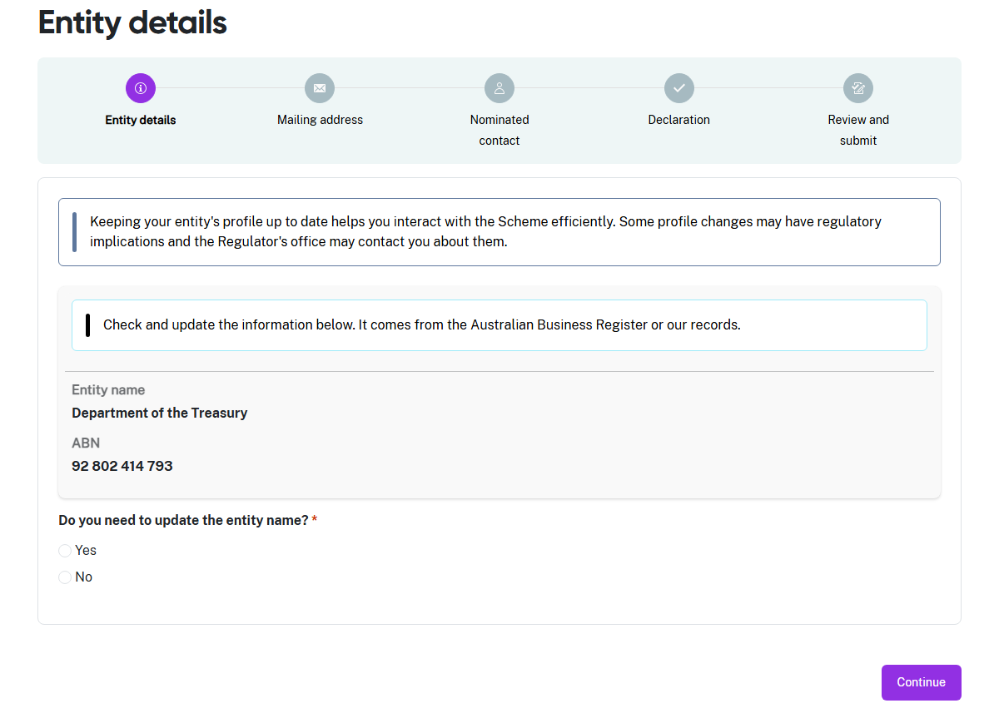
Refer to User Guide: Entity Details for help to complete this process in the portal.

