User Guide: Entity information
This guide explains how to manage and update entity information in the portal. You must keep the information you provide to the Regulator about your reporting entity up to date.
To access the portal you need a Digital ID and authorisation from your entity in Relationship Authorisation Manager to act on its behalf for payment times reporting.
For more information, see Help and support to use the portal on the Regulator’s website.
Version 1.0

Revision history
Version | Date | Description
1.0 | 16 Feb 2026 | Initial version with release of new portal.

Contents
Navigate to the Entity information form 2
Step 1: Before you start 3
Step 2: Entity information 4
Step 3: Mailing address 5
Step 4: Contacts 6
Step 5: Registered business names 9
Step 6: Ultimate controlling entity 11
Step 7: Controlled entities 14
Step 8: Declaration 23
Step 9: Review and submit 24

Navigate to the Entity information form
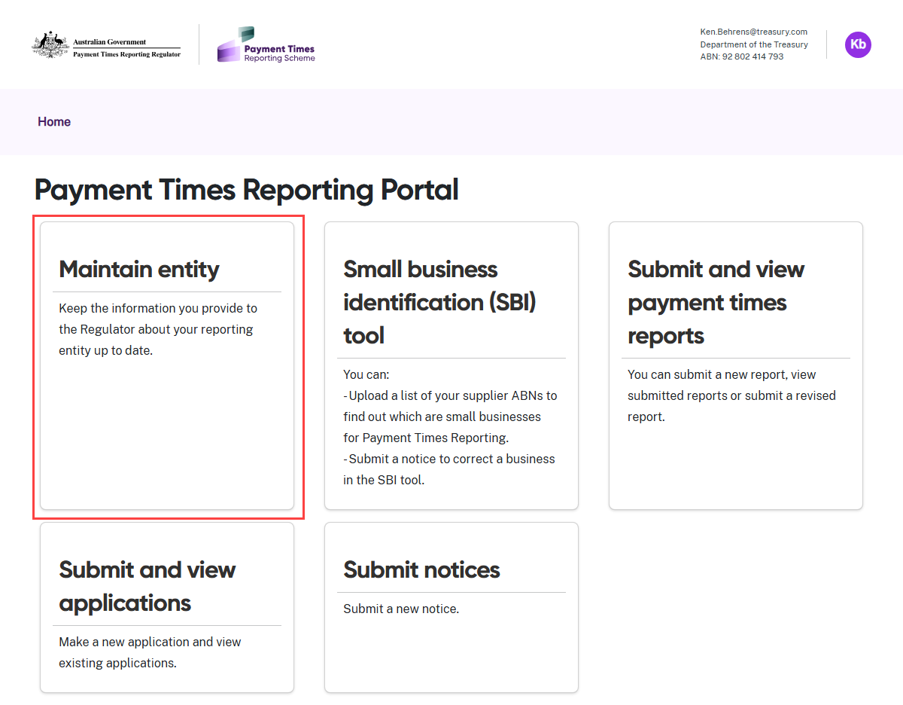
- Select the Maintain entity tile from the Home screen.

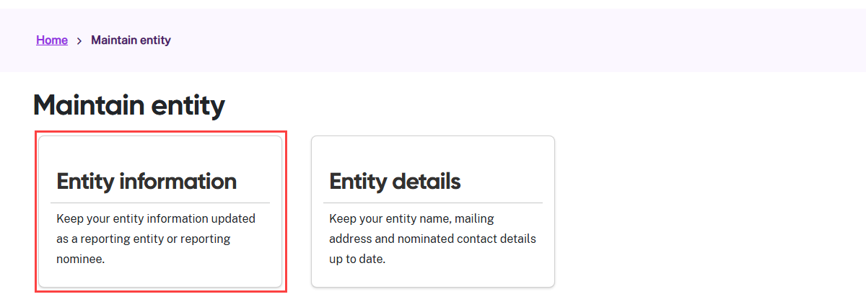
- Select the Entity information tile.

Step 1: Before you start
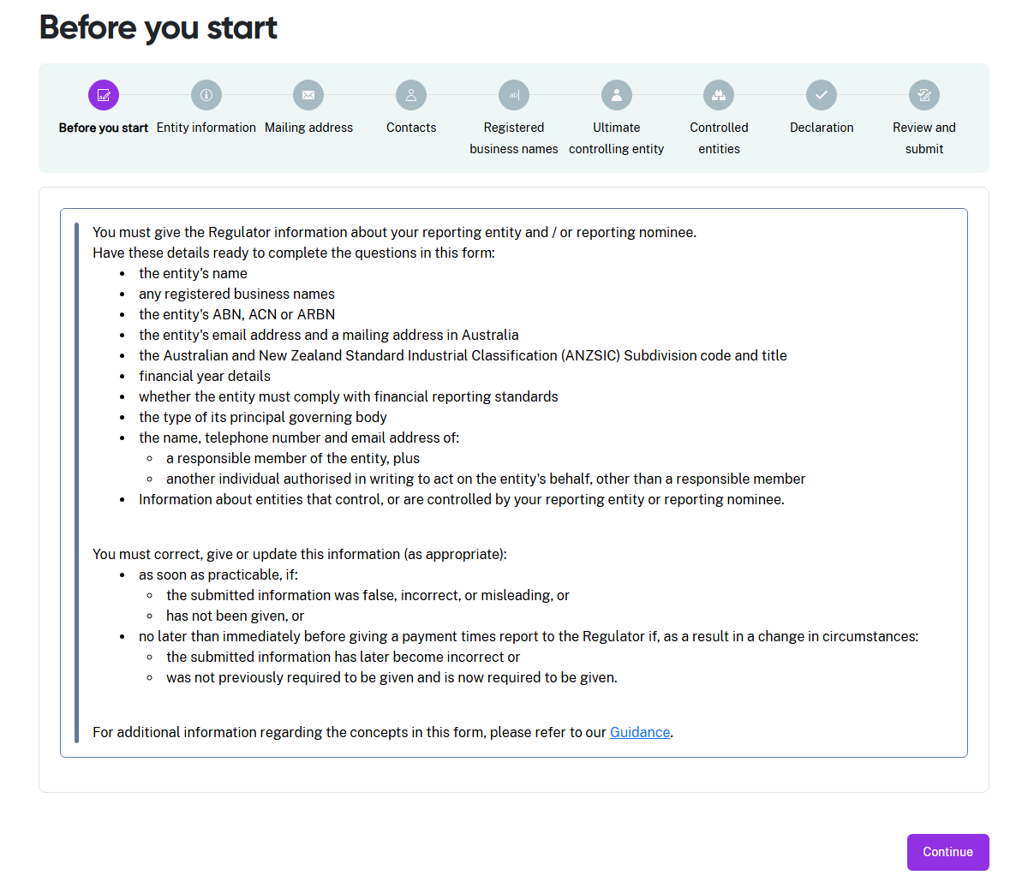

- Read the information on this page carefully and have these details handy to verify or update the information in the form.
- Select Continue when you are ready to begin the form.

 | The entity information form will prefill data from the ABR and from previously reported entity information.

 | Several other steps will appear for subsidiary reporting entities, entities that have subsidiary reporting entities or reporting nominees.

Step 2: Entity information
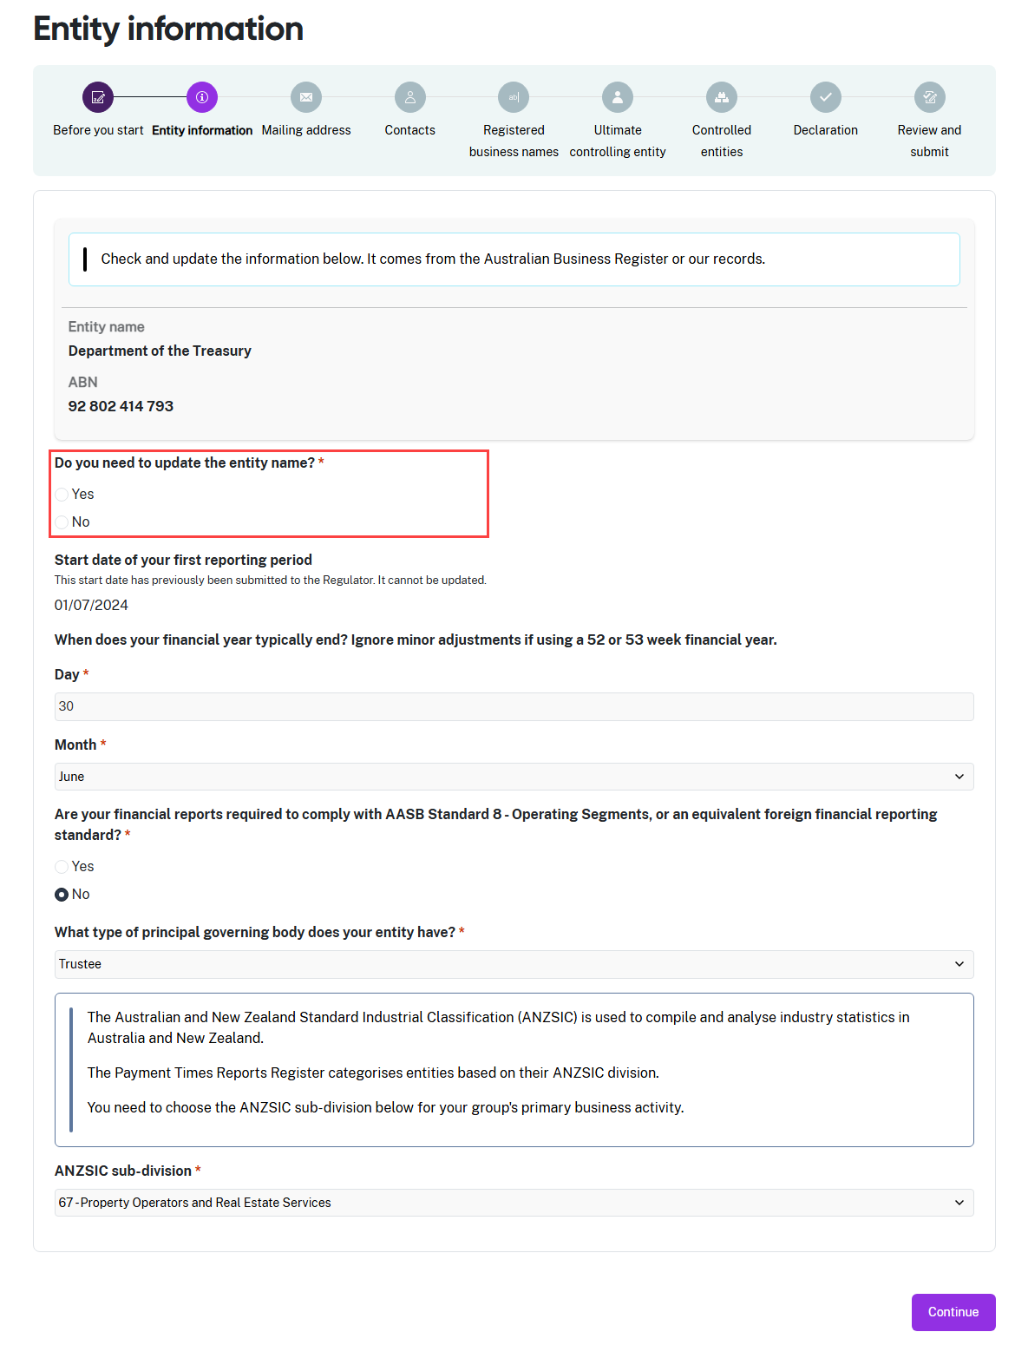
- Check the Entity name and ABN details carefully. Select Yes to update, or No if correct.
- The Start date of your first reporting period prefills from the first time you submitted this form or received a Determination from the Regulator. You cannot edit this date in the portal. If this date is not correct, send an email to support@paymenttimes.gov.au to request a change.
- Select Continue when the information on this page is correct.

Step 3: Mailing address
The address in this step reflects the Service of notice address in the Entity details process.
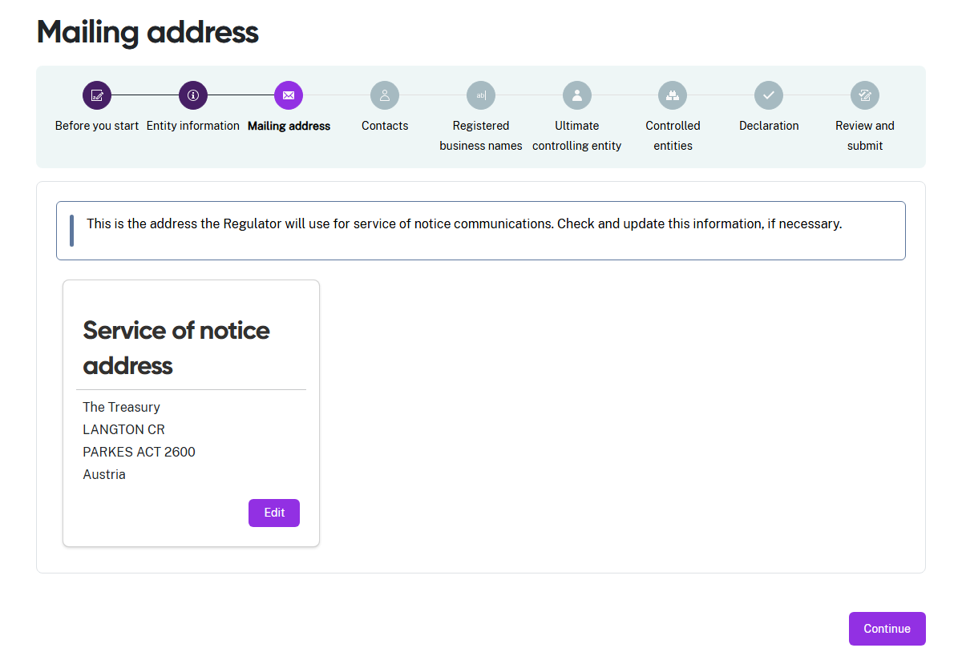
- Check the address information is correct.
- If you need to make a correction, select Edit. A screen with the address fields will slide into view from the right hand side of the screen.
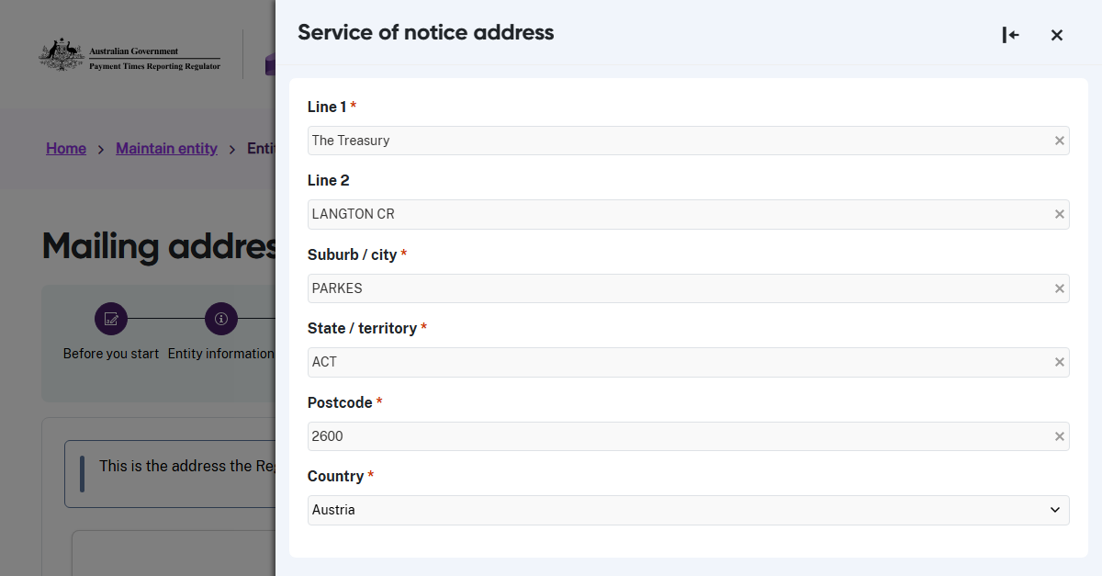
- The mandatory fields are marked with a red asterisk and cannot be left blank. Once the fields are complete, you can save the updated information.
- Select Continue to move to the next step.

Step 4: Contacts
In this step, provide the Regulator with details for two different individuals. These individuals must not be the same person. Enter details for:
- the Authorised contact, and
- the Responsible member.
Refer to the Guidance materials for more information.
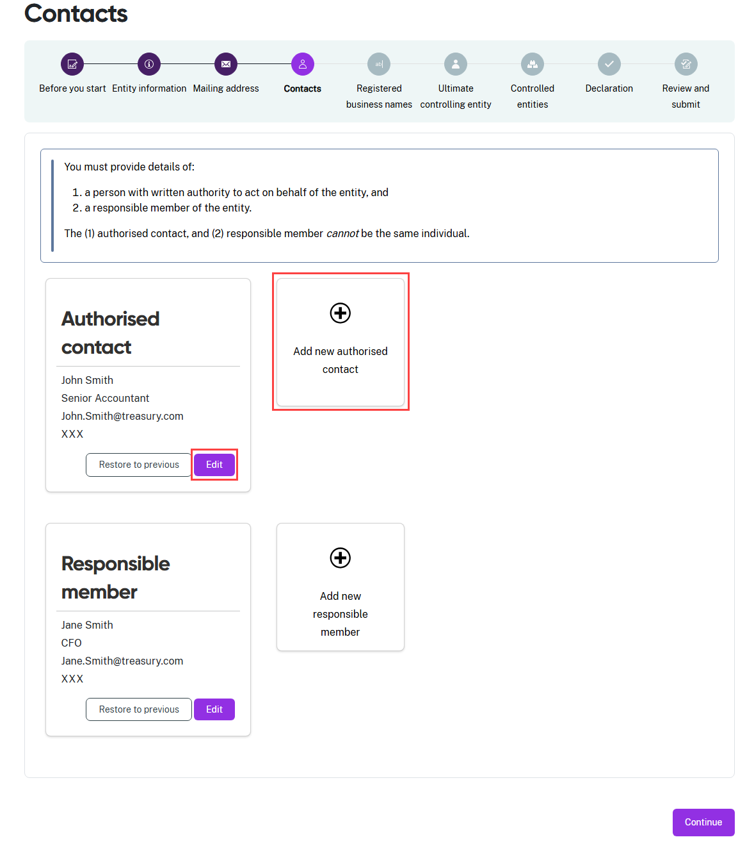
- Use the same process as the previous step to update the details for these contacts.
- To change this information, select Edit or + Add new…. The address screen slides in from the right-hand side of the screen.
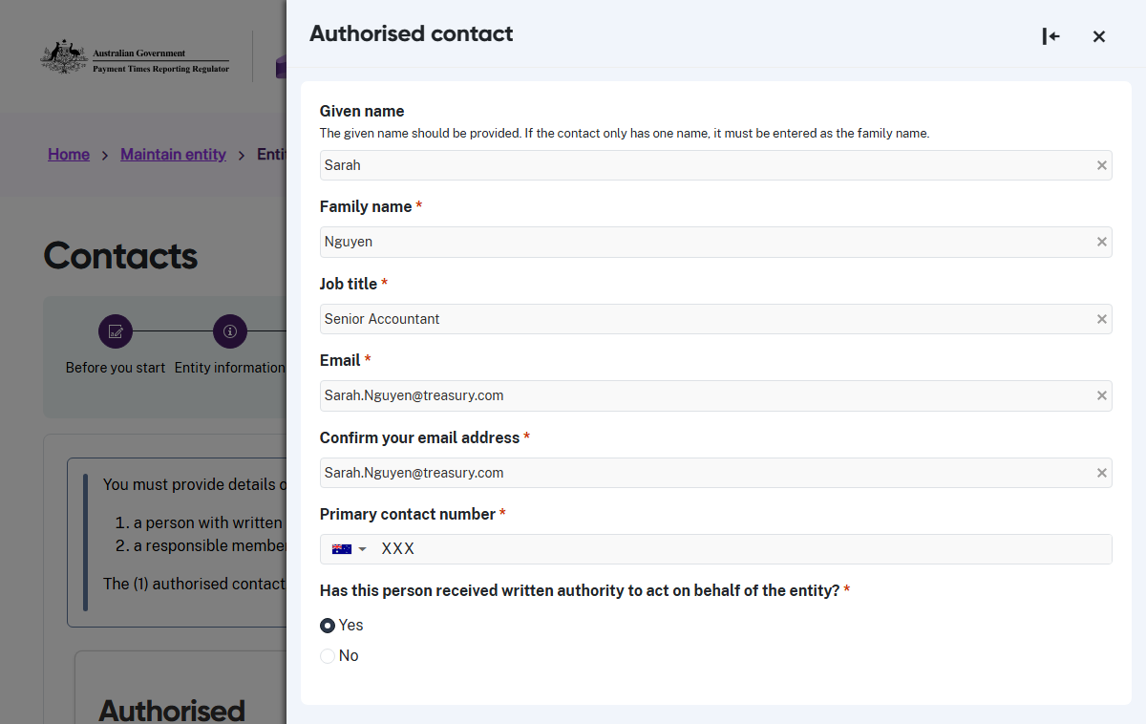
- Enter the updated information. Mandatory fields are marked with a red asterisk and cannot be left blank.
- In the final part of the Authorised contact update, confirm that the entity has authorised this person in writing to act on its behalf for payment times reporting.
- Select Yes to confirm they are authorised in writing.
- Select No if you cannot confirm this person has written authorisation to act on behalf of the entity.
  - If you select No, you cannot record this person as an authorised contact. You must provide details for a person who has written authorisation to act on behalf of the entity.
- Once these fields are complete, you can save the updated information.

When an entity’s principal authority or authorisation administrator authorises a person to act on behalf of the business in Relationship Authorisation Manager (RAM), this counts as written authorisation.

- Repeat these steps if you need to update the Responsible member information. You do not need to confirm that the Responsible member has written authorisation to act on behalf of the entity.

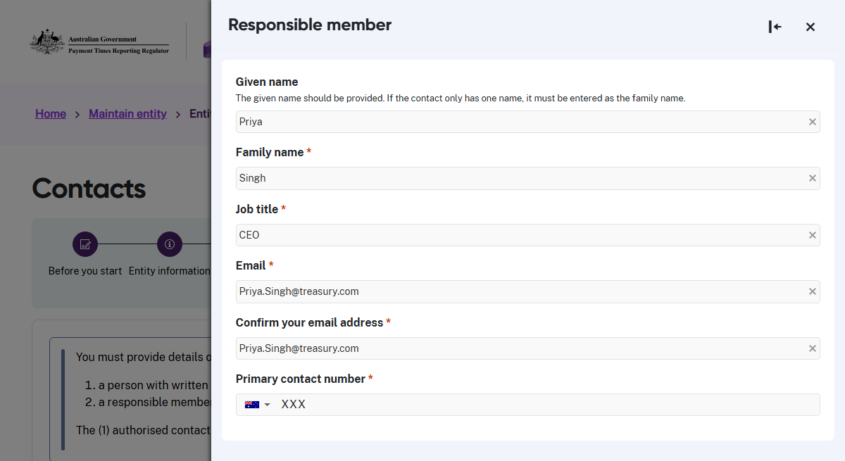
- After you complete these fields, save the updated information.
- The system displays the updated information. If you updated a record in error,
select Restore to previous during the same session to undo the changes.
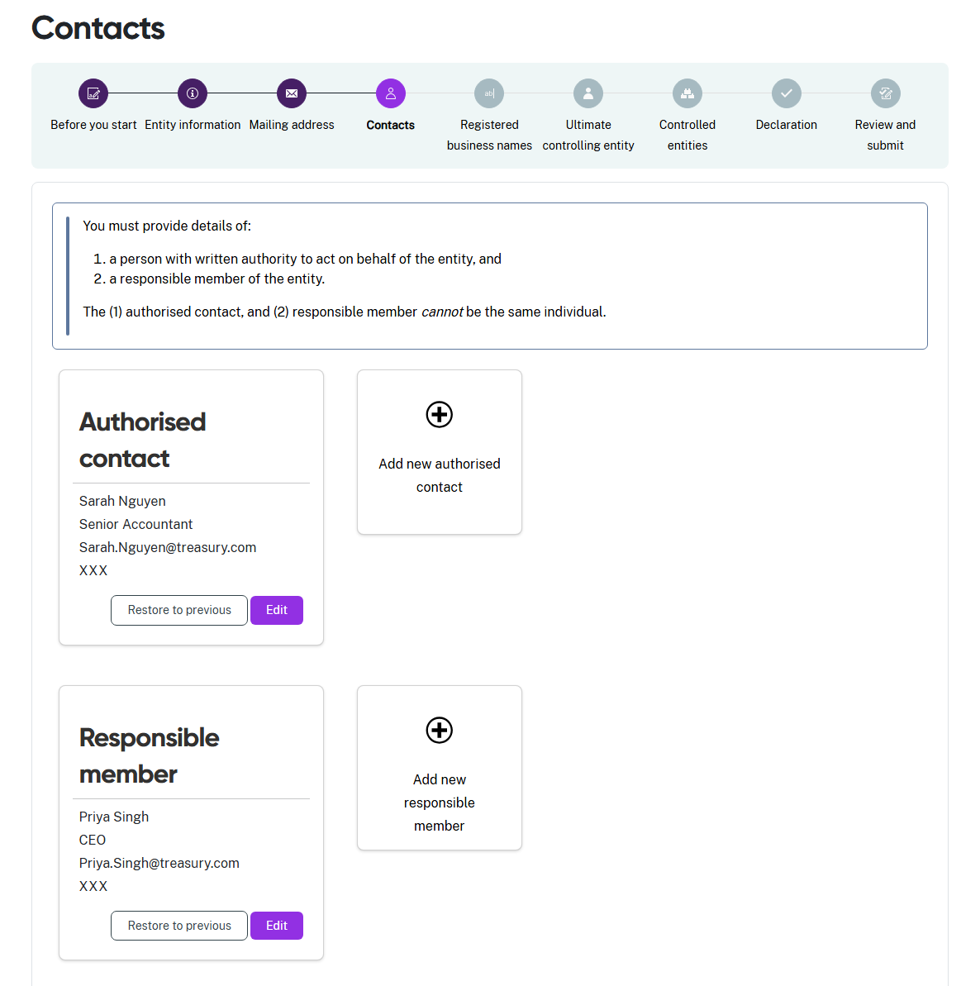

Step 5: Registered business names
The portal prefills registered business name information from the Australian Business Register (ABR). Check this information and make sure it is correct; you can edit the entries as needed.
If the ABR information is complete and correct
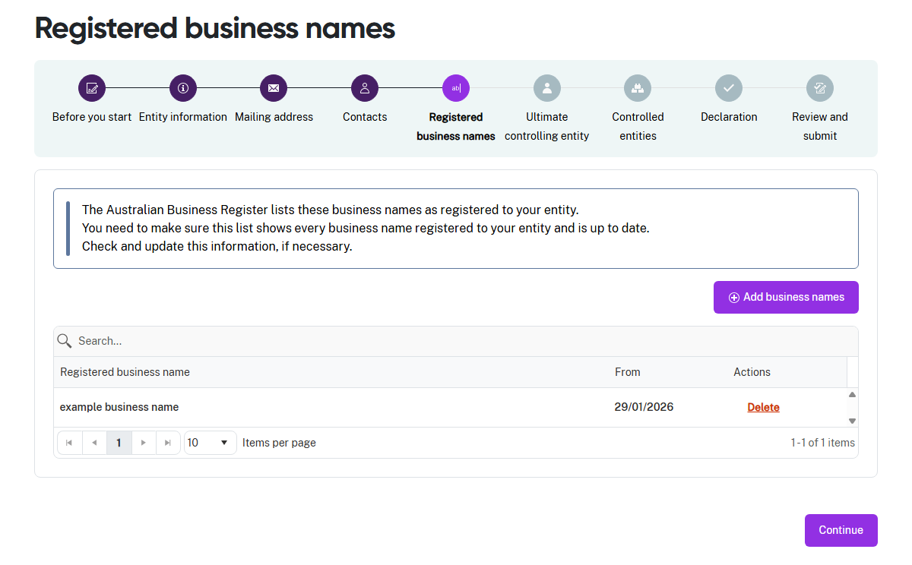
- Select Continue if you do not need to change the information shown.
- The portal will move you to Step 6: Ultimate controlling entity.
Adding a Registered business name
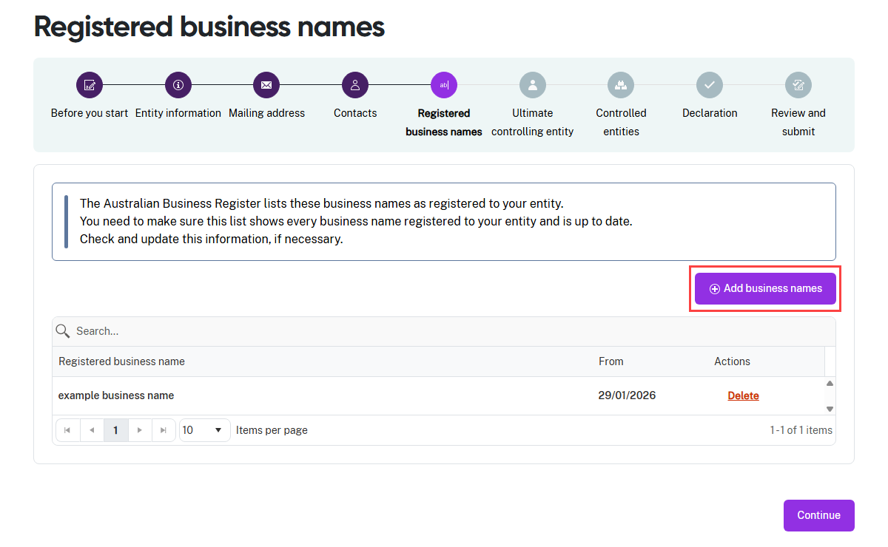
- Select Add business names and the entry field slides in from the right-hand side of the screen.
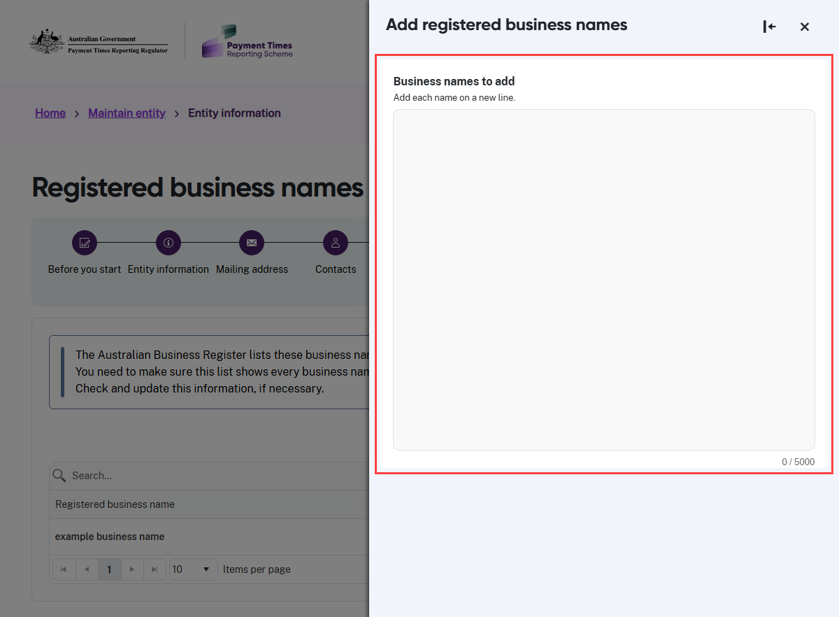
- Enter the additional business names. Each name must be on a new line.
- Select Continue when you finish adding the additional business names.
Deleting a Registered business name
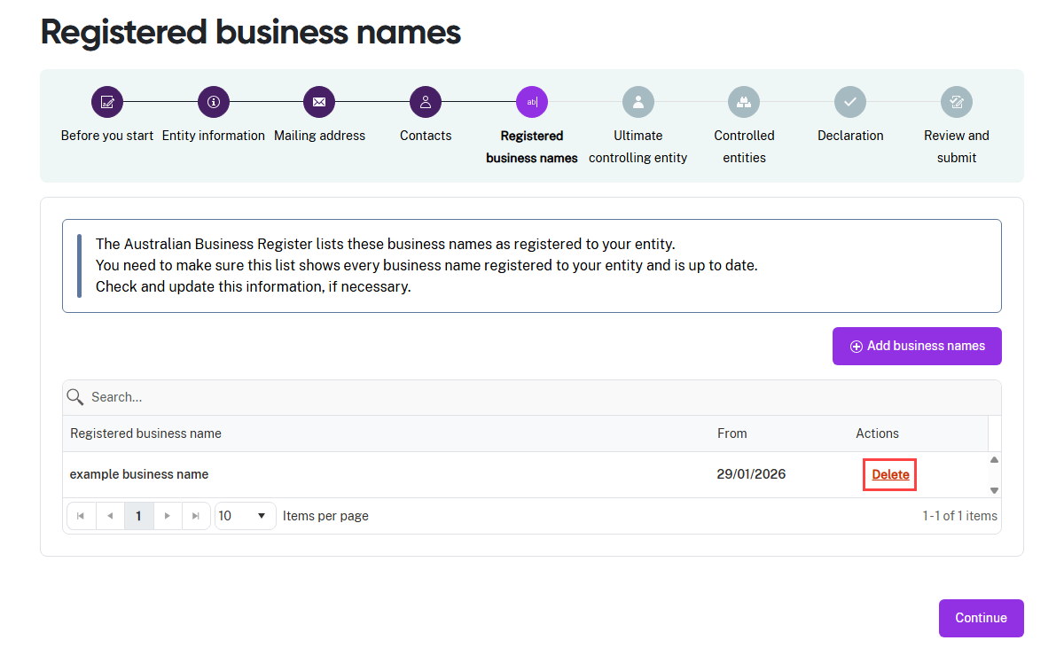
- Select Delete to remove each incorrect entry.
- Select Continue when the remaining information is correct.

Step 6: Ultimate controlling entity
This step records if the entity is controlled by an ultimate parent entity in the group structure.
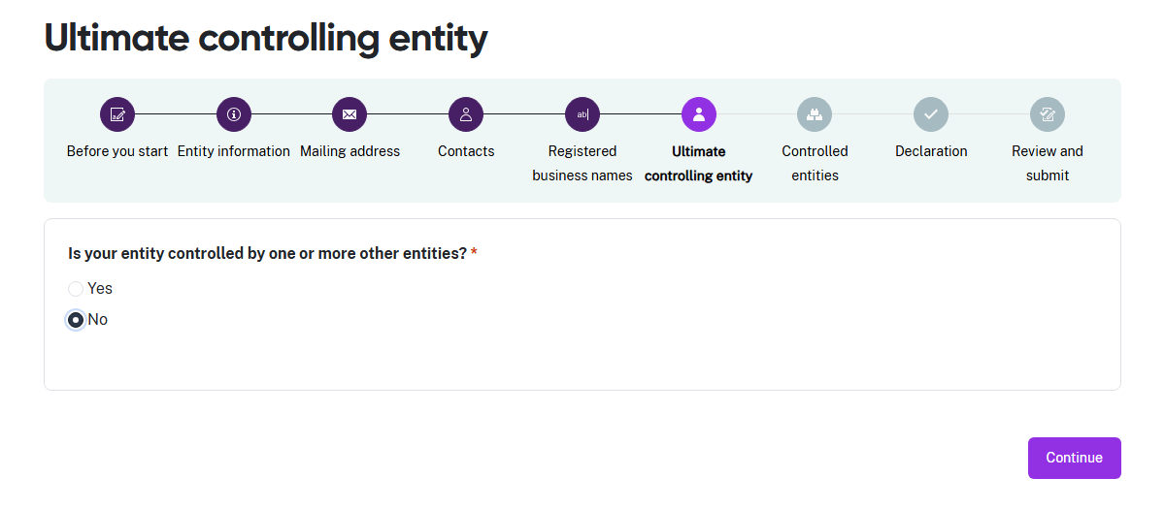
- If your entity is not controlled by any other entities, select No, then select Continue.
- The portal will move you to Step 7: Controlled entities.

Adding an Ultimate controlling entity
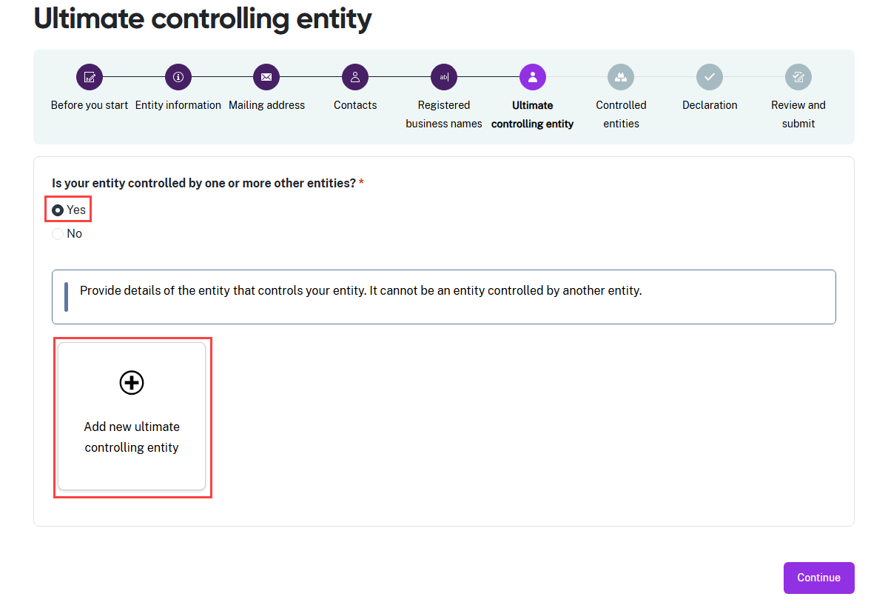
- If you need to add the ultimate controlling entity, select Yes and the +Add new… tile appears.
- Select +Add new… and the entry field slides in from the right-hand side of the screen.

Ultimate controlling entity with an ABN or ACN or ARBN
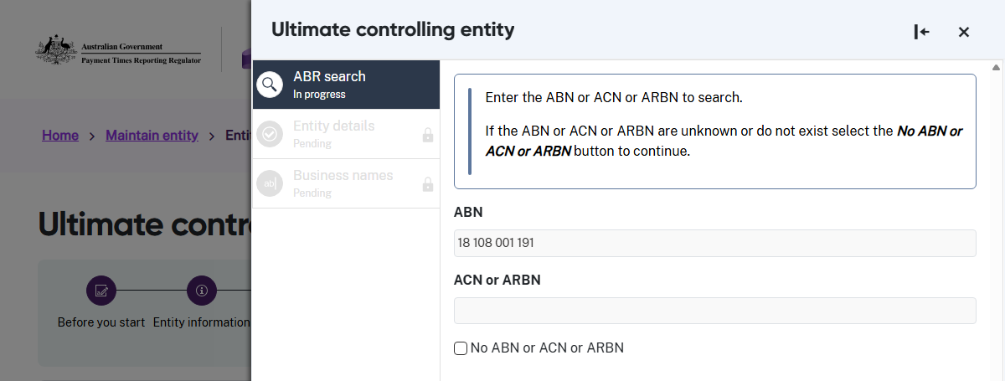
- Enter the ABN in the search field and then select Continue to search the ABR.
- If there isn’t an ABN, but you have an ACN or an ARBN, enter the number and then select Continue to search the ABR.

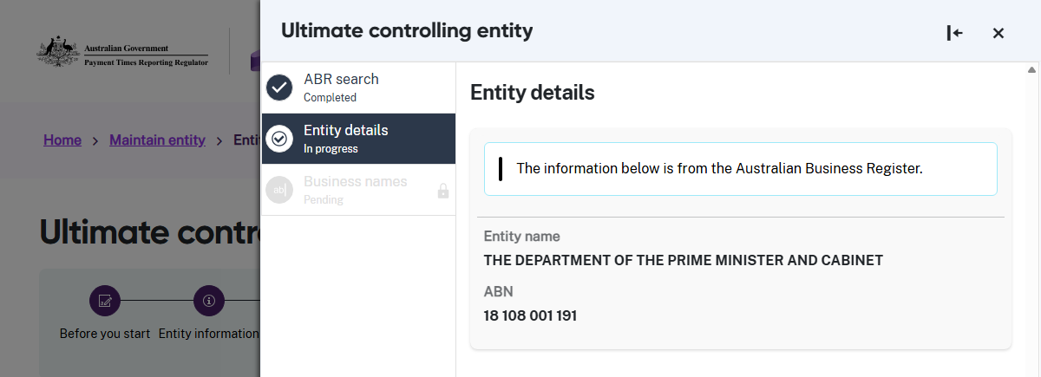
- Check the information returned from the ABR is correct and select Continue when it is.

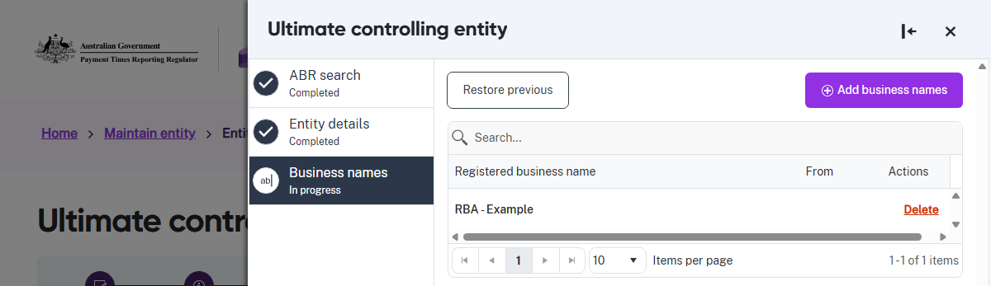
- This entity name will display as an Ultimate controlling entity and show the Registered business names from the ABR.
- When this information is correct, select Continue.
- The portal will move you to Step 7: Controlled entities.
Ultimate controlling entity without an ABN, ACN or ARBN
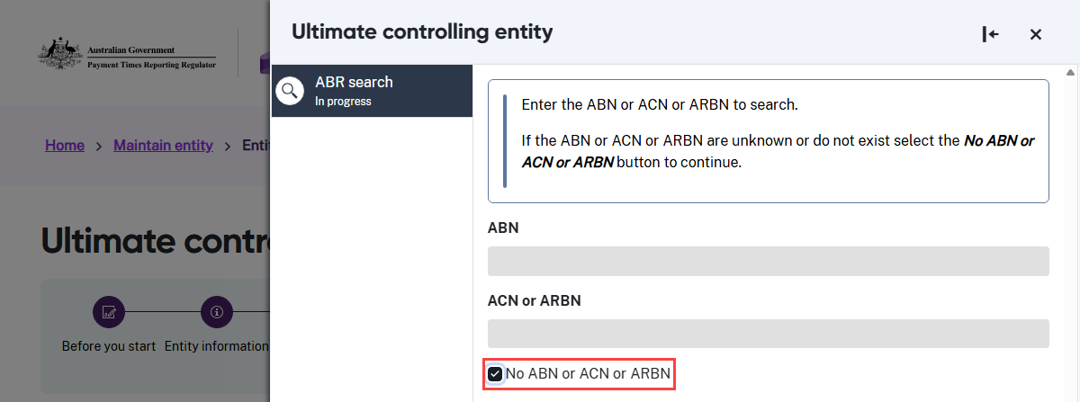

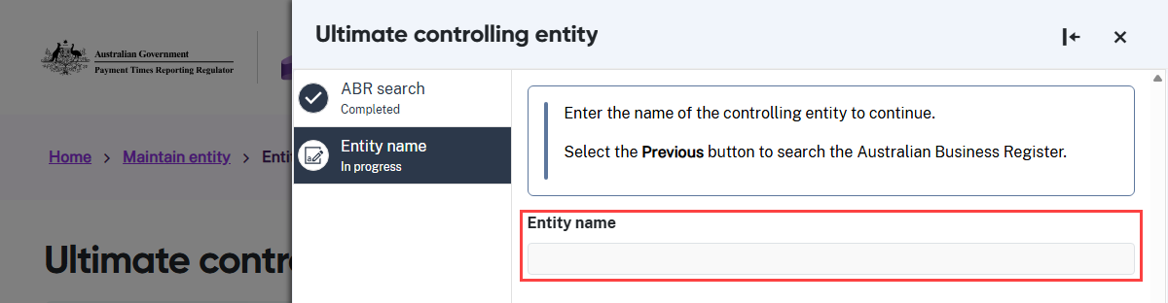

- If the ultimate controlling entity does not have an ABN, ACN or ARBN, select the check box to enter the name of the Ultimate controlling entity without searching the ABR.
- Check this information is correct. If it is, select Continue.
- The portal will move you to Step 7: Controlled entities.

Step 7: Controlled entities
If your reporting entity controls other entities, they must be reflected in this step. Read about Identifying controlled entities in the Guidance materials for more information.
Entity without Controlled entities
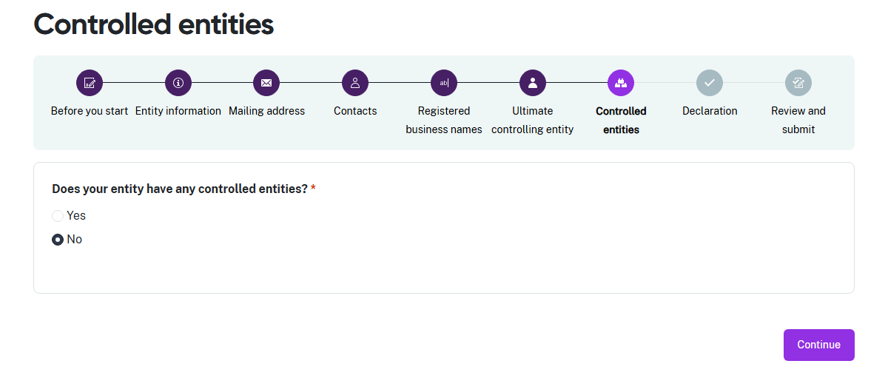
- If your entity does not control any other entities, select No.
- Select Continue and the portal will move you to Step 8: Declaration.

Entity with Controlled entities with an ABN
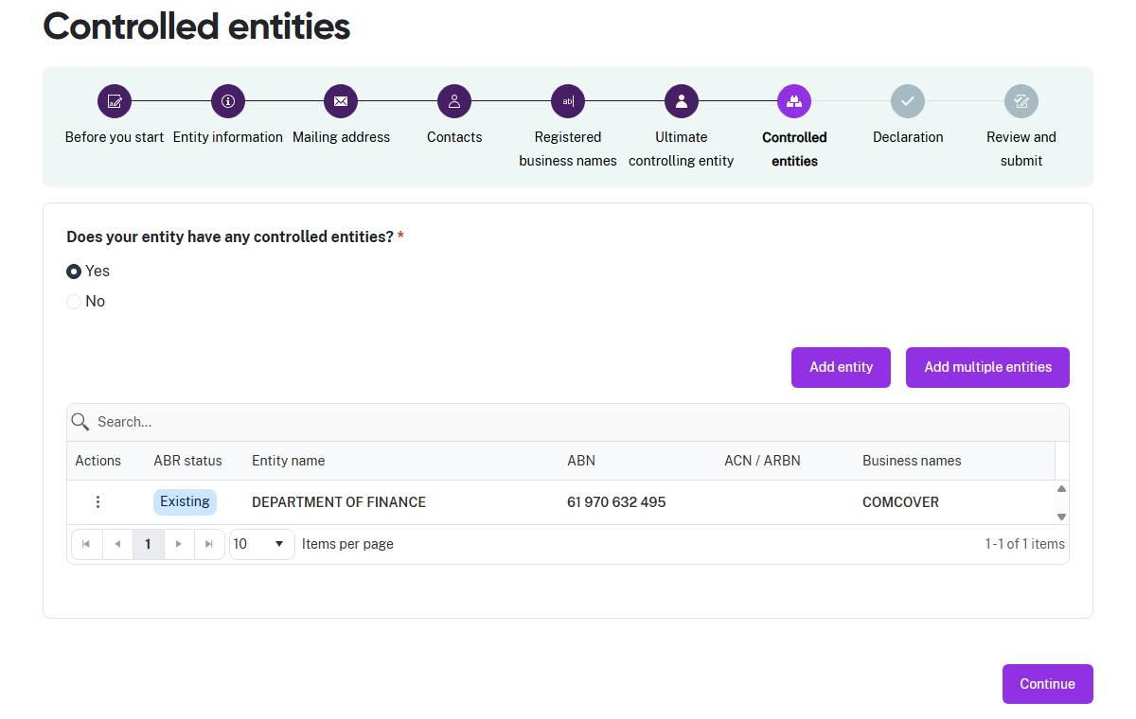
- If your entity does control other entities as specified in the Guidance materials, select Yes. The portal will then display ABR information for all controlled entities with an ABN and the name of all controlled entities without an ABN.
- Check this information is correct. If it is, select Continue.
Entity with Controlled entities without an ABN
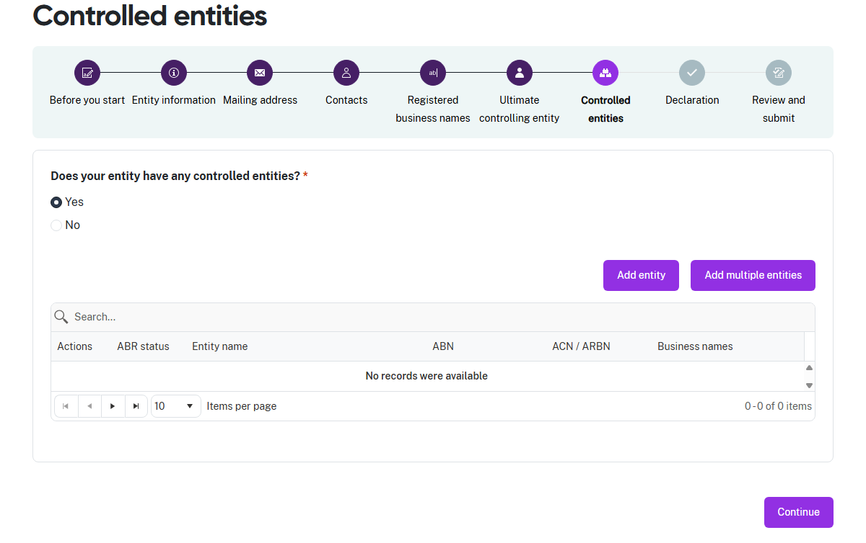
- If your entity controls one or more entities without an ABN and they are not shown, you must enter them by name.

Add a single Controlled entity
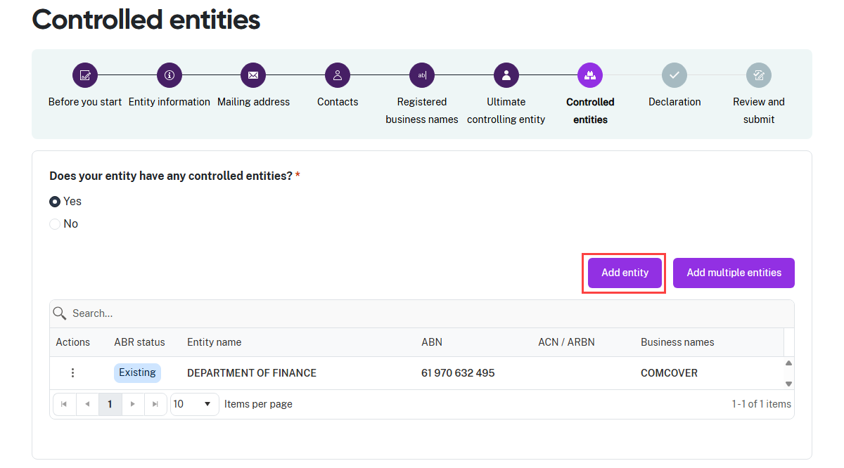
- If you need to add one Controlled entity, select Add entity and the entry field slides in
from the right-hand side of the screen.
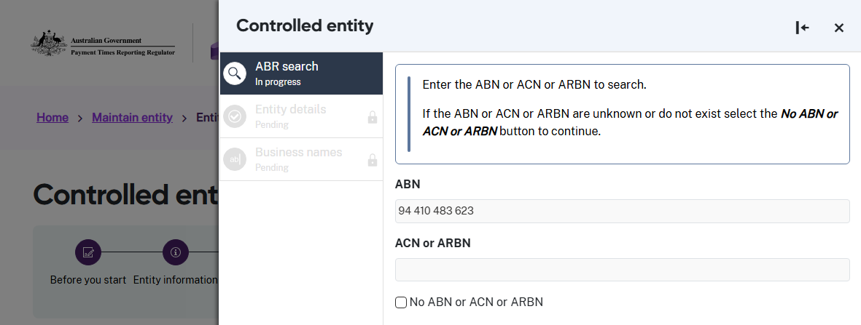
- If your Controlled entity has an ABN, enter it in the ABN field, then select Continue.
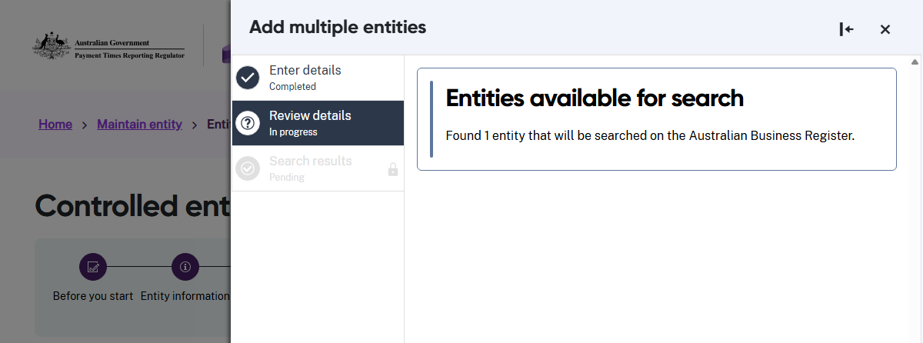
- If your ABN is valid, the portal searches the ABR.
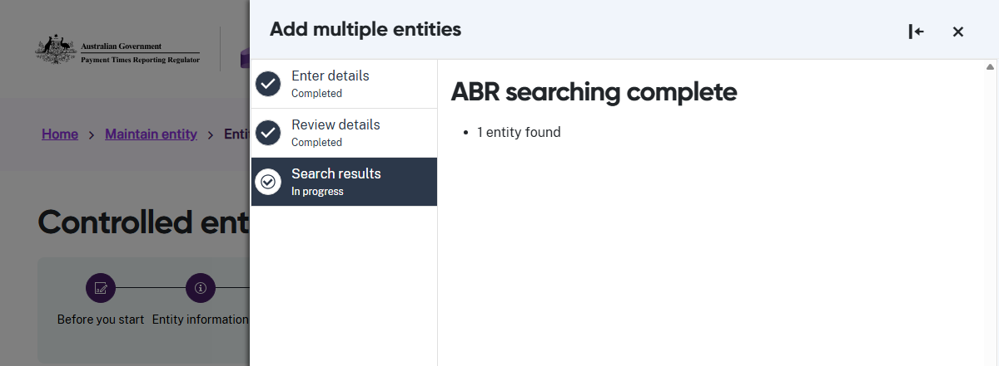
- The portal shows you the search is complete.

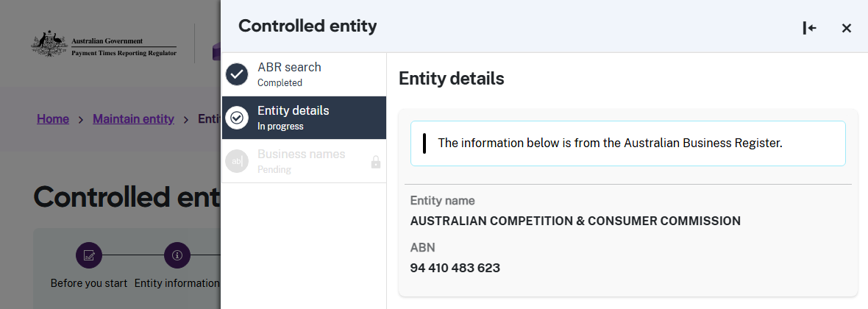
- Check the information returned from the ABR is correct
- Select Continue when it is.

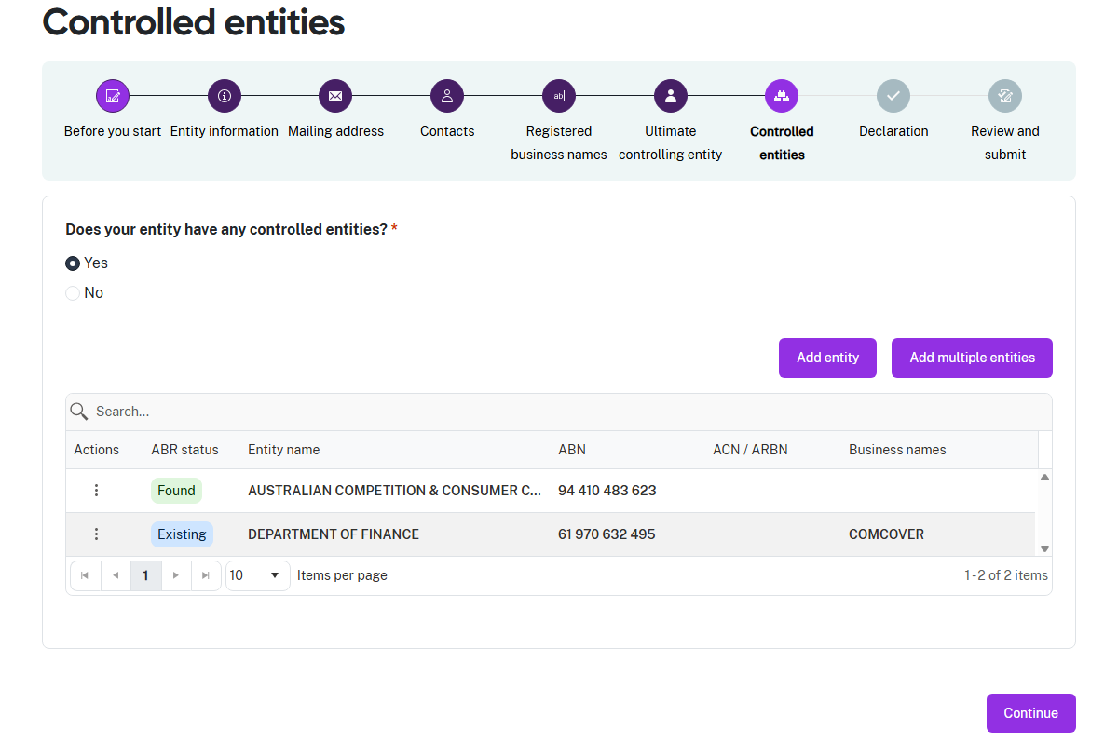
- The portal displays the successfully added Controlled entity with any Registered business names. Check this information is correct.
- If it is, select Continue to proceed to Step 8: Declaration.
- If you need to update the Registered business name information for this Controlled entity, click on the stacked dots under Actions and select Edit.
- Use the same process as Step 5: Registered business names to update this information.
- Select Continue to proceed to Step 8: Declaration.

Add multiple Controlled entities
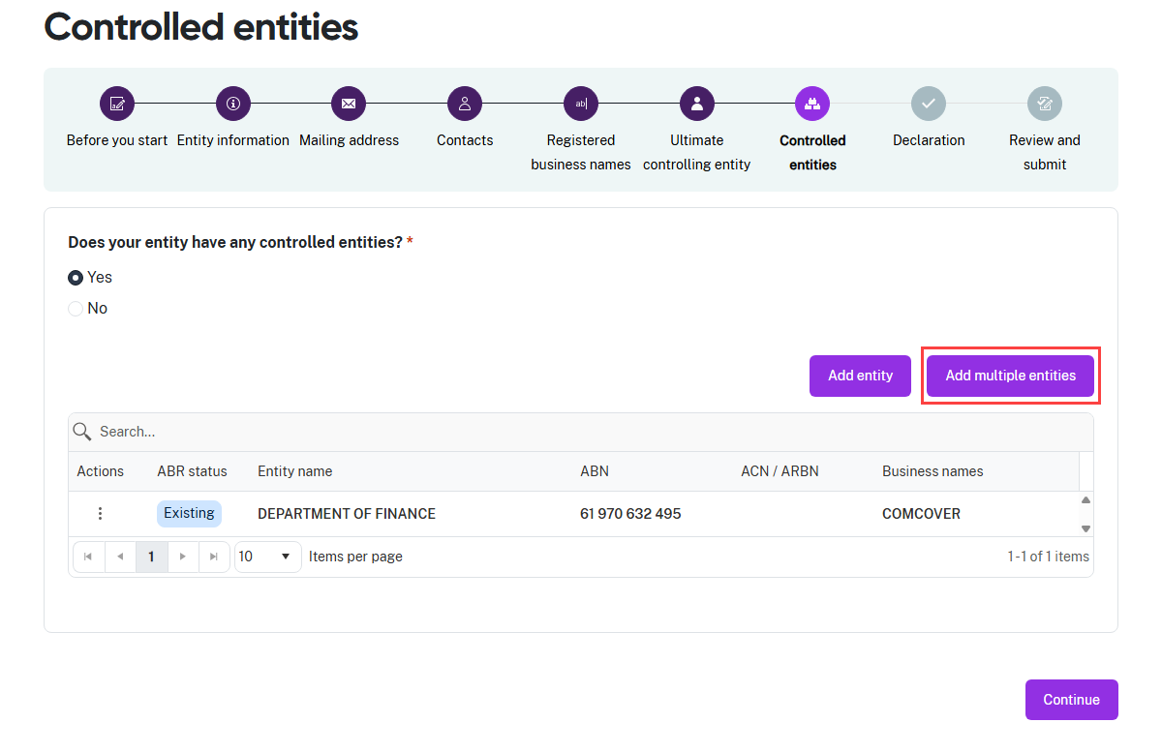
- Select Add multiple entities, the entry field slides in from the right-hand side of the screen.

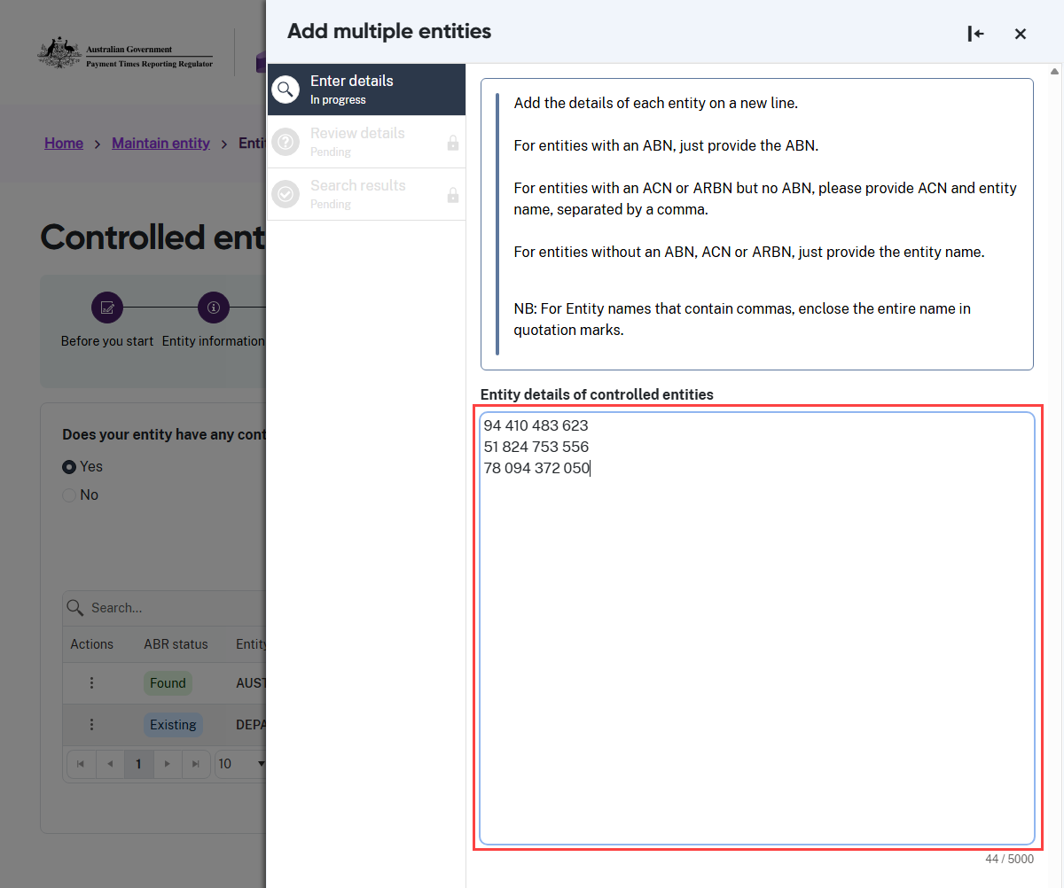

Read the instructions on this screen carefully before entering any information.

- This example shows how to add Controlled entities with ABNs. Copy and paste the ABNs into the field. Each ABN must be on a new line.
- Select Continue to validate the ABNs.

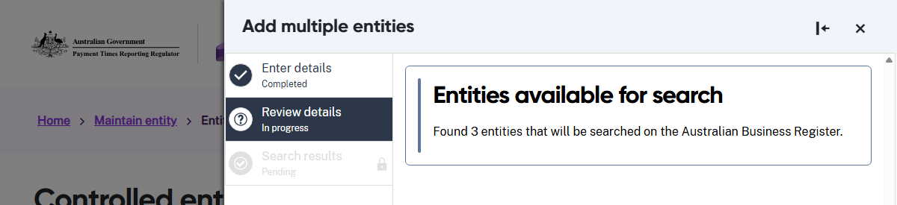
- The portal displays the results of the validation.
- Select Continue to search the ABR.

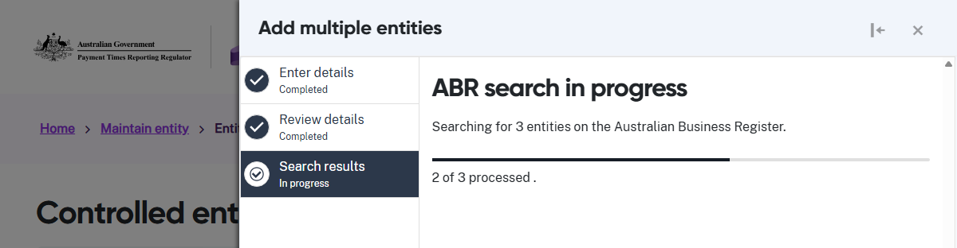
- The portal searches the ABR.

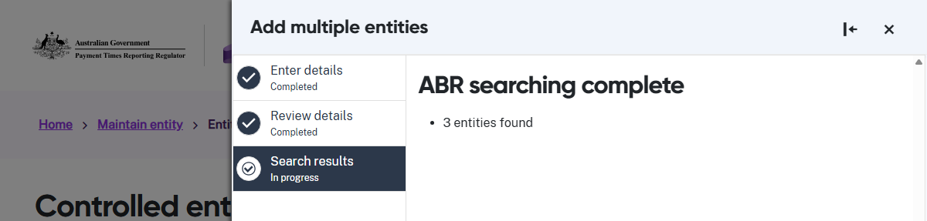
- Select Continue to see the entity information retrieved from the ABR.

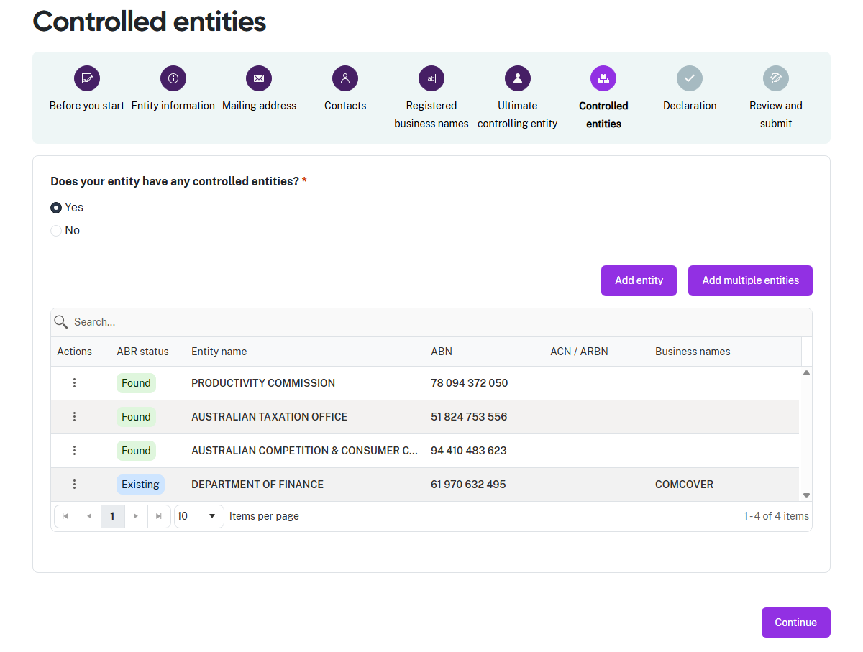
- The portal displays the successfully added Controlled entities with any Registered business names. Check this information is correct.
- If it is, select Continue to proceed to Step 8: Declaration.
Delete a Controlled entity
The portal allows you to delete one Controlled entity at a time.
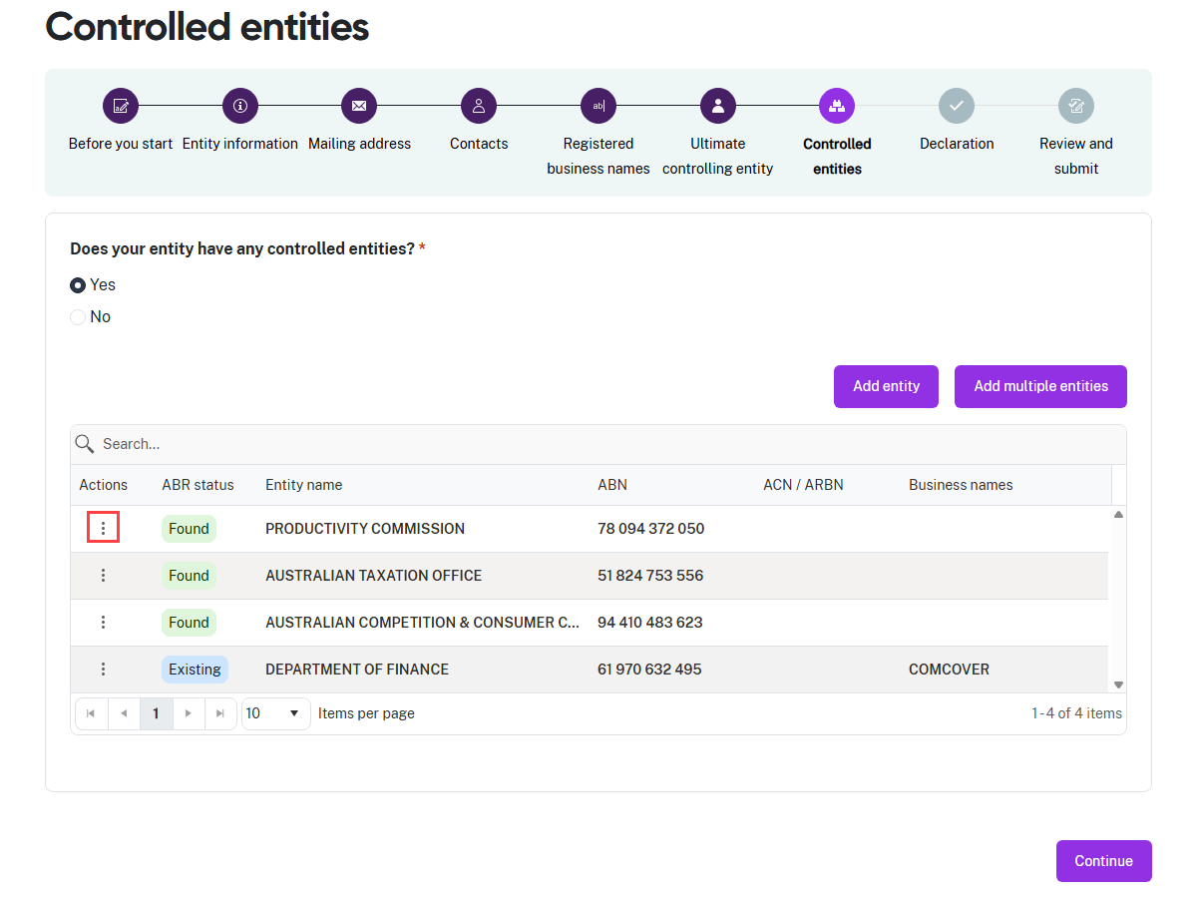
- To delete a Controlled entity, click on the stacked dots under Actions.

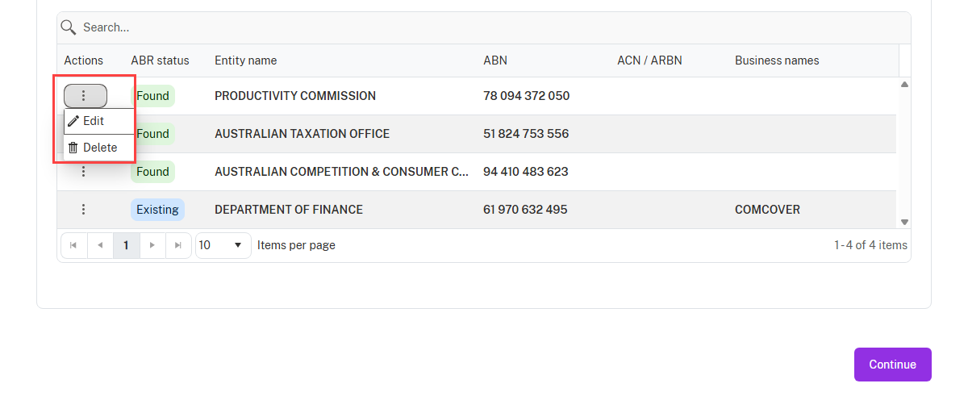
- The portal displays two fields, select Delete.

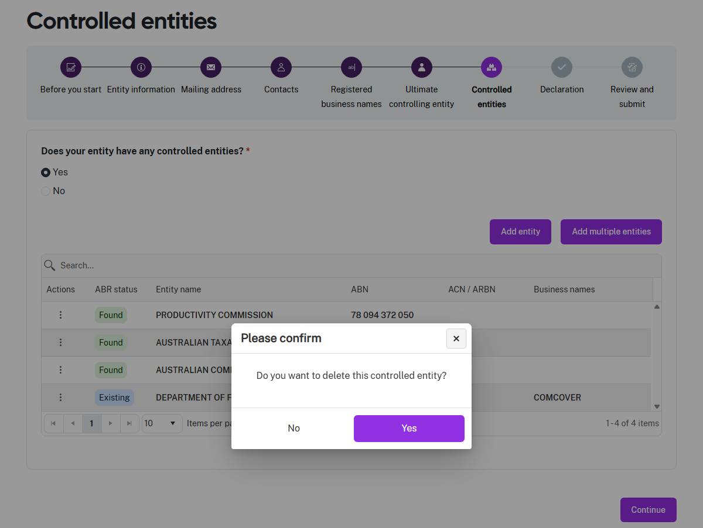
- The portal asks you to confirm that you want to delete the Controlled entity.
- Select Yes to delete the entity, or No to cancel and return to the previous screen.
- After you finish deleting Controlled entities, select Continue.

Step 8: Declaration
The declaration links to the Digital ID credentials you use to log in to the portal.
Read this declaration carefully. You are making a statement that may lead to regulatory action if the information in this form is not true and correct.

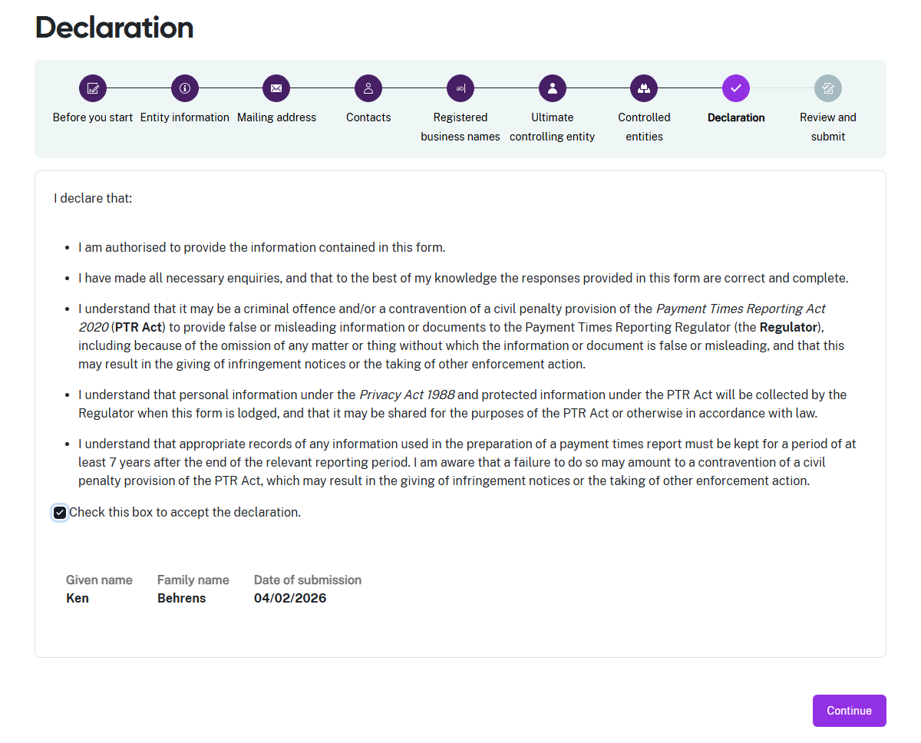
- If you think there may be an error earlier in the form, you can click a circle icon in the progress guide to return to that section of the form.
- Check the declaration box when you are satisfied the information in this form is correct and complete.
- Select Continue to proceed to Step 9: Review and submit.

Step 9: Review and submit
This step lets you review all the information in the form before you submit it to the Regulator.
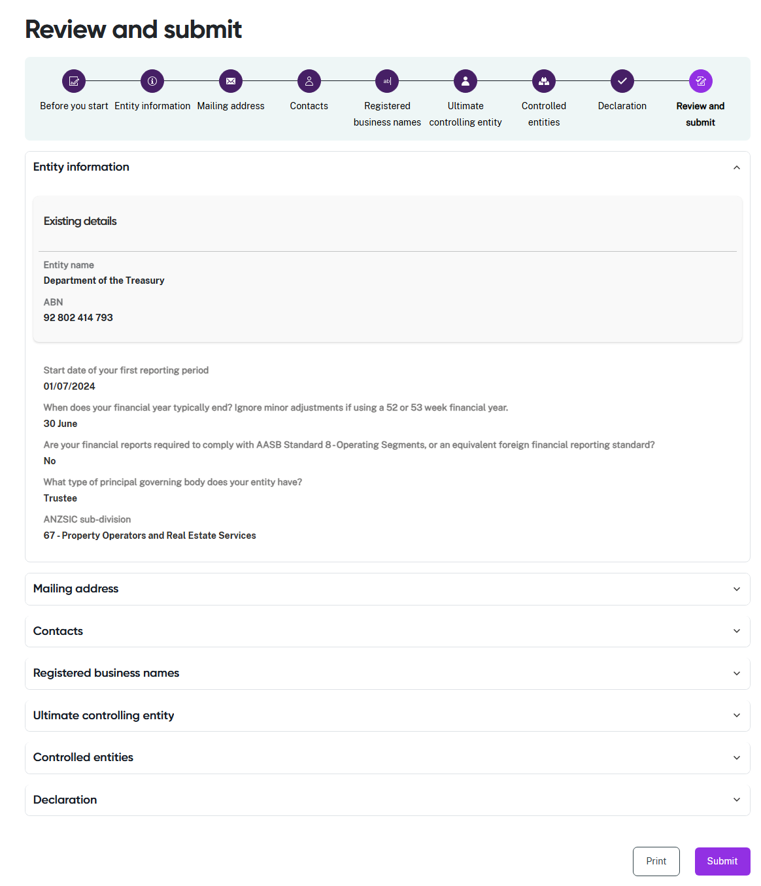
- Review the information in a section by clicking on the down arrow at the right hand side of the section name. Collapse the view of the section by clicking the up arrow.
- Click a circle icon in the progress guide to return to that section of the form if you need to update information.
- Select Print to print a paper copy of the form using a connected printer, or to save a copy as a PDF. The form prints with all sections expanded to show all details.
- Select Submit to close this form and provide your Entity information to the Regulator.

