User Guide: Entity details
This guide explains how to manage and update entity details in the portal. You must keep the information you provide to the Regulator about your entity up to date.
To access the portal you need a Digital ID and authorisation from your entity in Relationship Authorisation Manager to act on its behalf for payment times reporting.
For more information, see Help and support to use the portal on the Regulator’s website.
Version 1.0

Revision history
Version | Date | Description
1.0 | 16 Feb 2026 | Initial version with release of new portal.

Contents
Navigate to the Entity details form 2
Step 1: Entity details 3
Step 2: Mailing address 4
Step 3: Nominated contact 5
Step 4: Declaration 8
Step 5: Review and submit 9

Navigate to the Entity details form
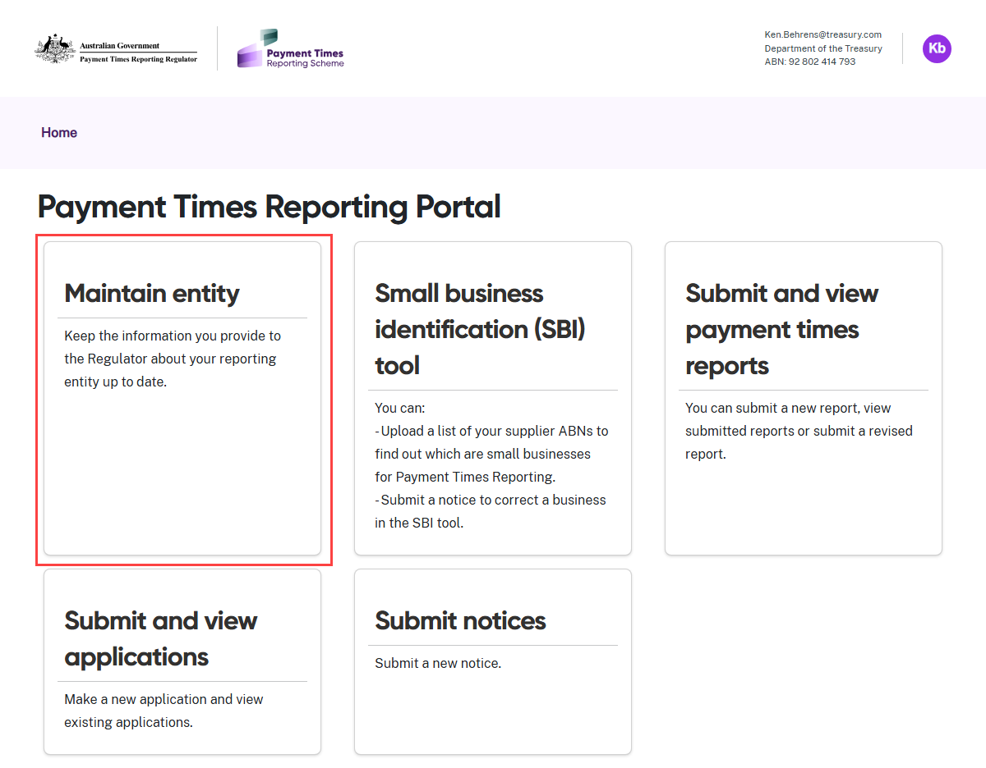
- Select the Maintain entity tile from the Home screen.
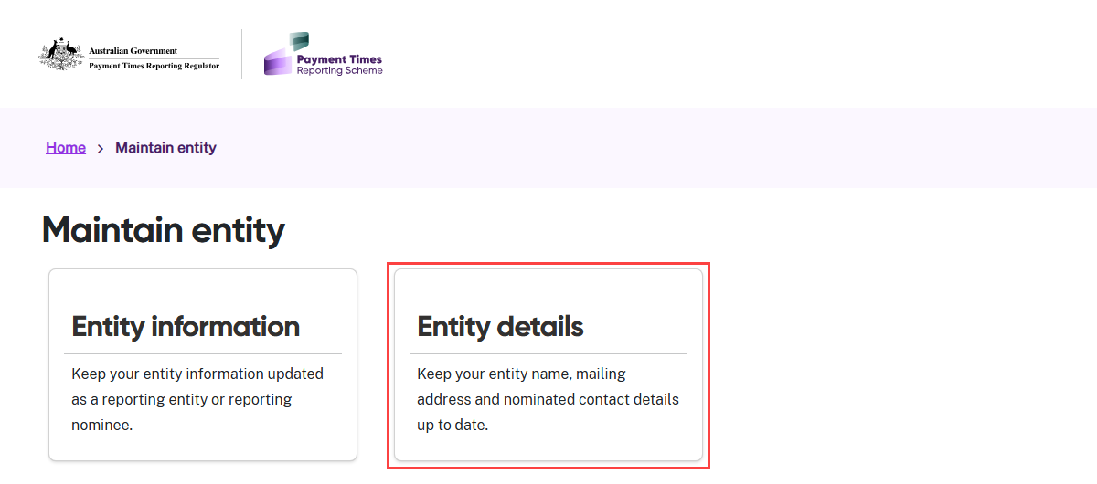
- Select the Entity details tile.

Step 1: Entity details
 | The entity details form will prefill data from the ABR and from previously reported entity details.
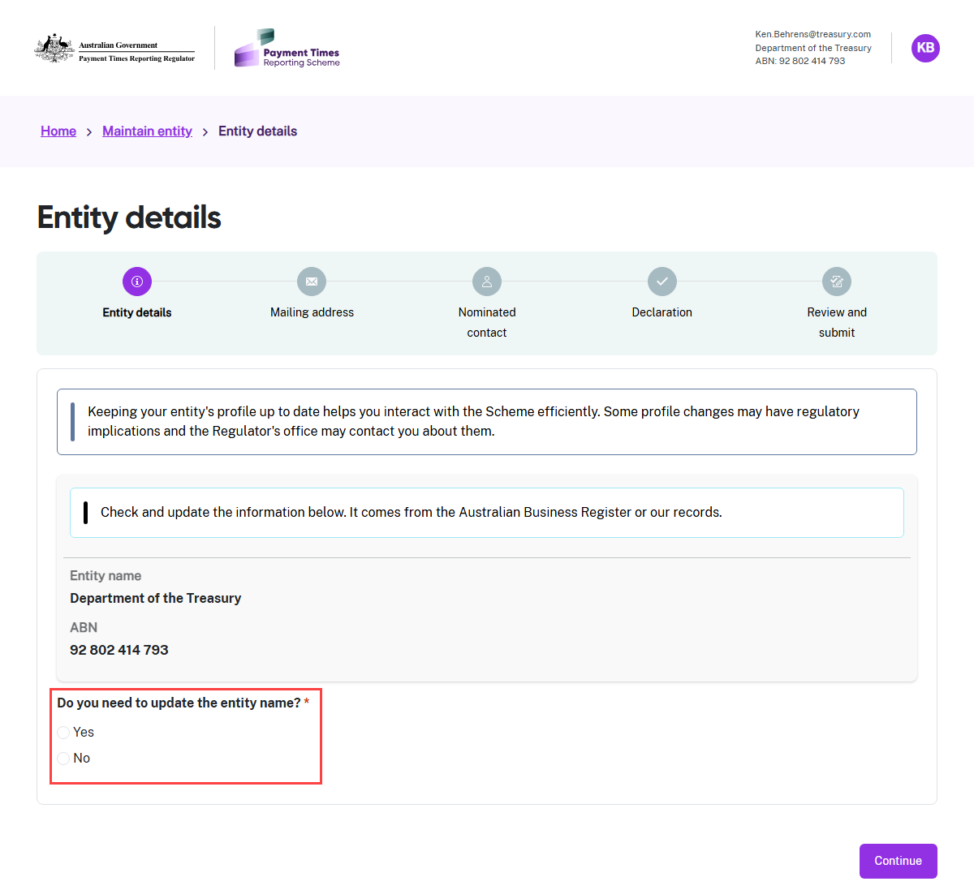
- This page shows the details the portal retrieved from the Australian Business Register (ABR) or our records.
- Check the Entity name and ABN details carefully. Select Yes to update the Entity name, or No if the name is correct.
- Select Continue when you are ready to begin the form.

Step 2: Mailing address
The address reflects the Service of notice address in the Entity details process.
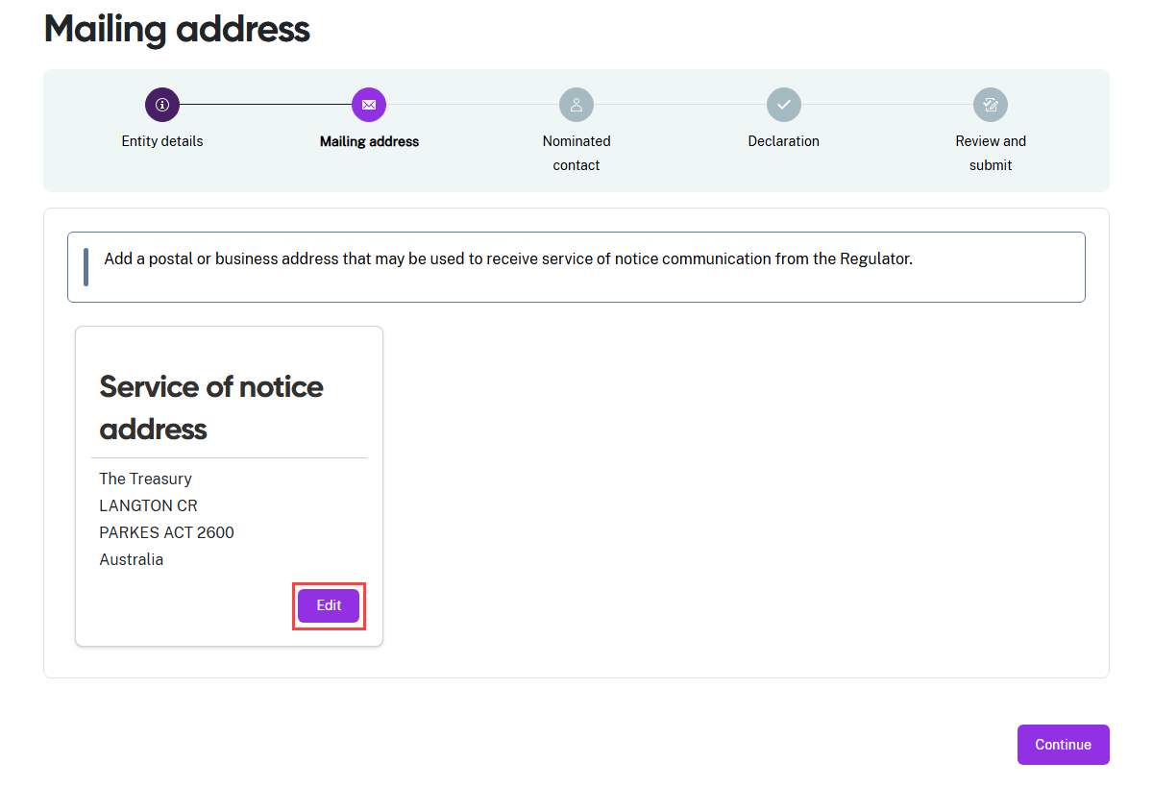
- Check the address information is correct.
- If it is, select Continue and the portal will move you to Step 3: Nominated contact.
- If you need to make a correction, select Edit. A screen with the address fields will slide into view from the right hand side of the screen.
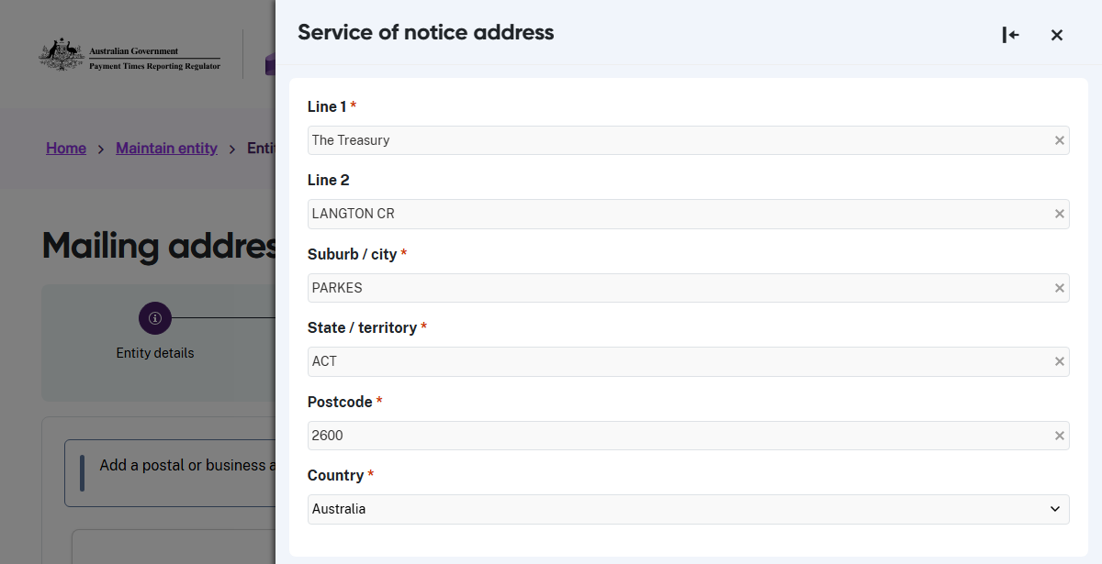
- The mandatory fields are marked with a red asterisk and cannot be left blank.
- Select save when the information is correct and then select Continue.

Step 3: Nominated contact
Every entity must nominate one primary contact. This person serves as the main point of contact for all communications from the Regulator.
 | Your entity must keep nominated contact details up to date.  If the primary contact is unavailable, you need to identify someone else and update the nominated contact details in this form.
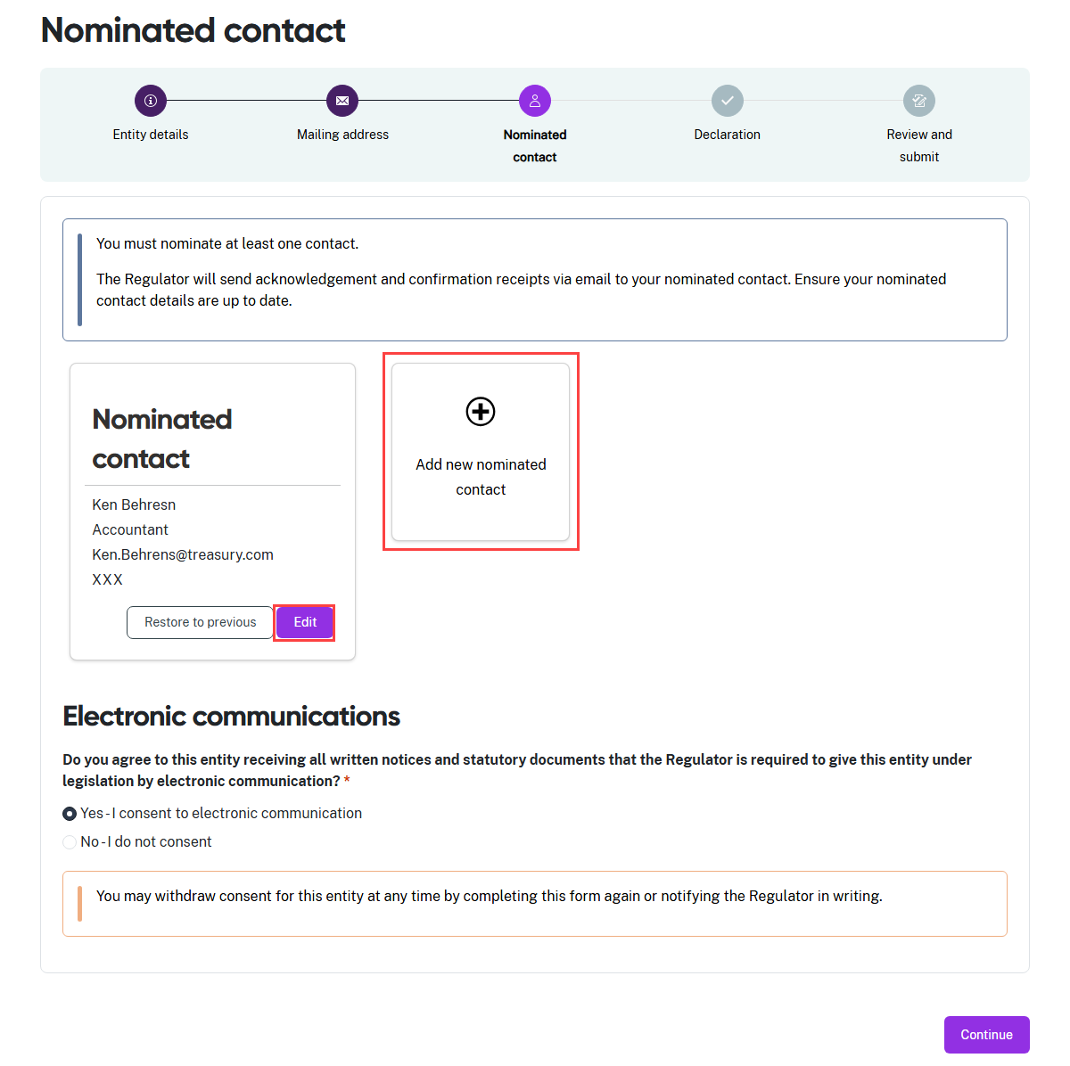
- To update the Nominated contact, select Edit, or to replace the nominated contact, select +Add new…

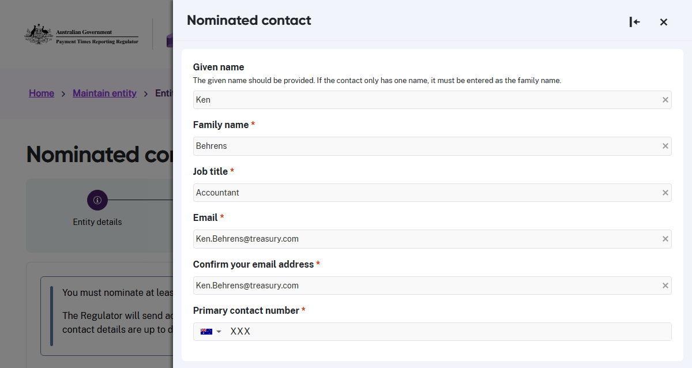
- A screen with the contact information fields will slide into view from the right hand side of the screen.
- After you complete these fields, save the updated information. If you updated a record in error, select Restore to previous during the same session to undo the changes.

All users must answer a new question about receiving electronic communications the first time they log in to the new portal. This question is now clearer and more specific.
You must decide whether you agree to the Regulator sending documents it must provide under legislation (such as notices) electronically by email.
If you do not consent, the Regulator must send these documents by post.

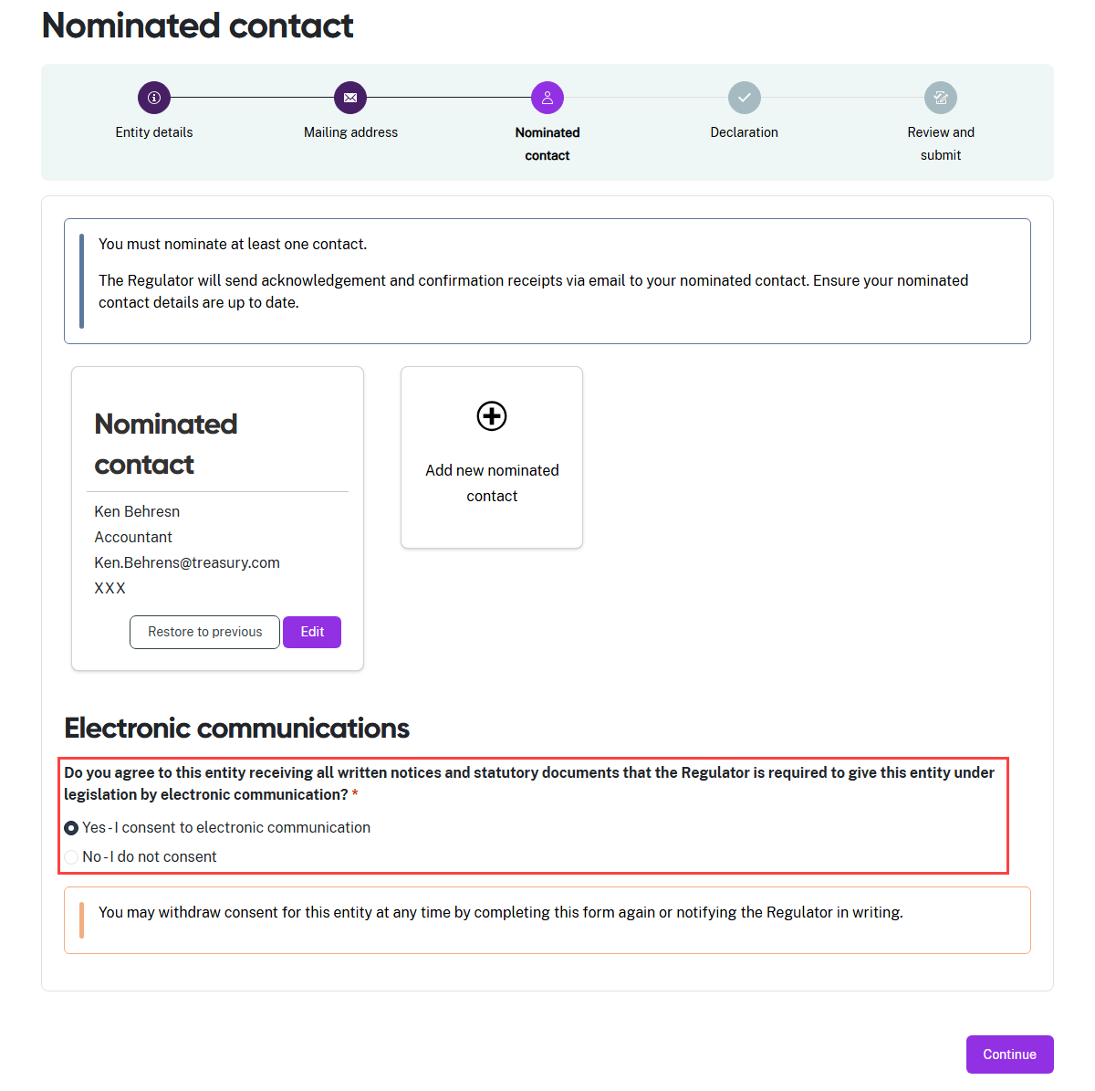
- Read the question asking if you consent to the Regulator sending the documents it must give your entity by email.
- Select Yes if you consent to the Regulator sending documents to your entity by email. You will see an information message pop up to advise that you may withdraw your agreement to use email at any time, and how to communicate this change.
- Select No if you do not agree to your entity receiving these documents by email. You will see an information message pop up to advise that you will receive these documents by post.
- Select Continue to move to Step 4: Declaration.

Step 4: Declaration
The declaration links to the Digital ID credentials you use to log in to the portal.
Read this declaration carefully. You are making a statement that may lead to regulatory action if the information in this form is not true and correct.

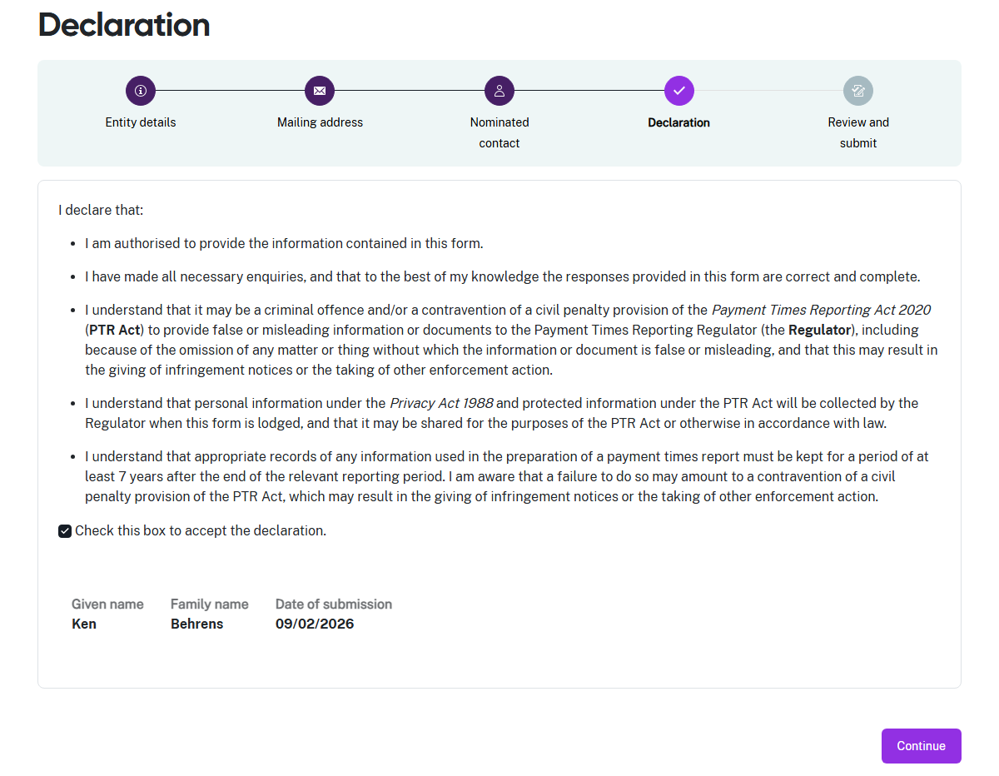
- If you think there may be an error earlier in the form, you can click a circle icon in the progress guide to return to that section of the form.
- Check the declaration box when you are satisfied the information in this form is correct and complete.
- Select Continue to proceed to Step 5: Review and submit.

Step 5: Review and submit
This step lets you review all the information in the form before you submit it to the Regulator.
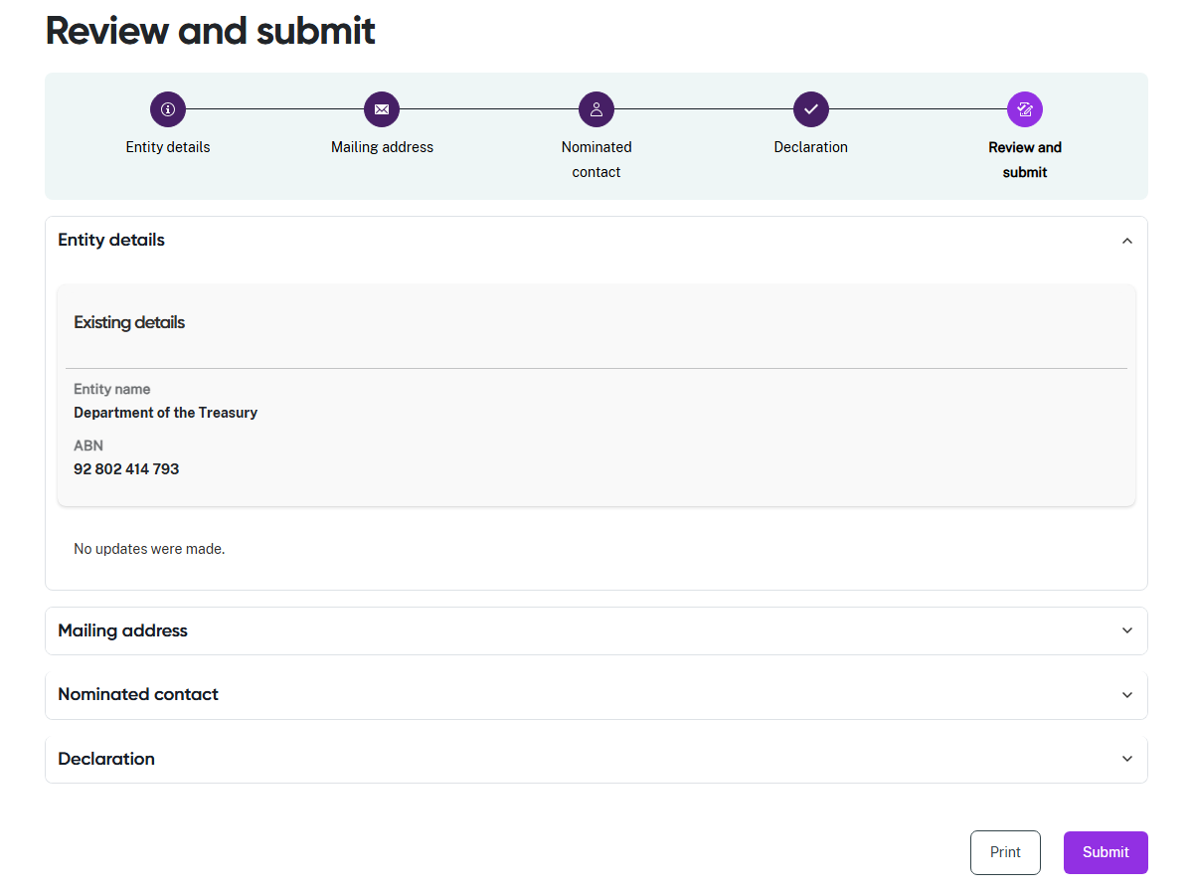
- Review the information in a section by clicking on the down arrow at the right hand side of the section name. Collapse the view of the section by clicking the up arrow.
- Click a circle icon in the progress guide to return to that section of the form if you need to update information.
- Select Print to print a paper copy of the form using a connected printer, or to save a copy as a PDF. The form prints with all sections expanded to show all details.
- Select Submit to close this form and provide your Entity details to the Regulator.

