User Guide: Correcting the SBI Tool
Read Information sheet 6: Small Business Identification (SBI) Tool to understand the different circumstances that may trigger updates to the SBI Tool. This guide explains the step-by-step process to request a correction to the SBI Tool.
The SBI Tool is only available through the portal. To access the portal you need a Digital ID and authorisation from your entity in Relationship Authorisation Manager to act on its behalf for payment times reporting.
For more information, see Help and support to use the portal on the Regulator’s website.
Version 1.0

Revision history
Version | Date | Description
1.0 | 16 Feb 2026 | Initial version with release of new portal.

Contents
Navigate to Notification to correct the SBI tool 2
Step 1: Enter the list of ABNs 3
Step 2: Provide supporting evidence 4
Step 3: Declaration 6
Step 4: Review and submit 7
Step 5: View submitted SBI Tool notices 7

Navigate to Notification to correct the SBI tool
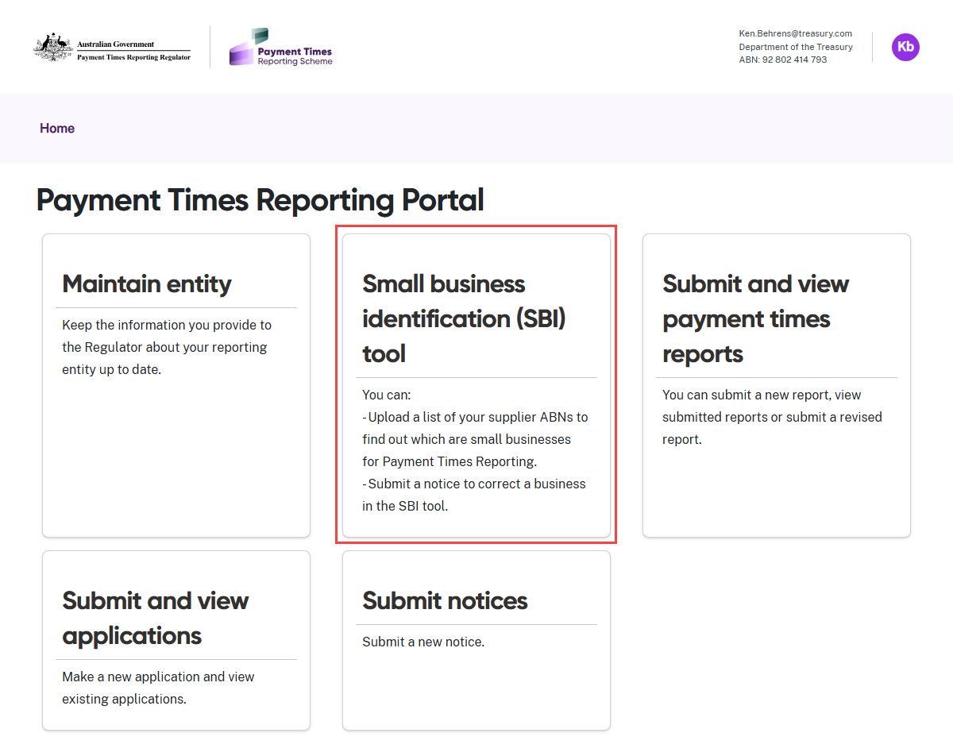
- Select the Small Business Identification (SBI) Tool tile from the Home screen.
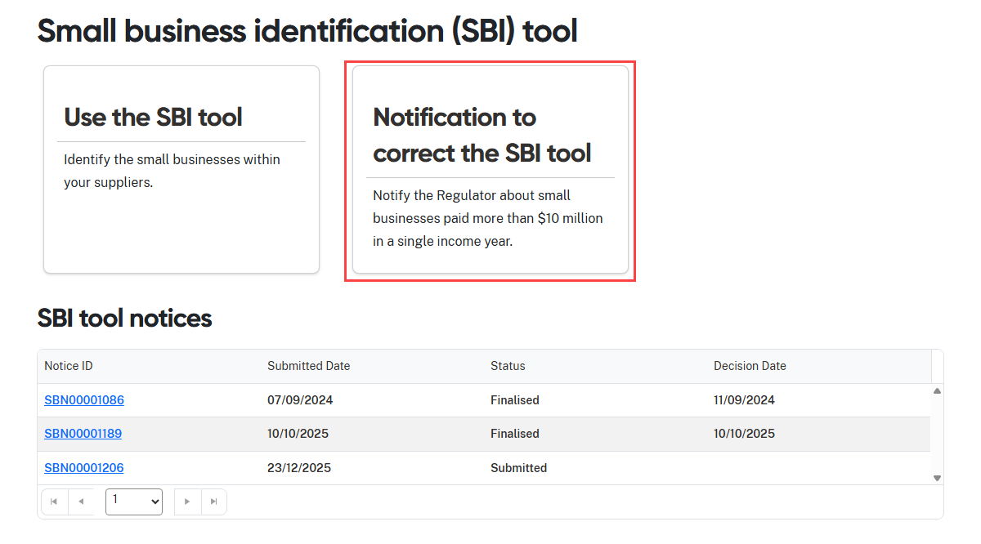
- Select the Notification to correct the SBI Tool tile.

Step 1: Enter the list of ABNs
When you review the SBI Tool output file, you may consider that the tool has incorrectly classified one or more ABNs as small businesses.
This step lets you enter ABNs you believe are not small businesses.
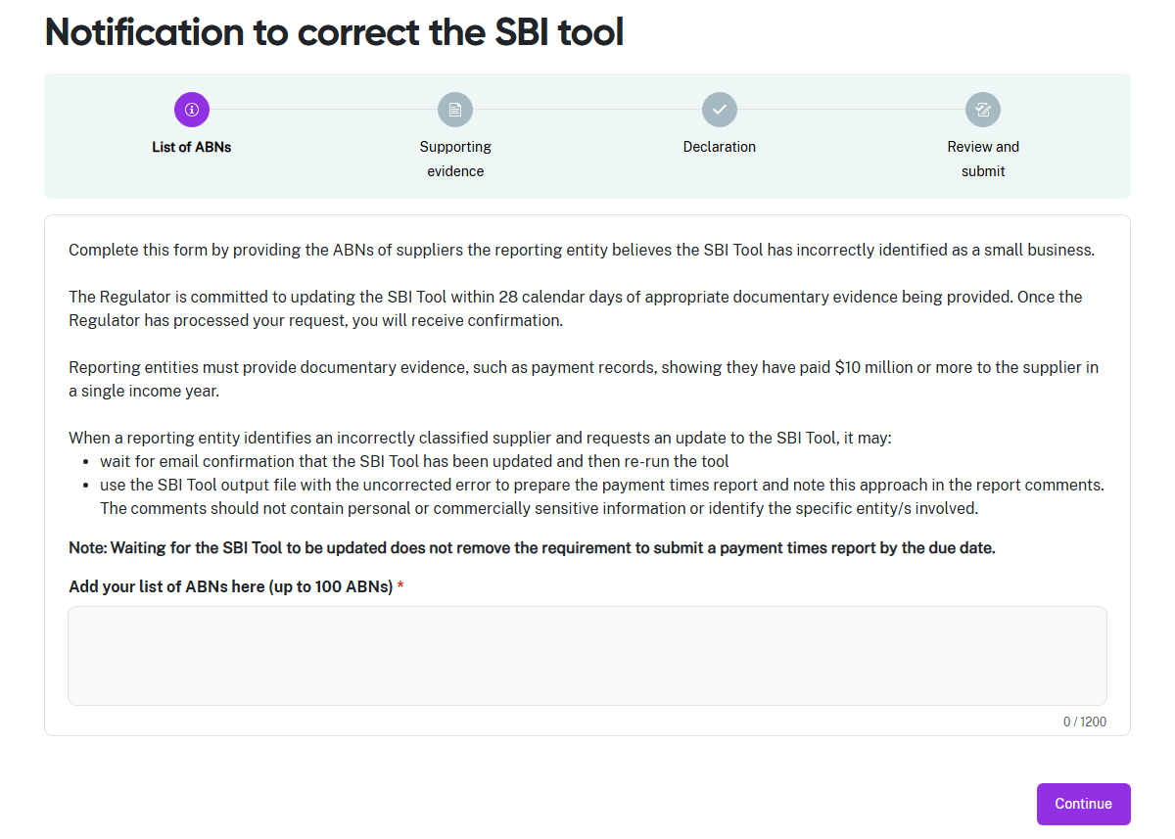
- Enter the ABNs you believe are incorrectly classified as small businesses in the field. You can type them in, or copy and paste up to 100 ABNs at a time in a notice. Each ABN must be on a new line.
- When the ABNs are in the field, select Continue.

Step 2: Provide supporting evidence
You must provide the Regulator with supporting evidence.
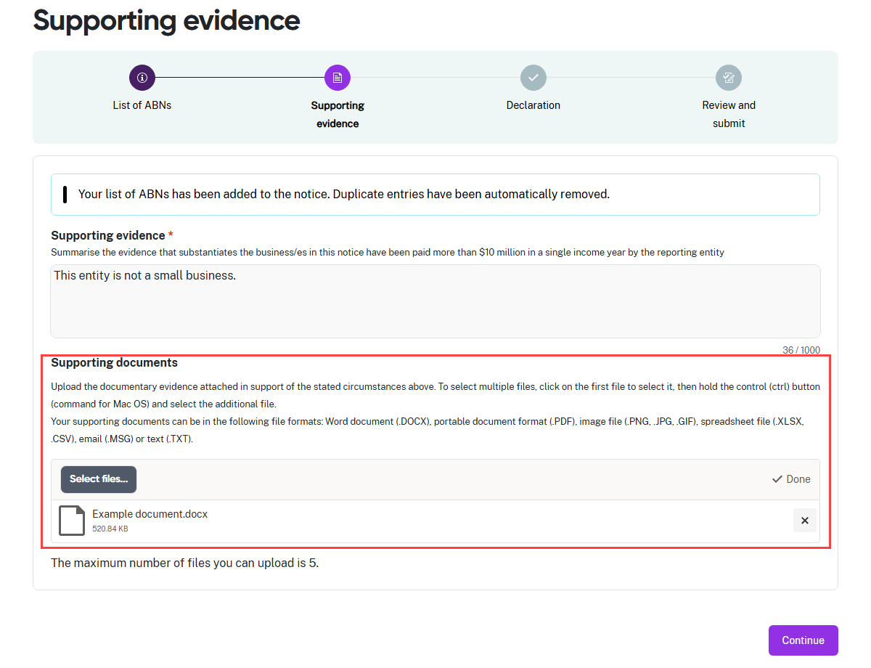
- The portal displays a confirmation message that it has added the valid ABNs you entered in the previous step to the notice.
- In the Supporting evidence free-text field, enter a summary of the evidence you are providing to support your position that these ABNs are not small businesses.
- You may upload up to 5 documents in support of your request to correct the SBI Tool.
- Click Select files… to launch your file directory. The upload process is the same as shown in User Guide: Using the SBI Tool.
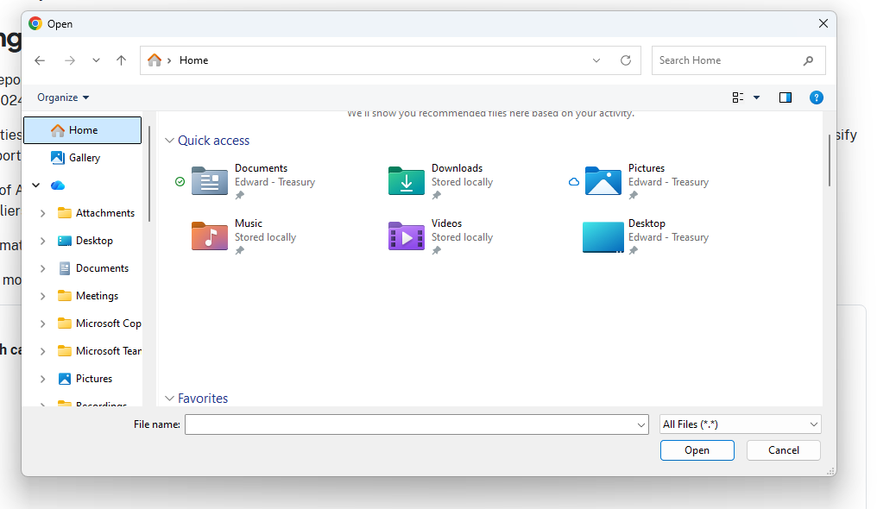
- Navigate through your folder structure to find your file.
- You can upload up to 5 files at once. Select the required file/s and select Open to upload the document/s.
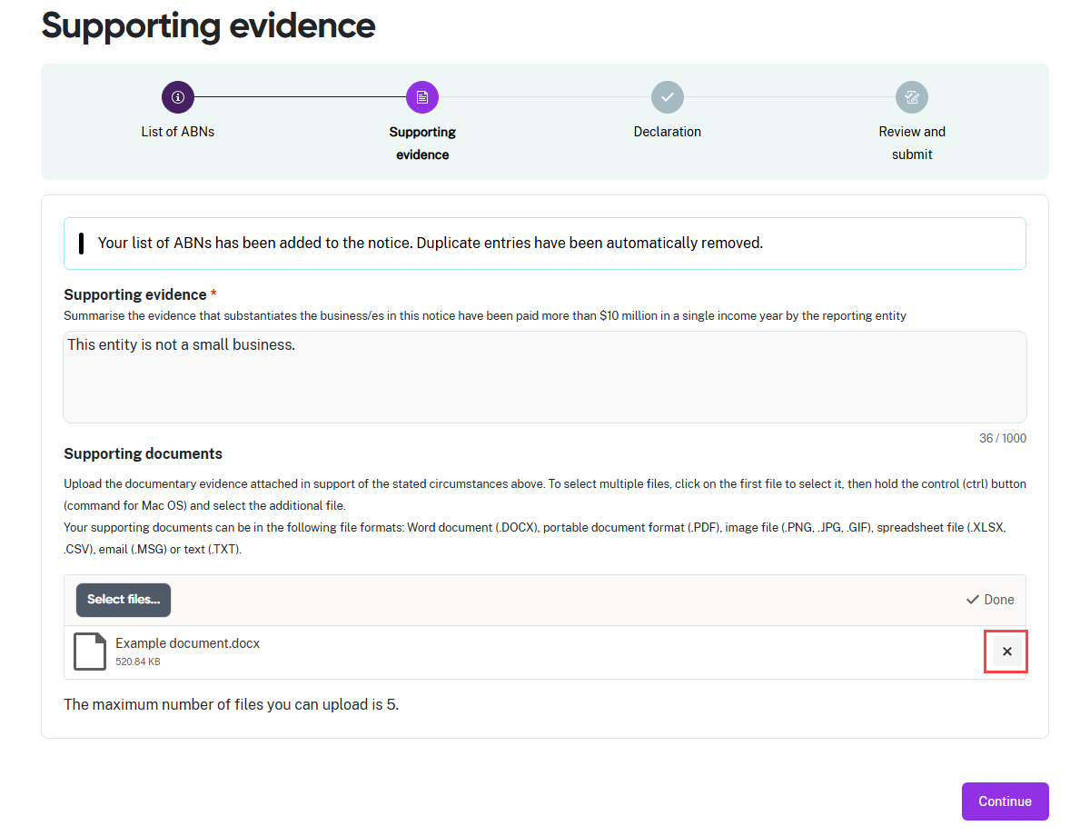
- If you upload the wrong document, select the X to remove it.
- When you attach the correct files to the notice, select Continue.

Step 3: Declaration
The declaration links to the Digital ID credentials you use to log in to the portal.
 | Read this declaration carefully. You are making a statement that may lead to regulatory action if the information in this form is not true and correct.

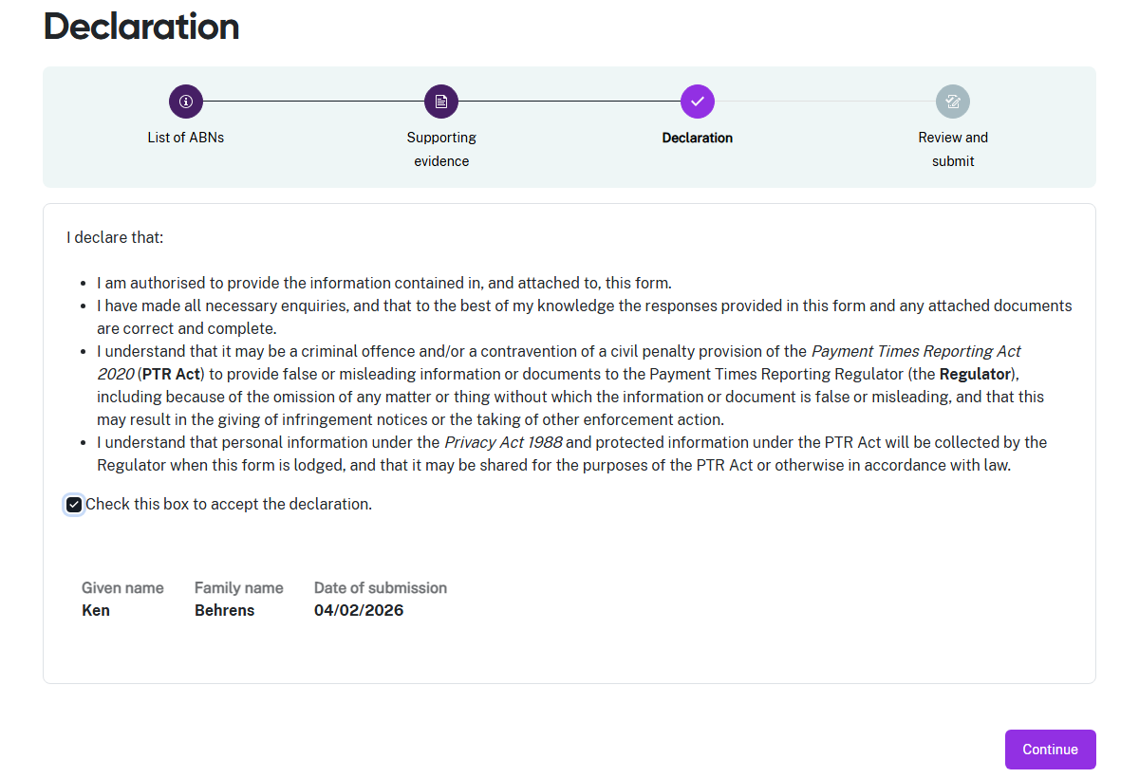
- If you think there may be an error earlier in the form, you can click a circle icon in the progress guide to return to that section of the form.
- Check the declaration box when you are satisfied the information in this form is correct and complete.
- Select Continue to proceed to Step 5: Review and submit.

Step 4: Review and submit
This step lets you review all the information in the form before you submit it to the Regulator.
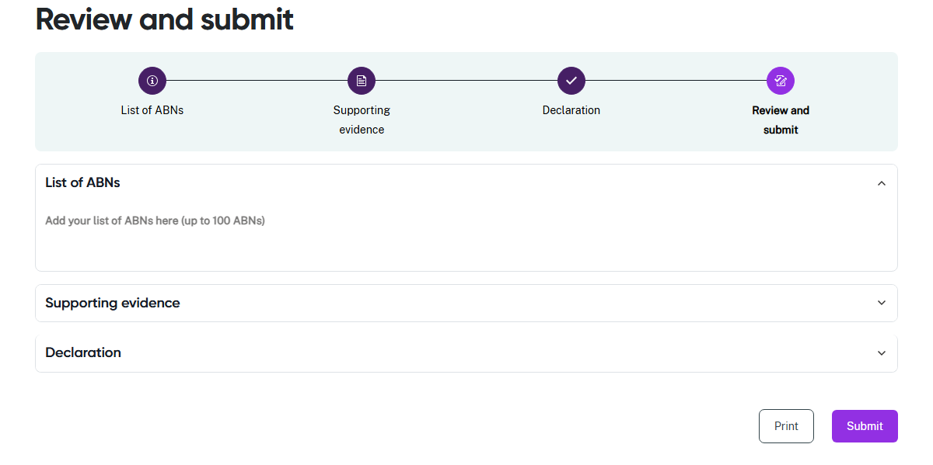
- Review the information in a section by clicking on the down arrow at the right hand
side of the section name. Collapse the view of the section by clicking the up arrow.
- Click a circle icon in the progress guide to return to that section of the form if you
need to update information.
- Select Print to print a paper copy of the form using a connected printer, or to save
a copy as a PDF. The form prints with all sections expanded to show all details.
- Select Submit to close this form and provide your entity information to the Regulator.

Step 5: View submitted SBI Tool notices
You can see information about your submitted notices to correct the SBI Tool under the
tiles, including their current status so you can track their progress.
