User Guide: Apply for more time to
report
This guide outlines the step-by-step processes in the portal to submit an application to the Regulator for an extension of time to report.
For information about the applications available to you, visit the Guidance resources on the website.
To access the portal you need a Digital ID and authorisation from your entity in Relationship Authorisation Manager to act on its behalf for payment times reporting.
For more information, see Help and support to use the portal on the Regulator’s website.
Version 1.0

Revision history
Version | Date | Description
1.0 | 16 Feb 2026 | Initial version with release of new portal.

Contents
Application for an extension of time - single 2
Navigate to Submit and view applications 2
Step 1: Before you start 3
Step 2: Entity details 4
Step 3: Report details 5
Step 4: Reason for extension 6
Step 5: Declaration 9
Step 6. Review and submit 10
Application for an extension of time - modifiable 11
Navigate to Submit and view applications 11
Step 1: Before you start 12
Step 2: Entity details 13
Step 3: Report details 14
Step 4. Reason for extension 15
Step 5: Declaration 17
Step 6: Review and submit 18

Application for an extension of time - single

Navigate to Submit and view applications
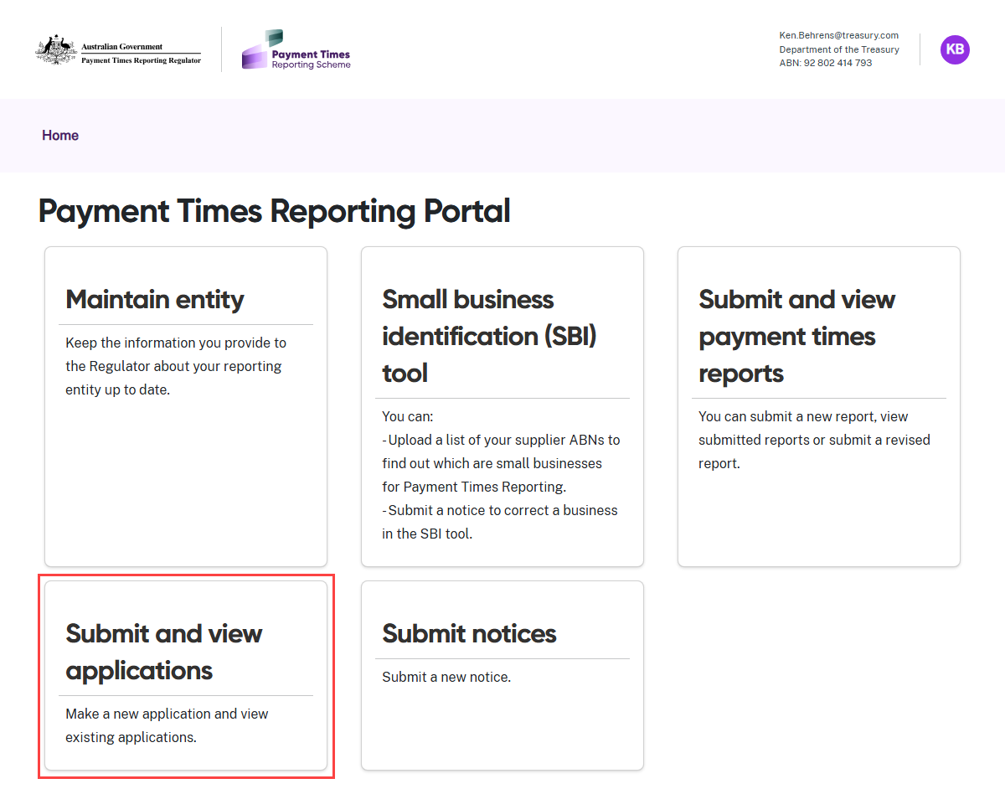
- Select the Submit and view applications tile from the Home screen.

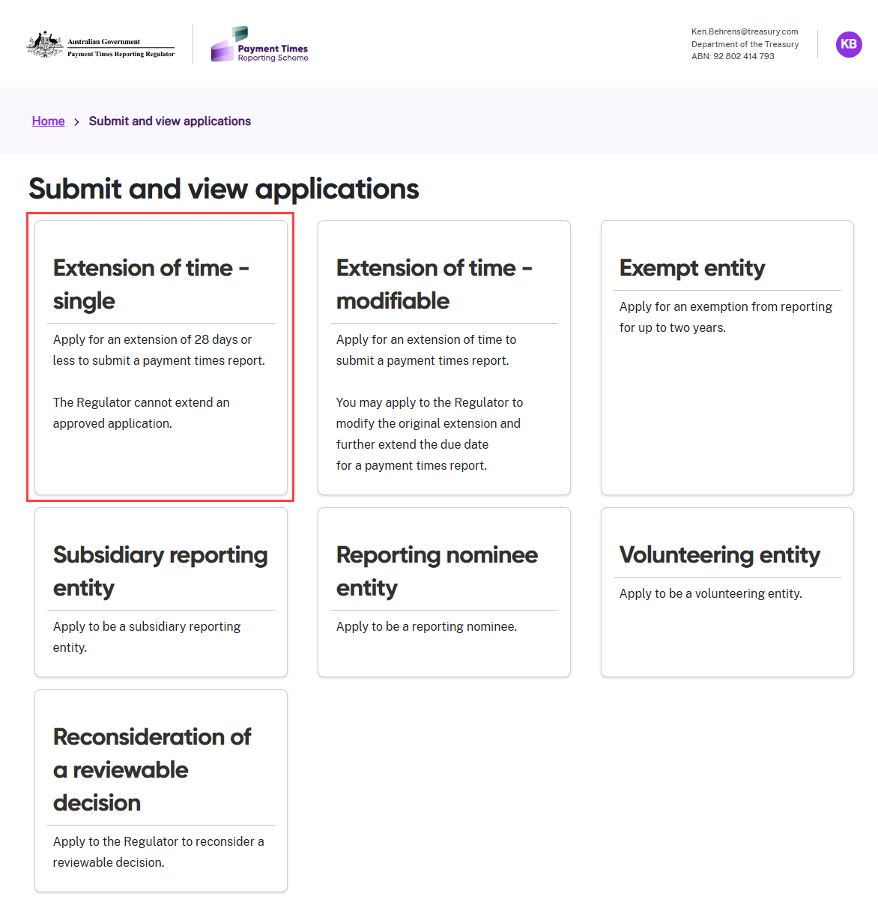
- Select the Extension of time - single tile.

Step 1: Before you start
Consider your circumstances carefully to confirm that this application type is right for your entity. Consult the Guidance materials or seek legal advice if you need help deciding.
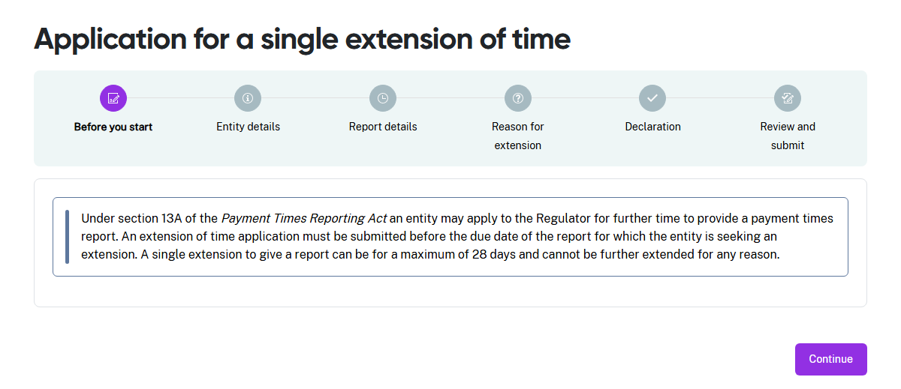

Step 2: Entity details
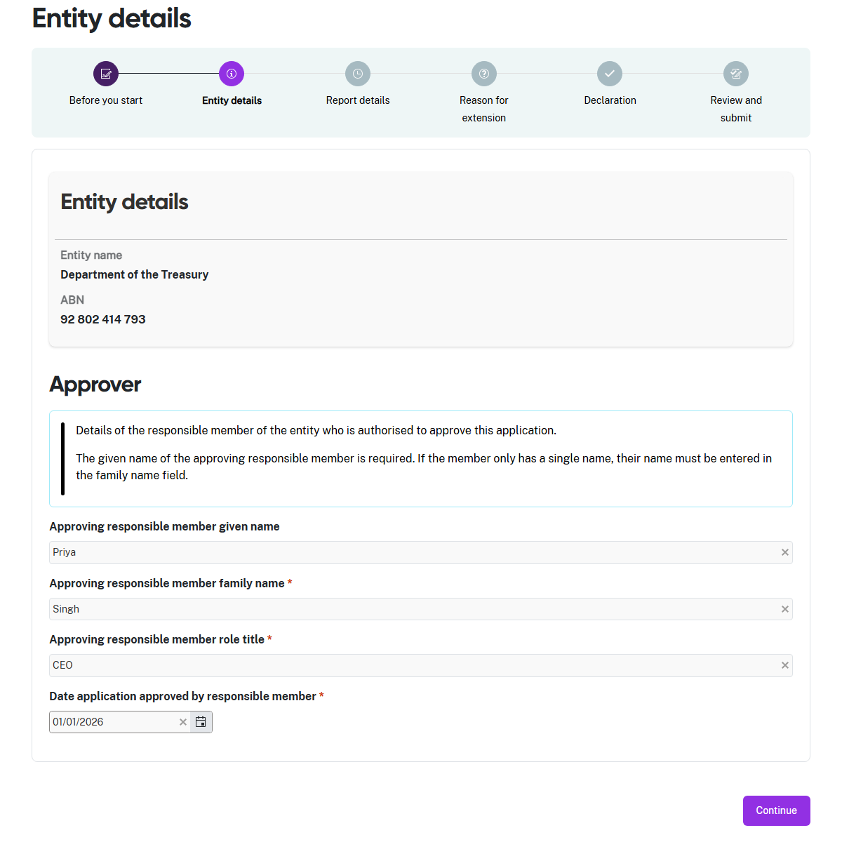
- Enter the Given name of the responsible member for your entity. The responsible member is a person with the authority to approve the information in this application.
- Enter the Family name of the responsible member for your entity.
- Enter the Role title of the responsible member for your entity.
- Enter the date the responsible member approved this application, then select Continue.

Step 3: Report details
In this step, enter the reporting period for which you are requesting an extension of time to report.
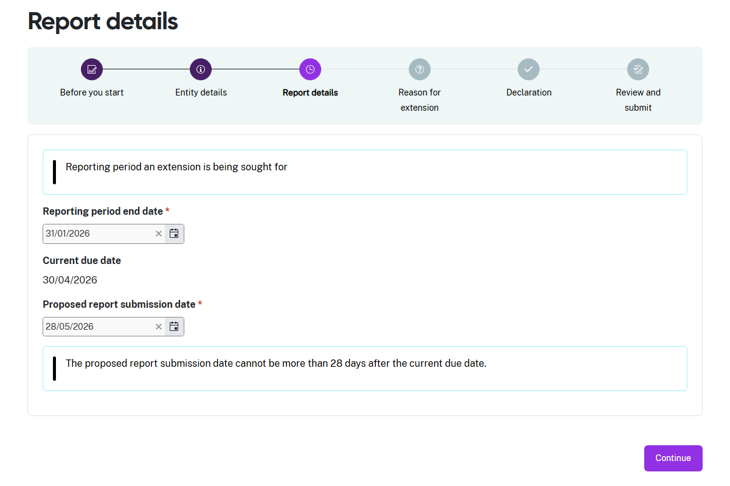
- Enter the End date of the reporting period for which you are requesting an extension.
- Enter the Date you propose to submit the report for this reporting period. For this type of application, you cannot propose a date more than 28 calendar days after the due date for this reporting period.
- Select Continue to move to the next step.

Step 4: Reason for extension
You must explain the circumstances that caused your entity to apply for extra time to report.
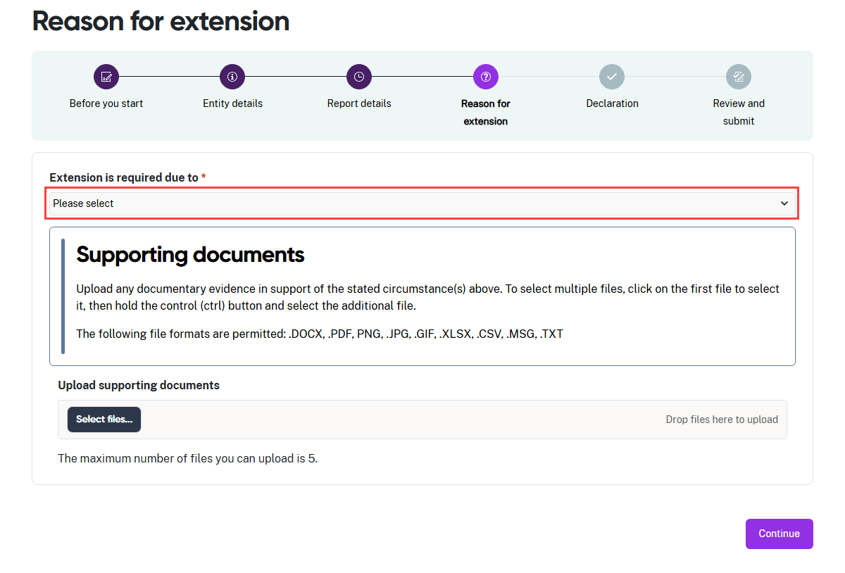
- The drop-down list displays some common circumstances an entity may experience
to cause them to apply for more time to report.
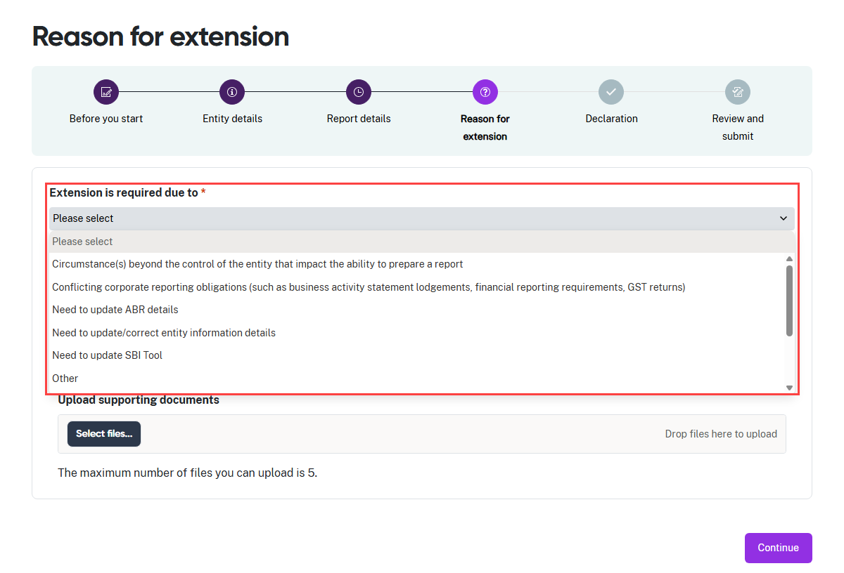
- Select the reason your entity needs an extension of time to report.
- Select Other if the listed circumstances do not describe the reason your entity is
applying for an extension.

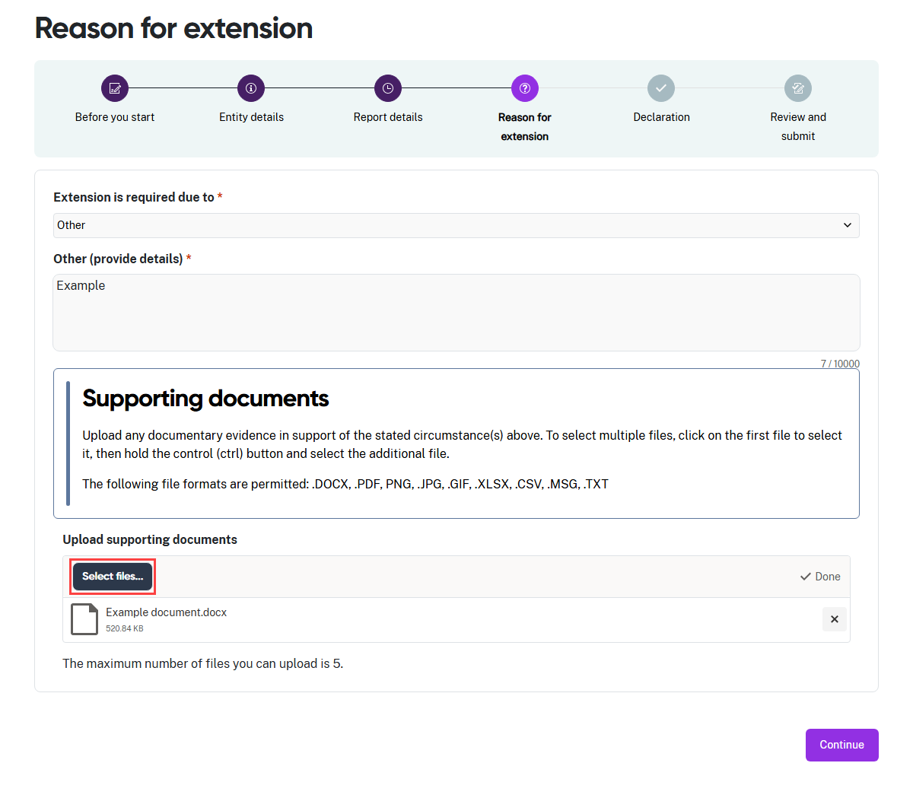
- If you selected Other, you must provide details explaining why your entity needs an extension of time to report.
- You have the option to upload documentary evidence in support of your entity’s application. Read the information in the Supporting documents section of this step carefully before uploading any documents.
- Click Select files… to launch your file directory.
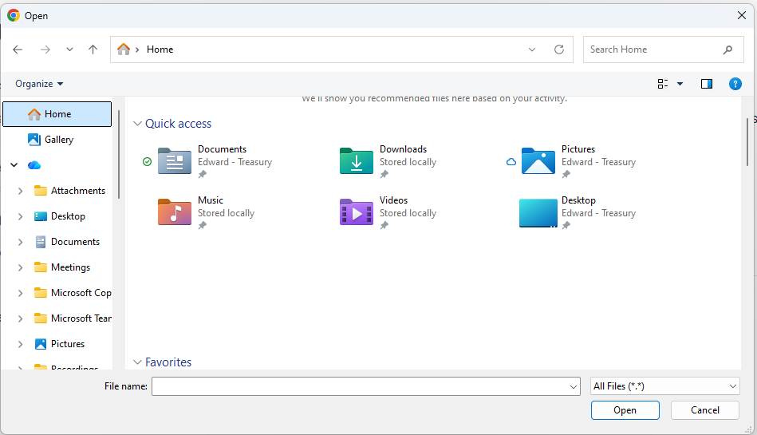
- Navigate through your folder structure to find your file or files.
- You can upload up to 5 files. Select the required file/s and select Open
to upload the document/s.
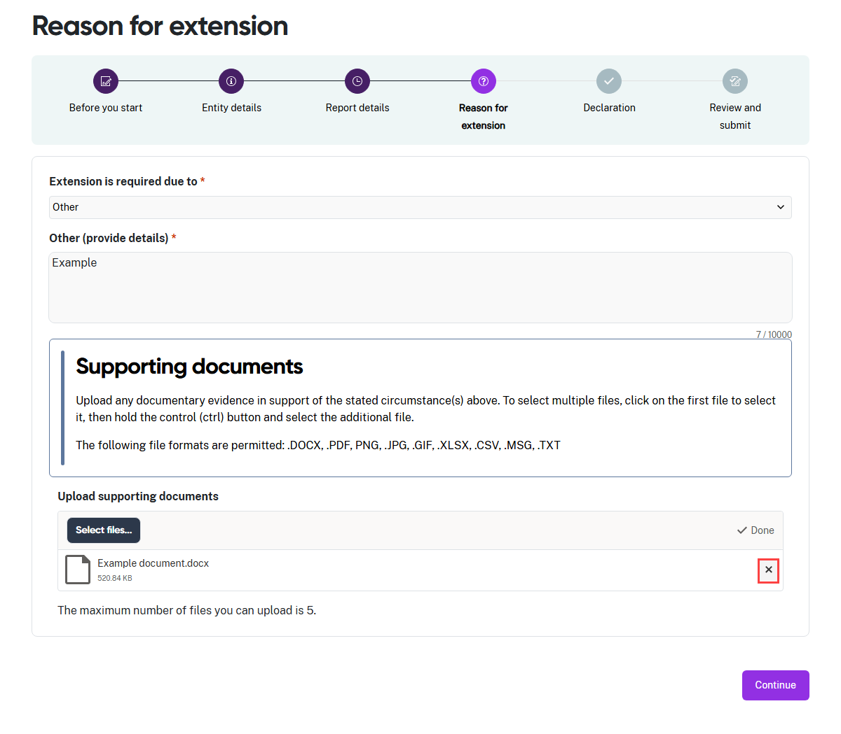
- Your files will display in the window.
- If you upload the wrong document, select the X to remove it.
- After you attach the correct files to the application, select Continue.

Step 5: Declaration
The declaration links to the Digital ID credentials you use to log in to the portal.
 | Read this declaration carefully. You are making a statement that may lead to regulatory action if the information in this form is not true and correct.

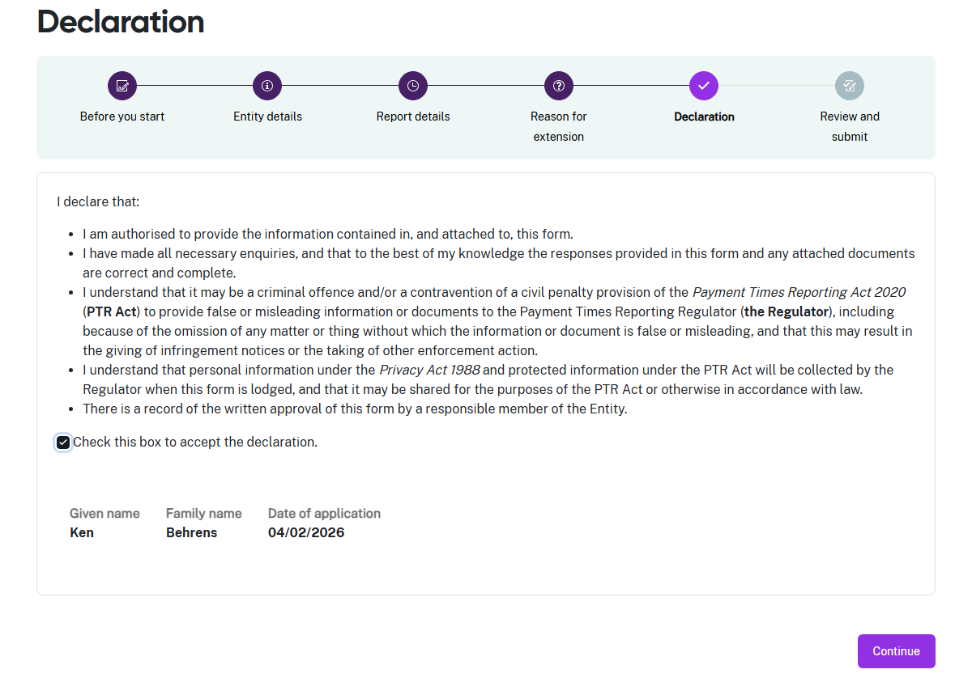
- If you think there may be an error earlier in the application form, you can click a circle icon in the progress guide to return to that section of the form.
- Check the declaration box when you are satisfied the information in this application form is correct and complete.
- Select Continue to proceed to Step 6: Review and submit.

Step 6. Review and submit
This step lets you review all information in the application form before you submit it.
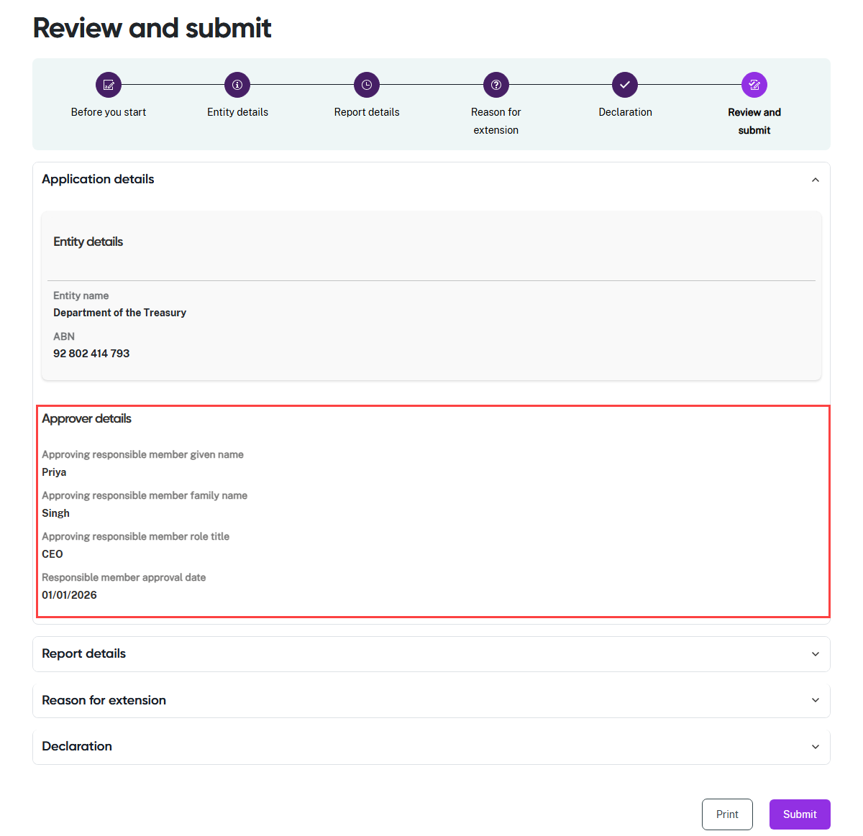
- Review the information in a section by clicking on the down arrow at the right hand side of the section name. In this example, the Approver details section is expanded to show the summary details displayed by the portal.
- Collapse the view of the section by clicking the up arrow.
- Click a circle icon in the progress guide to return to that section of the application form if you need to update information.
- Select Print to print a paper copy of the form using a connected printer, or to save
a copy as a PDF. The form prints with all sections expanded to show all details.
- Select Submit to close this form and submit your entity’s application to the Regulator.

Application for an extension of time - modifiable

Navigate to Submit and view applications
- Select the Submit and view applications tile from the Home screen.

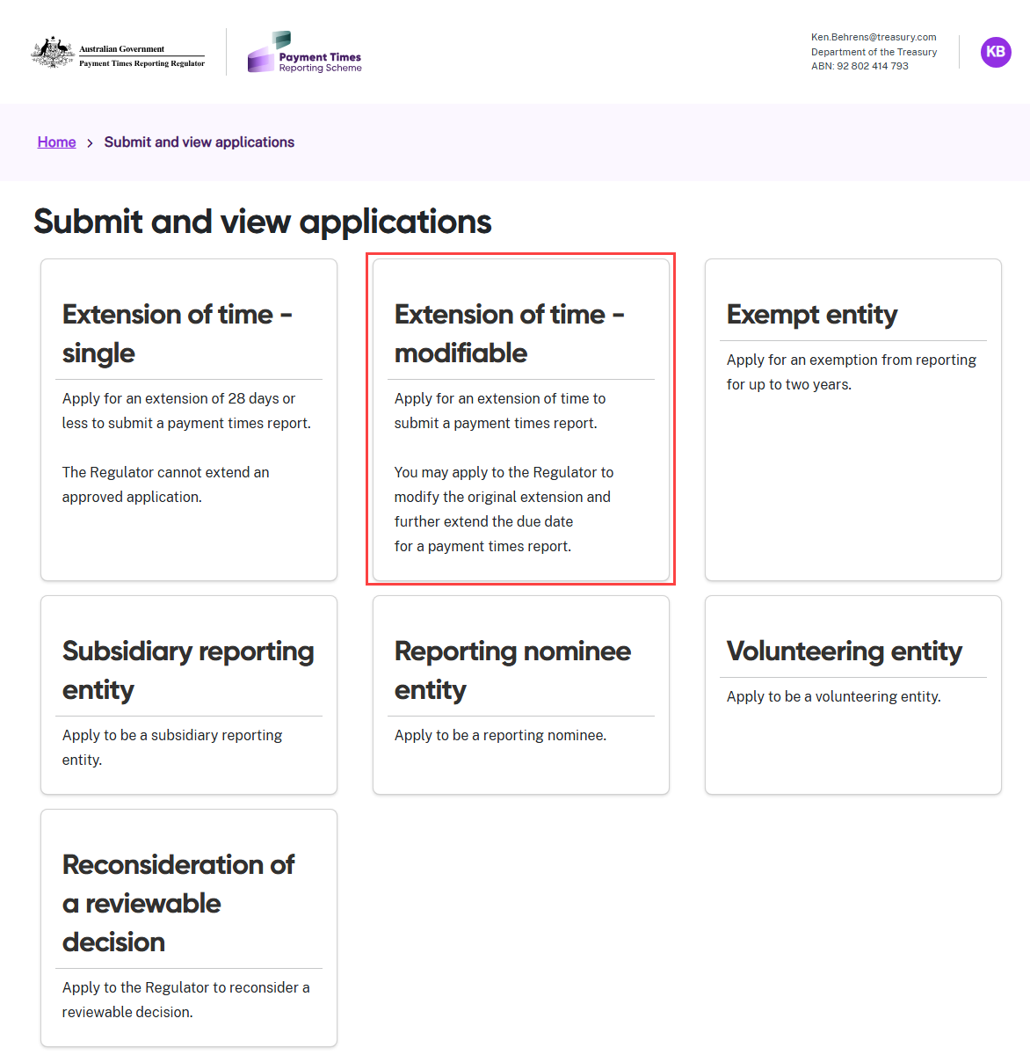
- Select the Extension of time - modifiable tile.

Step 1: Before you start
Consider your circumstances carefully to confirm that this application type is right for your entity. Consult the Guidance materials or seek legal advice if you need help deciding.
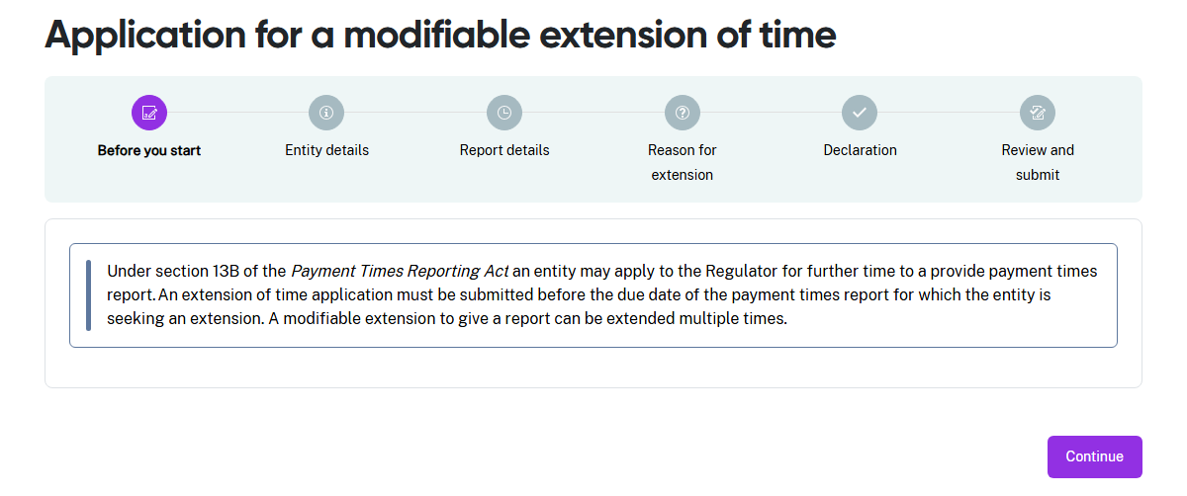

Step 2: Entity details
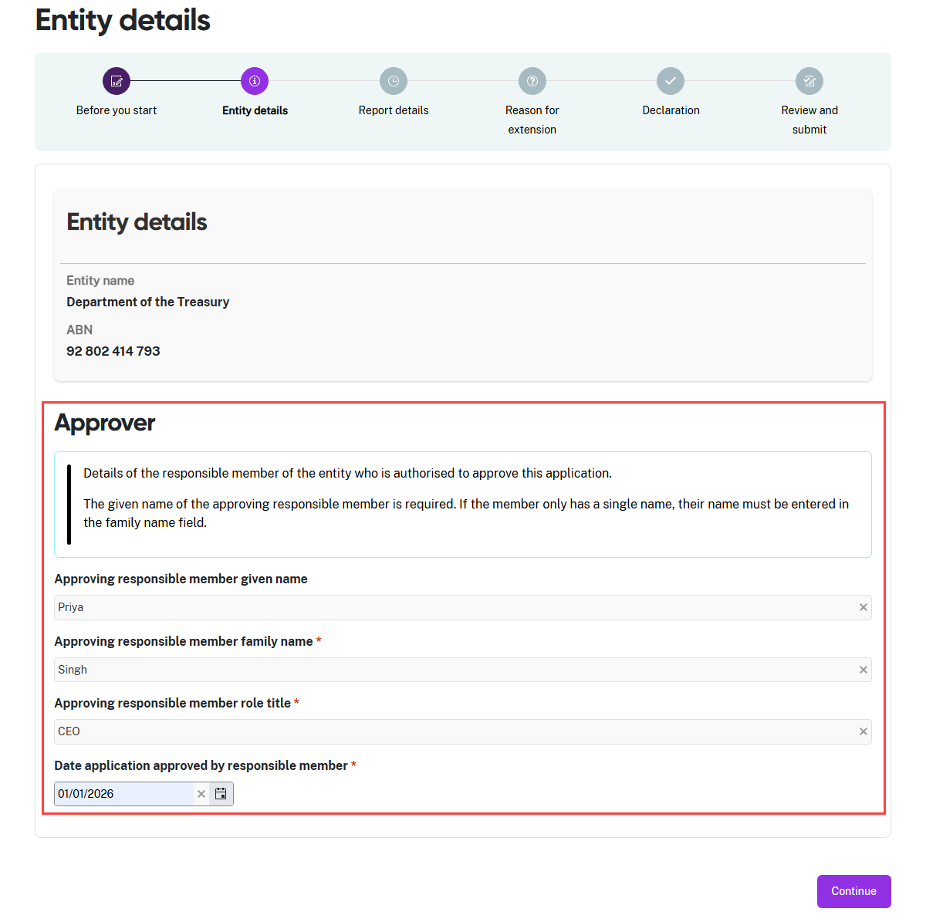
- Enter the Given name of the responsible member for your entity. The responsible member is a person with the authority to approve the information in this application.
- Enter the Family name of the responsible member for your entity.
- Enter the Role title of the responsible member for your entity.
- Enter the date the responsible member approved this application, then select Continue.

Step 3: Report details
In this step, enter the reporting period for which you are requesting an extension of time to report.
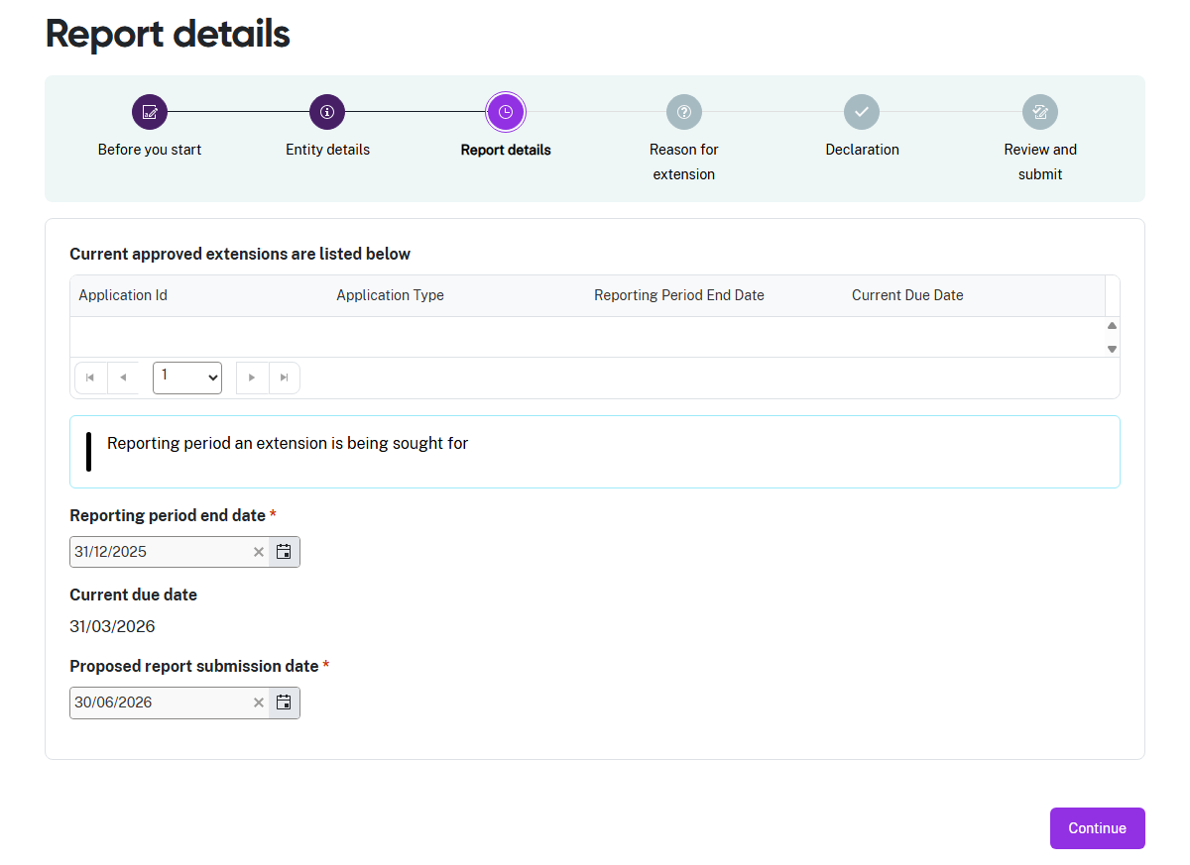
- The portal displays any current approved extensions in the table.
- Enter the End date of the reporting period for which you are requesting an extension.
- Enter the Date you propose to submit the report for this reporting period.
- Select Continue to move to the next step.

Step 4. Reason for extension
You must explain the circumstances that caused your entity to apply for extra time to report.
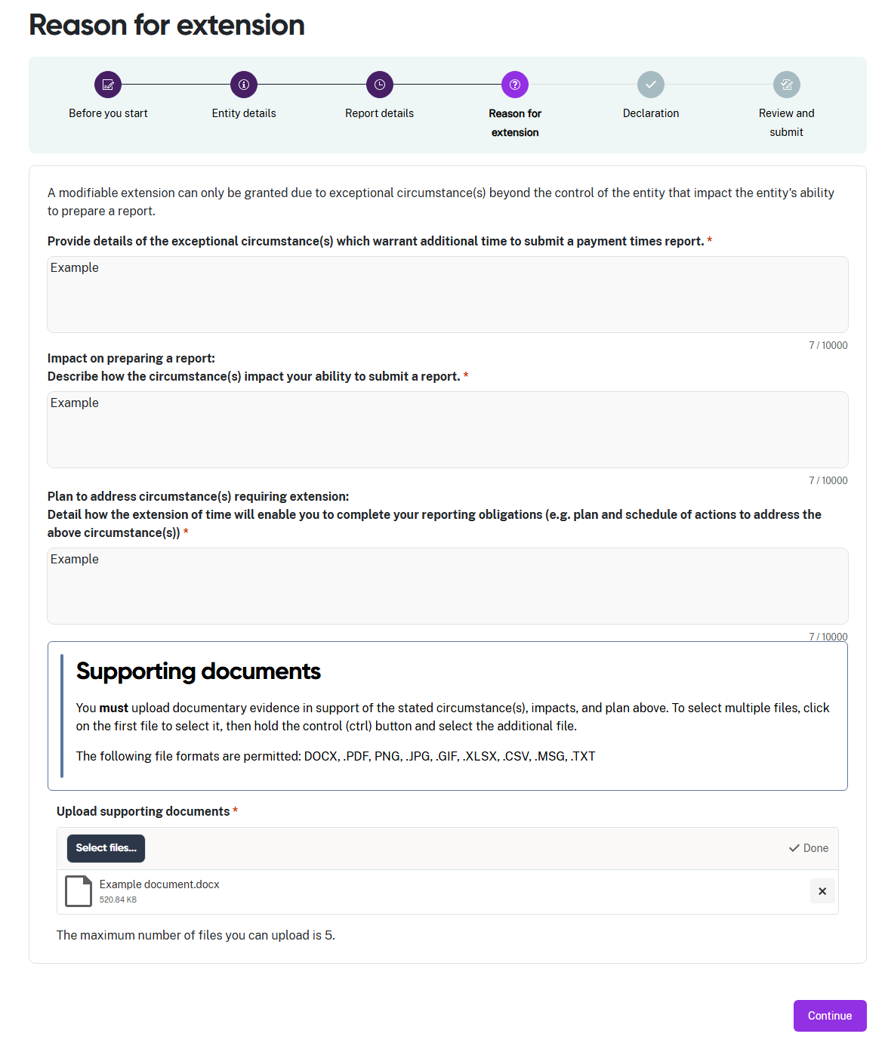
- Read the information about modifiable extensions on this page of the application form carefully.
- All fields in this step are mandatory fields and are marked with a red asterisk. They cannot be left blank.
- Enter the details of the exceptional circumstance(s) that justify additional time for your entity to report.
- Enter a description of how these circumstance(s) impact your entity’s ability to report.
- Enter details of how an extension of time to report will enable your entity to meet their reporting obligations.
- You must upload documentary evidence in support of your entity’s application for a modifiable extension of time to report.
- Read the information in the Supporting documents section of this step carefully before uploading any documents.
- Click Select files… to launch your file directory.

- Navigate through your folder structure to find your file or files.
- You can upload up to 5 files. Select the required file/s and select Open
to upload the document/s.
- Your files will display in the window.
- If you upload the wrong document, select the X to remove it.
- After you attach the correct files to the application, select Continue.

Step 5: Declaration
The declaration links to the Digital ID credentials you use to log in to the portal.
Read this declaration carefully. You are making a statement that may lead to regulatory action if the information in this form is not true and correct.

- If you think there may be an error earlier in the application form, you can click a circle icon in the progress guide to return to that section of the form.
- Check the declaration box when you are satisfied the information in this application form is correct and complete.
- Select Continue to proceed to Step 6: Review and submit.

Step 6: Review and submit
This step lets you review all information in the application form before you submit it.
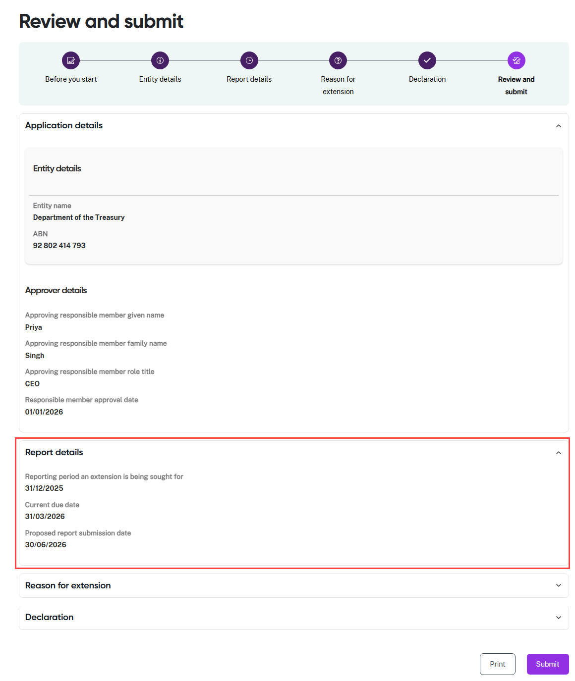
- Review the information in a section by clicking on the down arrow at the right hand side of the section name. In this example, the Approver details and Report details sections are expanded to show the summary details displayed by the portal.
- Collapse the view of the section by clicking the up arrow.
- Click a circle icon in the progress guide to return to that section of the application form if you need to update information.
- Select Print to print a paper copy of the form using a connected printer, or to save
a copy as a PDF. The form prints with all sections expanded to show all details.
- Select Submit to close this form and submit your entity’s application to the Regulator.

