

Regulator’s Update
  - January 2026

© Commonwealth of Australia 2026
ISBN: 978-1-923278-36-3
This publication is available for your use under a Creative Commons Attribution 4.0 International licence, with the exception of the Commonwealth Coat of Arms, the Treasury logo, photographs, images, third party materials, materials protected by a trademark, signatures and where otherwise stated. The full licence terms are available from creativecommons.org/licenses/by/4.0/legalcode.
Use of Treasury material under a Creative Commons Attribution 4.0 International licence requires you to attribute the work (but not in any way that suggests that the Treasury endorses you or your use of the work).
Treasury material used ‘as supplied’
Provided you have not modified or transformed Treasury material in any way including, for example, by changing the Treasury text; calculating percentage changes; graphing or charting data; or deriving new statistics from published Treasury statistics – then Treasury prefers the following attribution:
Source: The Commonwealth of Australia.
Derivative material
If you have modified or transformed Treasury material, or derived new material from those of the Treasury in any way, then Treasury prefers the following attribution:
Based on Commonwealth of Australia data.
Use of the Coat of Arms
The terms under which the Coat of Arms can be used are set out on the Department of the Prime Minister and Cabinet website
(see www.pmc.gov.au/government/commonwealth-coat-arms).
Other uses
Enquiries regarding this licence and any other use of this document are welcome at:
Manager
Media Unit
The Treasury
Langton Crescent
Parkes ACT 2600
Email: media@treasury.gov.au
In the spirit of reconciliation, the Treasury acknowledges the Traditional Custodians of country throughout Australia and their connections to land, sea and community. We pay our respect to their Elders past and present and extend that respect to all Aboriginal and Torres Strait Islander peoples.

Contents
Letter from the Regulator 1
The Regulator’s priority areas 3
Engagement and education 8
Purposeful stakeholder engagement 9
How the Regulator is helping you 11
Regulator’s forward engagement program 13
Research and intelligence 14
Key payment times reporting measures 15
Data snapshot 17
Data insights 18
Industry insights 27
Industry focus 31
Commonwealth procurement 34
Compliance and enforcement 35
Compliance and enforcement update 36
Fast small business payer 40
Slow small business payer 42
Small Business Identification (SBI) Tool 44
Applications 46
Tips to avoid common errors 47
Appendix A – Insights: methodology and assumptions 52
Appendix B – Data tables 54

Letter from the Regulator

It gives me great pleasure to share with you the Regulator’s Update for January 2026.
Firstly, I acknowledge the Traditional Owners and Custodians of Country throughout Australia and recognise their continued connection to the lands, waterways and skies. I pay my respect to Elders past, present and emerging. In the spirit of reconciliation, I also extend my respect to all non-Indigenous Australians.
Over the past year I have focused on implementing the Australian Government’s reforms to the Payment Times Reporting Scheme (the Scheme). With these reforms now largely implemented, this Update provides an opportunity to report on our regulatory work, reflect on our achievements over the past year and outline my priorities for 2026.
The Scheme is not just about compliance – it is about shaping a culture of fairness that benefits Australia’s economy. Large businesses and Commonwealth entities have the power to set the standard and lead the way in fair payment practices for small businesses.
Commonwealth entities are expected to play a leadership role in demonstrating timely payment practices and fostering a culture of prompt payment. Corporate Commonwealth entities and Commonwealth companies have obligations under the Scheme and are not treated any differently from any other reporting entity. Recent analysis of reported data from these Commonwealth entities highlights areas of strong performance as well as opportunities for improvement, underscoring the importance of accountability across all sectors. As part of my escalating approach to compliance, I have written to several Commonwealth entities to remind them of their reporting obligations.
The reforms introduced key reporting measures that offer deeper insight into the payment practices and behaviour of Australia’s large businesses and certain Commonwealth entities. Of particular importance is the 95th percentile payment time, which shows how long it takes for 95 per cent of small business invoices to be paid – a key metric underpinning the recently introduced fast and slow small business payer incentives.
In this Update we take a closer look at reported data for the 95th percentile payment time measure and the implications for reporting entities. We look at how closely entities across industries are tracking for eligibility on the Fast Small Business Payer List, as well as those who may meet the definition of a Slow Small Business Payer.
The Fast Small Business Payer List is now available on the public interactive Payment Times Reports Register and is updated daily. I would like to take this opportunity to congratulate our first fast small business payers who are leading the way in delivering faster payments to small businesses.
As the Regulator, I remain committed to Transparency – transparency in how I administer the Scheme and what that means for reporting entities. Through updates to Information sheet 7 – Our regulatory powers I have provided more clarity and transparency on how our regulatory powers may be used. Following Reporting Cycle 9, updates were also made to Information sheet 6 – Small Business Identification (SBI) Tool.
These changes provide reporting entities with greater clarity about when and how SBI Tool data is updated, and the evidence required from reporting entities to support requests to update the data.
Transparency goes hand in hand with our escalating approach to compliance and enforcement. The team commenced work on my priorities for the 2025–26 year by reaching out to entities and giving them an opportunity to explain their conduct before any enforcement action is taken.
Following Reporting Cycle 9, I wrote to over 650 reporting entities, advising them they had been identified as slow small business payers and to give them an opportunity to improve payment practices to help them avoid receiving a slow small business payer direction.
During the same period, where I had reasonable grounds to believe that an entity had contravened a civil penalty provision of the Payment Times Reporting Act 2020 (the Act) and it was within the relevant time period, I exercised my powers to issue infringement notices under the Regulatory Powers (Standard Provisions) Act 2014.
In my capacity as an Assistant Secretary in Treasury, I am responsible for the Payment Times Procurement Connected Policy (the Policy). This Policy complements the Scheme by leveraging the Government’s procurement to improve payment times for Australian small businesses in the supply chain of Commonwealth contracts. Under the Policy, any reporting entity awarded a Commonwealth contract valued above $4 million must pay its subcontracts valued up to $1 million within 20 calendar days and pay interest on late payments. These same obligations are to be passed down to reporting entity subcontractors. Reporting entities must comply with the Policy.
I have commenced a review of the Policy in line with the Commonwealth Procurement Rules and associated guidance. As part of this review, my team will contact and survey reporting entities to assess compliance with the Policy, evaluate its effectiveness, and determine whether it is achieving the Government’s policy objectives.
I encourage you to attend the next Regulator’s Stakeholder Liaison Forum in mid-March 2026, where we will explore some of the insights and topics in this Update in more detail. I invite you to register your attendance for this online event via the paymenttimes.gov.au website. I look forward to seeing you there.
Before signing off, I want to bring us back to the Why – why what we do matters. Timely payments are not just good practice – they are good business. In today’s competitive and volatile environment, reputation and trust matters more than ever. The Scheme offers large businesses a unique opportunity to demonstrate leadership, transparency and commitment to fair business dealings.
Thank you for your continued engagement and leadership in responsible payment practices, benefitting small businesses and the Australian economy.
Yours sincerely
Robyn Beutel
Payment Times Reporting Regulator

The Regulator’s priority areas

The year in review – 2025
In 2025, I set our priority areas to provide transparency, clarity on where we focused our efforts and to effect positive behavioural change to drive better outcomes for small businesses.
Importantly, being open about our priorities holds us to account – did we do what we said we would do?

Regulator Performance – Best Practice Principles
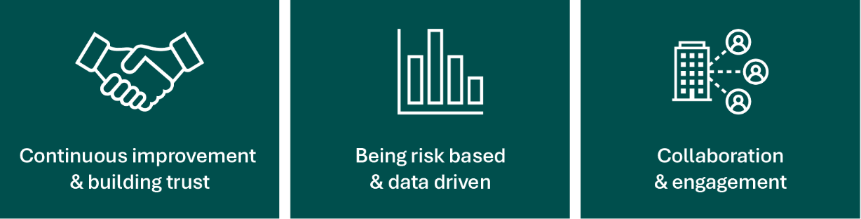
We made good progress in implementing the Government’s reforms to the Scheme. In doing so, we matured as a regulator by strengthening our integrity, delivering significant improvements to our ICT infrastructure and tools, investing heavily in stakeholder engagement and education materials and collaborating with professional bodies.

Integrity and transparency
- Published the Regulator’s Statement of Intent - providing a roadmap on how regulatory functions will be delivered, reinforcing commitment to integrity, professionalism and best practice regulation.
- Published our 2025–26 Compliance and Enforcement Priorities - outlining our key priority areas, the conduct and harms we prioritise, and our escalating approach to compliance.
- Introduced our Service Charter - covering the standard of behaviour you can expect from us, what we ask of you, and the actions you can take if we have not met your expectations.

ICT infrastructure and tools
- Major ICT releases to support reporting entities meet their legislated reporting obligations under the amended the Act, including a new webform to capture reporting information and a self-assessment questionnaire.
- Increasing transparency through a new interactive Payment Times Reports Register - an accessible and user-friendly tool that allows users to search and compare reported data, including key reporting measures introduced as part of the reforms.

Stakeholder engagement and education
- Published quick reference guides and demonstration videos for users of the refreshed Payment Times Reporting Portal.
- Delivered updated guidance materials and education sessions, including how to complete a payment times report under the reformed Scheme and answers to commonly asked questions.
- Collaborated with several professional bodies, tailoring and delivering payment times information in different forums for their members, and engaged with state Small Business Commissioners.

Regulator’s 2025 priority areas
  Engagement & Education | Greater stakeholder engagement and education  We invested heavily in stakeholder engagement and education. Attendance at the Regulator’s Stakeholder Liaison Forums increased significantly in 2025 compared to previous years.  Stakeholder engagement is trending upwards. Attendance at the February 2025 forum increased 175 per cent and the number of organisations by 179 per cent, compared with February 2024. At the August 2025 forum 674 attendees represented 508 organisations – that is a 120 per cent and 167 per cent increase respectively on the February 2025 forum.  The Regulator undertook strategic engagements with industry associations, professional bodies, professional service providers and small business advocates to raise the profile of the Scheme, promote responsible payment practices, develop mutually beneficial relationships and lay the foundations for future collaboration.  Our education initiatives during the year concentrated on helping reporting entities to meet their reporting obligations under the reformed Scheme. We delivered:  - 4 online education sessions in March and April 2025, with over 2,700 people attending  - a range of explanatory and guidance documents for reporting entities to help them prepare new payment times reports  - updated key information sheets on using our regulatory powers (Information Sheet 7) and the SBI Tool (Information Sheet 6).

  Research & Intelligence | Better understand drivers of payment practices and increase transparency  In 2025, we initiated research projects; our primary focus was to quantify the economic impact of slow payments and analyse the potential reach and demographic of small businesses impacted by slow payments, at both the entity and industry level.  We improved the presentation and transparency of information in the publicly available Payment Times Reports Register to ensure it makes data easier to understand and provides a clear visual summary of each reporting entity’s payment performance.  The Payment Times Reports Register now contains the key reporting measures introduced by the reforms, including the new ‘Paid on Time’ tab for all industries and individual entities, and consolidated group structures with controlled entities.

  Compliance & Enforcement | Strengthening integrity and taking action  We increased our compliance activities in 2025, focusing on entities that were required to report but had not met their obligations, together with those submitting potentially false or misleading reports.  We wrote to entities that:  - failed to submit a report to remind them of their reporting obligations  - submitted reports late  - submitted reports that were potentially false or misleading, or  - were identified as being at risk of meeting the criteria to receive a slow small business payer direction.  We expanded the use of our regulatory powers, including sending formal information gathering notices and issuing infringement notices.

The year ahead: 2026 priority areas
Our commitment to the 3 principles of regulator best practice consistent with the Commonwealth’s Regulator Performance (RMG 128) is ongoing.
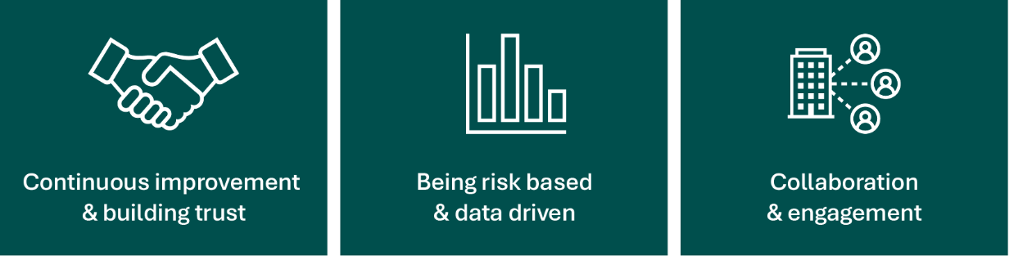

ICT infrastructure and tools
We will release a new Payment Times Reporting Portal in mid-February 2026. This is a major ICT release that delivers significant improvements to usability and efficiency, effectively implementing the remaining reforms. After this release, we will enter a sustainment phase for the ICT infrastructure.
  Engagement & Education | Strategic stakeholder engagement and education  Continue strategic engagements with industry associations, professional bodies, professional service providers and small business advocates to raise the profile of the Scheme and promote responsible payment practices.  Leverage the trusted relations we established in 2025 for purposeful engagements aligned to the 3 pillars of our stakeholder engagement strategy: influence, inform and collaborate.  Support reporting entities by providing fit-for-purpose educational resources and tools to help them understand and meet their legal obligations.

  Research & Intelligence | Better understand drivers of payment practices and increase transparency  Use data to inform research projects that will help us to better understand the drivers of payment and procurement practices, including the economic impact of slow payment times. Research will highlight how improved payment times and practices can strengthen small businesses cash flow, build resilient supply chains, and support productivity in Australia.  Increase transparency through continual improvements to the public Payment Times Reports Register and publication of research and data insights highlighting fast and slow small business payers.

Compliance & Enforcement | Strengthening integrity and taking action  Continue to strengthen the integrity of the Scheme through data-informed compliance activities, applying greater scrutiny to the completeness and quality of reports received and holding entities to account.  Encourage positive behavioural shifts and improve voluntary adherence to statutory obligations by continuing to apply nudge strategies.

Engagement and education
Purposeful stakeholder engagement
How the Regulator is helping you
Regulator’s forward engagement program

Purposeful stakeholder engagement
Purposeful engagement goes beyond communication; it’s about building a culture where every interaction leads to meaningful outcomes. Every interaction is an opportunity to build mutual understanding and drive positive outcomes through open, two-way communication. The Regulator strives to foster a collaborative environment by facilitating constructive discussions where stakeholder feedback is genuinely valued and acted on where appropriate.
The Regulator has 4 stakeholder engagement priorities, supported by the 3 pillars of our stakeholder engagement strategy: influence, inform and collaborate.

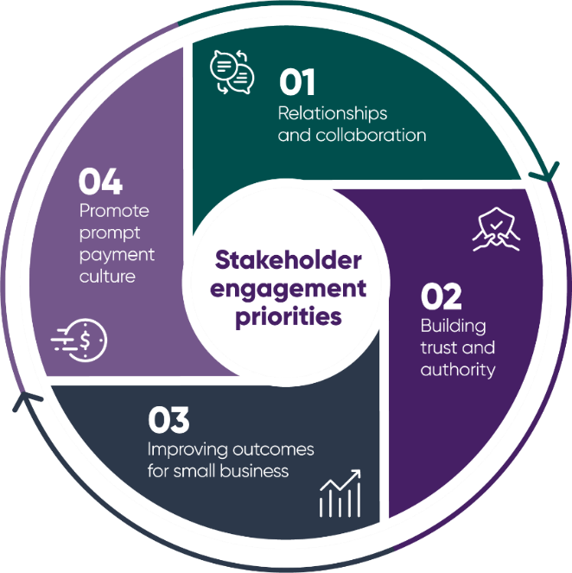

The 3 pillars of our stakeholder engagement strategy

Influence

Influence is about shaping the payment practices landscape through shared responsibility and expertise. Both the Regulator and stakeholders play a vital role in driving behavioural change to improve payment times and practices.
This pillar creates opportunities for stakeholders to raise concerns, share insights, and contribute meaningfully to better outcomes.

Inform

Keeping stakeholders informed is essential for building trust and credibility. This pillar focuses on transparency and timely, accurate communication, and ensuring stakeholders remain up to date on relevant developments, key milestones, and important decisions.
Providing clear and consistent information enables stakeholders to understand their obligations, anticipate change, and make informed decisions that support better payment practices.

Collaborate

Collaboration is essential to building shared ownership and aligning stakeholders with the Scheme’s objectives. This pillar focuses on creating meaningful opportunities for stakeholders to contribute their expertise, share insights, and work alongside the Regulator to address challenges.
Collaboration ensures practical outcomes are informed by diverse perspectives and supports the implementation of effective improvements. By influencing behaviours, informing decisions, and working together on solutions, we strengthen the payment environment for small businesses and the broader economy.

How the Regulator is helping you
We’re committed to making compliance easier. Feedback from our engagement activities drives continuous improvement to our guidance, helping entities to get the clarity and support they need.

Direct engagement
One of the ways our team helps entities meet their reporting requirements is by responding to enquiries sent to support@paymenttimes.gov.au.

Entities most commonly seek further guidance and information on the following:
- applications for extensions of time and subsidiary reporting
- how to complete reporting fields
- complying with reporting obligations, such as reporting entity criteria and the use of the SBI Tool, and
- correspondence from the Regulator advising the entity has been identified as a slow small business payer.

Proactive engagement
Our proactive approach delivers strong results. For the period 1 July to 31 December 2025:
- nearly 300 entities submitted a report for the first time, after engagement with the Regulator
- 112 reports were removed at the request of entities; they were incorrectly lodged by entities within their consolidated group, rather than by the head reporting entity (parent entity), and
- 200 reports were revised due to errors identified in the original report.
We work with large businesses to help them comply with their reporting obligations under the Act.
In 2025, we contacted more than 1,000 large businesses that may have had outstanding reports, reminding them to submit their payment times reports. We engaged with entities that submitted information in payment times reports and entity information forms that contradicted information available to the Regulator.
The Regulator wrote to more than 650 reporting entities identified as slow small business payers in Reporting Cycle 9, advising them to improve payment times to avoid a Slow Small Business Payer Direction.
In response, more than 150 entities have engaged with the Regulator, and over 50 entities have confirmed that they have taken steps to improve payment practices, including securing approval from their governing bodies to implement faster payment policies.
We introduced the Regulator’s Newsletters to keep stakeholders informed and connected. Each newsletter provides timely updates on key dates, upcoming events, system enhancements and guidance changes – helping our stakeholders to stay informed.

Consider collaborating with us
Working with the Regulator can help to raise awareness, build capability and foster a culture of continuous improvement in payment times and practices in your organisation or industry.
Consider how your organisation could benefit from collaboration opportunities with us – such as tailored educational workshops, joint participation in panel discussions or contributing to joint research projects.
If your organisation is interested in exploring how we can work together, please get in touch via engagement@paymenttimes.gov.au .

Regulator’s forward engagement program

Register now: online demonstrations of the new Payment Times Reporting Portal
We invite you to join a short webinar for a demonstration of the new portal. We will walk you through the new layout and key features, show you how the system works, and highlight the improvements designed to make reporting easier.
We are hosting several webinars at different times ahead of and shortly after the release of the new portal. All webinars will cover the same content, so you can simply register for the time that works best for you.
 | Event details  Date: 5 February 2026  Time: 2:00 pm – 3:15 pm AEDT  Platform: Microsoft Teams webinar  Date: 12 February 2026  Time: 10:00 am – 11:15 am AEDT  Platform: Microsoft Teams webinar  Date: 19 February 2026  Time: 2:00 pm – 3:15 pm AEDT  Platform: Microsoft Teams webinar

Please note: the webinars are demonstrations only – they are not training sessions. They are intended to give users an overview of what the portal can do and what to expect when it becomes available in mid-February 2026.

The Regulator’s online Stakeholder Liaison Forum is on 12 March 2026
The Regulator is committed to regular and open collaboration with stakeholders to build trust and strengthen relationships across the business sector.
Our Stakeholder Liaison Forum is an opportunity to engage directly with the Regulator and leadership team. Stay informed, take the opportunity to have your questions answered, and hear about key initiatives and developments in the Scheme.
Register online now to attend this event.

Research and intelligence
Key payment times reporting measures
Data snapshot
Data insights
Industry insights

Key payment times reporting measures
Measures introduced from 1 July 2024 improve the clarity and granularity of reported data to give both the Regulator and the community a more detailed and accurate view of large businesses’ payment practices. They provide greater transparency and context to users of the reports in the Payment Times Reports Register. These measures support the assessments for the payment incentives and provide insights on payment discipline and reliability, by showing how consistently a business meets its own commitments to pay on time.

80th percentile payment time (in days)
The 80th percentile indicates the number of days it took for a reporting entity to make 80 per cent of all small business trade credit payments in the reporting period. It offers a practical midpoint between average and extreme values by providing insight into whether slower payments by the entity are outliers, or representative of a more systemic practice of the entity. It is particularly useful for assessing general payment culture and tracking improvements over time.

95th percentile payment time (in days)
This measure indicates the number of days it took to make 95 per cent of all small business trade credit payments in the reporting period. This measure is key for assessing the payment incentives. It identifies the time it takes for an entity to pay the majority of invoices, excluding outliers and one-offs. This figure removes the slowest payment times of an entity, but more accurately reflects when a small business will be paid due to the removal of extreme outliers.
The 80th and 95th percentile metrics indicate the number of days at which 80 per cent and 95 per cent of small business invoices are paid. Both measures are important for understanding the midpoint and extremes of payment behaviour.
Example
If the 80th percentile payment time is 45 days and the 95th percentile payment time is 60 days for an entity, small businesses can anticipate the majority of payments being made within 45 days, with some taking up to 60 days and a small portion taking longer than 60 days. This information helps small businesses prepare for potential delays and manage their cash flow more effectively.

Average payment time (in days)

Both average and median payment times measures are included in the data collected, as payment times to small businesses do not necessarily follow a symmetrical distribution. The average payment time represents the statistical mean of the payment times calculated for all payments in the small business trade credit payments dataset.

The average payment time metric provides a clear, comparable indicator of payment performance across reporting entities and gives small businesses an awareness of when invoices are likely to be paid. It’s a useful tool for forecasting cashflow and planning working capital.
Example
If the average payment time for a large business is 32 days, but the 95th percentile is 60 days, it suggests most invoices are paid in 32 days, but a few are significantly delayed.

Common payment terms (in days)

Reporting the most frequently used payment terms helps to distinguish whether prolonged payments are due to non-compliance or permissive contractual arrangements. It also supports benchmarking across entities and industries regarding payment expectations. This measure replaces the average standard payment terms reported since the Scheme began in 2021.
Common payment terms allow terms to be compared with payment times to judge reliability.
Example
If a business has 60 day payment terms but consistently pays in 45 days, that’s better than a business with 30 day payment terms but an average payment time of 60 days.

Percentage of invoices paid on time (within payment terms)
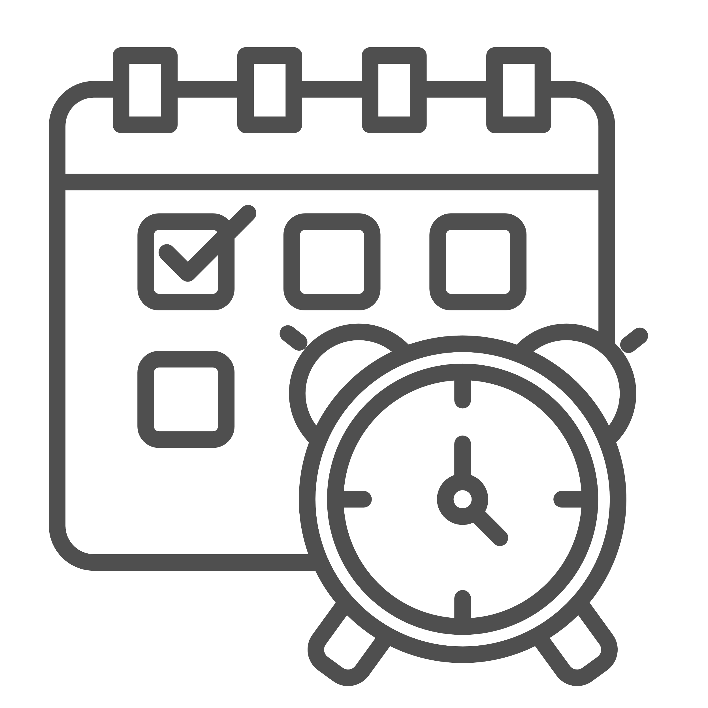
This field provides a compliance-based view, measuring how often large businesses meet their agreed payment terms for small business suppliers. It is a critical indicator of responsible procurement practices and enables targeted monitoring and public accountability.
This metric provides a measure of reliability by showing how often a business meets its own payment commitments. It is a strong indicator of payment discipline. A higher percentage means the business is more likely to pay on time.

Data snapshot
The data used in this Update reflects reported data for the reporting period 1 January to 30 June 2025 (Reporting Cycle 9). Data and analysis reflect payment times reports and revised reports for Reporting Cycle 9 received on or before 31 December 2025.
Figure 1: Key measures data snapshot
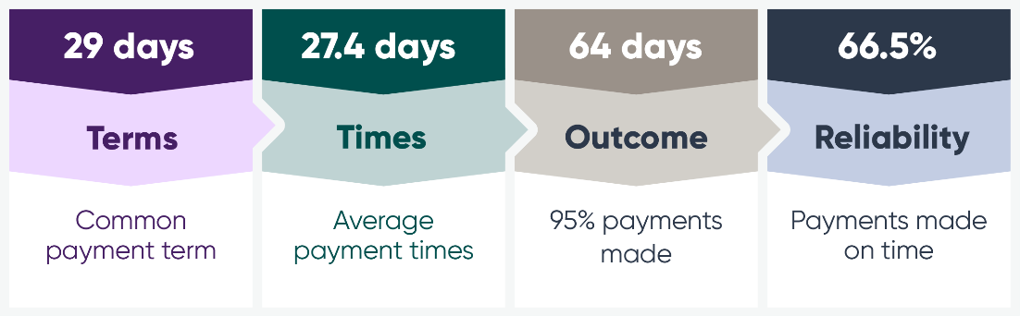
Figure 2: Industry data snapshot
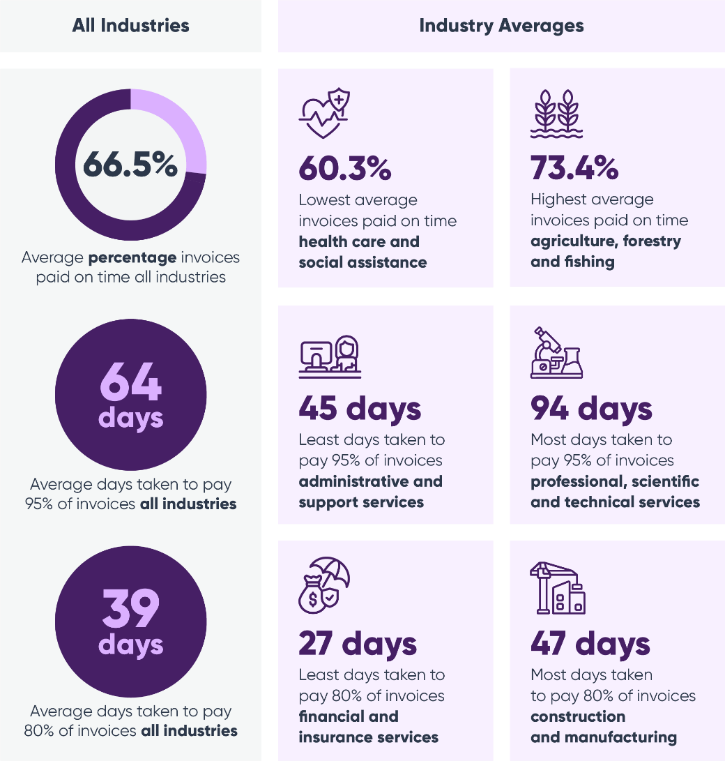
Note: Use caution when interpreting the data and insights in this Update. Some reporting measures introduced from 1 July 2024 are not directly comparable with data from Reporting Cycle 7 or earlier. For further information about the data in this Update, refer to Appendix A.

Data insights
In Reporting Cycle 9, most reported payment performance measures remained relatively stable, with the exception of time taken to pay 95 per cent of small business invoices. This measure worsened, with the average number of days increasing from 58 days to 64 days.
While average common payment terms shortened by one day, this small improvement was not matched by faster payments. Instead, average payment times increased slightly, marking a modest reversal of the improving trend seen in earlier cycles. The time taken to pay a majority of invoices increased, with the average 95th percentile payment time lengthening by almost a week. This indicates that the invoices with the longest payment times in this reporting cycle were paid significantly later than in the previous reporting cycle.
Payment outcomes showed a similar softening. Although the percentage of invoices paid on time improved slightly, the share paid within 30 days remained steady at 68.2 per cent. Taken together, these results point to a general easing in payment discipline. Despite the slight shortening in reported terms, overall performance deteriorated. This indicates reporting entities have room to improve the timeliness and consistency of their payments.
Reported data will continue to be monitored to identify emerging trends.
Table 1: Comparison of key measures across Reporting Cycles 8 and 9
 | Reporting Cycle 8 | Reporting Cycle 9
Average common payment term | 30 days | 29 days
Average payment time | 27.1 days | 27.4 days
Average 95th percentile payment time | 58 days | 64 days
Percentage of invoices paid on time | 66.4% | 66.5%

Payments made in more than double the agreed payment term
Although the average common payment term across all industries is 29 days, entities are often taking significantly longer to pay their small business suppliers.
As shown in Figure 3 (and detailed in Table 7, Appendix B), on average 80 per cent of small business invoices are paid within 39 days. But, to reach 95 per cent of small business invoices paid, it takes 64 days.

It’s taking longer than double the average agreed payment term for the vast majority of small business invoices to be paid. These figures highlight the gap between stated payment terms and actual payment behaviour.

Figure 3: Payment terms and times, Reporting Cycle 9 (see Table 7, Appendix B)
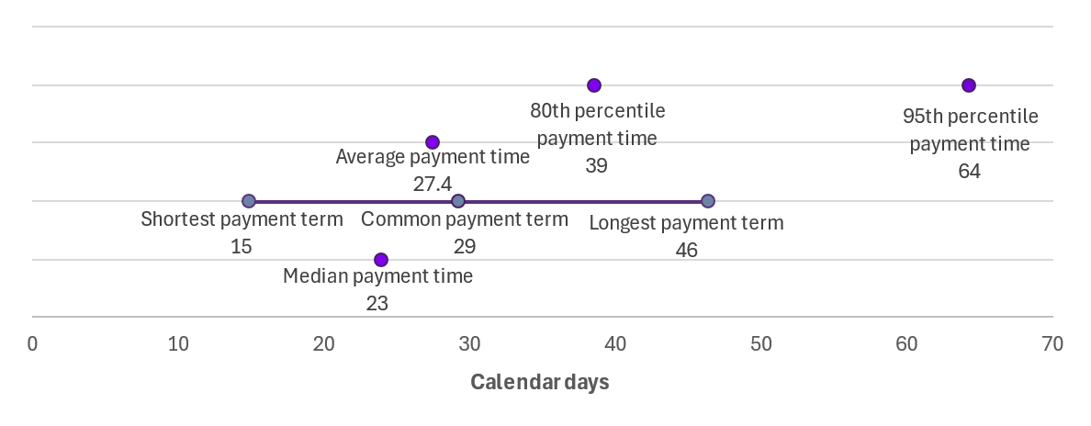

Small businesses are big players in the
supply chain
In Reporting Cycle 9, 3,098 entities reported buying goods and services from small business suppliers. On average, they sourced around 28.7 per cent of their total procurement value from small businesses.
Trade with small business was significant across all sectors. The lowest proportion was reported in the mining industry at 21.1 per cent, while the highest was in the construction industry at 43.3 per cent.
Since the Scheme began in 2021, the share of procurement from small businesses has remained relatively stable, ranging from 28.7 per cent in Reporting Cycle 9 from the peak of 30.3 per cent in Reporting Cycle 8 (see Table 1, Appendix B).
These figures highlight the vital role small businesses play in the supply chains of Australia’s largest companies, across all industries.
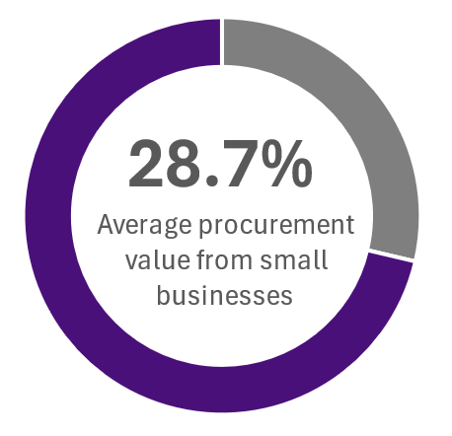

Entities paying in 20 days or less
In Reporting Cycle 9, 134 entities reported making 95 per cent or more of their payments to small business suppliers in 20 days or less. These entities may qualify as a Fast Small Business Payer if they continue this practice for 2 consecutive reporting periods. This achievable benchmark is to encourage faster payment practices.
Fast small business payers are publicly recognised on the Payment Times Reports Register, offering those entities a reputational incentive for their achievement and providing stakeholders a clear, verifiable indicator of strong payment performance.
Figure 4: Number of entities paying 95 per cent of invoices in 20 days or less, 21–30 days and more than 30 days
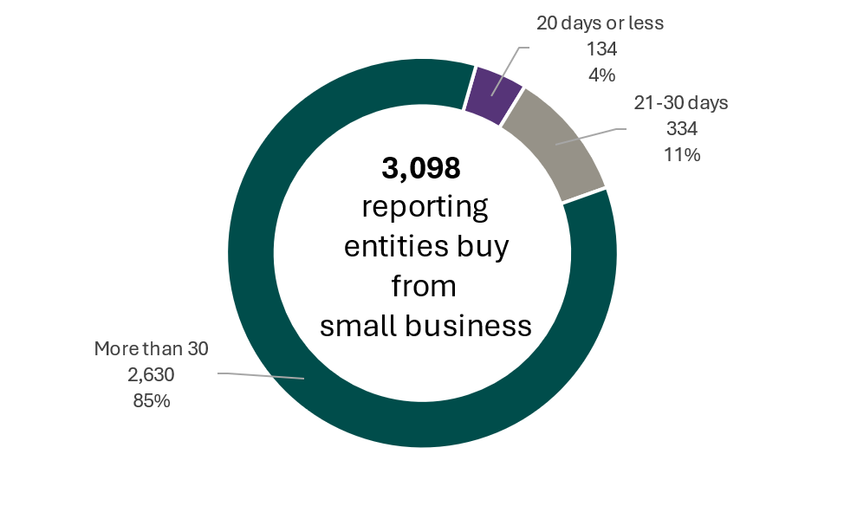

Invoices paid within 30 days
To encourage faster payments, a slow small business payer direction may be issued to an entity in the slowest 20 per cent of small business payers, both overall and within specific industries. Directions from the Regulator or the Minister for Small Business can require reporting entities to make public statements identifying themselves as a Slow Small Business Payer; again, creating a reputational incentive to improve performance.
On average, the proportion of payments made to small business suppliers within 30 days has steadily increased from 63.2 per cent in June 2021 to 68.2 per cent in June 2025, a 5.0 percentage point increase from Reporting Cycle 1.
Figure 5: Average invoices paid in 30 days, Reporting Cycles 1 to 9 (see Table 6, Appendix B)
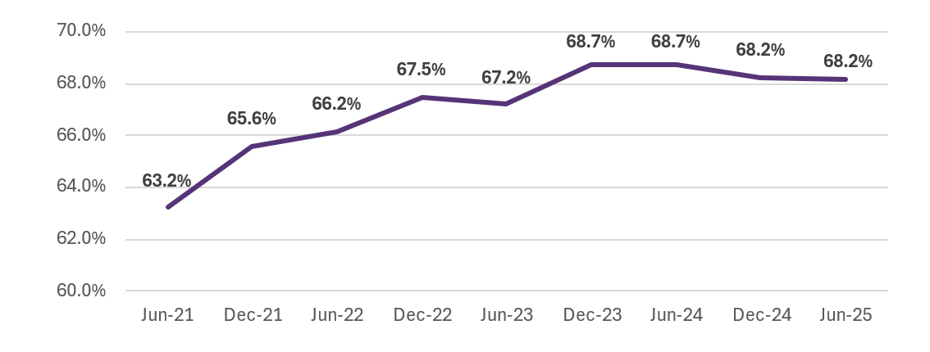
Over the same period, the proportion of entities with average payment times in the 31-60 days range decreased from 28.2 per cent to 25.0 per cent, while those taking more than 60 days decreased from 8.6 per cent to 6.8 per cent. This indicates a modest but positive shift towards faster payment practices among reporting entities.

Figure 6: Proportion of entities with average payment times in day ranges, Reporting Cycles 1 and 9
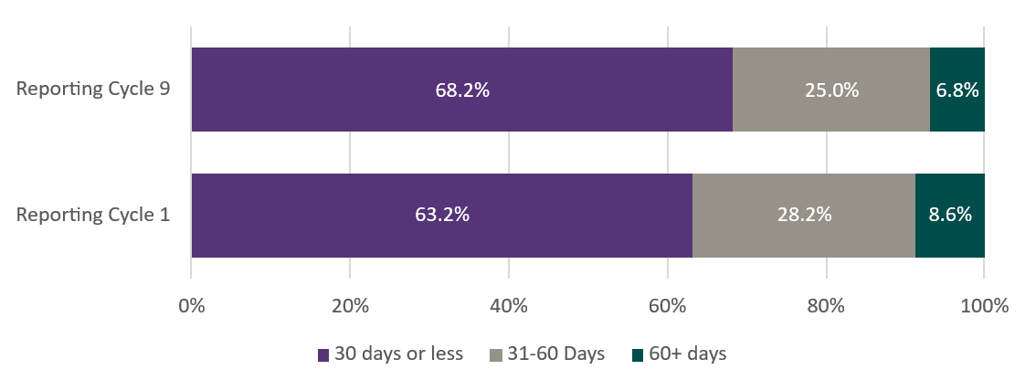
Small businesses are big players in the supply chain; they are getting paid faster but we need to do better.

Mining and the Information Media and Telecommunications industries are some of the slowest paying
In Reporting Cycle 9, a majority of entities (2,630 entities or 85 per cent) reported taking more than 30 days to pay 95 per cent or more of their invoices (see Figure 7 below).
Figure 7: Number and percentage of entities making 95 per cent of payments in 30 days or less, 31–60 days and more than 60 days
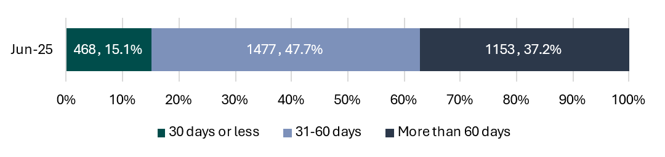
Both the Mining and the Information Media and Telecommunications industries reported offering small businesses average common payment terms of 32 and 29 days respectively. Their average payment times were 30 and 24.7 days respectively, suggesting payments are generally made within agreed terms.
However, despite both industries offering terms of around 30 days, 95 per cent of small business invoices were paid in 70 days and 67 days respectively, more than 3 times the agreed payment term.
These extended payment periods can create significant cash flow challenges and increase costs for small business suppliers.
Figure 8: Average payment terms and times for reported data, Reporting Cycle 9 (for all industries, see Table 9, Appendix B)
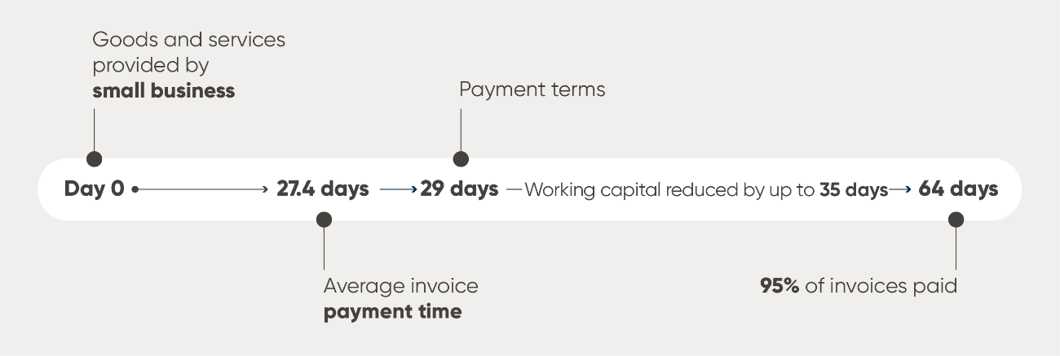

Commonwealth entities
Generally speaking, the Act applies to large businesses and some Commonwealth entities, with annual consolidated revenue more than $100 million, having a connection to Australia and not registered as a charity under the Australian Charities and Not-for-profit Commission Act 2012.
A Commonwealth entity is considered a reporting entity if it is a Corporate Commonwealth entity or a Commonwealth company as defined in the Public Governance, Performance and Accountability Act 2013 and it meets the definition of reporting entity in section 7 of the Act.
In Reporting Cycle 9, of the 91 Corporate Commonwealth entities and Commonwealth companies, 35 had reporting obligations under the Scheme. All 35 entities, comprising 29 Corporate Commonwealth entities and 6 Commonwealth companies submitted a payment times report to the Regulator during this cycle.

Commonwealth entities perform better than the average, but there is still room for improvement
Commonwealth entities reported offering small business suppliers an average common payment term of 19.6 days, well under the all-industry average of 29 days. Commonwealth entities also performed better with payment times, with an average of 16.4 days, 11.0 days less than the all-industry average payment time of 27.4 days.
Despite offering a common payment term of 19.6 days, Commonwealth entities still took an average of 40 days to pay 95 per cent of their small business supplier invoices.
Figure 9: Key metrics for Commonwealth entities
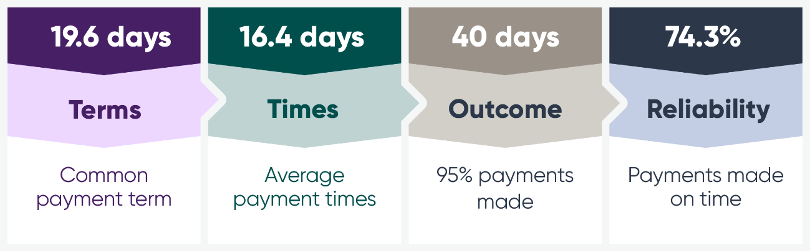

Table 2: Commonwealth reporting entities key metrics, Reporting Cycle 9
Cth entity type | Commonwealth entity name  in alphabetical order | Common payment term (days) | Average payment time (days) | 95th percentile payment time (days) | Invoices paid  on time  (%)
CCE | Airservices Australia | 20 | 28.9 | 72 | 41.6%
CC | ASC Pty Ltd | 30 | 36.4 | 76 | 55.7%
CCE | Australian Broadcasting Corporation | 20 | 21.0 | 58 | 75.0%
CCE | Australian Digital Health Agency | 20 | 11.0 | 29 | 85.3%
CCE | Australian Hearing Services | 20 | 21.0 | 63 | 75.0%
CCE | Australian Institute of Health and Welfare | 8 | 15.0 | 38 | 84.5%
CCE | Australian Maritime Safety Authority | 30 | 22.1 | 41 | 69.2%
CCE | Australian Nuclear Science and Technology Organisation | 30 | 16.0 | 30 | 87.0%
CCE | Australian Postal Corporation | 1 | 25.0 | 72 | 67.1%
CC | Australian Rail Track Corporation Limited | 20 | 29.7 | 73 | 63.6%
CCE | Australian Reinsurance Pool Corporation | 0 | 10.5 | 26 | 0.0%
CCE | Australian Renewable Energy Agency | 30 | 11.4 | 34 | 91.0%
CCE | Australian Sports Commission | 30 | 21.0 | 61 | 74.7%
CC | Australian Sports Foundation Limited | 14 | 14.7 | 27 | 54.2%
CC | CEA Technologies Pty Limited | 30 | 28.0 | 52 | 80.8%
CCE | Civil Aviation Safety Authority | 21 | 14.1 | 44 | 85.2%
CCE | Clean Energy Finance Corporation | 14 | 7.6 | 23 | 77.7%
CCE | Coal Mining Industry (Long Service Leave Funding) Corporation | 30 | 15.3 | 30 | 80.8%
CCE | Comcare Australia | 1 | 30.3 | 71 | 41.5%
CCE | Commonwealth Scientific and Industrial Research Organisation | 14 | 6.1 | 10 | 94.6%
CCE | Commonwealth Superannuation Corporation | 20 | 8.1 | 22 | 93.9%
Table 2: Commonwealth reporting entities key metrics, Reporting Cycle 9 (continued)
Cth entity type | Commonwealth entity name  in alphabetical order | Common payment term (days) | Average payment time (days) | 95th percentile payment time (days) | Invoices paid  on time  (%)
CCE | Creative Australia | 30 | 19.3 | 48 | 88.9%
CCE | Defence Housing Australia | 30 | 2.0 | 5 | 79.0%
CCE | Director of National Parks | 20 | 10.2 | 28 | 90.9%
CCE | Export Finance and Insurance Corp | 14 | 14.0 | 31 | 57.9%
CCE | Grains Research & Development Corporation | 30 | 15.0 | 47 | 89.0%
CCE | Housing Australia | 14 | 17.4 | 39 | 72.7%
CCE | Murray-Darling Basin Authority | 20 | 9.4 | 30 | 87.1%
CCE | National Disability Insurance Agency | 20 | 20.0 | 31 | 86.1%
CCE | National Gallery of Australia | 20 | 4.3 | 16 | 91.2%
CC | NBN Co Limited | 20 | 23.4 | 58 | 87.0%
CCE | Reserve Bank of Australia | 20 | 9.2 | 29 | 86.2%
CC | Snowy Hydro Limited | 7 | 14.4 | 35 | 75.8%
CCE | Special Broadcasting Service Corporation | 7 | 9.8 | 27 | 47.6%
CCE | Tourism Australia | 30 | 11.6 | 27 | 82.0%
 | All Commonwealth entities | 19.6 | 16.4 | 40 | 74.3%
Legend: CCE: Corporate Commonwealth entity – a Commonwealth entity that is a body corporate.
CC: Commonwealth company – a Corporations Act 2001 company that the Commonwealth controls.

Commonwealth entities – opportunities for improvement

95th percentile payment time
The 95th percentile payment time provides a clearer picture of when small businesses can expect to be paid, as it excludes extreme outliers and reflects typical payment behaviour.
For Commonwealth entities, this measure shows 95 per cent of small business invoices are paid within an average of 40 days, with individual entity results ranging from 5 days to 76 days.
This means a small business could wait up to 56.4 days longer than the average common payment term of 19.6 days to be paid by a Commonwealth entity, highlighting the gap that can exist between agreed terms and actual payment times for Commonwealth entities.

Percentage of invoices paid on time (within payment terms)
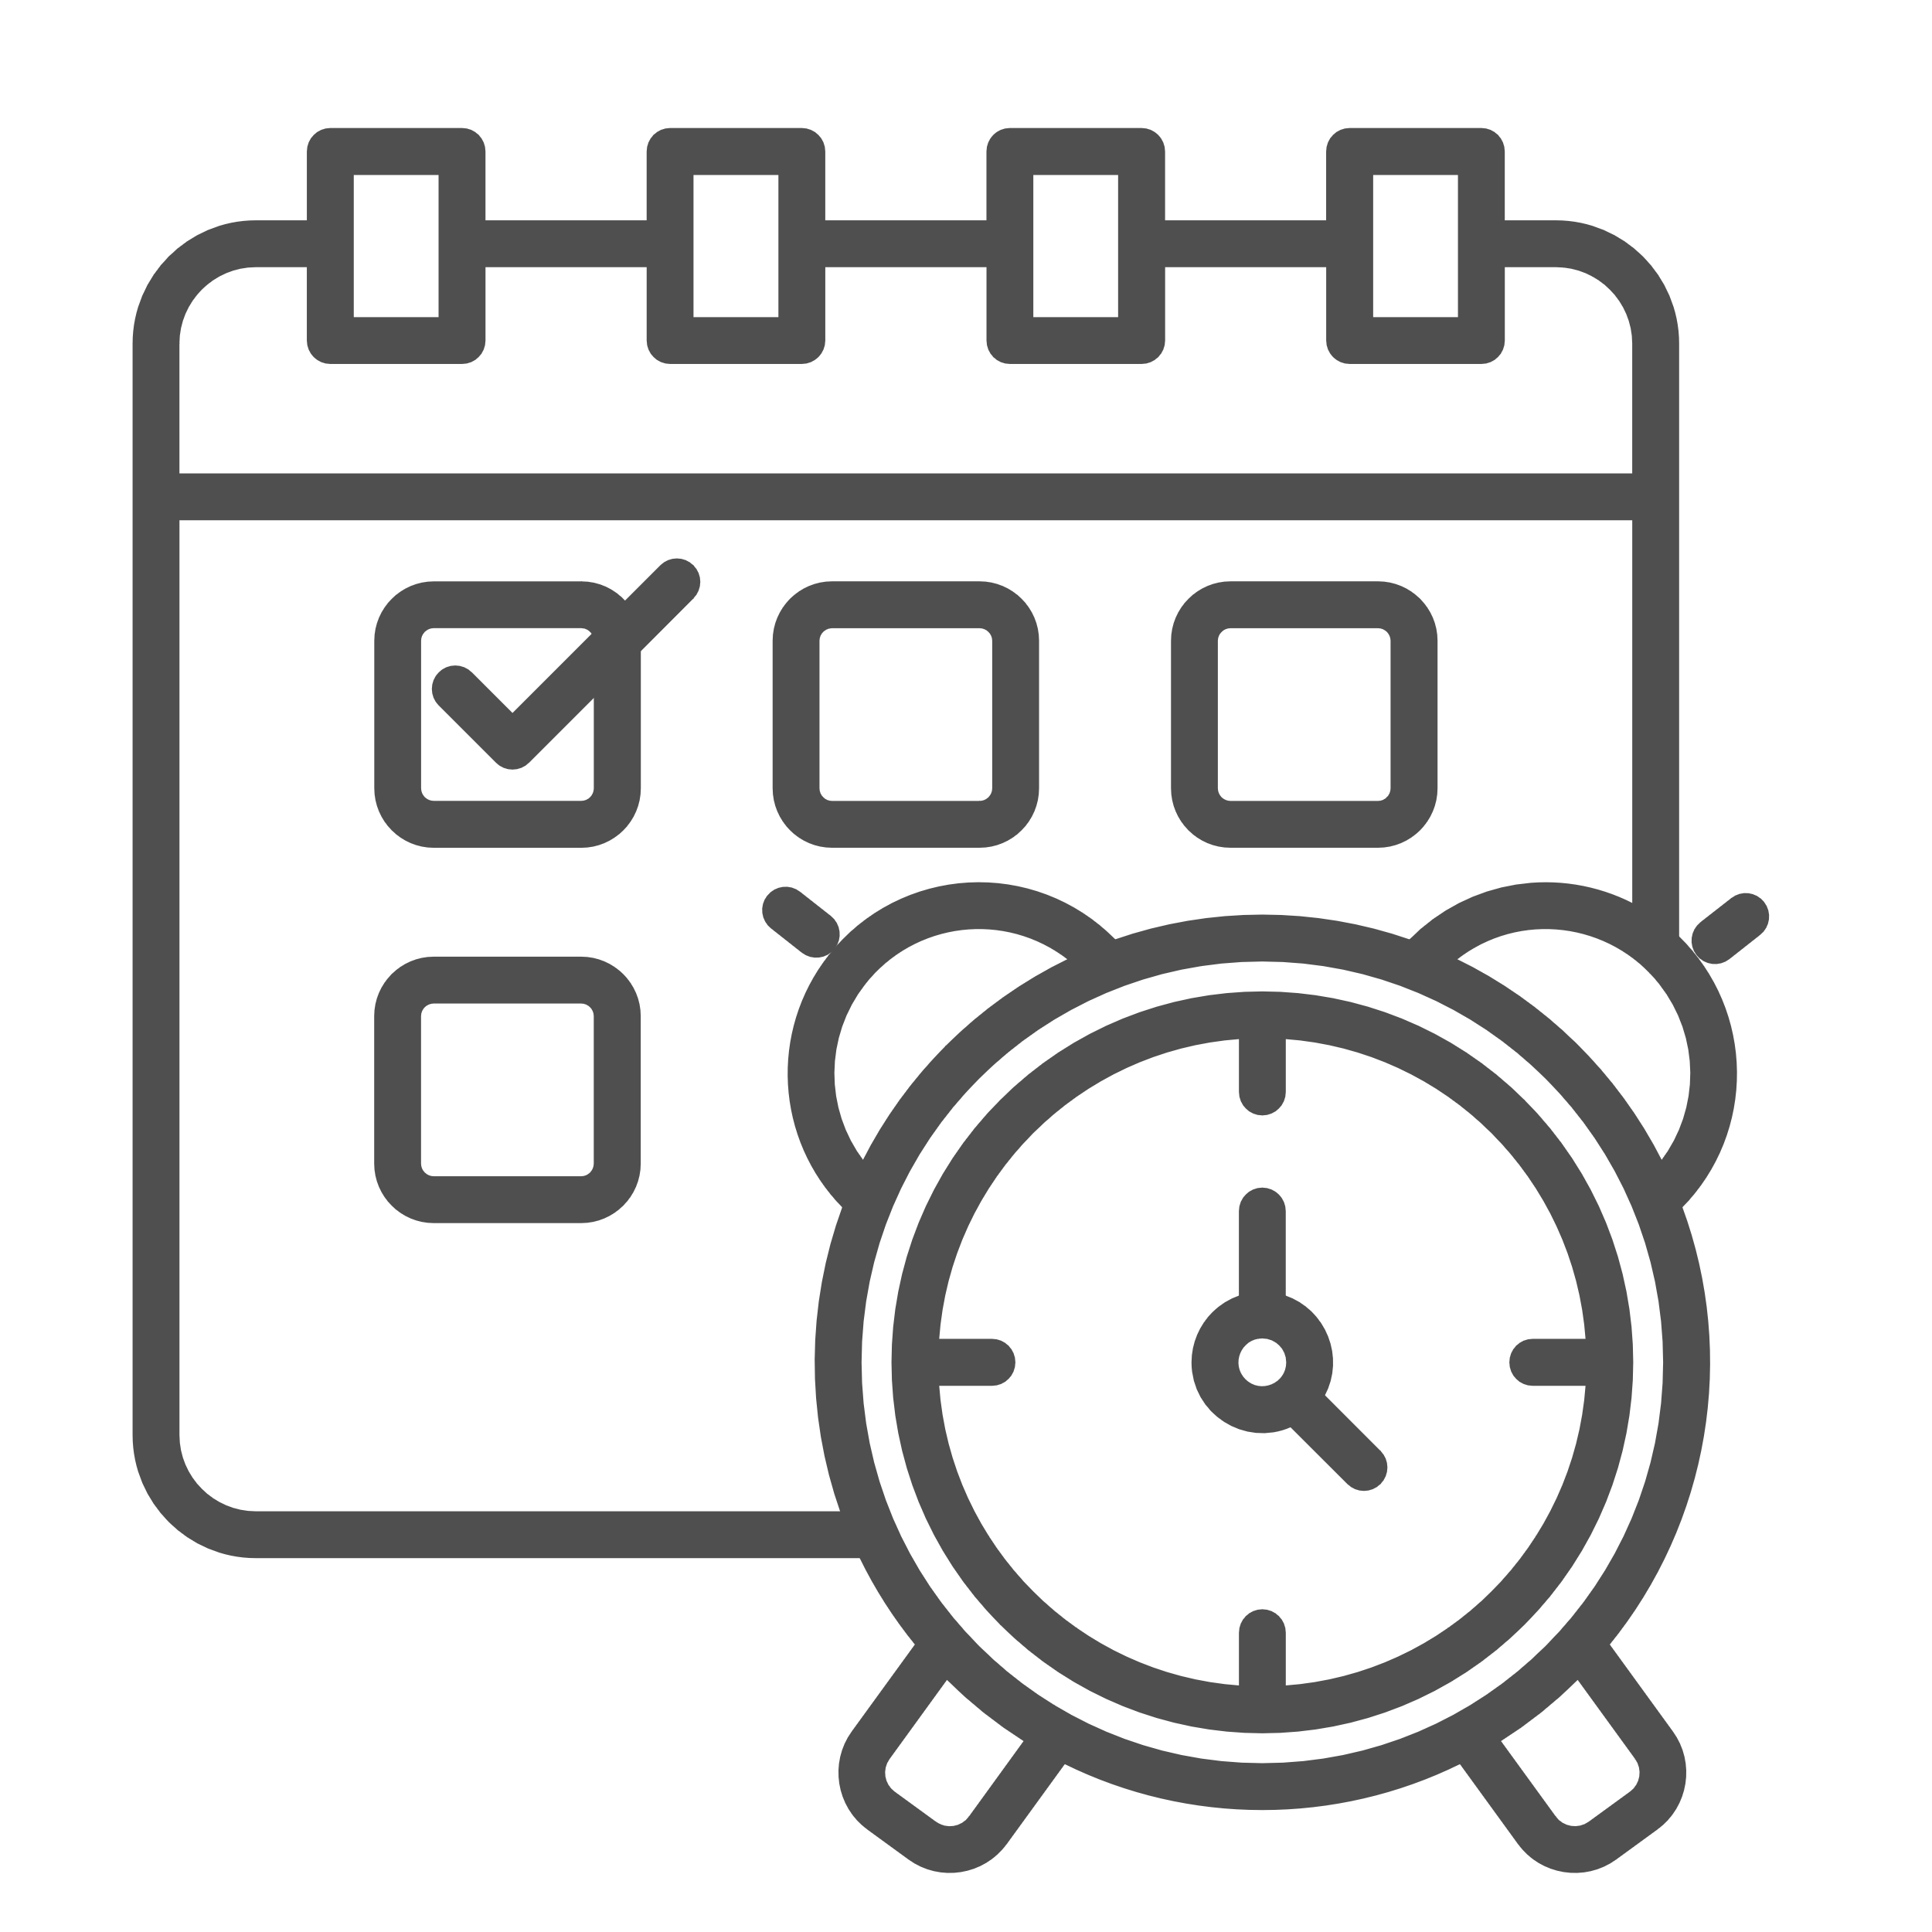
This measure reflects whether Commonwealth entities meet the payment terms agreed with their small business suppliers and is a strong indicator of payment reliability.
On average, Commonwealth entities pay small business suppliers on time 74.3 per cent of the time, outperforming the all-industry average of 66.5 per cent.
However, performance varies significantly even among Commonwealth entities. The best-performing Commonwealth entity exceeded their slower paying peers by around 53 percentage points, while at the other end of the scale, some entities pay only 4 out of every 10 invoices on time – leaving 6 out of 10 invoices paid late.

Performance of Commonwealth entities remains a focus area for the Regulator
Commonwealth entities are more reliable in paying invoices on time.
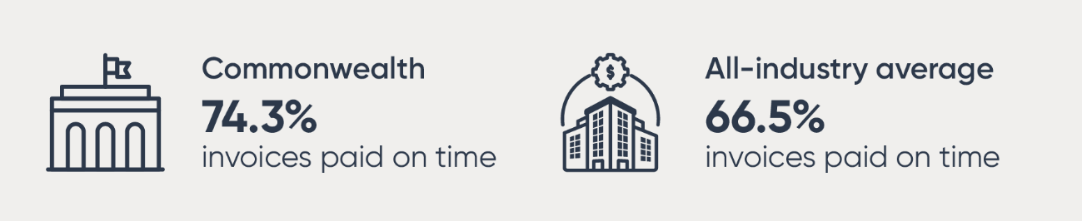
When it comes to being paid on time, small businesses can expect greater reliability from Commonwealth entities. While 74.3 per cent of invoices are paid on time, delays of up to 76 days still occur.
The Australian Government expects Commonwealth entities to lead by example by paying small businesses promptly.
The Regulator strongly urges Commonwealth entities to take action by actively monitoring performance, addressing bottlenecks, and implementing business improvements to ensure all payments meet agreed terms.

Industry insights

Payment times reporting applies to all industries
In Reporting Cycle 9, 3,098 reporting entities submitted reports across all 19 of the Australian and New Zealand Standard Industrial Classification (ANZSIC) Divisions (ANZSIC 2006 – ABS 2013).

Figure 10: Number of reporting entities by ANZSIC Division, Reporting Cycle 9

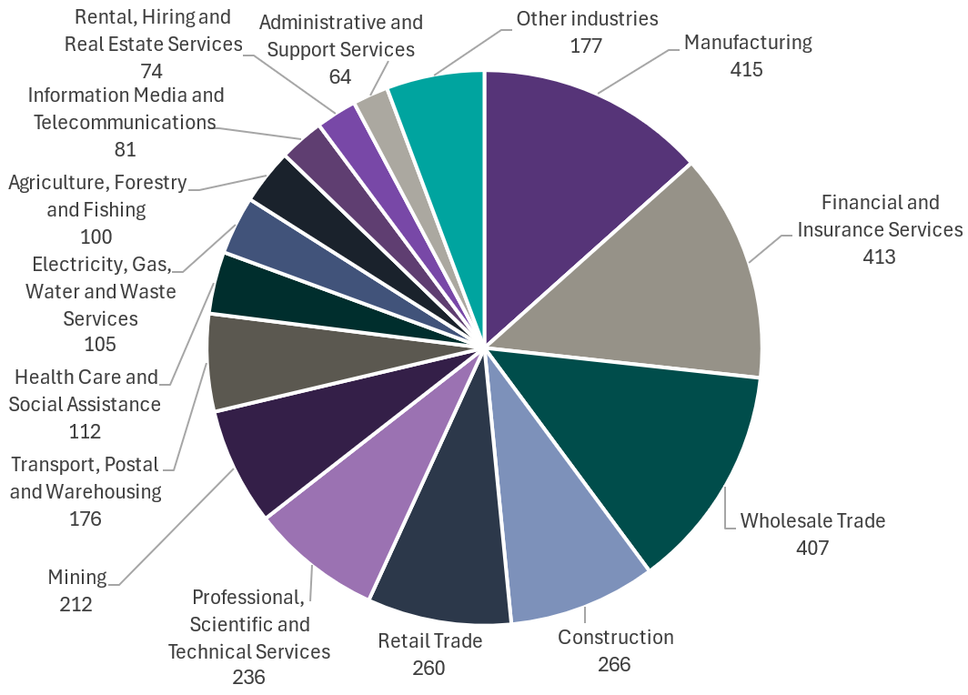
Notes:
- Industry insights for this cycle are based on the ANZSIC subdivision given by each reporting entity in the Entity Information form in the portal. The ANZSIC subdivision reflects the reporting entity’s self-assessed primary business activity.
- ‘Other industries’ include reporting entities where the industry proportion reflected less than 2 per cent. Data for all industries is provided in Table 3, Appendix B.

Payment terms vary across industries
At an industry level, the average common payment terms vary across industries, ranging from 20 days in the Education and Training industry to 35 days in the Manufacturing industry.
Across all industries, the average common payment term is 29 days. (see Table 3, Appendix B for full industry data).
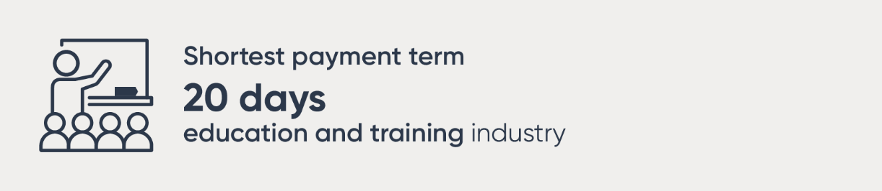



Figure 11: Average common payment term by industry (days) for Reporting Cycle 9 (see Table 3, Appendix B)
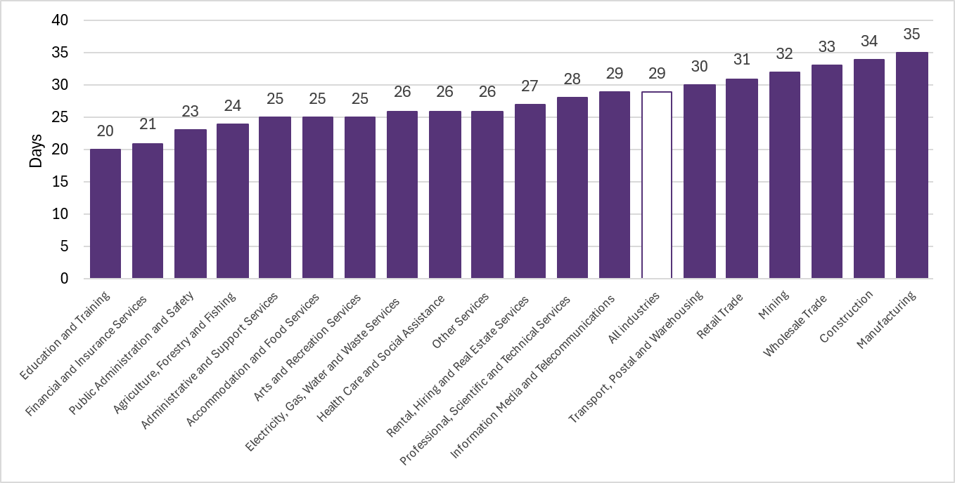

On-time payment performance by industry
In Reporting Cycle 9, the Agriculture, Forestry and Fishing industry reported the highest proportion of small business payments on time at 73.4 per cent, while the Health Care and Social Assistance industry reported the lowest at 60.3 per cent.
By comparison, in Reporting Cycle 8, the Rental, Hiring and Real Estate Services industry had the highest proportion of small business payments made on time at 72.5 per cent, while the Accommodation and Food Services industry had the lowest proportion at 58.6 per cent.
Reporting Cycle 9




Reporting Cycle 8
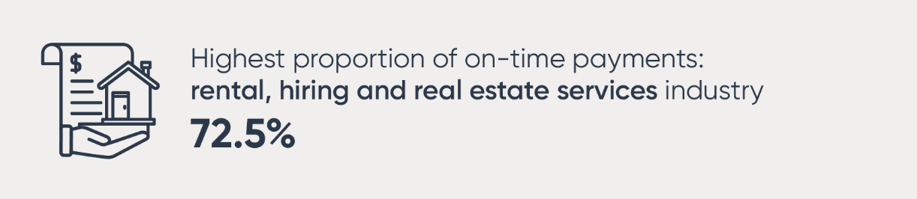

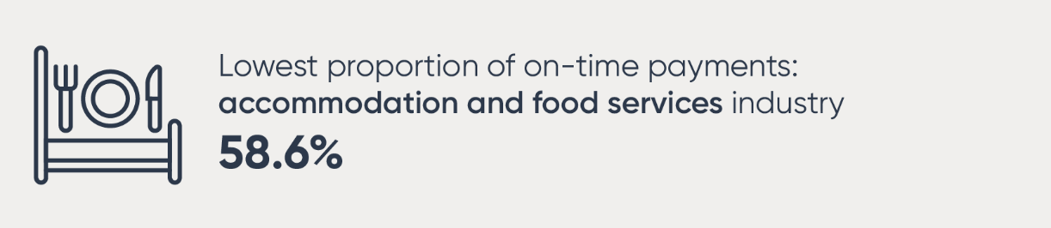

In Reporting Cycle 9, 12 industries recorded on-time payment rates above the all-industry average of 66.5 per cent (see Figure 12).

Figure 12: Proportion of payments paid on time by industry for Reporting Cycle 9 (see Table 9, Appendix B)
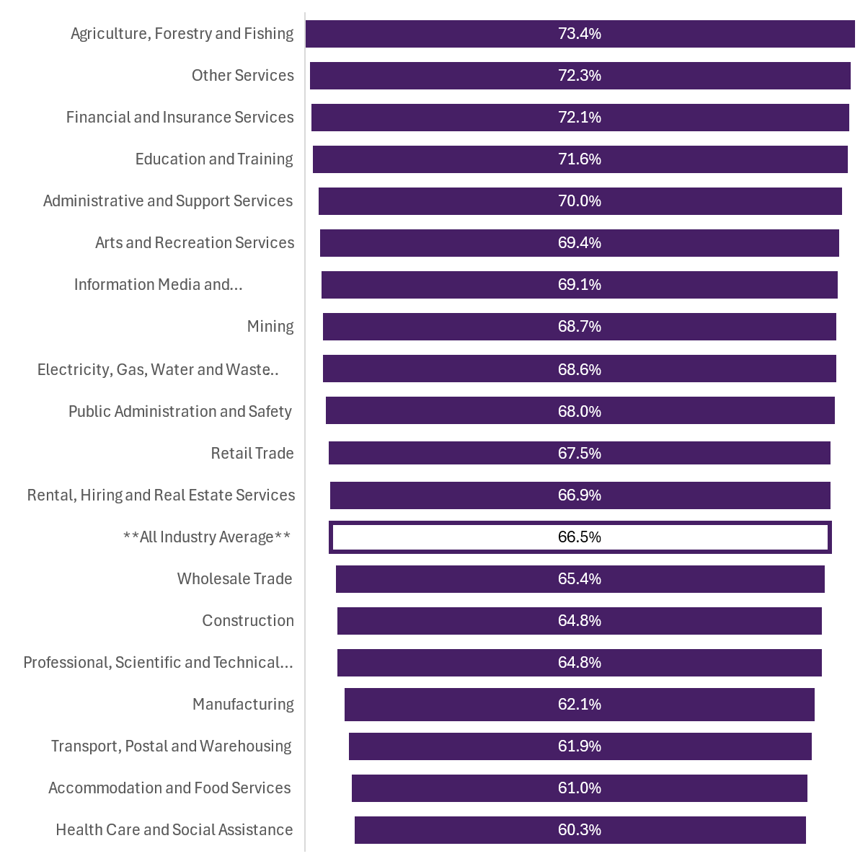

Industry focus

Regional series spotlight: the Transport, Postal and Warehousing industry
Australia’s size and relative isolation make the Transport, Postal and Warehousing industry a critical enabler of national economic activity, particularly for regional and remote communities. This industry connects people and goods, supports e-commerce and delivery services and underpins supply chains across all states and territories. It is also a major employer and an industry with wide small-business exposure. Reporting entities in this industry engaged with approximately 297,962 small-business suppliers in 2024.
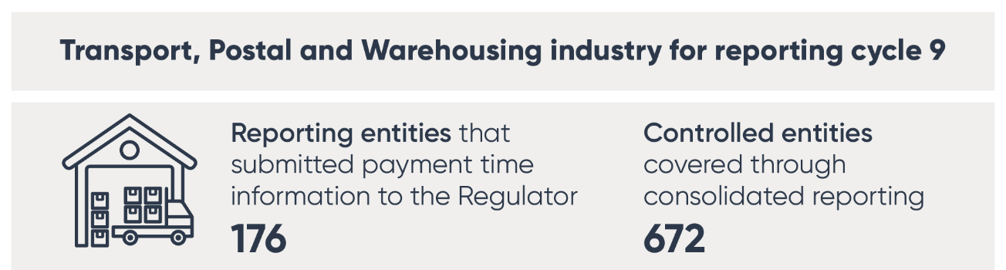
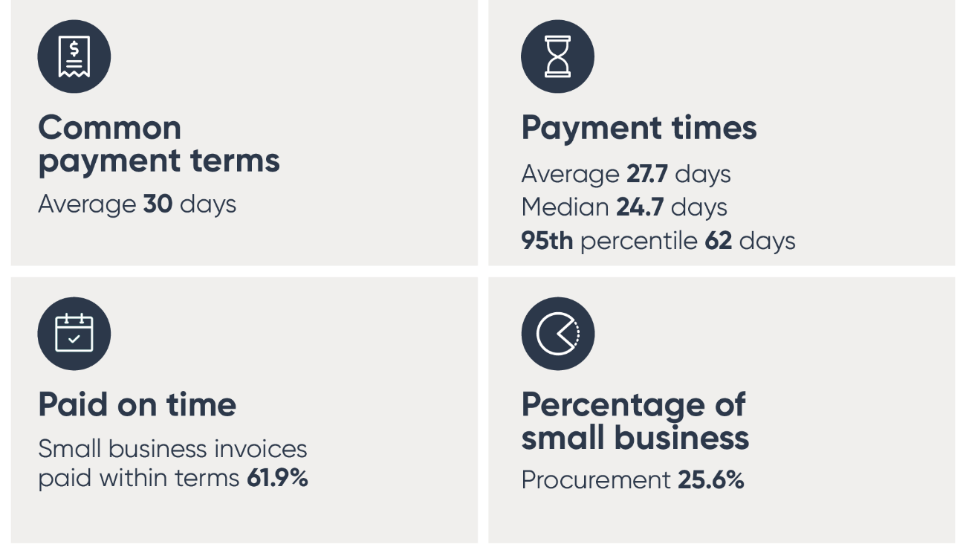

Although on average this industry offers a common payment term of around 30 days, a substantial proportion of payments fall outside these terms, with 38.1 per cent of invoices paid late. For small business suppliers, the impact can be significant, with average 80th and 95th percentile payment times of 41 and 62 days respectively for this industry, meaning most small businesses are waiting twice as long to receive payment.
The analysis for Figure 13 uses the Australian Bureau of Statistics (ABS) Remoteness Areas framework to classify locations based on the registered address of small businesses. This approach ensures consistency in defining major cities versus regional and remote areas. Using data from the Australian Business Register, 228,955 (or 76.84 per cent) of small businesses that supplied this industry are located in major cities of Australia, while 69,007 (or 23.16 per cent) are in regional and remote Australia.
Figure 13: Number and percentage of small business supplying reporting entities in this industry, by remoteness area
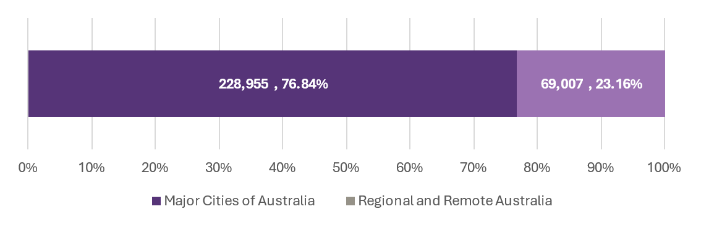
Recent ABS national industry data shows continued economic expansion. In 2023–24, sales and service income for this industry increased by $8.2 billion since 2022–23, representing a 3.5 per cent rise year-on-year. Growth was led by road transport activity, which contributed an additional $4.4 billion to industry income.
Figure 14: Income growth in the Transport, Postal and Warehousing industry, 2022–23 to 2023–24 ($billion)
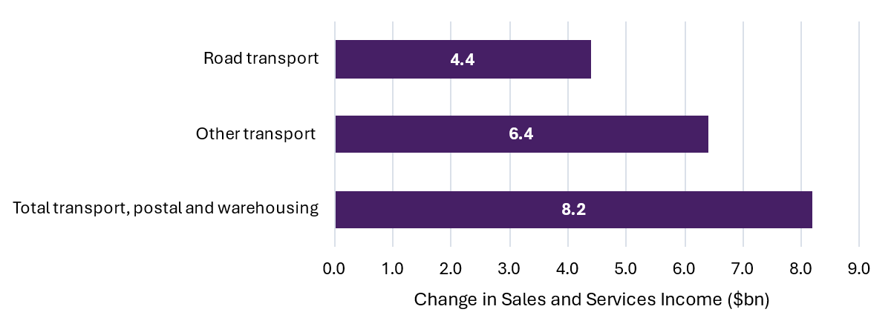

Industry earnings also increased over the year, although asset revaluations contributed notably to reported profit movements. This sector’s contribution to national production remained significant, generating $113.1 billion in Gross Value Added in 2023–24. The number of actively trading businesses likewise expanded, reaching 249,289 in 2024–25, an increase of 5.1 per cent from the previous year.
The scale of industry activity is further reflected in national freight movements. Australia’s domestic freight task reached 785.4 billion tonne-kilometres in 2023–24, including a record 86 billion tonne-kilometres transported by road in New South Wales alone. These volumes demonstrate why payment reliability is critical: small carriers, couriers and logistics small and medium enterprises (SMEs) are embedded throughout every freight corridor, delayed payments can weaken the liquidity sustaining those operations.
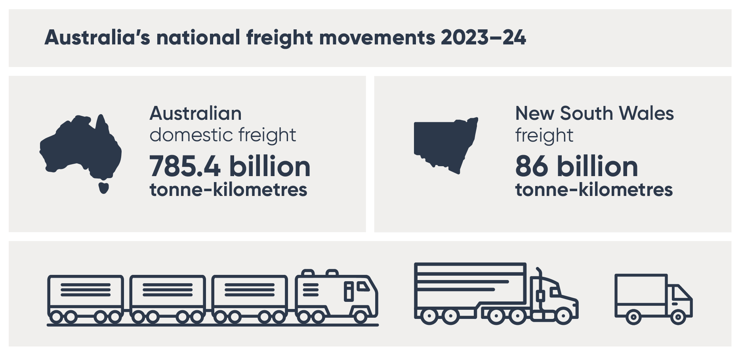
Given the direct impact of payment times on small business cashflow, the Regulator continues to emphasise the accurate use of the SBI Tool when reporting. With the industry’s average 95th percentile payment time currently at 62 days, it is clear:
The Transport, Postal and Warehousing sector must commit to delivering faster and more reliable payment times for the small businesses that support its operations.

Commonwealth procurement
The Commonwealth leverages the scale of Australian Government procurement to help improve payment times for small businesses.
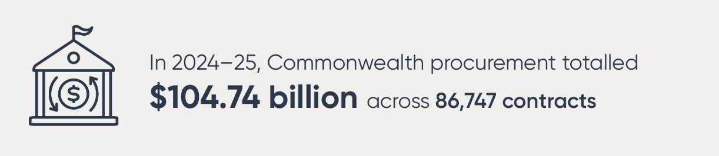

The Payment Times Procurement Connected Policy
The Payment Times Procurement Connected Policy (the Policy) is a Government initiative designed to improve payment practices within Government procurement supply chains. Its primary objective is to ensure that large businesses benefitting from significant Commonwealth contracts pay their small business subcontractors promptly.
The Policy requires reporting entities to pay their subcontractors within 20 days, and complements the Scheme and the Supplier Pay-On Time or Pay Interest Policy.
Reporting entities have several obligations under the Policy, including:
- declaring themselves to be reporting entities to Commonwealth entities when they submit tenders, prior to entering contracts with Commonwealth entities
- agreeing to the inclusion of certain contract clauses (Policy contract clauses)
- when awarded Government contracts valued over $4 million (GST inc.), to pay their subcontracts valued up to $1 million (GST inc.) within 20 calendar days, and
- using their reasonable endeavours to reflect the same obligations in their contracts with subcontractors who are also reporting entities.
Subcontractors not paid within 20 calendar days have the right to seek interest payments from reporting entities.
Both non-corporate Commonwealth entities and corporate Commonwealth entities have an important role to play in ensuring that this Government policy is implemented in their procurements. For further details about the policy and your obligations as a reporting entity, refer to the Payment Times Procurement Connected Policy – Guidelines on the Treasury website.
Treasury is currently reviewing the effectiveness of the Policy to determine whether it is meeting the Government’s policy objectives.

Commonwealth Procurement Rules
The Government announced significant updates to the Commonwealth Procurement Rules, effective from 17 November 2025. These changes are designed to deliver tangible benefits for Australian businesses, especially SMEs; by increasing access to Australian Government contracts, supporting diversity, improving procurement processes and enhancing transparency. Read more about the changes on the Department of Finance website.

Compliance and enforcement
Compliance and enforcement update
Fast small business payer
Slow small business payer
Small Business Identification Tool
Applications
Tips to avoid common errors

Compliance and enforcement update
In July 2025, the Regulator published the 2025–26 Compliance and enforcement priorities, to outline our escalating approach to compliance. We are actively monitoring performance and conduct in each of the 3 priority areas.
The Regulator directly engaged with entities over the past 6 months that failed to comply with their obligations under the Act and took appropriate enforcement action to address non-compliance.
Consistent with our escalating approach to non-compliance, the Regulator exercised a range of statutory powers that included issuing infringement notices to several large businesses where there were reasonable grounds to believe that they had failed to submit payment times reports.

Compliance and Enforcement Priorities
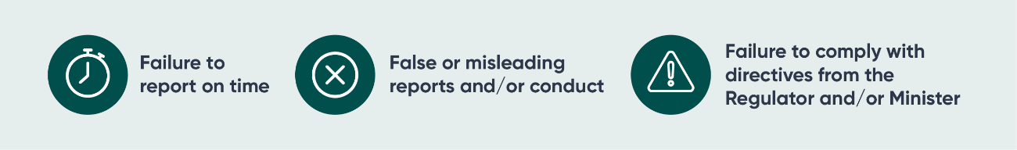

Compliance priority: failure to report on time

Failure to submit a payment times report
In the second half of 2025, we engaged with 1,334 entities, including 5 Commonwealth entities we identified as potentially having reporting obligations, but had not submitted a payment times report under the reformed Scheme.
All figures in this section are from 1 July to 31 December 2025.

Entities that have never reported under the reformed Scheme
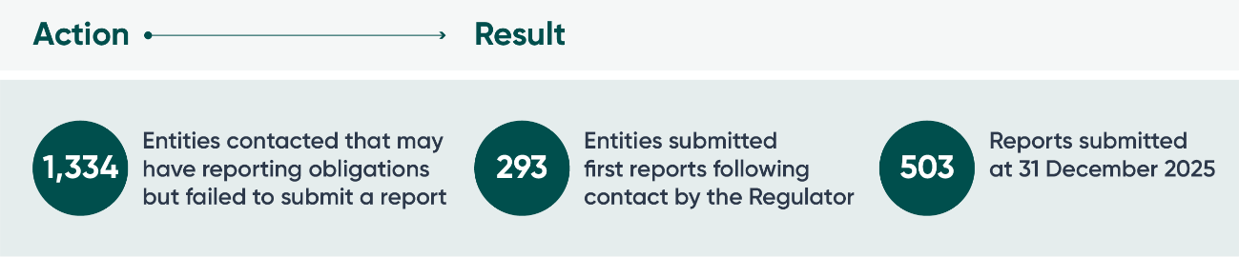
We asked entities to assess their reporting obligations under the reformed Scheme and address any potential non-compliance. As a result, 293 entities submitted payment times reports for the first time, with a total of 503 reports submitted by these entities as at 31 December 2025.
This compliance initiative also helped to identify instances where controlled entities within consolidated reporting groups had incorrectly submitted individual reports, rather than have their payment data covered under a single consolidated report.

Entities that submitted a report but failed to submit a subsequent report
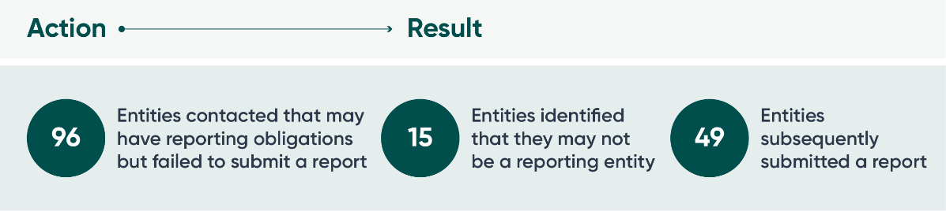
We engaged with 96 entities that had reported in one reporting period, but failed to submit a report in a subsequent period to remind them of their ongoing reporting obligations.
As a result of this engagement, 49 entities submitted a subsequent report. A further 15 entities have advised their report should not have been submitted because they may not have met the legislative requirements of a reporting entity; 10 of those reports were subsequently withheld.

Failure to submit a report within the timeframe


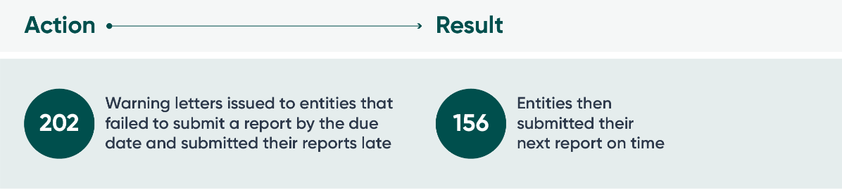
The Regulator issued 202 warning letters to entities that submitted their payment times reports after the due date.
If these entities fail to meet their reporting obligations again, the Regulator will take enforcement action, which may include publishing details of the entity and its non-compliance on the Payment Times Reports Register and issuing infringement notices.

Compliance priority: false or misleading reports and/or conduct

Failure to use the SBI Tool when preparing a report
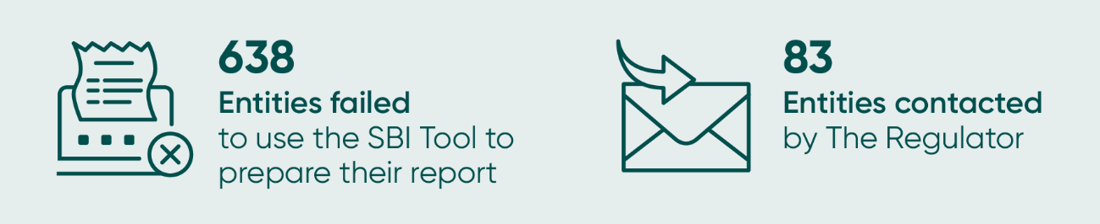
The Regulator identified 638 payment times reports that appear to have been prepared without using the SBI Tool. Entities must use the SBI Tool to determine which payments were made to small business suppliers each time a report is prepared.
From the 83 entities contacted by the Regulator, 46 advised that the SBI Tool was run by an entity within the consolidated group. While it is acceptable for a controlled entity within a corporate group to access the SBI Tool on behalf of the reporting entity, an increasing number of reports are being submitted without any evidence of SBI Tool usage. Preparing a report without accessing the SBI Tool may result in false or misleading information.
As part of the Regulator’s escalating approach to compliance and enforcement and to support accurate reporting, the Regulator took proactive steps by writing to entities that appeared not to have used the SBI Tool when preparing their report/s. Clarification was sought on whether the entity, or another entity within its consolidated group, had used the SBI Tool and the Regulator requested supporting evidence, such as the SBI Tool output file.
Entities that continue to submit reports without using the SBI Tool may face public disclosure of their non-compliance and may be issued an infringement notice.

False or misleading information submitted in a report


The Regulator continues to monitor reports and actively engage with entities where information is suspected to be inaccurate, false or misleading.
As a result of this engagement, entities requested the removal of 112 wrongly submitted reports from the Payment Times Reports Register and revised 200 reports to amend incorrectly reported information.

Help us prevent fraud
The Regulator is committed to preventing fraud through false and/or misleading reporting. If you suspect payment times reports contain false and/or misleading information on payment practices, report it by emailing us at compliance@paymenttimes.gov.au

Compliance priority: failure to comply with directives from the Regulator and/or Minister
We continue to actively monitor compliance with directives from the Regulator.
In 2026, we will continue to monitor reporting entities’ attitudes to compliance and take appropriate regulatory action. Entities can expect the Regulator to have a focus on both the fast small business payer and slow small business payer incentives.
Regulatory action will be taken where entities misrepresent themselves as fast small business payers or do not comply with slow small business payer directions.

Noticed something unusual?
If you suspect that an entity has incorrectly represented itself as a Fast Small Business Payer, or an entity has failed to comply with a slow small business payer direction, report it to the Regulator by emailing us at compliance@paymenttimes.gov.au

Fast small business payer

Most entities are not fast small business payers
The Fast Small Business Payer List (the List) is a reputational incentive under the Scheme. It recognises large businesses that consistently pay their small business suppliers promptly. The List is publicly available on the Payment Times Reports Register, providing visibility and transparency on fast, high-performing small business payers, while encouraging broader adoption of faster payment practices.

How to qualify for the fast small business payer recognition
To be included on the List, an entity must meet all the following criteria:
- be a reporting entity or reporting nominee, as defined under sections 7 and 10L respectively of the Act, and
- have submitted two consecutive payment times reports, with each showing a 95th percentile payment time of 20 days or less, and
- the end date of the most recent reporting period is not more than 9 months old.

Where are the most and fewest potential fast small business payers?
As at 31 December 2025:


In the Information Media and Telecommunications and Health Care and Social Assistance industries:



These results highlight there is significant room for improvement across all industries.

Stretch goal – to have 90 per cent of entities within an industry qualify as fast small business payers
To see at least 90 per cent of eligible entities in an industry have a qualifying payment time of 20 days or less, a substantial reduction in the number of days taken to pay 95 per cent of small business invoices (95th percentile payment times) is required:
- The Financial and Insurance Services industry is the closest, needing a reduction of 48 days.
- The Education and Training industry is the furthest, needing a reduction of 103 days.
Data from Reporting Cycle 9 shows that most entities are not yet close to having a qualifying payment time of 20 days or less. Achieving a 95th percentile payment time of 20 days or less requires significant improvements in payment practices across the board.
Table 3: Percentage of potential fast small business payers by industry

Industry  Ranked by potential fast payers | Potential  fast payers  (%) | Reduction in days by industry to achieve fast payer of at least
Industry  Ranked by potential fast payers | Potential  fast payers  (%) | 80%  (days) | 90%  (days)
Administrative and Support Services | 10.9% | 47 | 62
Financial and Insurance Services | 6.6% | 38 | 48
Education and Training | 5.9% | 72 | 103
Electricity, Gas, Water and Waste Services | 4.8% | 44 | 58
Other Services | 3.6% | 53 | 88
Agriculture, Forestry and Fishing | 3.0% | 40 | 50
Public Administration and Safety | 2.9% | 51 | 56
Mining | 2.4% | 55 | 71
Accommodation and Food Services | 2.3% | 49 | 70
Arts and Recreation Services | 1.9% | 40 | 57
Transport, Postal and Warehousing | 1.7% | 51 | 66
Professional, Scientific and Technical Services | 1.7% | 65 | 87
Rental, Hiring and Real Estate Services | 1.3% | 63 | 78
Wholesale Trade | 1.2% | 63 | 79
Construction | 0.8% | 57 | 79
Manufacturing | 0.5% | 65 | 75
Retail Trade | 0.4% | 55 | 71
Health Care and Social Assistance | 0% | 62 | 72
Information Media and Telecommunications | 0% | 56 | 67
All Industries | 2.3% | 56 | 71
Note: Shows the reduction in the number of days in the reported 95th percentile payment time to achieve at least 80 per cent and 90 per cent of the industry as fast payers, as at 31 December 2025.
Being publicly acknowledged as fast small business payers provides reputational signals to the market that a business supports small businesses. This status can be used in marketing, procurement and corporate reporting to differentiate a business from competitors that have slower payment practices.

Slow small business payer
With the reformed Scheme now in operation across 2 full reporting cycles, the Regulator is focused on identifying slow small business payers.
The Regulator and/or the Minister may issue a slow small business payer direction (direction) to the slowest payers, in line with their compliance and enforcement powers.

When is an entity considered to be a slow small business payer?
A reporting entity or a reporting nominee is identified as a slow small business for a reporting cycle if:
- it has given the Regulator a payment times report for a reporting period that ended within that reporting cycle, and that payment times report has a 95th percentile payment time that is more than 30 days, and
- their 95th percentile payment time ranks:
  - in the bottom 20 per cent of all reporting entities and reporting nominees overall, or
  - in the bottom 20 per cent in a division of the ANZSIC, based on its reported primary business activity.
Payment times reports from the following entities are excluded from the calculation for the purposes of identifying the bottom 20 per cent:
- volunteer entities, and
- entities that are not required to provide details of their payment times as they submit modified reports.


The 30-day ‘safe harbour’: fairness in slow payer identification
The Regulator will not classify entities as slow small business payers if they pay 95 per cent of their small business invoices within 30 days, even if they fall within the slowest 20 per cent of entities.
This ‘safe harbour’ protects businesses that meet a reasonable payment standard and ensures that only genuinely slow paying entities are identified. It reinforces fairness and proportionality in how payment performance is assessed under the Scheme.
In Reporting Cycle 9, only 469 entities reported a 95th percentile payment time of 30 days or less. The average 95th percentile payment time across all entities was 64 days.

Reporting cycle vs reporting period
A reporting cycle differs from a reporting period. To compare payment times for entities with different financial years and reporting periods, payment times reports are assigned to a reporting cycle based on the end date of the relevant reporting period (see Appendix A).
There are two reporting cycles each year:
- 1 January to 30 June, and
- 1 July to 31 December.

Slow small business payer direction
A reporting entity or reporting nominee may be subject to a direction if it is identified as a Slow Small Business Payer in 2 consecutive reporting cycles.
Importantly, failure to submit a payment times report does not exempt an entity from being subject to a direction. Where a report has not been submitted (for a prior or future cycle) the entity is taken to have been identified as a slow small business payer for that cycle.
The decision to give a direction remains at the discretion of the Regulator and/or Minister.
Before a direction is issued:
- all relevant matters and supporting information will be considered, and
- entities will be given an opportunity to provide written submissions for consideration by the decision maker.

When may directions be issued?
Reporting Cycle 9 and Reporting Cycle 10 are the first 2 consecutive reporting cycles that will be considered for identifying slow small business payers and issuing directions.
The first directions will be considered after 31 March 2026 when reports for Reporting Cycle 10 are due to be given to the Regulator.

What may a direction require an entity to do?
If a reporting entity or reporting nominee receives a direction, it may be required to publicly disclose its status as a Slow Small Business Payer.
This disclosure may need to appear on the entity’s:
- website
- procurement and tender documents
- environmental, social and governance (ESG) sustainability reports, and/or
- other relevant public-facing materials.

Compliance with directions
Entities that fail to comply with a direction are liable to civil penalties.
As part of the Regulator’s 2025–26 Compliance and Enforcement Priorities, we will actively monitor compliance with directions issued by the Regulator and/or the Minister.

Small Business Identification Tool
We encourage all reporting entities to read the updated Information Sheet 6 published in December 2025, which provides clearer, consolidated guidance on the use of the SBI Tool.
The updated information sheet outlines:
- what the SBI Tool is used for
- how to interpret outcomes
- when to re-check supplier classifications, and
- how to contact the Regulator to request updates outside the annual cycle.
The strengthened information sheet provides reporting entities with clearer guardrails while maintaining the SBI Tool’s ease of use. It focuses on how it should be used, when its underlying data can change, and what the Regulator requires when submitting a request to change an entity’s classification.

Purpose of the SBI Tool
The SBI Tool is designed to help reporting entities determine which of their suppliers are classified as small businesses for the purposes of payment times reporting.
Did you know?
Use of the SBI Tool is required by law
Reporting entities must use the tool to identify small business suppliers each time a payment times report is submitted.

Trends in SBI Tool usage
Over the past year, the Regulator has observed strong and consistent use of the SBI Tool, particularly in the lead-up to reporting periods. This pattern indicates it is being used for its intended purpose: checking small business status ahead of preparing and submitting reports.

When can SBI Tool results change?
Information Sheet 6 clarifies that SBI Tool outcomes are point-in-time assessments. Changes to the underlying data may occur in two ways:

Annual updates: The Regulator refreshes the SBI Tool’s inputs each year to reflect the most current available data.
Ad hoc changes: The data may also be updated at any time, when a request to change a supplier’s classification is received and approved by the Regulator.

How to request an ad hoc change
Entities must submit a ‘Notification to Correct the SBI Tool’ form to the Regulator through the portal. Each request must be supported by one of the following:
- a statutory declaration affirming the supplier was paid $10 million or more in their financial year, or
- documentary evidence showing the supplier was paid $10 million or more in their financial year (e.g. contracts, statements, or supplier confirmation identifying the relevant financial year), or
- evidence that the supplier is part of a corporate group with consolidated annual revenue of $10 million or more. For example:
  - the supplier’s parent is listed as a reporting entity on the Payment Times Reports Register, or
  - financial statements showing consolidated revenue above the threshold.
If you’re unable to provide the required evidence, you may ask the supplier to contact the Regulator directly to request a correction to their classification for the purposes of payment times reporting.

Processing times
The Regulator is committed to processing these notification forms within 28 days, provided all required documentation has been submitted for consideration.
For the period 1 July to 31 December 2025, the Regulator received:
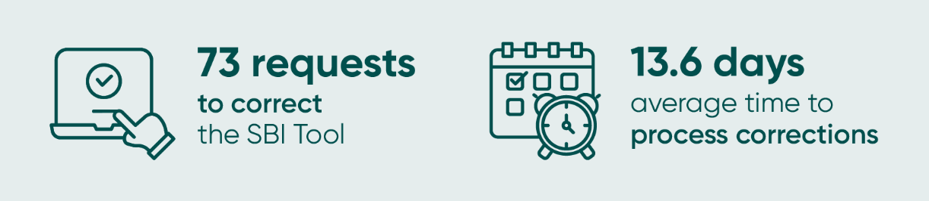

Applications
Over the 6 months from 1 July to 31 December 2025, the Regulator processed a total of 484 applications. These applications were either approved, rejected or withdrawn at the request of the applicant.
Applications breakdown
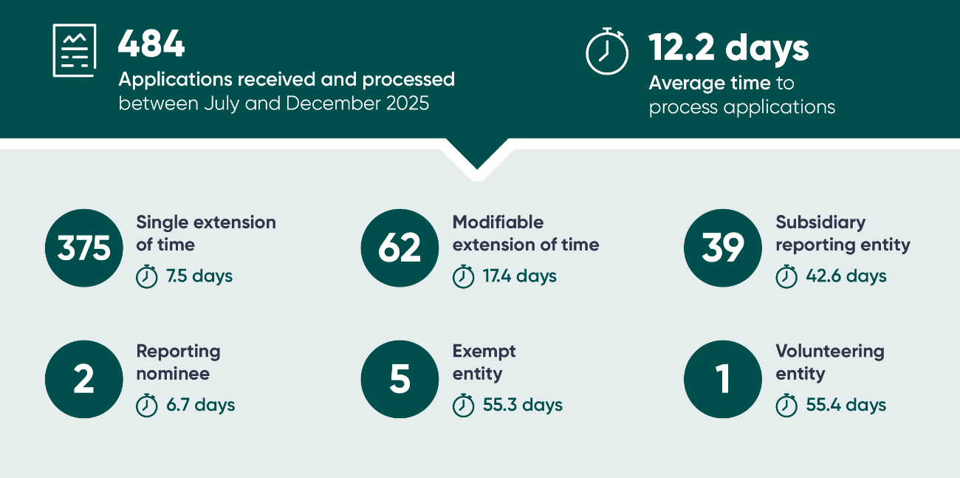
Note: Numbers within green circles depict applications processed under each category
The Regulator continues to process a large number of applications. Processing times can vary by application type and range from 6.7 days to 55.4 days. The most common reasons for delays in processing applications are issues with the application form and the evidence provided. This means we have to write to applicants to request additional information which takes time. To avoid delays in processing times, see the section Tips to avoid common errors.

Tips to avoid common errors
The Regulator continues to identify common errors that can lead to inaccurate or misleading reports, incorrectly completed Entity Information forms and invalid or incomplete applications. Administrative errors such as these may result in entities failing to meet their obligations under the Act, the Payment Times Reporting Rules 2024 (the Rules) and cause delays in processing applications.

Applications and notices: tips to avoid delays
A large number of applications continue to be submitted without the appropriate evidence or information:
- more than 40 per cent of applications to be a subsidiary reporting entity required additional information due to not meeting evidentiary thresholds
- almost 30 per cent of applications to be a subsidiary reporting entity were withdrawn or rejected, either because of insufficient evidence or the wrong application type was submitted, and
- only 36 per cent of the submitted notices to cease reporting were valid.
Due to the wrong application type being submitted, the Regulator did not approve any applications to be an exempt entity or a reporting nominee during the period 1 July to 31 December 2025. Careless errors such as these cause unnecessary delays in processing applications.

How you can help reduce processing times
To help strengthen your application and assist with assessment, consider these tips:
- Complete all parts of the application form.
- Provide relevant documentary evidence that supports your application. Refer to the published Guidance Materials for examples specific to your application type.
- Include a valid date of effect:
  - For example, an application to be a subsidiary reporting entity can only take effect from the start of the provisional reporting period in which the application is submitted, or from the start of the following period. The date of effect cannot be backdated.
- Do not submit a notice to cease reporting if the entity:
  - was a reporting entity before 1 July 2024, and
  - did not meet the reporting entity criteria under the reformed scheme at the start of the entity’s first reporting period on or after 1 July 2024. In this case, the obligation to report ceases automatically.
- An entity can only cease to be a reporting entity if its consolidated revenue falls below $100 million in 2 consecutive reporting periods.
  - An entity cannot give a notice to cease reporting after just one year of falling below the threshold.
- If a reporting entity is acquired by another reporting entity during its reporting period, it cannot submit a notice to cease reporting until the start of its next reporting period after the acquisition.

Reporting: tips to avoid submitting false or misleading information
The Regulator has identified several common issues that have resulted in:
- false or misleading reports, and
- incorrectly completed Entity Information forms.
Providing false or misleading information to the Regulator can lead to non-compliance with the Act and the Rules and may result in regulatory action.
Between 1 July and 31 December 2025, 312 reports were revised or removed from the Payment Times Reports Register following engagement with entities.
We continue to work closely with entities to correct reported data and strengthen the integrity of the Payment Times Reports Register.

Common reporting issues and how to avoid them

1. Consolidated reporting
Issue: Controlled entities are incorrectly submitting their own reports.
Clarification: A reporting entity is the highest-level entity (parent entity) in a corporate group. It meets all criteria under section 7 of the Act, including not being controlled by another entity that also qualifies as a reporting entity.
An entity that is controlled by a reporting entity should not submit its own report, unless:
- it has applied for, and received, a determination from the Regulator to be a subsidiary reporting entity, or
- its parent entity does not meet the reporting entity criteria, in which case the controlled entity may be a reporting entity in its own right.
Examples:
Scenario 1
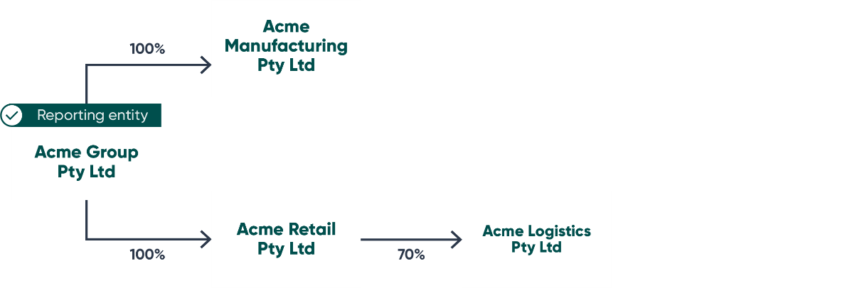
In this scenario, if Acme Group Pty Ltd satisfies all criteria to be a reporting entity, it is the only entity in the group required to submit a payment times report. As the reporting entity, Acme Group Pty Ltd must prepare and submit a consolidated report, covering the payment times information for:
- Acme Group Pty Ltd
- Acme Manufacturing Pty Ltd
- Acme Retail Pty Ltd
- Acme Logistics Pty Ltd
Scenario 2
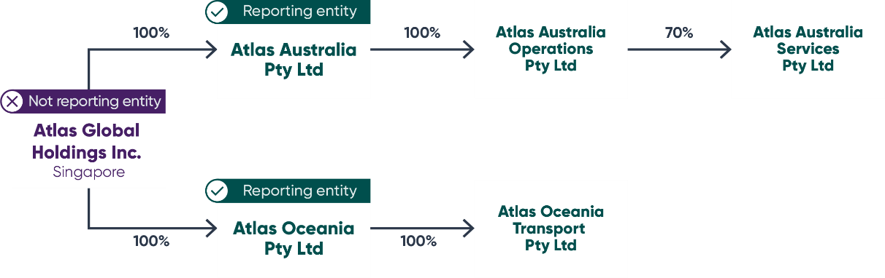
In this scenario, if Atlas Global Holdings Inc. does not satisfy all criteria to be a reporting entity, then Atlas Oceania Pty Ltd and Atlas Australia Pty Ltd may each be a reporting entity as they are not controlled by a reporting entity.
If Atlas Oceania Pty Ltd and Atlas Australia Pty Ltd each satisfy all criteria to be a reporting entity, their reporting obligations are:
Atlas Oceania Pty Ltd must prepare and submit a consolidated report, covering the payment times information for:
- Atlas Oceania Pty Ltd
- Atlas Oceania Transport Pty Ltd
Atlas Australia Pty Ltd must prepare and submit a consolidated report, covering the payment times information for:
- Atlas Australia Pty Ltd
- Atlas Australia Operations Pty Ltd
- Atlas Australia Services Pty Ltd

2. Range of most common payment terms
Issue: Entities are reporting minimum and maximum values for the most common payment terms that do not align with the reporting entity’s most common payment term.

Tip: These fields must reflect the minimum and maximum values of the most common payment terms reported by each individual entity in a consolidated group, which includes the reporting (parent) entity.
If the minimum and maximum are the same, this value must match the most common payment term field.

3. 80th and 95th percentile payment times
Issue 1: The 80th and 95th percentile payment time values are inconsistent with the percentage of invoices paid within 30 days, 31–60 days and more than 60 days.
Tip: If the 95th percentile payment time is 60 days or less, the sum of the percentages for ‘Invoices paid within 30 days’ and ‘Invoices paid within
31–60 days’ should be equal to or greater than 95 per cent.

Issue 2: Entities are entering the number of days as decimal values in the 80th and 95th percentile payment time fields.
Tip: These fields must reflect the whole number of days it took to pay 80 per cent and 95 per cent of small business invoices.
Decimal values are not accepted and may result in incorrect and very large entries. For example, 45.3 days will be reported as 453 days, and 14.45 days will be reported as 1,445 days.
In Reporting Cycle 9, 20 payment times reports were submitted with a 95th percentile payment time of more than 365 days. The Regulator wrote to the relevant entities that submitted reports with potentially incorrect data, resulting in 7 reports being corrected.

Did you know?
Incorrect entries in these fields may result in the entity being flagged for a slow small business payer direction or not being identified as a Fast Small Business Payer.

Entity information form completed incorrectly
The Regulator has identified that some Entity Information forms in the portal have been completed incorrectly. Some of the common errors include:
- indicating the entity is required to prepare financial reports under the Australian Accounting Standards Board’s (AASB) Australian Accounting Standard AASB 8 – Operating Segments, but then submitting a standard report without identifying operating segments
- listing the entity as its own ultimate controlling entity
- including ‘subsidiary reporting entities’ that have not received a determination from
the Regulator, or
- providing an ANZSIC subdivision, including title and code that does not reflect the entity’s primary business activity.
Additionally, the Regulator has identified that Entity Information forms are being submitted by entities that are controlled by reporting entities. An entity that is controlled by a reporting entity cannot submit its own reports and therefore should not be submitting an Entity Information form.

Appendix A – Insights: methodology and assumptions

Reporting cycles
Reporting Cycle 1 | Reporting Cycle 2 | Reporting Cycle 3 |  | Reporting Cycle 9
1/01/2021–30/06/2021 | 1/07/2021–31/12/2021 | 1/01/2022–30/06/2022 | ⟶ | 1/01/2025–30/06/2025
Reports are assigned to a reporting cycle based on the reporting period end date. For example, reports with a reporting period end date of 15 March 2025 will be categorised as Reporting Cycle 9 for the purpose of payment times reporting.
Prior to December 2024, reports were assigned by the reporting period start date. This change has a minimal effect and aligns all reports under the reforms to Scheme.
Reporting cycles and reporting instances (that is an entity’s first report, second report, etc.) do not reconcile due to the timing of reports. For example, an entity’s first reporting instance may have occurred in Reporting Cycle 2 or 3.
Historic report statistics may change when entities submit reports for previous reporting cycles or revise reports.

Insights are at a point in time
Data is subject to revision and reports are received on a continuous basis, including for historical reporting cycles. Previous reports can also be updated by submitting a revised report.
Insights provided in this Update are based on reports received on or before 31 December 2025 and subsequently published. These insights are subject to change as additional or revised reports are submitted and published after this date.
Note: Caution should be exercised when interpreting the data or insights in this Update as the key reporting measures may not be directly comparable to measures from reporting cycles pre-July 2024. The July 2025 Regulator’s Update was the first publication to publish insights based on the new measures.

Analysis on payment times
Reports received for Reporting Cycle 9 (1 January 2025 to 30 June 2025) contain reported payment terms and payment times data relating to payments made to small business suppliers. Reported data includes payment times expressed in days for average payment times, median payment times, the 80th percentile payment time, the 95th percentile payment time and percentage of invoices paid on time (within payment terms). Payments for invoices paid to small business suppliers are grouped into 3 separate day ranges (within 30 days, 31-60 days and more than 60 days).

Consolidated reporting
Consolidated reporting was introduced to the Scheme from 1 July 2024. Consolidation of entities using the AASB accounting standards provides a consistent and well understood framework for entities. It also reduces unnecessary administrative and compliance burden for individual entities in a group. Consolidated reporting allows a single report for a corporate group to be provided to the Regulator for publication to the Payment Times Reports Register.

Assumptions
Unless otherwise stated, the following assumptions apply:

Included in the analysis
- Analysis is based on self-reported data from all reporting entities that make payments to small businesses (including volunteer entities).
- References to reporting entities include those that meet the definition of a reporting entity under section 7 of the Act, as well as volunteering entities, subsidiary reporting entities, and reporting nominees, as determined by the Regulator.
- Analysis for Reporting Cycle 9 is based on reports with reporting period end dates on or before 30 June 2025 and received by 31 December 2025. Therefore, data insights published in the Update are subject to revision as entities continue to submit reports.
- Reports submitted for Reporting Cycle 9 includes key measures, such as average payment times, median payment times, the 80th and 95th percentile payment times, and percentage of invoices paid on time.

Excluded from analysis
Reports which indicate no procurement from small businesses are excluded from calculations for payment terms and payment times.
Superseded reports are excluded from calculations. A superseded report is an original report that has been replaced by a subsequent revised report. Only the most recent revised report is used for analysis. A count of superseded reports is displayed in Table 4.

Appendix B – Data tables
All data tables reflect payment times reports and revised reports received on or before 31 December 2025, reflecting small business payment activity up to and including Reporting Cycle 9. Reporting Cycle 10 is presented in Table 4 to give a complete picture of all reports received on or before 31 December 2025.
Time series data has been included in some tables below. Note: Following the reforms, time series data is not always comparable due to a number of reasons, including consolidated reporting or differences in reporting measures. In some instances, the Regulator has separated data for reporting period start dates before and after 1 July 2024.
Table 1: Share of small business procurement, Reporting Cycles 1 to 9
Reporting cycle | Cycle range | Proportion of total procurement value with small businesses
Reporting cycle | Cycle range | Reporting periods start dates
Reporting cycle | Cycle range | Before 1 July 2024 | After 1 July 2024
Reporting cycle 1 | 1 Jan 2021 – 30 Jun 2021 | 29.3%
Reporting cycle 2 | 1 Jul 2021 – 31 Dec 2021 | 29.7%
Reporting cycle 3 | 1 Jan 2022 – 30 Jun 2022 | 29.7%
Reporting cycle 4 | 1 Jul 2022 – 31 Dec 2022 | 29.5%
Reporting cycle 5 | 1 Jan 2023 – 30 Jun 2023 | 30.0%
Reporting cycle 6 | 1 Jul 2023 – 31 Dec 2023 | 30.1%
Reporting cycle 7 | 1 Jan 2024 – 30 Jun 2024 | 30.1%
Reporting cycle 8 | 1 Jul 2024 – 31 Dec 2024 | 29.6% | 30.3%
Reporting cycle 9 | 1 Jan 2025 – 30 Jun 2025 |  | 28.7%

Table 2: Report types, Reporting Cycle 9
Report type | Total reports  (No. and %)
Standard | 2,792 (83.4%)
No small business procurement | 238 (7.1%)
AASB 8 | 312 (9.3%)
Has nominee | n/a (0.0%)
External administration | 4 (0.1%)
Total reports on the Register (this cycle) | 3,346 (100%)

Table 3: Reporting entities by industry, Reporting Cycle 9
Industry  Ranked by number of reporting entities | Reporting  entities  (No. and %) | Controlled  entities  (No.) | Average common  payment terms  (days) | Proportion of total procurement value with small businesses  (%)
Manufacturing | 415 (13.4%) | 1,185 | 35 | 27.6%
Financial & Insurance Services | 413 (13.3%) | 2,468 | 21 | 23.9%
Wholesale Trade | 407 (13.1%) | 814 | 33 | 24.7%
Construction | 266 (8.6%) | 2,012 | 34 | 43.3%
Retail Trade | 260 (8.4%) | 1,891 | 31 | 25.5%
Professional, Scientific & Technical Services | 236 (7.6%) | 925 | 28 | 31.2%
Mining | 212 (6.8%) | 1,371 | 32 | 21.1%
Transport, Postal & Warehousing | 176 (5.7%) | 672 | 30 | 25.6%
Health Care & Social Assistance | 112 (3.6%) | 1,708 | 26 | 30.9%
Electricity, Gas, Water & Waste Services | 105 (3.4%) | 696 | 26 | 22.1%
Agriculture, Forestry & Fishing | 100 (3.2%) | 271 | 24 | 41.5%
Rental, Hiring & Real Estate Services | 74 (2.4%) | 637 | 27 | 30.7%
Information Media & Telecommunications | 81 (2.6%) | 625 | 29 | 23.5%
Administrative & Support Services | 64 (2.1%) | 327 | 25 | 41.9%
Arts & Recreation Services | 55 (1.8%) | 336 | 25 | 37.1%
Accommodation & Food Services | 43 (1.4%) | 475 | 25 | 32.7%
Public Administration & Safety | 34 (1.1%) | 86 | 23 | 31.0%
Other Services | 28 (0.9%) | 186 | 26 | 37.6%
Education & Training | 17 (0.5%) | 137 | 20 | 39.3%
All industries | 3,098 (100%) | 16,741 | 29 | 28.7%
Table 4: Payment times reports received by 31 December 2025, Reporting Cycles 1 to 10
Reporting Cycle | Cycle range | Number of reports  (No.) | Average standard payment terms (days) | Average common payment terms (days) | Average proportion of procurement value with small business (%) | Average proportion of invoices paid within 30 days (%)
Cycle 1 | 1 Jan – 30 Jun 2021 | 6,355 | 36.7 | n/a | 29.3% | 63.2%
Cycle 2 | 1 Jul – 31 Dec 2021 | 7,528 | 35.9 | n/a | 29.7% | 65.6%
Cycle 3 | 1 Jan – 30 Jun 2022 | 7,753 | 35.4 | n/a | 29.7% | 66.2%
Cycle 4 | 1 Jul – 31 Dec 2022 | 7,965 | 35.1 | n/a | 29.5% | 67.5%
Cycle 5 | 1 Jan – 30 Jun 2023 | 8,014 | 34.9 | n/a | 30.0% | 67.2%
Cycle 6 | 1 Jul – 31 Dec 2023 | 8,171 | 34.8 | n/a | 30.1% | 68.7%
Cycle 7 | 1 Jan – 30 Jun 2024 | 8,155 | 35.0 | n/a | 30.1% | 68.7%
Cycle 8 | 1 Jul – 31 Dec 2024 | 3,453 | 35.2 | 30 | 30.1% | 68.4%
Cycle 9 | 1 Jan – 30 Jun 2025 | 3,104 | n/a* | 29 | 28.7% | 68.2%
Cycle 10 | 1 Jul – 31 Dec 2025 | 294
Total |  | 60,792
Superseded reports |  | 2,030
Total reports |  | 62,822
* The average standard payment terms reported since the Scheme began in 2021 has been replaced with the most common payment term.

Table 5: Payment terms and times for Commonwealth entities, Reporting Cycle 9
Averages | Common payment term (days) | Median payment time (days) | Average payment time (days) | 80th percentile payment time  (days) | 95th percentile payment time (days) | Average percentage paid on time  (%)
Commonwealth Entity Averages | 19.6 | 12 | 16.4 | 20 | 40 | 74.3%
All industry Averages | 29 | 23 | 27.4 | 39 | 64 | 66.5%

Table 6: Average payment times with day ranges, Reporting Cycles 1 to 9
Reporting Cycle | Cycle range | Proportion of entities with average payment times within:
Reporting Cycle | Cycle range | 30 days  (%) | 31-60 days  (%) | >60 days  (%)
Cycle 1 | 1 Jan 2021 - 30 Jun 2021 | 63.2% | 28.2% | 8.6%
Cycle 2 | 1 Jul 2021 - 31 Dec 2021 | 65.6% | 26.6% | 7.8%
Cycle 3 | 1 Jan 2022 - 30 Jun 2022 | 66.2% | 25.8% | 8.1%
Cycle 4 | 1 Jul 2022 - 31 Dec 2022 | 67.5% | 24.8% | 7.7%
Cycle 5 | 1 Jan 2023 - 30 Jun 2023 | 67.2% | 24.8% | 8.0%
Cycle 6 | 1 Jul 2023 - 31 Dec 2023 | 68.7% | 24.1% | 7.1%
Cycle 7 | 1 Jan 2024 - 30 Jun 2024 | 68.7% | 24.0% | 7.3%
Cycle 8 | 1 Jul 2024 - 31 Dec 2024 | 68.2% | 25.0% | 6.8%
Cycle 9 | 1 Jan 2025 - 30 Jun 2025 | 68.2% | 25.0% | 6.8%

Table 7: Payment times and terms, Reporting Cycle 9
Common payment term | Median payment time | Average payment time | 80th percentile payment time | 95th percentile payment time
29 | 23.0 | 27.4 | 39 | 64

Table 8: Average percentage of payments within 30 days by industry, Reporting Cycle 9
Industry  Ranked by alphabetical order | Reporting Cycle 9
Industry  Ranked by alphabetical order | 1 Jan 2025 to 30 Jun 2025 (%)
Ranked by alphabetical order | %
Accommodation and Food Services | 74.2%
Administrative and Support Services | 75.8%
Agriculture, Forestry and Fishing | 72.8%
Arts and Recreation Services | 79.9%
Construction | 54.7%
Education and Training | 76.6%
Electricity, Gas, Water and Waste Services | 77.9%
Financial and Insurance Services | 87.3%
Health Care and Social Assistance | 71.6%
Information Media and Telecommunications | 74.1%
Manufacturing | 54.3%
Mining | 63.5%
Other Services | 67.9%
Professional, Scientific and Technical Services | 70.0%
Public Administration and Safety | 78.9%
Rental, Hiring and Real Estate Services | 73.8%
Retail Trade | 65.3%
Transport, Postal and Warehousing | 67.0%
Wholesale Trade | 64.1%
All industries | 68.2%

Table 9: Payment terms and times measures by industry, Reporting Cycle 9
Industry  Ranked by alphabetical order | Average common payment term (days) | Average payment time (days) | 80th percentile payment time (days) | 95th percentile payment time (days) | Average percentage paid on time  (%)
Accommodation & Food Services | 25 | 25.4 | 35 | 54 | 61.0%
Administrative & Support Services | 25 | 22.6 | 31 | 45 | 70.0%
Agriculture, Forestry & Fishing | 24 | 23.4 | 35 | 49 | 73.4%
Arts & Recreation Services | 25 | 21.1 | 30 | 50 | 69.4%
Construction | 34 | 33.5 | 47 | 68 | 64.8%
Education & Training | 20 | 24.4 | 33 | 62 | 71.6%
Electricity, Gas, Water & Waste Services | 26 | 23.5 | 31 | 48 | 68.6%
Financial & Insurance Services | 21 | 17.4 | 27 | 49 | 72.1%
Health Care & Social Assistance | 26 | 27.5 | 39 | 62 | 60.3%
Information Media & Telecommunications | 29 | 24.7 | 35 | 67 | 69.1%
Manufacturing | 35 | 33.7 | 47 | 67 | 62.1%
Mining | 32 | 30.0 | 39 | 70 | 68.7%
Other Services | 26 | 28.4 | 38 | 57 | 72.3%
Professional, Scientific & Technical Services | 28 | 27.9 | 38 | 94 | 64.8%
Public Administration & Safety | 23 | 23.3 | 31 | 51 | 68.0%
Rental, Hiring & Real Estate Services | 27 | 25.8 | 34 | 56 | 66.9%
Retail Trade | 31 | 28.7 | 40 | 77 | 67.5%
Transport, Postal & Warehousing | 30 | 27.7 | 41 | 62 | 61.9%
Wholesale Trade | 33 | 29.3 | 41 | 65 | 65.4%
All Industries | 29 | 27.4 | 39 | 64 | 66.5%



Department of Finance, Flipchart of PGPA Act Cth entities and companies, 5 January 2026.
Department of Finance, Flipchart of PGPA Act Cth entities and companies, 5 January 2026.
Payment Times Reporting Regulator, How to Identify Small Business Suppliers (SBI Tool) (n.d.).
Australian Bureau of Statistics, Remoteness Areas, Jul 2021–Jun 2026.
ABS, Australian Industry, 2023–24 Financial Year (Catalogue No 8155.0, 2023–24).
ABS, Australian Industry, 2023–24 Financial Year.
ABS, Australian System of National Accounts, 2024–25.
Bureau of Infrastructure and Transport Research Economics, Australian Infrastructure and Transport Statistics Yearbook 2024 (2024).
ABS, Counts of Australian Businesses, Including Entries and Exits, July 2021–June 2025 (Catalogue No 8165.0, 2025).
BITRE, Australian Infrastructure and Transport Statistics Yearbook 2024.
BITRE, Australian Infrastructure and Transport Statistics Yearbook 2024.
Payment Times Reporting Regulator, How to Identify Small Business Suppliers (SBI Tool) (Guidance Material, 2025).
This assumes that all entities meet the other criteria for becoming a fast payer.

