

Regulator’s Update

July 2025

© Commonwealth of Australia 2025

This publication is available for your use under a [Creative Commons Attribution 4.0 International](https://creativecommons.org/licenses/by/4.0/) licence, with the exception of the Commonwealth Coat of Arms, the Treasury logo, photographs, images, third party materials, materials protected by a trademark, signatures and where otherwise stated. The full licence terms are available from [creativecommons.org/licenses/by/4.0/legalcode](https://creativecommons.org/licenses/by/4.0/legalcode).

Creative Commons BY icon

Use of Treasury material under a [Creative Commons Attribution 4.0 International](https://creativecommons.org/licenses/by/4.0/) licence requires you to attribute the work (but not in any way that suggests that the Treasury endorses you or your use of the work).

**Treasury material used ‘as supplied’**

Provided you have not modified or transformed Treasury material in any way including, for example, by changing the Treasury text; calculating percentage changes; graphing or charting data; or deriving new statistics from published Treasury statistics – then Treasury prefers the following attribution:

Source:The Commonwealth of Australia.

**Derivative material**

If you have modified or transformed Treasury material, or derived new material from those of the Treasury in any way, then Treasury prefers the following attribution:

Based on Commonwealth of Australia data.

**Use of the Coat of Arms**

The terms under which the Coat of Arms can be used are set out on the Department of the Prime Minister and Cabinet website (see [www.pmc.gov.au/government/commonwealth-coat-arms](http://www.pmc.gov.au/government/commonwealth-coat-arms)).

**Other uses**

Enquiries regarding this licence and any other use of this document are welcome at:

Manager  
Media Unit  
The Treasury  
Langton Crescent   
Parkes ACT 2600  
Email: [media@treasury.gov.au](mailto:media@treasury.gov.au)

In the spirit of reconciliation, the Treasury acknowledges the Traditional Custodians of country throughout Australia and their connections to land, sea and community. We pay our respect to their Elders past and present and extend that respect to all Aboriginal and Torres Strait Islander peoples.

Contents

Letter from the Regulator 1

Update on Regulator’s 2025 Priority Areas 3

What Do the New Payment Times Reporting Measures Mean? 4

How The Regulator Is Helping You 6

New Measures Data Snapshot 7

Spotlight 8

Data Insights 10

Industry Insights 13

Tips to Avoid Common Reporting Errors 15

Policy Update 17

Commitment to Continuous Improvement 18

Engagement and Education 20

Compliance and Enforcement 22

Applications 23

Appendix A – Insights: Methodology and Assumptions 27

Appendix B – Data Tables 29

# Letter from the Regulator

I am pleased to be sharing with you the Regulator’s Update for July 2025. In this update, I outline the progress made in my priority areas for 2025, share updated insights and highlight the value that new reporting fields bring to increasing transparency of payment terms, times and practices under the Scheme. I will also address some of the common reporting errors being identified over this transition period to assist reporting entities in avoiding non‑compliance and strengthening the integrity and quality of their self- reported data.

Firstly, I acknowledge the Traditional Owners and Custodians of Country throughout Australia and recognise their continuing connection to the lands, waterways and skies. I pay my respect to Elders past, present and emerging.

As the Regulator, I have a responsibility to administer the Scheme, promote timely payment practices, foster a culture of prompt payment and improve the transparency of the payment terms, times and practices of large businesses and certain government entities. Delivering on these responsibilities supports economic growth and improves outcomes for Australia’s small business suppliers who are big players in the supply chain. My [Statement of Intent](https://paymenttimes.gov.au/news/regulators-statement-intent-published) provides a roadmap for how I will deliver my functions and reinforces **my commitment to integrity, professionalism and best practice regulation**.

**Transparency** is at the heart of the reformed Scheme bringing significant change. During periods of change it is important to communicate what the change is, who it impacts and what it means. Over the past 6 months, my team and I have invested heavily in stakeholder engagement and education to help people understand the changes and legal reporting requirements, and to help reporting entities get ready for the new consolidated reporting.

It is easy to get caught up in all the technical requirements, but we must not forget the ***Why*** – why what we do matters. In my January 2025 Update, I said the Scheme aims to effect positive change in procurement and payment practices of large businesses, Commonwealth corporate entities and companies to support small business’ contribution to Australia’s economy and social fabric. This still holds true and with the ever increasing commentary around the current global economic volatility, there has never been a better time for Australia’s large businesses and Commonwealth entities to show leadership in responsible payment practices by paying their small business suppliers faster and embedding better payment practices into their business operations. Together, we can make responsible payment practices the accepted norm. Moving money through the system faster not only supports small business sustainment and growth, but it also delivers benefits to the Australian economy. Previous research shows a 30‑day payment time from large businesses to their small business suppliers delivers over $300 million to the Australian economy.

Thank you to those reporting entities who submitted their payment times reports for Reporting Cycle 8 on time. We received a total of 3,056 reports.

Over recent months, I have asked you to do better than 30‑day payment times, so it’s pleasing to see the dial has shifted slightly for this reporting cycle with an average payment time of 26.2 days. However, we cannot become complacent. We must continue to improve payment times in all industries to support economic growth.

My teams are now focused on analysing reported data to gain insights into the payment practices within and across industries, and to identify potential non‑compliance and taking appropriate action.

**Stakeholder engagement has and continues to trend upwards** over the 12 months to February 2025 with a 175% increase in stakeholder attendance and an even greater number of organisations represented, an increase of 179%. The online educational workshops – Getting Ready for Reporting attracted almost 3,000 participants. This is a positive sign that stakeholders are proactively engaging with the Regulator to stay informed of their obligations and to seek guidance.

I have recently released our[**Service Charter**](https://paymenttimes.gov.au/about/service-charter). The Service Charter outlines our commitment to you, the standard of service and behaviours you can expect from us, and what we ask of you when engaging with the Regulator. I encourage you to take the time to familiarise yourself with our Charter which is available on the Regulator’s website.

I would also like to take this opportunity to invite you to attend the next **Regulator’s Stakeholder Liaison Forum**, an online event to be held on **14 August 2025**.

Thank you for your ongoing engagement and leadership in responsible payment practices, benefiting small businesses and the Australian economy – remember the ***Why***.

Yours sincerely,



**Robyn Beutel**

**Payment Times Reporting Regulator**

# Update on Regulator’s 2025 Priority Areas

In January, the Regulator identified 3 key priority areas to guide our efforts in promoting positive behavioural change to drive better outcomes for small businesses. Over the past 6 months, we have proactively advanced these priorities and intensified our efforts to raise awareness of the Scheme among key stakeholders, ensuring broader understanding and visibility.

|  |  |
| --- | --- |
| **Engagement & Education** | Greater stakeholder engagement and education Targeted stakeholder engagements, educational sessions and fit-for-purpose resources have been developed to help reporting entities understand and meet their reporting obligations.  We have also introduced targeted surveys and used feedback to enhance guidance materials and develop additional resources to help reporting entities in understanding their reporting obligations.  For more information about the Regulator’s engagements, click [here](bookmark://_Engagement_and_Education). |
|  |  |
| **Research & Intelligence** | Better understand drivers of payment practices and increase transparency The Regulator is undertaking a range of research projects to better understand the drivers of payment and procurement practices and the impacts on small businesses.  The Payment Times Reports Register has been enhanced to include the new reporting measures, increasing transparency and making payment times data more accessible. Enhancing the Register is ongoing and future enhancements will include the publication of the Fast Small Business Payer list. |
|  |  |
| **Compliance & Enforcement** | Strengthening Integrity and Taking Action Compliance and enforcement focus areas for 2025–26 include:   * Failure to report on time * False or misleading reports and/or conduct * Failure to comply with directives from the Regulator and/or Minister   The Regulator remains committed to our escalating approach to non‑compliance and ensuring reporting entities are afforded procedural fairness where we make decisions that impact them.  For more information about the Regulator’s compliance and enforcement activities, click [here](bookmark://_Compliance_and_Enforcement). |

# What Do the New Payment Times Reporting Measures Mean?

The updated Payment Times Reports Register includes the new data fields for reporting periods, beginning 1 July 2024. These data fields enhance the Regulator’s ability to evaluate large business payment practices with greater depth and precision. The improvements increase the granularity and clarity of the data, strengthening the Regulator’s ability to assess compliance and target education or enforcement activities where they are most needed.

Some of the most valuable additions include:

## 80th Percentile Payment Time (in days)

The 80th percentile reflects the number of days it took for a reporting entity to make 80% of all small business trade credit payments in a reporting period. It offers a practical midpoint between average and extreme values by providing insight into whether slower payments by the entity are outliers, or representative of a more systemic practice of the entity. It is particularly useful for assessing general payment culture and tracking improvements over time.

## 95th Percentile Payment Time (in days)

This measure indicates the number of days it took to make 95% of all small business trade credit payments in the reporting period. It helps identify the time it takes for an entity to pay the majority of invoices, excluding outliers and one-offs. This figure removes the slowest payment times of an entity, but more accurately reflects when a small business will be paid due to the removal of extreme outliers.

The 80th and 95th percentile metrics indicate the number of days at which 80% and 95% of small business invoices are paid. Both measures are important for understanding the midpoint and extremes of payment behaviour.

For example, if the 80th percentile payment time is 45 days and the 95th percentile payment time is 60 days, small businesses can anticipate the majority of payments being made within 45 days with some taking up to 60 days, and a small portion taking longer than 60 days. This information helps small businesses prepare for potential delays and manage their cash flow more effectively.

## Average Payment Time (in days)

Both average and median payment times measures are included in the data collected, as payment times to small businesses do not necessarily follow a symmetrical distribution. The average payment time represents the statistical mean of the payment times calculated for all payments in the small business trade credit payments dataset. The average payment time metric provides a clear, comparable indicator of payment performance across reporting entities.

****The average payment time gives small businesses awareness of when invoices will be paid. It’s a useful tool for forecasting cashflow and planning working capital. For example, if a large businesses average payment time is 32 days, but the 95th percentile is 60 days, it suggests most invoices are paid in 32 days, but a few are significantly delayed.****

## Common Payment Terms (in days)

Reporting the most frequently used payment terms helps to distinguish whether prolonged payments are due to non‑compliance or permissive contractual arrangements. It also supports benchmarking across entities and industries regarding payment expectations. This measure replaces the average standard payment terms reported since the scheme began in 2021.

****Common payment terms enables comparing terms with payment times to judge reliability. For example, if a business has 60 day payment terms but consistently pays in 45 days, that’s better than a business with 30 day payment terms but 60 day average payment time.****

## Percentage of Small Business Invoices Paid Within Payment Term (Paid on time)

This field provides a compliance-based view, measuring how often large businesses meet their agreed payment term for small business suppliers. It is a critical indicator of responsible procurement practices and enables targeted monitoring and public accountability.

****This metric provides a measure of reliability, by showing how often a business meets its own payment commitments. It is a strong indicator of payment discipline. A higher percentage means the business is more likely to pay on time.****

# How The Regulator Is Helping You

Since the reforms, the Regulator has maintained a focus on education as a non‑compliance preventive measure, supporting entities to transition to new reporting requirements across several mediums, including 4 online education sessions and the release of new guidance, video demonstrations and quick reference guides.

It was pleasing to see almost 3,000 participants and actively engaged in the online education sessions where participants were stepped through a worked example – in total we received more than 500 questions.

If you have a question or need assistance to meet your reporting obligations, check out the online resources available to you below:

## Enhanced Guidance

Enhanced guidance has been published on the Regulator’s website to help you better understand reporting concepts, calculations and access responses to commonly asked questions.

* [**Guidance Materials**](https://paymenttimes.gov.au/sites/ptrs.gov.au/files/regulatory-resource/ptrs-guidance-materials-march2025.pdf) – Outlining key reporting concepts and obligations, including details on the applications and the fast and slow small business payer regimes.
* [**Understanding Reporting Fields document**](https://paymenttimes.gov.au/sites/ptrs.gov.au/files/2025-03/reporting-fields-guidance.pdf) – Demonstrating what data fields are required in a payment times report and how they should be calculated
* [**Worked Example**](https://paymenttimes.gov.au/sites/ptrs.gov.au/files/2025-03/worked-example-standard-pt-report.xlsx) – Highlighting how a reporting entity within a fictional corporate group compiles data to complete a standard payment times report
* [**Q&A document**](https://paymenttimes.gov.au/sites/ptrs.gov.au/files/2025-04/education-sessions-questions-and-answers.pdf) – Providing answers to commonly asked questions from the February 2025 Stakeholder Liaison Forum and the technical education sessions.

## Portal Guidance

The Regulator published 3 short demonstration videos to help entities navigate key features in the Portal.

* [Session 1: Accessing the Portal](https://aus01.safelinks.protection.outlook.com/?url=https%3A%2F%2Fvimeo.com%2F1093924003&data=05%7C02%7CRashmi.Mattewada%40TREASURY.GOV.AU%7Ce37bd4bdf1d545d0696008ddaeeb2b5a%7C214f1646202147cc8397e3d3a7ba7d9d%7C0%7C0%7C638859047263888617%7CUnknown%7CTWFpbGZsb3d8eyJFbXB0eU1hcGkiOnRydWUsIlYiOiIwLjAuMDAwMCIsIlAiOiJXaW4zMiIsIkFOIjoiTWFpbCIsIldUIjoyfQ%3D%3D%7C0%7C%7C%7C&sdata=J6yapym66fxJN6cMGysQx0e4Ubny0ZI0tX5xEBRp1rg%3D&reserved=0)
* [Session 2: Completing the entity information form](https://aus01.safelinks.protection.outlook.com/?url=https%3A%2F%2Fvimeo.com%2F1093924769&data=05%7C02%7CRashmi.Mattewada%40TREASURY.GOV.AU%7Ce37bd4bdf1d545d0696008ddaeeb2b5a%7C214f1646202147cc8397e3d3a7ba7d9d%7C0%7C0%7C638859047263910084%7CUnknown%7CTWFpbGZsb3d8eyJFbXB0eU1hcGkiOnRydWUsIlYiOiIwLjAuMDAwMCIsIlAiOiJXaW4zMiIsIkFOIjoiTWFpbCIsIldUIjoyfQ%3D%3D%7C0%7C%7C%7C&sdata=qu4CJ%2BSz0vphdxA6ze6rMsJogs5q5%2BB198S71Nv0bFU%3D&reserved=0)
* [Session 3: Submitting and revising reports](https://aus01.safelinks.protection.outlook.com/?url=https%3A%2F%2Fvimeo.com%2F1093925038&data=05%7C02%7CRashmi.Mattewada%40TREASURY.GOV.AU%7Ce37bd4bdf1d545d0696008ddaeeb2b5a%7C214f1646202147cc8397e3d3a7ba7d9d%7C0%7C0%7C638859047263922876%7CUnknown%7CTWFpbGZsb3d8eyJFbXB0eU1hcGkiOnRydWUsIlYiOiIwLjAuMDAwMCIsIlAiOiJXaW4zMiIsIkFOIjoiTWFpbCIsIldUIjoyfQ%3D%3D%7C0%7C%7C%7C&sdata=9LDUQ%2Fps56lyfZT8cyYxXibVE2endKXlThm1N5RCPSA%3D&reserved=0)

## Portal Quick Reference Guides

Quick Reference Guides for the refreshed Portal are available to help reporting entities access and get set up in the Portal, prepare and provide their entity information, and submit a new payment times report.

* [Quick Reference Guide 1: Getting set up in the Portal](https://paymenttimes.gov.au/sites/ptrs.gov.au/files/2025-05/qrg-1-getting-set-up.docx)
* [Quick Reference Guide 2: Entity Information](https://paymenttimes.gov.au/sites/ptrs.gov.au/files/2025-05/qrg-2-entityinformation.docx)
* [Quick Reference Guide 3: Submitting a Report](https://paymenttimes.gov.au/sites/ptrs.gov.au/files/2025-05/qrg-3-submitting-report.docx)

|  |
| --- |
| Collaborate with us  If your organisation wants to explore collaboration opportunities with the Regulator, please get in touch via our engagement mailbox [engagement@paymenttimes.gov.au](mailto:engagement@paymenttimes.gov.au). |

# New Measures Data Snapshot

The data used in the Regulator’s Update for July 2025 reflects reported data for period 1 July to 31 December 2024, or Reporting Cycle 8. Note: Caution should be exercised when interpreting the data or insights in this Update as the new reporting measures may not be directly comparable to previous reporting cycles.

New Measures Data Snapshot

This infographic summarises reporting data for Reporting Cycle 8. It shows:
• Average common terms: 29 days
• Average payment times: 26.2 days
• 95% payments made within: 56 days
• Payments paid on time: 68.1%


Data snapshot

This infographic has data visualisation elements summarising small business procurement and payment performance. It shows: 
• Average small business procurement: 29.3% 
• Minimum industry average (accommodation and food services): 60.4%
• Maximum industry average (electricity, gas, water and waste services): 77.0%
• Average invoices paid on time in all industries: 68.1%
• Average days taken to pay 95% of invoices in all industries: 56 days
• Fastest time to pay 95% of invoices (public administration and safety): 37 days
• Slowest time to pay 95% of invoices (manufacturing): 67 days
• Average days taken to pay 80% of invoices in all industries: 37 days
• Fastest time to pay 80% of invoices (public administration and safety): 20 days
• Slowest time to pay 80% of invoices (manufacturing): 48 days

# Spotlight

## Entities Paying in 20 Days or Less

A key objective of the Scheme is to influence behavioural change to improve payment times. A reporting entity will qualify as a **fast small business payer** if it makes **95% or more of its payments in 20 days or less to small business suppliers for two consecutive reporting periods.**

Figure 1: Number of entities paying 95% of payments in 20 days or less, 21‑30 days and more than 30 days

This doughnut chart shows the number of entities paying 95% of invoices within different timeframes: 

117 entities paid in 20 days or less. 

225 entities paid in 21 to 30 days. 

1,498 entities paid in more than 30 days.

There were a total of 1,840 reporting entities with small business procurement who reported in Reporting Cycle 8.Of these reporting entities, **117** reported making 95% or more of their small business payments in 20 days or less. (see Table 2, Appendix B for counts of reports for Reporting Cycle 8). **These entities will qualify as a fast small business payer, if they continue to make 95% or more payments in 20 days or less in the next reporting period.**

## Manufacturing and Construction some of the slowest paying industries

In Reporting Cycle 8, a majority of entities (1,498 entities or 81%) reported paying 95% or more of their invoices in more than 30 days (Figure 2 refers).

Figure 2: Percentage and number of entities paying 95% of payments in 30 days or less, 31‑60 days and more than 60 days

This horizontal bar chart shows the proportion of entities paying 95% of invoices in different time bands: 

 18.6% (342 entities) paid in 30 days or less. 

46.2% (850 entities) paid in 31 to 60 days. 

35.2% (648 entities) paid in more than 60 days. 

### Both Manufacturing and Construction industries reported some of the slowest payment practices.

Both industries reported paying over 95% of small business invoices in 67 and 60 days respectively. However, both industries reported offering, average common payment terms of 36 and 33 days respectively and average payment times of 33.4 days and 29.1 days.

By examining the average number of days it takes these industries to pay 80% of small business supplier invoices, we can see small businesses are still waiting longer than the average common payment terms at 48 days and 40 days (see Table 10, Appendix B for all industries). These extended timeframes contribute to cash flow challenges and increased costs for small business suppliers, and when combined with conflicting reported data, these highlight areas of focus for the Regulator.

|  |
| --- |
| Have you recently changed your payment times or terms?  If your organisation has improved your payment practices for small business suppliers, we’d like to gain an understanding of the drivers of your changed business practices!  Share your story by emailing us at [engagement@paymenttimes.gov.au](https://austreasury.sharepoint.com/sites/pt-function/rao/engagement@paymenttimes.gov.au) |

## Are you in the 30 Day Safe Harbour?

**Reporting entities making 95% or more of their small business payments in 30 days or less will be safe from the Minister’s slow small business payer direction power that commences later this year.**

This acts as a performance based safe harbour: even if a reporting entity or reporting nominee is statistically among the slowest payers, it can avoid the regulatory consequences – such as being subject to a Slow Small Business Payer direction – by demonstrating that it pays 95% of its small business invoices within 30 days.

In this reporting cycle, 342 reporting entities reported paying 95% of their small business invoices within 30 days (see Figure 1).

|  |
| --- |
| New Incentives to pay in 30 days  Reforms introduce new Slow Small Business Payer Ministerial directions that can be given to the slowest 20% of payers overall **and** by industry.  Directions can require public statements identifying the reporting entity as a Slow Small Business Payer.  Reporting entities and reporting nominees have a safe harbour from receiving a Ministerial direction by paying 95% of their small business suppliers within 30 days. Find out more [here](https://paymenttimes.gov.au/guidance/regulatory-resources/guidance-materials). |

# Data Insights

Across all industries on average, reporting entities reported making payments to small business suppliers in **26.2 days**. However, only **68.1%** of small business invoices are paid on time and **some small businesses are still waiting on average up to 56 days to receive payments**.

This indicates that on average around one third of small business are paid after the agreed payment terms.

Are you meeting your payment terms? **If not, why not?**

Figure 3: Average payment terms and times for reported data, Reporting Cycle 8 (for all industries see Table10, Appendix B)

This timeline graphic illustrates payment delays: 

Day 0: Goods and services provided by small businesses. 

At 26.2 days: Average invoice payment time. 

At 29 days: Reported payment terms. 

At 56 days: Maximum time taken to pay invoice. 

A note highlights that working capital may be reduced by 27 days when payment exceeds payment terms. 

## Reporting Entities Are Not Meeting Their Own Payment Terms

Despite offering an **average common payment term** of **29 days** across all industries, Figure 4 below shows entities reported significantly longer average payment times when paying the majority of their small business invoices (see Table 7, Appendix B). On average, **80%** of small business invoices are being paid in **37 days** and **95%** of small business invoices are being paid within **56 days** – that’s **almost double the agreed common payment term for 95% of all small business invoices paid.**

Figure 4: Payment terms and times, Reporting Cycle 8 (see Table 7, Appendix B)

This timeline graphic illustrates payment delays:
• Day 0: Goods and services provided by small businesses.
• At 26.2 days: Average invoice payment time.
• At 29 days: Reported payment terms.
• At 56 days: Maximum time taken to pay invoice.
• A note highlights that working capital may be reduced by 27 days when payment exceeds payment terms.


## Small Businesses Are Big Players in the Supply Chain

In Reporting Cycle 8, **1,840 entities** reported procuring or buying from small business suppliers. On average, these entities reported procuring around **29.3%** of their total procurement value from small business suppliers.

The volume of small business procurement was significant across all sectors, with the lowest value reported in the Mining industry at **21.1%** and the highest proportion in the Education and Training industry at **51.7%.**

Since 2021, the total value of procurement from small business suppliers has remained steady, ranging from **29.2%** to **30.1%** (see Table 1, Appendix B).

Small businesses are important contributors to the supply chain of Australia’s largest businesses across all industries

Figure 5: Proportion of procurement by value from small businesses, Reporting Cycle 8   
(see Table 1, Appendix B)

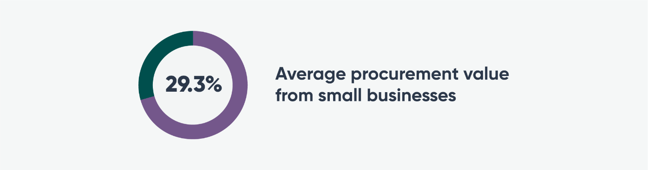

## Invoices Paid Within 30 Days

On average, the proportion of payments made to small business suppliers within 30 days has steadily increased from 63.2% in June 2021 to **70.3% in December 2024**.

Figure 6: Average invoices paid in 30 days, Reporting Cycles 1 to 8 (see Table 6, Appendix B)

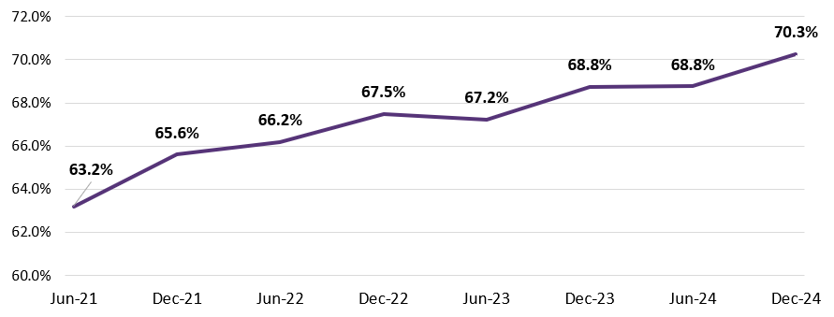

## Commonwealth Entity Insight

On average, Commonwealth Corporate Entities and Companies reported a common payment term of **20 days**, 9 days less than the all industry average of 29 days. **However, disappointingly, Commonwealth Corporate Entities and Companies reported paying 95% of their small business suppliers within 42 days – this is more than double the reported average common payment term of 20 days** (see Table 9, Appendix B). Again, this will be an area of focus for the Regulator.

# Industry Insights

## Payment Times Reporting Applies to All Industries

In Reporting Cycle 8, reports were submitted by **1,951**[1] reporting entities across all 19 Australian and New Zealand Standard Industrial Classification (ANZSIC) Divisions (ANZSIC 2006 – ABS 2013). **Almost half of these reporting entities (48%) were from the Financial and Insurance Services and Wholesale Trade industries.**

There has been a significant shift in the reported distribution of reporting entities by industry when compared to previous reporting cycles. This change in distribution can be largely attributed to new consolidated reporting obligations, however some industries may be underrepresented due to outstanding reports. Therefore, we expect these distributions to change as approved reporting extensions fall due (see Applications section for further details) and further non‑compliant reporting entities are identified through compliance activities.

Figure 7: Number of reporting entities by ANZSIC Division, Reporting Cycle 8.

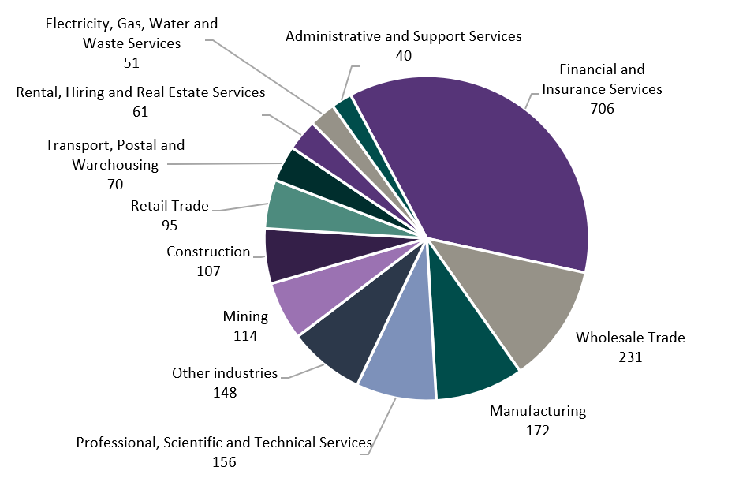

Note: ‘Other industries’ include reporting entities where the industry proportion reflected less than 2%. Data for all industries is provided in Table 3, Appendix B.

## Payment Terms Vary Across Industries

At an industry level, the average common payment term varies across industries, ranging from 17 days in the Other Services industry to 36 days in the Manufacturing industry (for all industry data, see Table 3, Appendix B). Across all industries the average common payment term is 29 days.

Figure 8: Average common payment term in days by industry, Reporting Cycle 8 (see Table 3, Appendix B)

This vertical bar chart shows average common payment terms by industry (in days) ordered from shortest to longest. 


## Who is Paying on Time

There were 10 industries paying above the all industry average paid on time of 68.1% (see Figure 5). The **Electricity, Gas, Water and Waste Services** industry made the highest proportion of small business payments on time at **77.0%,** while the **Accommodation and Support Services** industry paid the least on time at **60.4%.**

Figure 9: Proportion of payments paid on time by industry, Reporting Cycle 8 (see Table 10, Appendix B).

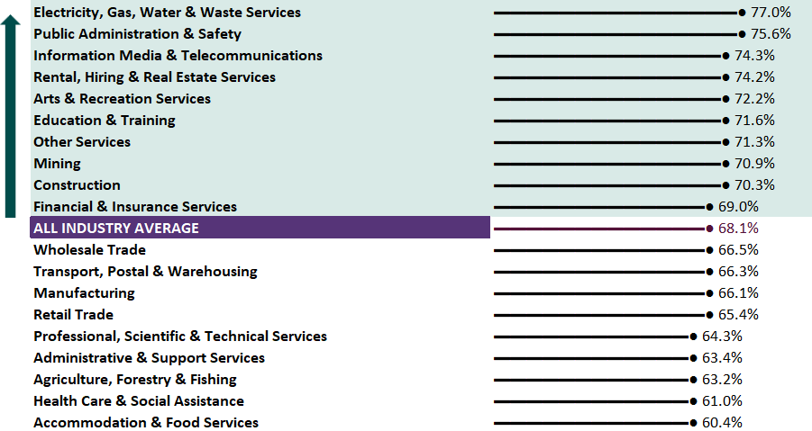

# Tips to Avoid Common Reporting Errors

During this transition reporting period, through our engagement with reporting entities and assurance activities undertaken of submitted reports identified a number of recurring issues that would result in inaccurate or misleading reports. To help you report accurately and avoid instances of non‑compliance, below are 3 of the most common errors and actionable tips.

## Reports Submitted by Subsidiaries Without a Determination

Subsidiaries that are controlled by reporting entities have incorrectly submitted payment times reports for the reporting period ending 31 December 2024.

A reporting entity is the highest‑level entity within a corporate group as defined by the Payment Times Reporting Act 2020 (Act). If an entity is controlled by another entity that meets the definition of reporting entity, it cannot be a reporting entity.

A subsidiary may only submit a payment times report if it is not controlled by a reporting entity **OR** if it has applied to the Regulator, and the Regulator has made a determination, for it to be a subsidiary reporting entity.

## Incorrect Calculations Entered Into Report Fields

Entities have submitted reports that contain fields that contradict responses in other fields of the report. The most common errors include:

* **95th percentile payment time that is lower than the 80th percentile payment time.** These fields require a response of the number of days it took the entity to make 80% and 95% of all small business trade credit payments in the reporting period. An entity cannot make 95% of all small business trade credit payments faster than 80% of all small business trade credit payments.
* **The percentage of invoices paid within 30 or 31‑60 days contradicting reported 80th and 95th percentile payment times.** For example, if the 95th percentile payment time is less than 30 days, the percentage of invoices paid within 30 days cannot be less than 95%.
* **Median payment time that is lower than 60 days but the sum of the percentage of invoices paid within 30 and 31‑60 days is less than 50%.** For example, if median payment time is 40 days, the sum of the responses in the fields ‘invoices paid within 30 days (%)’ and ‘invoices paid within 31‑60 days (%) cannot be less than 50%.

## Incorrect Format Used for certain Field Types

****Entities have submitted reports with 80th and 95th percentile payment times greater than 1,000 days where the entity had intended a response with a decimal point.****

There is a mixture of formats to be used when responding to particular fields with some fields requiring a response to 2 decimal places and others requiring a whole number.

The fields ‘80th percentile payment time’ and ‘95th percentile payment time’ must be recorded as a whole number as this is the number of days taken to make 80% and 95% of all small business trade credit payments in the reporting period. The web form used to submit a report does not allow a decimal point to be included for these fields. For example, if 25.75 is typed in the webform, it displays 2575 days and if uncorrected, will result in a higher number of days recorded than intended. For further information about reporting fields, including how to calculate these values, refer to the [Understanding Reporting Fields document](https://paymenttimes.gov.au/sites/ptrs.gov.au/files/2025-03/reporting-fields-guidance.pdf) located on the Regulator’s website.

|  |
| --- |
| If you become aware that your report contains errors or information that may be false or misleading, please correct the report by submitting a revised report. |

# Policy Update

## Service Charter

The Regulator has published a [Service Charter](https://paymenttimes.gov.au/about/service-charter), which is now available on the Regulator’s website.

The Service Charter outlines our commitment to you, what we ask of you, and how the Regulator may respond to unreasonable and inappropriate behaviour directed towards our staff, and actions you can take if we have not met your expectations, or you believe we have not adhered to the Charter.

Our top priorities are:

* Ensuring that all interactions with the Regulator are professional, courteous and respectful
* Upholding your right to procedural fairness, including your right to a fair and impartial decision, and
* Providing you with support and assistance, including taking your complaints seriously and handling them in a fair, confidential and responsive manner.

# Commitment to Continuous Improvement

The Regulator is committed to **continuous improvement**. This includes our continued enhancements to the systems that our stakeholders rely on. The recently **refreshed portal** allows entities to meet their reporting obligations under the reformed Payment Times Reporting Scheme. As part of the refresh we have taken steps to ease navigation by maintaining a consistent and familiar interface and introduced new functionality such as a webform for entities to submit reports.

Our Portal is continually evolving to make the user experience smoother and more intuitive – more enhancements planned this calendar year!

|  |
| --- |
| Reminder: Identify your small business suppliers  Reporting entities must use the Small Business Identification (SBI) Tool to identify their small business suppliers **each time** they are required to submit a payment times report. The SBI can be accessed by logging into the Portal. |

## Improvements to Interactive Register

The [Payment Times Reports Register](https://register.paymenttimes.gov.au/), publicly accessible through the Regulator’s website has been updated to include new reports for reporting periods starting 1 July 2024.

From 31 July 2025, the interactive Register also captures new payment times measures. The homepage now includes common payment terms, payment times, and the percentage of on‑time payments to small businesses. The Entity Search page also features comparisons of payment terms and times against industry averages. As we progress into the latter half of the year, the Regulator will actively monitor the Register’s usage to ensure it remains a reliable and trusted resource for decision‑making.

Payment Times interactive register

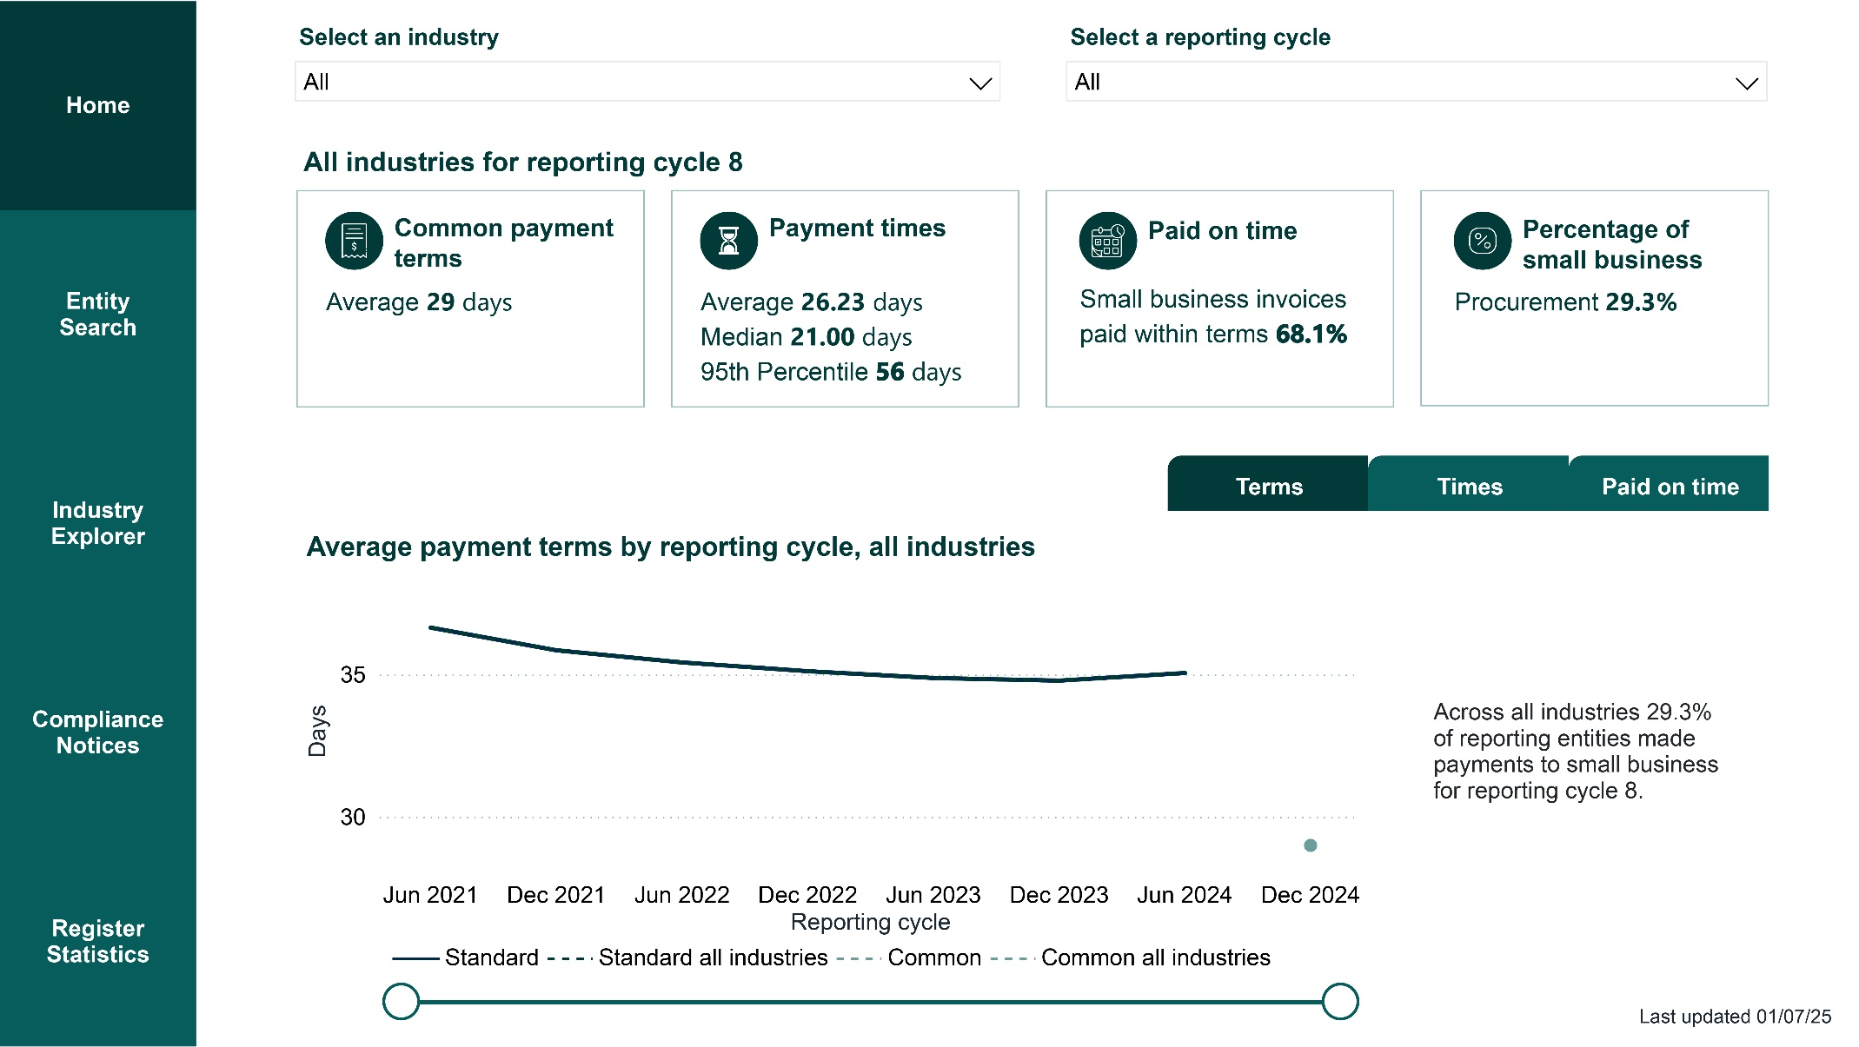

# Engagement and Education

## Purposeful Engagement

Over the period from January to June this year, the Regulators’ engagements have been aligned to each of the 4 stakeholder engagement priorities that are designed to:

* **Strengthen relationships and collaboration** by creating strategic relationships with key stakeholders by providing information that will allow them to participate in the Scheme in a meaningful way and advance the objectives of the Scheme. We have also established avenues for stakeholders to provide feedback to the Regulator to help drive continuous improvement and shape future engagements.
* **Build trust and authority** throughearly engagement and transparent communication with stakeholders to inform them of key changes, how regulatory functions will be delivered and to promote the Regulator as the authoritative source of information.
* **Educate and raise awareness** through targeted sessions that support reporting entities transitioning to the new Scheme to increase transparency of payment practices and behaviours towards small business.
* **Provide tailored support and foster collaboration** by sharing tools, insights, and refining approaches in response to stakeholder challenges to improve or promote prompt payment culture with stakeholders.

**Stakeholder engagement**

This infographic is a circular diagram divided into four numbered quadrants: 

1. Relationships and collaboration 

2. Building trust and authority 

3. Improving outcomes for small business 

4. Prompt payment culture 

Over the past 12 months, engagement has surged with growing attendance at Liaison Forums, Education sessions and targeted events. Stakeholders are showing an increased interest in leveraging the Interactive Register data to inform decision‑ making processes, signalling strong momentum and confidence in the Scheme’s tools and objectives.

In the 12 months to February 2025, we had a **175% increase** in attendance with an even greater **increase of 179%** in the number of organisations represented at the stakeholder liaison forum. Notably, we welcomed 8 major organisations that had not previously engaged with the Regulator.

Liaison Forum Historical Attendance

|  |  |  |
| --- | --- | --- |
| Liaison Forum | Attendees | Organisations Represented |
| **February 2025** | **330** | **226** |
| **September 2024** | 226 | 129 |
| **February 2024** | 120 | 81 |

The February 2025 stakeholder liaison forum attracted the largest audience since the commencement of the Scheme, with 330 attendees representing 226 organisations.

In support of the Regulator’s commitment to Best Practice Principle 1: Continuous Improvement, we launched a short survey at the conclusion of the forum. 90% of respondents reported that the Regulator had been transparent in its compliance and enforcement activities.

The Regulator conducted 11 strategic engagements, including 3 small business advocates, 3 professional bodies, 1 liaison forum, and 4 educational sessions. These engagements promoted the Register’s role in supporting small businesses and its influence in Commonwealth Government decision making, whilst building trust and increasing transparency.

The Regulator considers regular and ongoing collaboration with stakeholders as an important step to building trust and further strengthening relationships.

|  |
| --- |
| Save the date: Next Regulator’s Liaison Forum scheduled for 14 August 2025  Our Stakeholder Liaison Forum is an opportunity to engage directly with the Regulator’s leadership team.   * If you or your organisation haven’t attended before, we warmly invite you to join our upcoming session to hear directly from the Regulator’s leadership team. Please head to the [website](https://paymenttimes.gov.au/) and register your interest now! |

# Compliance and Enforcement

## Our Performance

Over the **6 months** to 30 June 2025, the Regulator received a total of **3,895 enquiries**. During this period, on average, the **Regulator took 5 business days to respond** to enquiries. Of these enquiries, there were 51 requests to update the SBI Tool and these requests were processed within an average of 8 business days.

Our engagement activities to inform and query reporting entities, resulted in **84 reports** being **corrected or removed** from the Register. For entities that did not adequately engage with the Regulator, we adopted an escalating approach, resulting in **43 published instances of non‑compliance**, bringing the total number to 241 published to date. In response to these decisions, the Regulator received **5 applications** seeking a **reconsideration of the decision** and **all 5 decisions** to publish non‑compliance were **upheld**.

Compliance Performance, 1 January 2025 to 30 June 2025

3,895 enquiry responses
5 reconsideration decisions completed 
7.6 days - average days to complete 51 SBI Tool update requests within our 28-day commitment

|  |  |
| --- | --- |
| **Compliance action between January and June 2025** | |
| **84** | **Reports corrected or removed resulting from engagements to inform and query** |
| **43** | **Non‑compliance notices**  (relating to 11 entities) |

|  |
| --- |
| **The Regulator is committed to preventing fraud** through false and/or misleading reporting. If you suspect payment times reports contain false and/or misleading information on payment practices, you should report it to [support@paymenttimes.gov.au](mailto:support@paymenttimes.gov.au) |

# Applications

In the **6 months** to 30 June 2025, the Regulator processed a total of **591 applications**. Of these applications, 516 related to an extension of time request. The Regulator approved 95% of these requests and the remaining 5% were withdrawn by the applicants. Short extension of time requests (28 days or less) were processed in less than 4 business days.

Applications Breakdown

591 Applications received and processed between January and June 2025

488 Short extension of time
17 Reporting nominee
28 Modifiable extension of time
17 Exeptions
44 Subsidiary reporting entity
1 Volunteering entity

There are two types of extension of time applications – those requesting an extension period under 28 days and those seeking an extension that exceeds 28 days. The requirements for each type of application is outlined below.

|  |  |
| --- | --- |
| Extension 28 days or less | Extension over 28 days |
| Must be made before the report due date | Must be made before the report due date |
| Must include the length of extension | Must include length of extension |
| Must state the circumstances resulting in the need for more time | Must state the **exceptional** circumstances resulting in the need for more time **and provide evidence** |
| Regulator must not have previously given more time to the entity for the period | An entity can apply for further time if needed |

Entities can now apply to the Regulator to become a reporting nominee, subsidiary reporting entity, exempt entity, or volunteering entity. The Regulator has observed that over 60% of applications are withdrawn by applicants, largely due to misunderstandings about the purpose of these application types.

While processing applications and enquiries to 30 June 2025, we observed:

* A large increase in enquiries about the Scheme, up 118% since the last Regulator’s Update, driven by the reforms and updated reporting requirements.
* Extension of time applications for periods over 28 days without the mandatory supporting evidence (see above for requirements).
* Entities seem to be misunderstanding the purpose of subsidiary reporting entity, reporting nominee, volunteering entity and exemption from reporting applications, resulting in incorrect submissions. For help, refer to pages 20‑23 and 54‑62 of the published [Guidance Materials.](https://paymenttimes.gov.au/sites/ptrs.gov.au/files/regulatory-resource/ptrs-guidance-materials-march2025.pdf)

If you intend to submit an application, please submit it early and ensure you have provided all necessary information and evidence for the Regulator to be able to action them promptly.

## 2025–26 Compliance Focus Areas

We have received less payment times reports than expected by 30 June 2025 under the new Scheme. We are engaging with other Regulators to identify entities who are not reporting but should be.

The Regulator released the [2025–26 Compliance and Enforcement Priorities](https://paymenttimes.gov.au/sites/ptrs.gov.au/files/2025-07/compliance-enforcement.pdf) which is available on the Regulator’s website. It outlines the Regulator’s priorities, our incremental approach to compliance and enforcement, and the specific behavioural harms to be targeted over the next 12 months.

The Regulator’s compliance and enforcement is focused on behaviours that cause harms resulting from:

* **Failure to report on time** – for entities who either did not lodge a report or lodged a report late
* **False or misleading reports and/or conduct** – including entities with false or misleading data in their report, entities who do not use the SBI Tool when preparing their report, entities who should not be on the fast small business payer list, and those falsely claiming to be fast payers, and
* **Failure to comply with directives from the Regulator and/or Minister** – Ensuring adherence to directives from the Regulator or Minister, such as information requests, compliance audit notices, and slow small business payer directives.

Compliance and Enforcement Priorities

Failure to report on time
False or misleading reports and/or conduct
Failure to complay with directives from the Regulator and/or Minister

The Regulator will continue to apply an escalating approach to compliance and enforcement, beginning with education and guidance for all entities aimed at preventing non‑compliance, through to applying the full force of the law for persistent and intentional non‑compliance. The Regulator will use all the legislative powers available to identify and address non‑compliance, in doing so, all entities will be afforded procedural fairness.

Escalating approach to compliance

This pyramid diagram represents the Regulator’s escalating approach to compliance. 

Educate and guide:
Education, guidance and outreach will raise awareness of the requirements and how to comply.

Inform and query: 
Engagement and warning letters including use of information gathering and compliance audit powers

Take action: 
Publish details of non-compliance, give infringement notices and/or enter into enforceable undertakings

Enforce:
Civil penalties


|  |
| --- |
| Case Study  An entity submitted a report stating a 95th percentile payment time lower than its 80th percentile payment time. Regulator staff identified this as mathematically impossible and contacted the entity. The issues were addressed, and the entity corrected its report on the same day, revising the 95th percentile payment time. No regulatory enforcement action was taken given the entity’s responsive actions to correct the data through a revised report.  **Entities are reminded that their engagement, responsiveness and remediation will impact our approach to non‑compliance and escalation.** |

# Appendix A – Insights: Methodology and Assumptions

## Reporting Cycles

Insights reported refer to **reporting cycles**. Reporting cycles represent a fixed six‑month period from January to June and July to December each year since the Scheme commenced:

|  |  |  |  |  |
| --- | --- | --- | --- | --- |
| Reporting Cycle 1 | Reporting Cycle 2 | Reporting Cycle 3 |  | Reporting Cycle 10 |
| 1/01/2021– 30/06/2021 | 1/07/2021– 31/12/2021 | 1/01/2022– 30/06/2022 | ⟶ | 1/07/2025– 31/12/2025 |

Reports are assigned to a reporting cycle based on the **reporting period end date** (prior to December 2024, reports were assigned by the start date). This change has a minimal effect and aligns all reports under the reforms. For example, a report with a reporting period end date of 15 March 2025 will be categorised as Reporting Cycle 9 for the purpose of payment times reporting.

Reporting instances (that is an entity’s first report, second report, etc.) and reporting cycles do not reconcile because of the timing of reports. For example, the first instance of reporting for an entity may have occurred in Reporting Cycle 2 or 3.

Historic report statistics may change when entities submit reports for previous reporting cycles and revisions are made to reports.

## Insights Are at a Point in Time

Data is subject to revision and reports are received on a continuous basis, including for historical reporting cycles. Previous reports can also be updated by submitting a revised report.

Insights provided in this Regulator’s Update are based on reports received on or before  
30 June 2025 and subsequently published. The insights are subject to change as additional reports or revised reports are submitted and published after this date.

## Analysis on Payment Times

Reports received for Reporting Cycle 8 (1 July 2024 to 31 December 2024) contain reported payment terms and payment times data relating to payments made to small business. Payments for invoices paid to small business are grouped into 3 day ranges (within 30 days, 31 to 60 days and more than 60 days).

This Regulator’s Update includes insights for the new data series, including payment times expressed in days for average payment times, median payment times, 80th percentile payment time, the 95th percentile and percentage of small business invoices paid within payment term (paid on time).

Reports superseded by a revised report and reports which indicate no procurement with small businesses are excluded from analysis on payment times.

## Consolidated Reporting

Reforms to the Payment Times Reporting Scheme introduced the principles of consolidation into the criteria to be a reporting entity. Consolidation of entities using the AASB accounting standards provides a consistent and well understood framework for entities. It also reduces unnecessary administrative and compliance burden for individual entities in a group. These reforms and the principles of consolidation allow a single report for a corporate group to be provided to the Regulator for publication to the Payment Times Reports Register.

## Assumptions

Unless otherwise stated, the following assumptions apply.

* Analysis is based on self‑reported data from all reporting entities that make payments to small businesses (including volunteer entities). Reports which indicate no procurement with small businesses are excluded from calculations for payment terms and payment times.
* Unless otherwise indicated, references to reporting entities includes reporting entities that meet the definition of a reporting entity under section 7 of the Act and volunteering entities, subsidiary reporting entities and reporting nominees, as determined by the Regulator.
* Analysis for Reporting Cycle 8 is based on reports with reporting period end dates on or before 31 December 2024 (unless indicated otherwise). These reports contain the new data measures, including average payment times, median payment times, 80th percentile payment time, the 95th percentile and paid on time.
* Data insights published in the Regulators Update are subject to revision as entities continue to submit reports. The Regulator received over 500 applications for extensions of time to submit reports. Additional reports for Reporting Cycle 8 have extensions until late July 2025. The volume of reports received will impact the data analysis.
* Report types that indicate no small business procurement do not include the new data measures and are excluded from analysis. Only standard and AASB8 report types are included in the data analysis. See Table 2 for counts of reports by report type.
* Superseded reports are excluded from calculations. A superseded report is an original report that has been replaced by a subsequent revised report. Only the most recent revised report is used for analysis. The count of superseded reports is displayed in Tables 4 and 5.

# Appendix B – Data Tables

All data tables reflect payment times reports and revised reports **received** on or before 30 June 2025, reflecting small business payment activity up to and including **Reporting Cycle 8.** Reporting Cycle 9 is only captured in Table 4.

Time series data has been included in some tables below. Note: Following the reforms, time series data is not always comparable due to a number of reasons, which may include consolidated reporting requirements or differences in reporting measures. In some instances, the Regulator has taken steps to separate data for reporting period start dates before and after 1 July 2024.

Table 1: Share of small business procurement, Reporting Cycles 1 to 8

|  |  |  |  |
| --- | --- | --- | --- |
|  |  | Proportion of total procurement with small businesses (value) | |
|  |  | Reporting periods start dates | |
| Reporting cycle | Cycle range | Before 1 July 2024 | After 1 July 2024 |
| Cycle 1 | 1 Jan 2021 – 30 Jun 2021 | 29.4% | n/a |
| Cycle 2 | 1 Jul 2021 – 31 Dec 2021 | 29.7% | n/a |
| Cycle 3 | 1 Jan 2022 – 30 Jun 2022 | 29.7% | n/a |
| Cycle 4 | 1 Jul 2022 – 31 Dec 2022 | 29.5% | n/a |
| Cycle 5 | 1 Jan 2023 – 30 Jun 2023 | 30.0% | n/a |
| Cycle 6 | 1 Jul 2023 – 31 Dec 2023 | 30.1% | n/a |
| Cycle 7 | 1 Jan 2024 – 30 Jun 2024 | 30.1% | n/a |
| Cycle 8 | 1 Jul 2024 – 31 Dec 2024 | 29.3% | 29.3% |

Table 2: Report types in Reporting Cycle 8

Reporting Cycle 8 includes reports received before and after 1 July 2024. Reports received from 1 July 2024 contain the new data measures (average payment times, median payment times, 80th percentile payment time, 95th percentile and paid on time). From the 1,951 reports received for reporting cycle 8, 111 reports were for no small business procurement, therefore the remaining 1,840 reports are used for data analysis in this report.

|  |  |  |  |
| --- | --- | --- | --- |
|  | Number of reports | |  |
|  | Reporting periods start dates | |  |
| Report type | Before 1 July 2024 | From 1 July 2024 | Total reports |
| Standard | n/a | 1,677 |  |
| No small business procurement | n/a | 111 |  |
| AASB8 | n/a | 163 |  |
| Has nominee | n/a | n/a |  |
| External administration | n/a | n/a |  |
| **Total reports on the register** | **1,105** | **1,951** | **3,056** |

Table 3: Reporting entities by industry Reporting Cycle 8

Table 3 contains reports with a reporting period end date between 1 July to 31 December 2024 (refer to Appendix, Reporting Cycles). There were 1,105 reports received where the reporting period start date was before 1 July 2024 (see Table 2 above). Data analysis in this report is based on the 1,840 reports received after 1 July 2024 for Reporting Cycle 8.

|  |  |  |  |
| --- | --- | --- | --- |
| Industry | Reporting entities | Average common payment terms | Proportion of total procurement value with small businesses |
| Ranked by number of reporting entities | No. (%) | (days) | (%) |
| Financial & Insurance Services | 624 (33.9%) | 27 | 27.7% |
| Wholesale Trade | 228 (12.4%) | 31 | 25.0% |
| Manufacturing | 169 (9.2%) | 36 | 28.0% |
| Professional, Scientific & Technical Services | 153 (8.3%) | 27 | 33.1% |
| Construction | 106 (5.8%) | 33 | 43.4% |
| Mining | 105 (5.7%) | 32 | 21.1% |
| Retail Trade | 93 (5.1%) | 32 | 22.5% |
| Transport, Postal & Warehousing | 70 (3.8%) | 28 | 25.2% |
| Rental, Hiring & Real Estate Services | 55 (3.0%) | 26 | 33.1% |
| Electricity, Gas, Water & Waste Services | 50 (2.7%) | 22 | 25.5% |
| Administrative & Support Services | 38 (2.1%) | 27 | 44.6% |
| Health Care & Social Assistance | 32 (1.7%) | 25 | 45.4% |
| Information Media & Telecommunications | 22 (1.2%) | 24 | 27.3% |
| Agriculture, Forestry & Fishing | 21 (1.1%) | 23 | 44.3% |
| Public Administration & Safety | 19 (1.0%) | 23 | 31.7% |
| Accommodation & Food Services | 18 (1.0%) | 28 | 30.6% |
| Other Services | 15 (0.8%) | 17 | 33.9% |
| Arts & Recreation Services | 11 (0.6%) | 26 | 36.0% |
| Education & Training | 11 (0.6%) | 19 | 51.7% |
| **All industries** | **1,840 (100.0%)** | **29** | **29.3%** |

Table 4: Payment times reports received by 30 June 2025, Reporting Cycles 1 to 9

|  |  |  |  |  |  |  |
| --- | --- | --- | --- | --- | --- | --- |
| Reporting cycle | Cycle range | Number of reports | Average standard payment terms | Average common payment terms | Average proportion of procurement value with small business | Average proportion of invoices paid within 30 days |
|  |  | No. | days | days | % | % |
| Cycle 1 | 1 Jan – 30 Jun 2021 | 8,273 | 36.6 | n/a | 29.4% | 63.2% |
| Cycle 2 | 1 Jul – 31 Dec 2021 | 9,919 | 35.9 | n/a | 29.7% | 65.6% |
| Cycle 3 | 1 Jan – 30 Jun 2022 | 10,299 | 35.4 | n/a | 29.7% | 66.2% |
| Cycle 4 | 1 Jul – 31 Dec 2022 | 10,569 | 35.1 | n/a | 29.5% | 67.5% |
| Cycle 5 | 1 Jan – 30 Jun 2023 | 10,713 | 34.9 | n/a | 30.0% | 67.2% |
| Cycle 6 | 1 Jul – 31 Dec 2023 | 10,884 | 34.8 | n/a | 30.1% | 68.8% |
| Cycle 7 | 1 Jan – 30 Jun 2024 | 10,884 | 35.1 | n/a | 30.1% | 68.8% |
| Cycle 8 | 1 Jul – 31 Dec 2024 | 3,056 | 35.4 | 29 | **29.3%**[2] | **70.3%** |
| Cycle 9 | 1 Jan – 30 Jun 2025 | 223 |  |  |  |  |
| **Total** |  | **74,819** |  |  |  |  |
| Superseded Reports | | 2,235 |  |  |  |  |
| **Total reports on the Register** | | **77,054** |  |  |  |  |

Table 5: Payment times reports by reporting instance

|  |  |  |  |
| --- | --- | --- | --- |
| Reporting instance | Number of reports | | Total reports |
|  | Reporting period start date | |  |
|  | Before 1 July 2024 | From 1 July 2024 |  |
| First report | 12,386 | 2,170 | 14,556 |
| Second report | 11,791 | 11 | 11,802 |
| Third report | 11,150 |  | 11,150 |
| Fourth report | 10,521 |  | 10,521 |
| Fifth report | 9,827 |  | 9,827 |
| Sixth report | 9,015 |  | 9,015 |
| Seventh report | 7,923 |  | 7,923 |
| Eighth report | 25 |  | 25 |
| **Total reports** | **72,638** | **2,181** | **74,819** |
| Superseded reports | 2,186 | 49 | 2,235 |
| **Total reports on the Register** | **74,840** | **2,230** | **77,054** |

Table 6: Payment times, Reporting Cycles 1 to 8

|  |  |  |  |  |
| --- | --- | --- | --- | --- |
|  |  | Invoices paid within | | |
| Reporting cycle | Cycle range | 30 days | 31‑60 days | >60 days |
| Cycle 1 | 1 Jan 2021 – 30 Jun 2021 | 63.2% | 28.2% | 8.6% |
| Cycle 2 | 1 Jul 2021 – 31 Dec 2021 | 65.6% | 26.6% | 7.8% |
| Cycle 3 | 1 Jan 2022 – 30 Jun 2022 | 66.2% | 25.7% | 8.1% |
| Cycle 4 | 1 Jul 2022 – 31 Dec 2022 | 67.5% | 24.8% | 7.7% |
| Cycle 5 | 1 Jan 2023 – 30 Jun 2023 | 67.2% | 24.8% | 8.0% |
| Cycle 6 | 1 Jul 2023 – 31 Dec 2023 | 68.8% | 24.1% | 7.1% |
| Cycle 7 | 1 Jan 2024 – 30 Jun 2024 | 68.8% | 23.9% | 7.3% |
| Cycle 8[3] | 1 Jul 2024 – 31 Dec 2024 | 70.2% | 23.6% | 6.2% |

Table 7: Payment times and terms, Reporting Cycle 8

|  |  |  |  |  |
| --- | --- | --- | --- | --- |
| Common payment term | Median  payment time | Average payment time | 80th percentile payment time | 95th percentile payment time |
| 29 | 21.0 | 26.2 | 37 | 56 |

Table 8: Average percentage of payments within 30 days by industry, Reporting Cycle 8

Average percentage of payments within 30 days by industry for Reporting Cycles 1 to 7 is available in the January 2025 Regulator’s Update publication.

|  |  |  |
| --- | --- | --- |
|  | Cycle 8 | |
|  | 1 Jul 2024 to 31 Dec 2024 | |
|  | Reporting periods start dates | |
| Industry | Before 1 July 2024 | From 1 July 2024 |
| Ranked by alphabetical order | % | % |
| Accommodation & Food Services | 73.9% | 75.3% |
| Administrative & Support Services | 77.3% | 67.4% |
| Agriculture, Forestry & Fishing | 69.2% | 82.7% |
| Arts & Recreation Services | 76.0% | 78.0% |
| Construction | 75.1% | 60.9% |
| Education & Training | 81.4% | 80.2% |
| Electricity, Gas, Water & Waste Services | 67.8% | 84.2% |
| Financial & Insurance Services | 89.4% | 75.4% |
| Health Care & Social Assistance | 69.4% | 74.4% |
| Information Media & Telecommunications | 70.1% | 83.0% |
| Manufacturing | 56.7% | 55.3% |
| Mining | 73.6% | 66.4% |
| Other Services | 72.4% | 80.7% |
| Professional, Scientific & Technical Services | 69.8% | 70.3% |
| Public Administration & Safety | 81.1% | 92.8% |
| Rental, Hiring & Real Estate Services | 73.2% | 74.2% |
| Retail Trade | 60.4% | 62.2% |
| Transport, Postal & Warehousing | 67.6% | 72.3% |
| Wholesale Trade | 69.7% | 65.4% |
| **All Industries** | **69.1%** | **70.2%** |

Table 9: Payment times and terms for Commonwealth entities, Reporting Cycle 8

|  |  |  |  |  |
| --- | --- | --- | --- | --- |
| Common payment term | Median payment time | Average payment time | 80th percentile payment time | 95th percentile payment time |
| 20 | 12.0 | 15.7 | 22 | 42 |

Table 10: New payment times measures by industry, Reporting Cycle 8

|  |  |  |  |  |  |
| --- | --- | --- | --- | --- | --- |
| Industry | Average common payment terms | Average payment time | 80th percentile payment time | 95th percentile payment time | Average percentage paid on time |
| Ranked by alphabetical order | (days) | (days) | (days) | (days) | (%) |
| Accommodation & Food Services | 28 | 24.6 | 30 | 45 | 60.4% |
| Administrative & Support Services | 27 | 28.6 | 35 | 53 | 63.4% |
| Agriculture, Forestry & Fishing | 24 | 20.3 | 31 | 45 | 63.2% |
| Arts & Recreation Services | 26 | 19.9 | 31 | 50 | 72.2% |
| Construction | 33 | 29.1 | 40 | 60 | 70.3% |
| Education & Training | 19 | 21.4 | 30 | 49 | 71.6% |
| Electricity, Gas, Water & Waste Services | 22 | 20.7 | 27 | 45 | 77.0% |
| Financial & Insurance Services | 27 | 23.8 | 34 | 52 | 69.0% |
| Health Care & Social Assistance | 25 | 26.2 | 34 | 52 | 61.0% |
| Information Media & Telecommunications | 23 | 20.6 | 39 | 61 | 74.3% |
| Manufacturing | 36 | 33.4 | 48 | 67 | 66.1% |
| Mining | 32 | 27.7 | 36 | 50 | 70.9% |
| Other Services | 17 | 17.6 | 28 | 53 | 71.3% |
| Professional, Scientific & Technical Services | 27 | 27.2 | 36 | 62 | 64.3% |
| Public Administration & Safety | 23 | 15.4 | 20 | 37 | 75.6% |
| Rental, Hiring & Real Estate Services | 26 | 22.8 | 33 | 52 | 74.2% |
| Retail Trade | 32 | 29.7 | 42 | 64 | 65.4% |
| Transport, Postal & Warehousing | 28 | 25.6 | 35 | 56 | 66.3% |
| Wholesale Trade | 31 | 28.6 | 40 | 58 | 66.5% |
| **All Industries** | **29** | **26.2** | **37** | **56** | **68.1%** |



1. Reporting Cycle 8 and data analysis captured in this update, exclude reports received prior to 1 July 2024. For more information, see Assumptions in Appendix A and Table 2, Appendix B.
2. Text in bold represents data for Reporting cycle 8 for reports received after 1 July 2024
3. Reporting cycle 8 reflects reports received after 1 July 2024