Getting set up in the Portal

## Quick Reference Guide 1

This guide explains the step-by-step process to successfully log in to the Payment Times Reporting Scheme Portal (Portal) for the first time and complete your set-up details.

To access the Portal you need a Digital ID, and then link the entity you are representing to your Digital ID in Relationship Authorisation Manager (RAM).

If you already have your Digital ID and entity linked in RAM, you can jump to **Step 3 – Log in to the Portal**.

Version 1.0 May 2025

# Step 1: Establish your Digital ID

Your Digital ID, such as myID, lets you prove who you are when logging in to government online services. [myID](http://www.myid.gov.au/) is the Australian Government's [Digital ID](https://www.digitalidsystem.gov.au/) app. It is currently the only Digital ID available to log in to our Portal.

### How to set up myID

Your myID is unique to you and can't be shared. As it's your personal Digital ID, you should set this up using a personal email address – don't use a shared or work email address.

### Before you start

To set up your myID, you need:

* **a smart device** – the myID app is compatible with most smart devices, such as smart phones, and is only available from the Apple App Store or Google Play
* **a personal email address** – as it’s your personal Digital ID, your ID documents will be linked to the email you choose.
* **to be 15 years or older** – age restrictions may also apply to use some government online services.

### Set up your myID in 3 steps:

1. **Download the myID app**

Only download the myID app from the official app stores. The app is compatible with most smart devices.

[Available on the App Store](https://itunes.apple.com/au/app/mygovid/id1397699449?mt=8) [Get it on Google Play](https://play.google.com/store/apps/details?id=au.gov.ato.mygovid.droid)

If you:

* are setting up your myID for the first time, continue to step 2
* have set up your myID before, select ‘I am an existing user’ and follow the prompts. See [Setting up your myID again](https://www.myid.gov.au/existinguser).

1. **Enter your details**

Open the myID app on your smart device and follow the prompts to:

* enter your email address – choose a personal email you have ongoing access to
* create a password
* enter your full name and date of birth.

1. **Choose your identity strength**

The Portal services can be accessed using a myID with a [Standard or Strong identity strength](https://www.myid.gov.au/how-set-myid#identity-strength). You can find support for [verifying your ID](https://www.myid.gov.au/verifying-your-id-myid) documents or photo.

# Step 2: Setting up myID for a business with RAM

To access the Portal and other government online services on behalf of a business, your myID generally needs to be linked to the business’s Australian business number (ABN). This is done in [RAM](https://info.authorisationmanager.gov.au/), which is a separate online service.

The [principal authority](https://info.authorisationmanager.gov.au/principalauthority) (the person responsible for the business) has to be the first person to link their myID to the business’s ABN. They need to:

1. [set up their myID](https://www.myid.gov.au/how-set-myid#three-steps-to-set-up-myid) with at least Standard identity strength
2. link their myID to the business’s ABN in  [RAM](https://info.authorisationmanager.gov.au/principalauthority).

Visit the [how to link your business online](https://info.authorisationmanager.gov.au/principal-authority#How_to_link) instructions for the full process.

If you’re unable to link online, there are [other ways you can link your business](https://info.authorisationmanager.gov.au/principal-authority#Other_ways_you).

# Step 3: Log in to the Portal

1. Go to the [Payment Times Reporting Regulator website](https://paymenttimes.gov.au/) and select **Visit the Portal**.

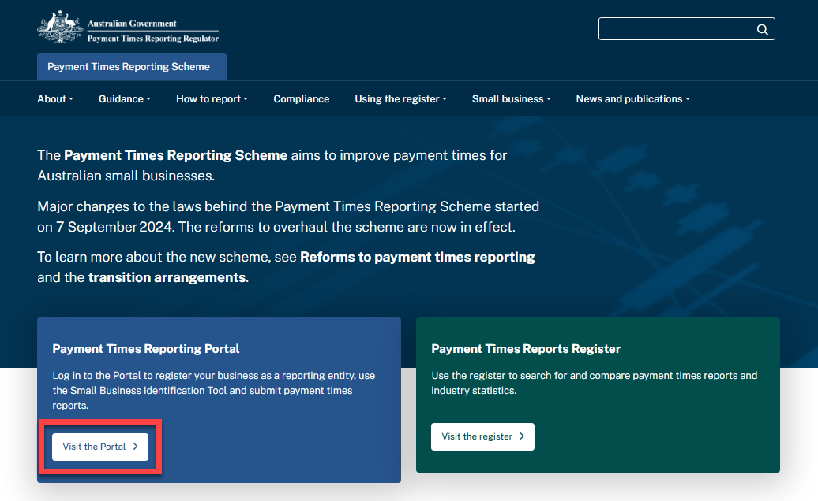

1. Select **Continue with Digital ID** to begin the login process.

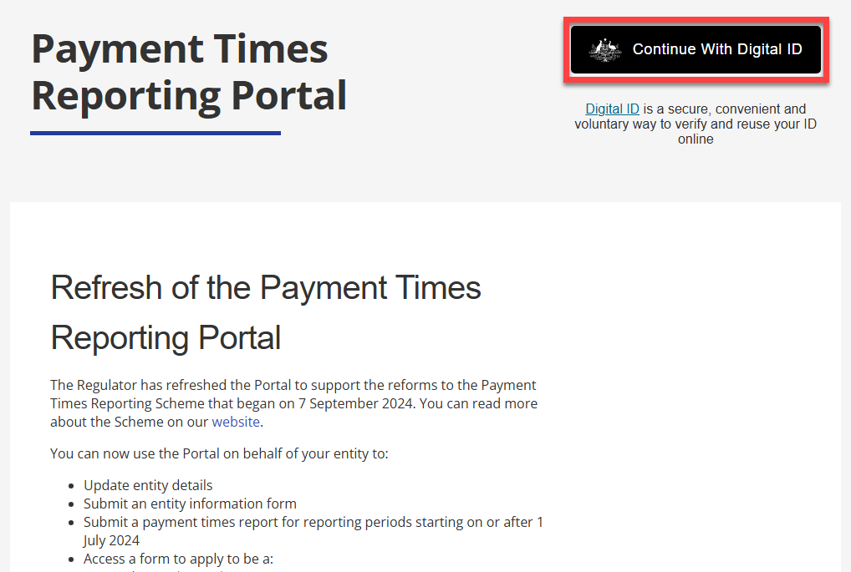

### Terms of Use

The Regulator has revised the Terms of Use for the refreshed Portal.

1. After you have read this information, **check the acknowledgement box** to continue.

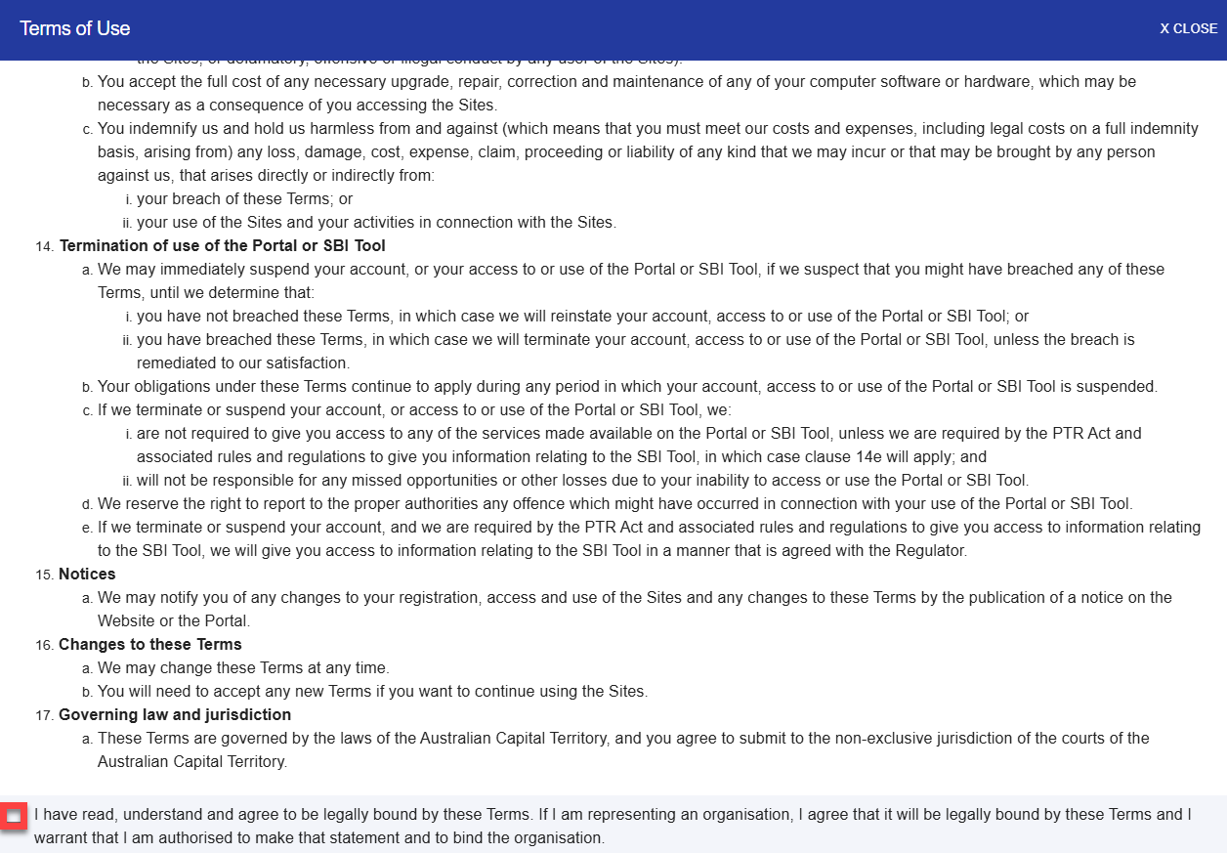

The Portal will direct you to the myID login page.

1. Follow the instructions on this page and use the login details you set up in the **Step 1: your Digital ID** section of this guide, or your myID login details if you’ve set these up already.

The myID login process uses two-factor authentication for security and you will need to confirm a code through a separate device, like a mobile phone. It’s helpful to have your device handy for this process.

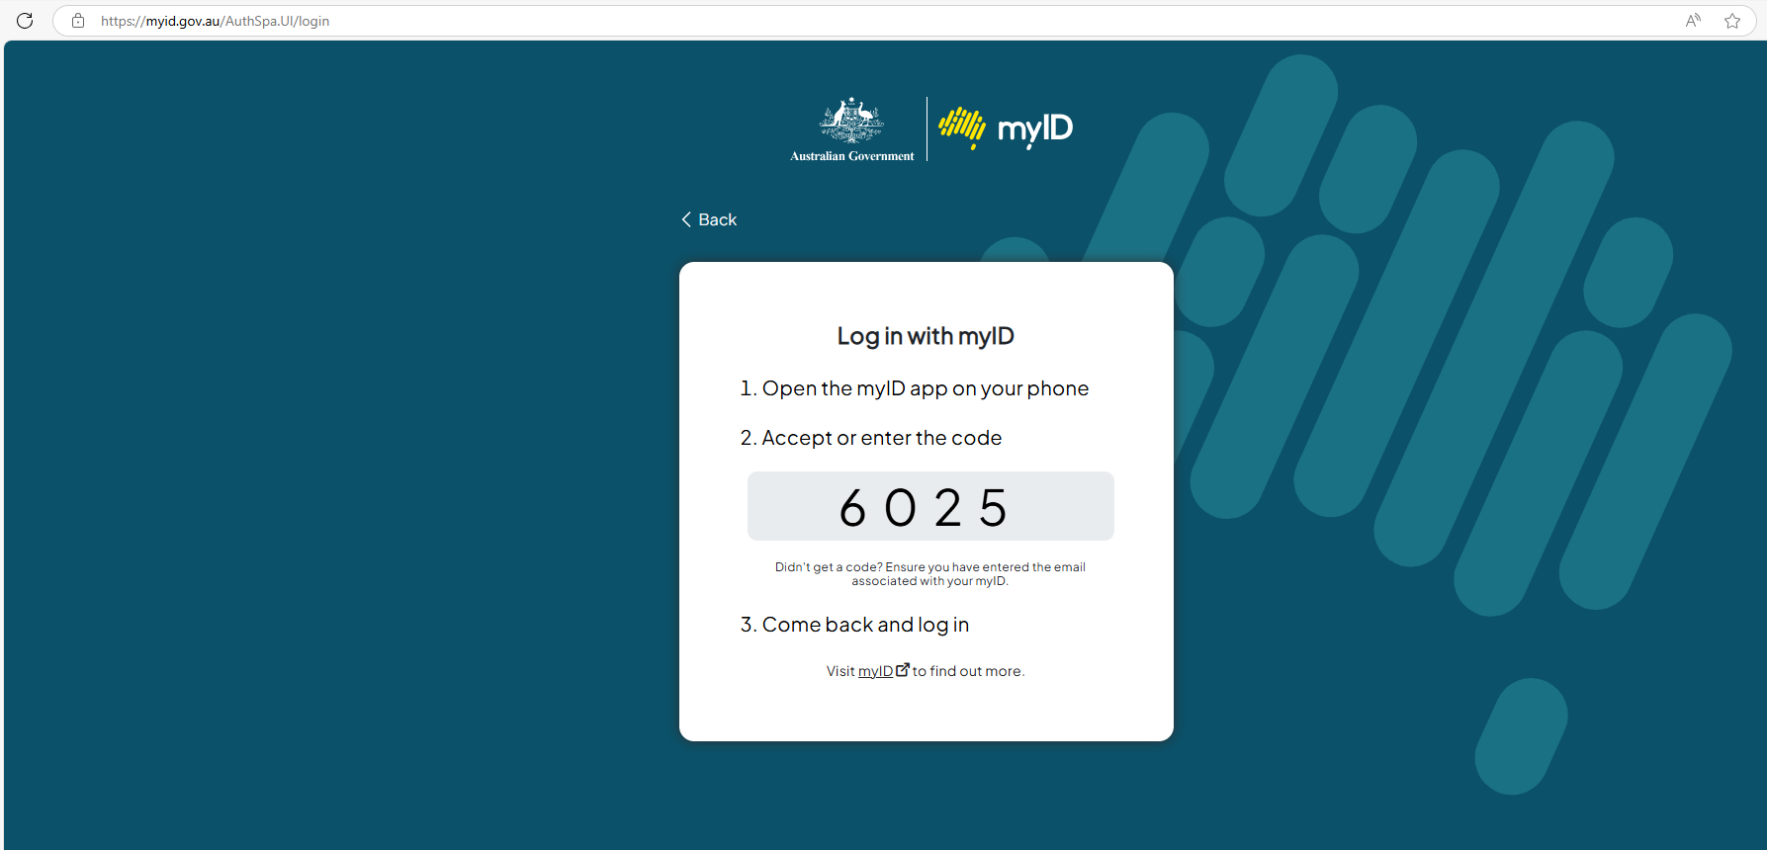

# Step 4: Your User Profile

Your User Profile displays the given name and family name from your Digital ID. You cannot change the name details in your User Profile as they are part of your identity authentication.

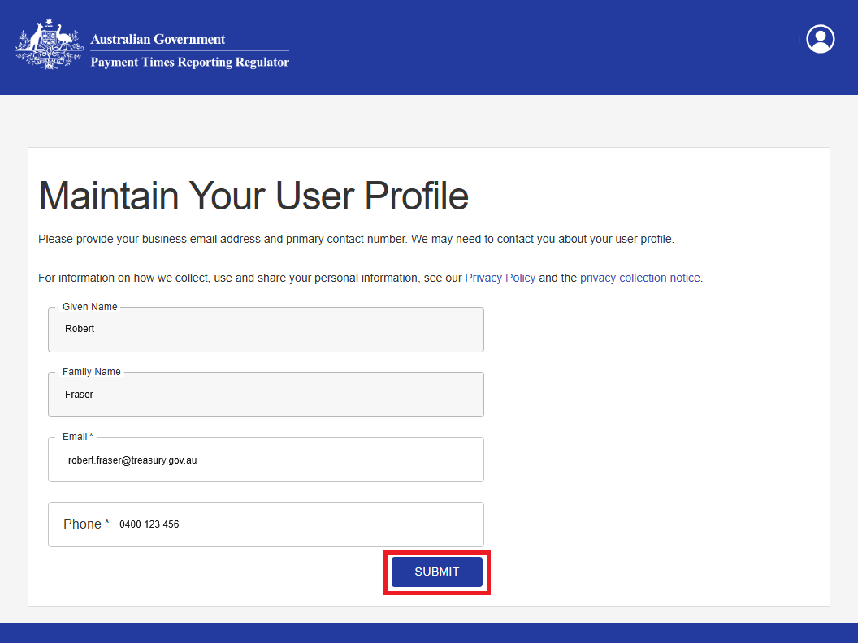

1. Confirm your **email** and add your contact **telephone number**.
2. When your information is correct, select **Submit.** You can return to this form and update your email and contact number at any time.

# Step 5: Self-Assessment Questionnaire

Complete this new, short questionnaire to create your entity’s profile and establish access to the features your entity needs in the Portal. Your responses determine which tiles appear in your Portal view.

1. After you have read this information, select **Start.**

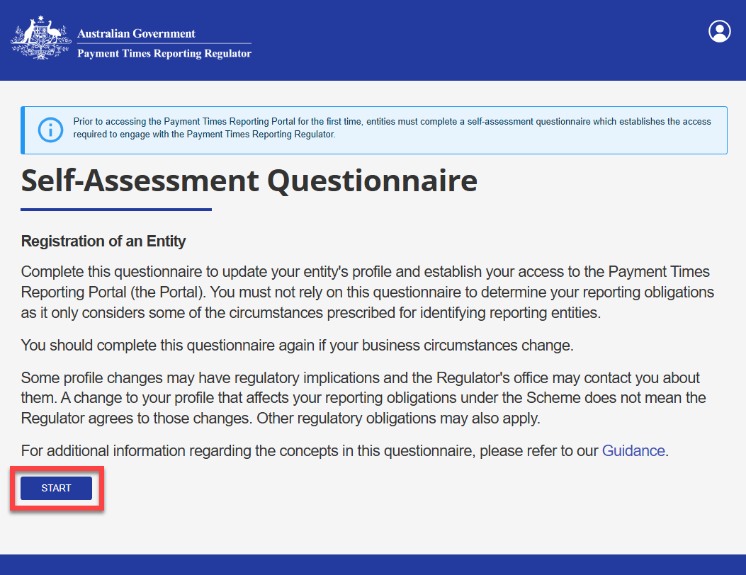

You need to select the purpose of your entity’s interactions with the Payment Times Reporting Scheme.

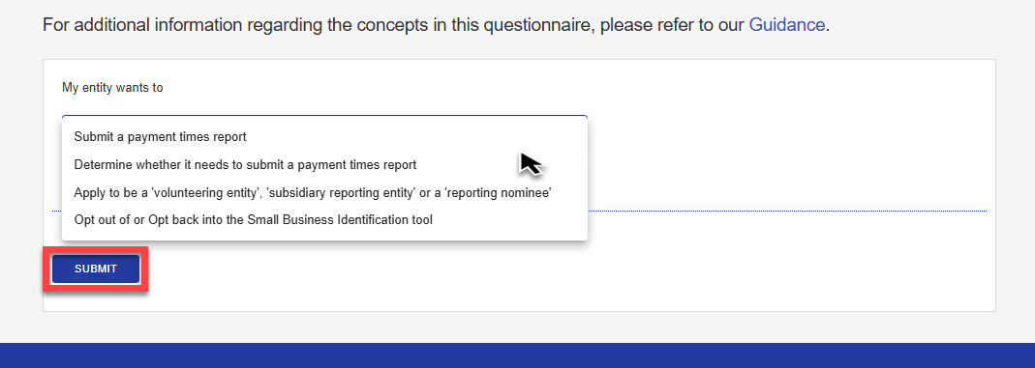

1. Select in the **My entity wants to** field to display the drop-down list of options.
2. Select one option from the list.

The Portal will either guide you through a series of questions or take you directly to the declaration, depending on your selections. The Questionnaire process helps you provide the information needed to set up your entity’s profile in the Portal.

IMPORTANT

The self-assessment questionnaire only considers some of the circumstances set out in the [legislation](https://aus01.safelinks.protection.outlook.com/?url=https%3A%2F%2Fwww.legislation.gov.au%2FC2020A00091%2Flatest%2Ftext&data=05%7C02%7CLeanne.Kennedy%40TREASURY.GOV.AU%7C0f180279d6644b6f630708dd82da8d79%7C214f1646202147cc8397e3d3a7ba7d9d%7C0%7C0%7C638810597379574178%7CUnknown%7CTWFpbGZsb3d8eyJFbXB0eU1hcGkiOnRydWUsIlYiOiIwLjAuMDAwMCIsIlAiOiJXaW4zMiIsIkFOIjoiTWFpbCIsIldUIjoyfQ%3D%3D%7C0%7C%7C%7C&sdata=slFfL5qMRaf6OWpv5lOyUhQViygbjYBjF%2Bic0ARXuF8%3D&reserved=0) for identifying reporting entities. Do not rely solely on the questionnaire to determine your reporting obligations. You should read our [Guidance](https://aus01.safelinks.protection.outlook.com/?url=https%3A%2F%2Fpaymenttimes.gov.au%2Fguidance&data=05%7C02%7CLeanne.Kennedy%40TREASURY.GOV.AU%7C0f180279d6644b6f630708dd82da8d79%7C214f1646202147cc8397e3d3a7ba7d9d%7C0%7C0%7C638810597379592254%7CUnknown%7CTWFpbGZsb3d8eyJFbXB0eU1hcGkiOnRydWUsIlYiOiIwLjAuMDAwMCIsIlAiOiJXaW4zMiIsIkFOIjoiTWFpbCIsIldUIjoyfQ%3D%3D%7C0%7C%7C%7C&sdata=5lzeiBPbr7q4tSvPVHb%2F0iT4yplM5%2F17mDvNngkogRo%3D&reserved=0) about reporting obligations to satisfy yourself that you understand and comply with your reporting obligations.

### Example 1

This example shows the beginning of the questions process for both the **Submit a payment times report** and the **Determine whether it needs to submit a payment times report** options from the drop-down list.

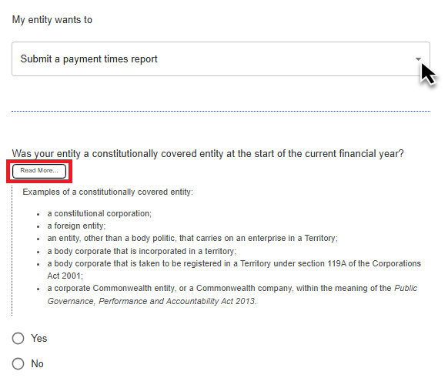

1. Read the questions carefully. Select **Read More…** to see more information to help you answer the question.
2. Select either **Yes** or **No** to each question as it appears.

The questions may vary between users and are based on your responses and your entity’s specific circumstances.

After you have answered all questions, you will see a Declaration about the information you supplied in the Questionnaire.

1. Read the Declaration carefully and **check the acknowledgement box** to confirm the statements are true for your answers.

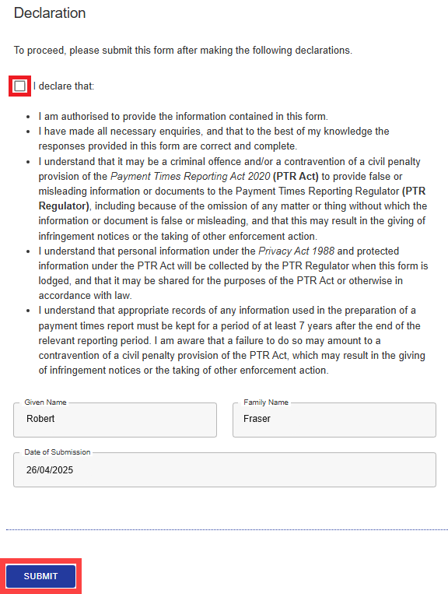

1. Select **Submit** to continue.

### Example 2

This second example shows the process for selecting the **Apply to be a ‘volunteering entity’, ‘subsidiary reporting entity’ or a ‘reporting nominee’** option from the drop-down list.

You won’t need to answer questions at this point in the setup process.

1. Read the Declaration carefully and **check the acknowledgement box** to confirm the statements are true for your answers.

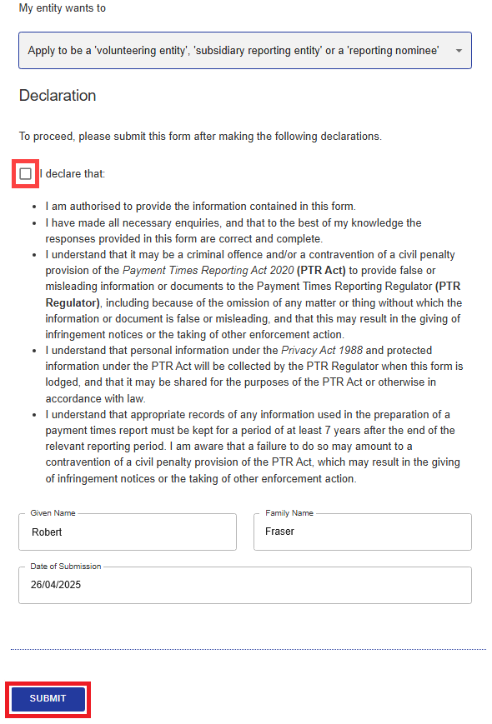  
9. Select **Submit** to continue.

### Your self-assessment outcome

The portal displays an information box showing the **Outcome** of your self-assessment. In this example, the entity meets the definition of a reporting entity.

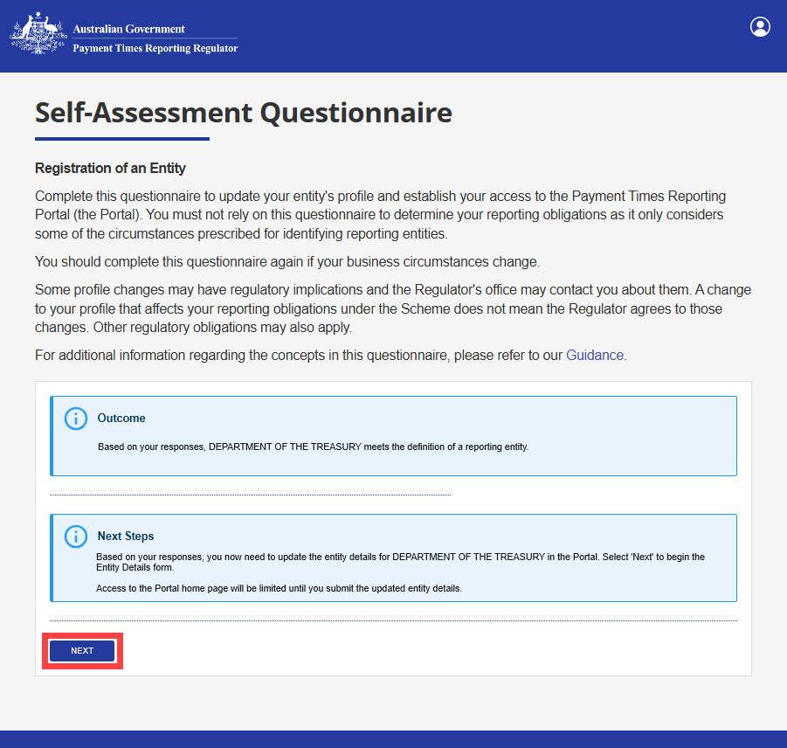

A second information box outlines the **Next Steps** in the set-up process. In this example, the next step is to update the entity’s details.

1. Select **Next** to proceed to the **Update Entity Details** form. You can only access limited features on the Portal home page until you complete this form.
2. In some circumstances the Portal displays additional questions after the outcome screen. Answer them to see the next steps, then select **Next** to continue.

# Step 6: Update Entity Details

1. Read the information on this screen and select **Start** to proceed.

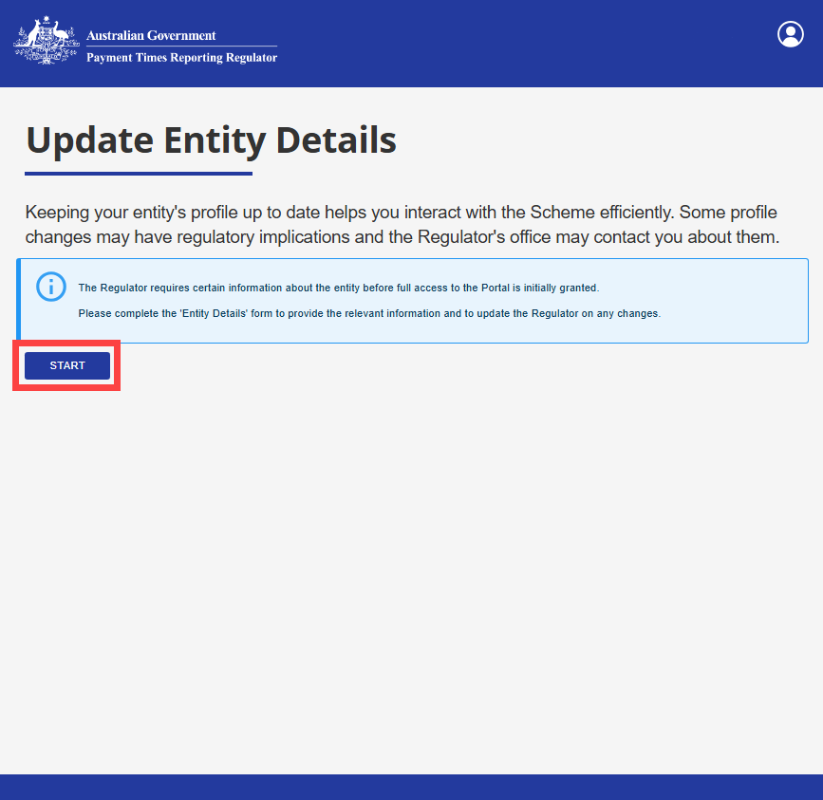

The Portal retrieves some of your entity’s information from the Australian Business Register.

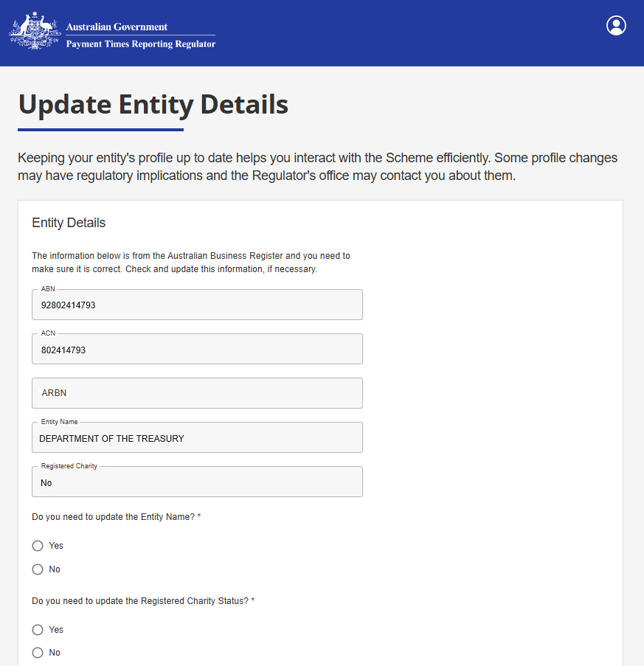

1. Check the Entity Name and the Registered Charity status is correct. Select **Yes** to update,  
   or **No** if correct.

### Mailing address

1. You must nominate **either** a postal address or a business address. The Regulator may use this address for certain official communications. Select either **Postal Address** or **Business Address.**
2. Check the details of your chosen address are correct. The Portal retrieves this information from the Australian Business Register, but you can edit the fields if needed.
3. Next, select the **Postal Address Country** field and select your country from the dropdown list.

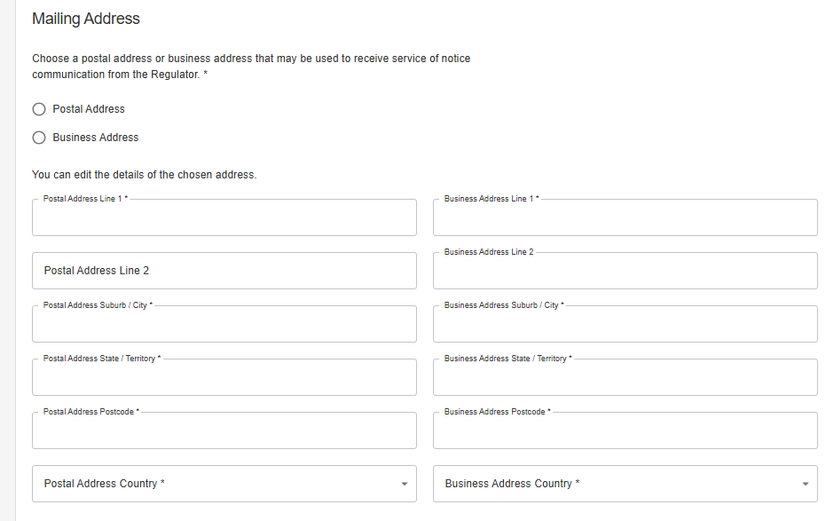

### Consent to electronic communications by email

We use email to send system-generated messages such as confirmation receipts and acknowledgements.

This question asks if you agree to receive all other communications about the Payment Times Reporting Scheme by email.

1. Select **Yes** or **No**. If you do not agree to using email and select **No**, the Regulator will send all other communications, including Notices, to your entity’s nominated mailing address.

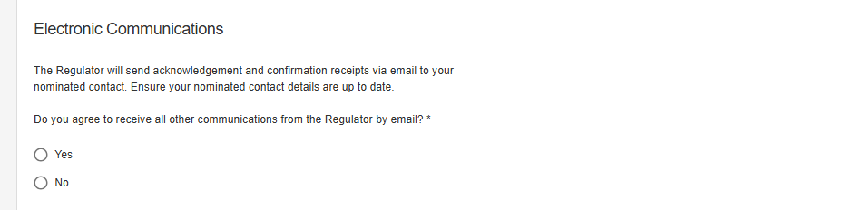

### The Nominated Contact for your entity

Every entity registered in the Portal must have a Nominated Contact. The Regulator uses this contact information for confirmation receipts and acknowledgements, and—if you’ve consented to electronic communication—for all correspondence, including Notices.

The Portal displays the contact information currently on record. You can update any fields if the details are incorrect.

Alternatively, you can nominate someone else to act as the Nominated Contact and receive communications from the Regulator on your entity’s behalf.

Ensure your entity’s Nominated Contact information is accurate and up to date.

If you nominate another person, confirm they understand they will receive and are responsible for managing official communications from the Regulator for this entity.

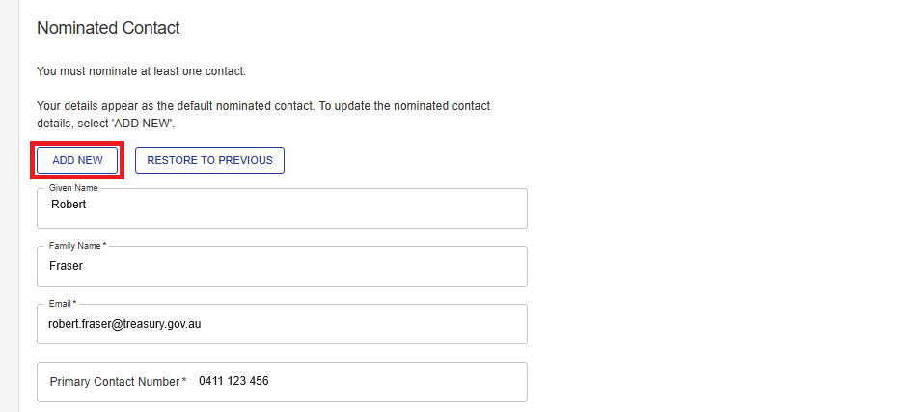

1. Select **Add New** to update the details for the Nominated Contact.

After you have completed the Entity Details form, you will see a Declaration about the information you have supplied.

1. Read the Declaration carefully and **check the acknowledgement box** to confirm the statements are true for your answers.

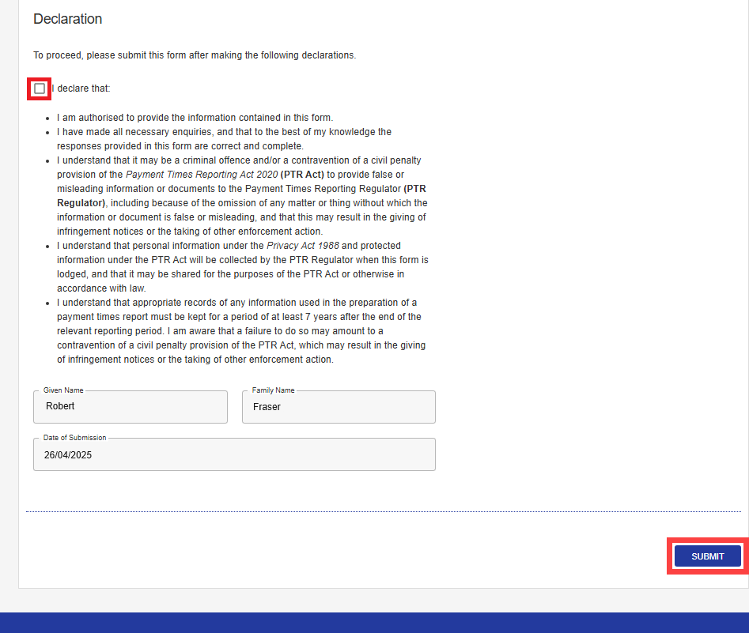

1. Select **Submit** to continue.

### Success!

A green information box confirms you have successfully completed the Portal set-up process.

You can change the information provided by selecting the **Maintain Entity and User Information** tile.

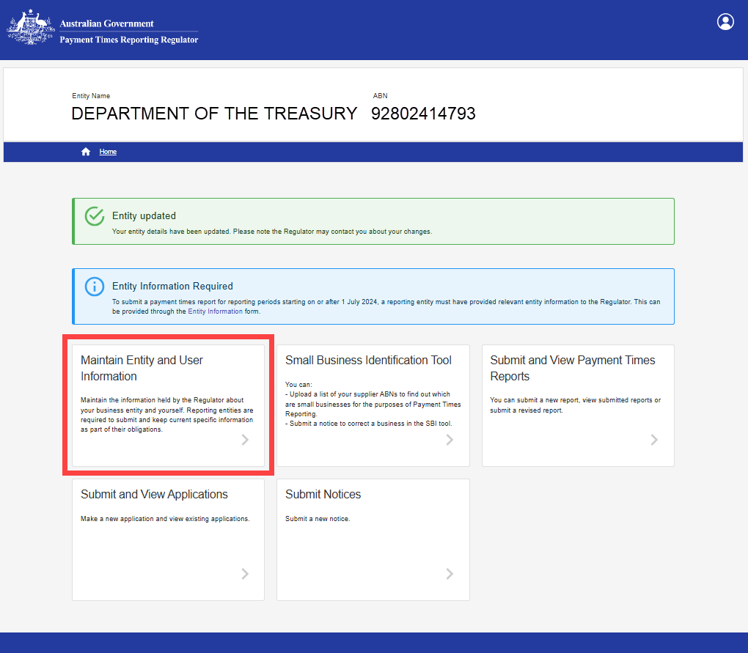.

### What’s next?

Some users will need to provide additional details about their entity before the Portal will allow them to submit a new payment times report.

1. The **‘Maintain Entity and User Information’** tile gives you access to the ‘Maintain Entity Information’ tile.

The blue information box has a link to the **Entity Information** form.

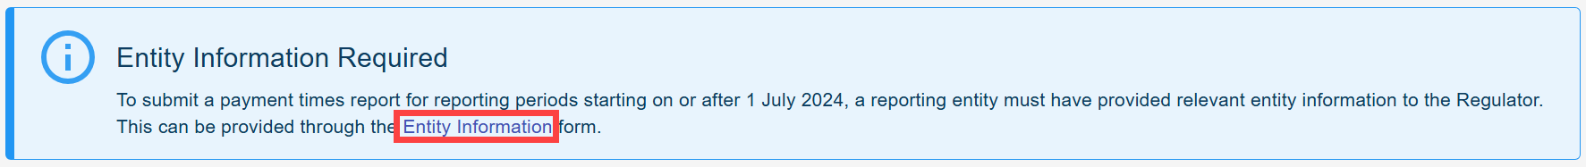

**Quick Reference Guide #2 – Entity Information** sets out the step-by-step process to complete the Entity Information form.

#### Contact us at [support@paymenttimes.gov.au](mailto:support@paymenttimes.gov.au) if you have questions about payment times reporting.