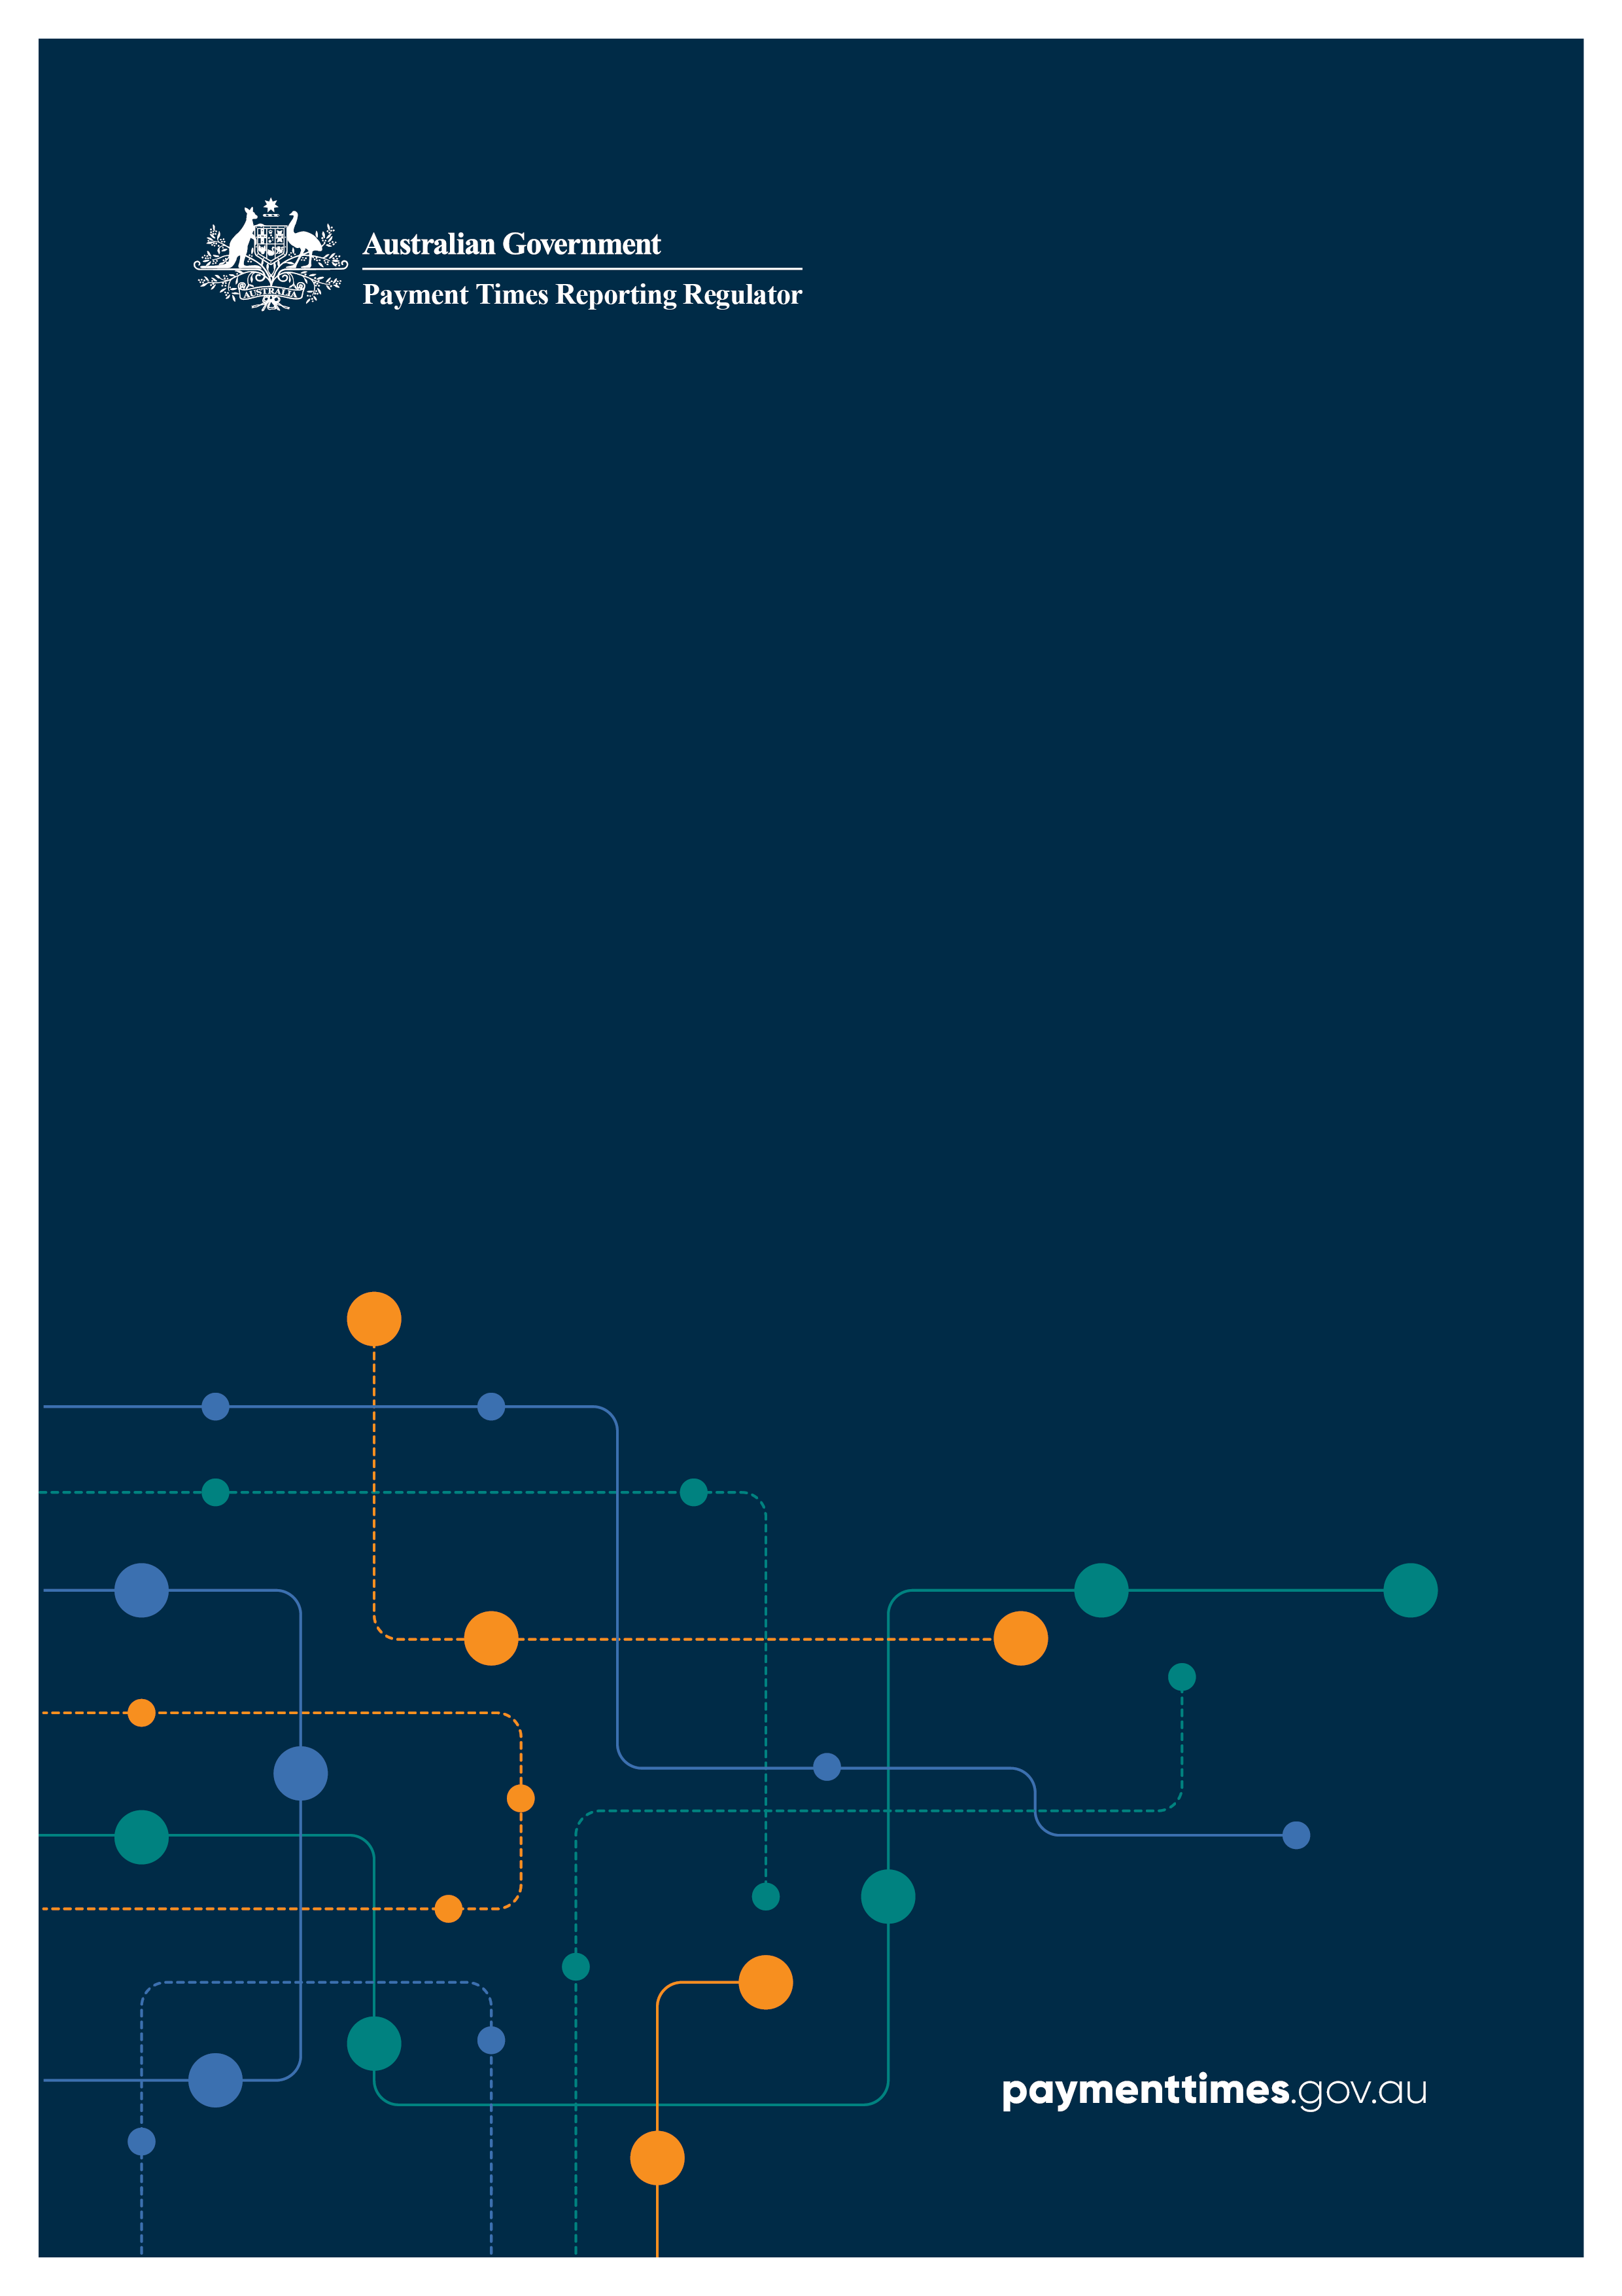

Payment Times Reporting: Guidance Materials

CONSULTATION SUMMARY AND RESPONSE

December 2024

© Commonwealth of Australia 2024

This publication is available for your use under a [Creative Commons Attribution 4.0 International](https://creativecommons.org/licenses/by/4.0/) licence, with the exception of the Commonwealth Coat of Arms, the Treasury logo, photographs, images, third party materials, materials protected by a trademark, signatures and where otherwise stated. The full licence terms are available from [creativecommons.org/licenses/by/4.0/legalcode](https://creativecommons.org/licenses/by/4.0/legalcode).

Creative Commons attribution licence 3.0 icon. 

Use of Treasury material under a [Creative Commons Attribution 4.0 International](https://creativecommons.org/licenses/by/4.0/) licence requires you to attribute the work (but not in any way that suggests that the Treasury endorses you or your use of the work).

**Treasury material used ‘as supplied’**

Provided you have not modified or transformed Treasury material in any way including, for example, by changing the Treasury text; calculating percentage changes; graphing or charting data; or deriving new statistics from published Treasury statistics – then Treasury prefers the following attribution:

Source:The Commonwealth of Australia.

**Derivative material**

If you have modified or transformed Treasury material, or derived new material from those of the Treasury in any way, then Treasury prefers the following attribution:

Based on Commonwealth of Australia data.

**Use of the Coat of Arms**

The terms under which the Coat of Arms can be used are set out on the Department of the Prime Minister and Cabinet website (see [www.pmc.gov.au/government/commonwealth-coat-arms](http://www.pmc.gov.au/government/commonwealth-coat-arms)).

**Other uses**

Enquiries regarding this licence and any other use of this document are welcome at:

Manager  
Media Unit  
The Treasury  
Langton Crescent   
Parkes ACT 2600  
Email: [media@treasury.gov.au](mailto:media@treasury.gov.au)

In the spirit of reconciliation, the Treasury acknowledges the Traditional Custodians of country throughout Australia and their connections to land, sea and community. We pay our respect to their Elders past and present and extend that respect to all Aboriginal and Torres Strait Islander peoples.

# Contents

Contents ii

Consultation Summary 3

Summary of feedback and changes 3

Publication of other information 3

Amendments made to Guidance Materials 4

# Consultation Summary

## Summary of feedback and changes

We received 13 written submissions in addition to feedback provided informally during industry consultation sessions and through enquiries.

As specified in the Exposure Draft Guidance, the Regulator does not intend to publish submissions received during the consultation process in their varying formats. Instead, we have prepared this consultation summary as a consolidation of feedback received and amendments made to the Guidance Materials as a result of that feedback. If an entity wishes to discuss its individual submission, contact us directly at [support@paymenttimes.gov.au](mailto:support@paymenttimes.gov.au).

The most significant changes to the Guidance Materials in response to feedback are:

* including more technical detail to better explain different circumstances
* revising the examples to improve clarity
* adding more examples to cater for more varied circumstances
* including more detail in the steps for preparing reports
* revising content to better align with legislative requirements.

Details of the changes are set out in this document on a section-by-section basis. In addition to these changes, we made other typographical and formatting corrections and updated the cross references.

Some of the feedback we received did not relate to the Guidance Materials or was not within the remit of the Guidance Materials as it would require changes to the *Payment Times Reporting Act 2020* (the **Act**) or the *Payment Times Reporting Rules 2024* (the **Rules**). The submissions contained:

* general comments about the complexity of the overhauled scheme compared with the old scheme
* enquiries on specific aspects of the scheme
* suggestions on policy matters
* suggestions that would require amendments to the Act
* suggestions that would require amendments to the Rules

We will consider general feedback outside the scope of the Guidance Materials in future policy development, legislative amendments and/or IT system updates. We will respond to enquiries on specific matters directly.

## Publication of other information

We updated the following Information sheets in line with the reforms and Guidance Materials:

* Information sheet 2: Regulator decisions – Your rights
* Information sheet 6: Small Business Identification (SBI) Tool
* Information sheet 7: Our regulatory powers

These Information sheets have been moved to the Archived Guidance section of the Regulator’s website and marked as only applicable in relation to reporting periods that commenced prior to 1 July 2024:

* Information Sheet 3: Who must report
* Information Sheet 4: Corporate Groups
* Information Sheet 5: Acquisitions, divestments and winding up
* Information Sheet 8: Reporting credit card transactions

We will continually review, update and add Information sheets in response to emerging trends in reporting, compliance and feedback from reporting entities.

We received multiple requests for the Regulator to release reporting templates in advance, to allow reporting entities to begin preparing reports. Alongside the Guidance Materials, we have published an interim guide on the Regulator’s website to help entities understand the reporting fields that will be required in the new payment times reports for periods commencing on or after 1 July 2024. Please note that this guide is intended to give an early indication of the reporting fields and is not yet final or comprehensive. We will release the updated version of this guide in early 2025 which will include:

* additional guidance on the report submission process
* expanded guidance and validation information for each reporting field.

We will publish a worked example to further assist entities in completing their reports.

The Regulator will hold a number of online information sessions for reporting entities early in 2025 to answer questions and assist with the preparation of reports.

## Amendments made to Guidance Materials

Below is a summary of the changes that have been made to the Guidance Materials following consideration of feedback received in submissions through the consultation process:

| **Guidance Section** | **Amendments following consultation** |
| --- | --- |
| Abbreviations | Added to provide full text of abbreviations used within the document. |
| Important notice about this guidance | Clarified the statement that the guidance is the Regulator’s practical administration approach to assist reporting entities comply with the Act. |
| **Entities that must report**: Revenue threshold | Clarified that the revenue threshold includes the total revenue of an entity and all its controlled entities. |
| **Entities that must report**: Revenue Threshold - Identifying controlled entities – *‘AASB 10: Test for control’* | Added a scenario to the practical example on testing for control and impact on consolidated revenue to include a Responsible Entity of a Managed Investment Fund. |
| **Entities that must report**: Revenue Threshold - Identifying controlled entities – *‘Using financial statements’* | Added an example relating to trusts. |
| **Entities that must report**: Revenue Threshold - Identifying controlled entities – *‘Foreign controlled entities’* | Clarified that foreign entities that are controlled by a reporting entity should have their revenue included when calculating consolidated revenue for the purposes of the Act.  Amended the example to improve clarity. |
| **Entities that must report**: Revenue Threshold - Identifying controlled entities – *‘Exceptions to consolidation’* | Amended example relating to an investment entity to improve clarity.  Amended example relating to joint control in a joint venture to improve clarity. |
| **Entities that must report**: Revenue Threshold – Consolidated Revenue | Amended text to provide clarity around the calculation of consolidated revenue. |
| **Entities that must report**: Revenue Threshold – Foreign currency translation | Added an example to clarify when and how foreign currency translation is to be used. |
| **Entities that must report**: Excluded Entities – Entities controlled by reporting entities | Corrected title of example from ‘Foreign controlled entities’ to ‘Foreign controlling entities’. |
| **Entities that must report**: Ceasing to be a reporting entity - Acquisitions by other reporting entities | Corrected text from ‘reporting cycle’ to ‘reporting period’. |
| **Volunteering and modifying reporting structures:** Nominee reporting entities - Becoming a nominee reporting entity | Added example to provide clarity for ‘Multiple entry consolidated groups and nominee reporting entity eligibility’. |
| **How and when to report:** Reporting periods – When to report | Provided clarity that the financial years and reporting periods are examples only. |
| **How and when to report:** How to Report - Entity information – ‘*Identifying and classifying details’* | Provided additional clarity for determining which primary business activity an entity should be classified under where an entity has multiple business activities. |
| **How and when to report:** How to Report - Entity information – ‘*Entity structure’* | Corrected text to include additional entity structure information required for nominee reporting entities |
| **What to report:** Step 1: Identify entities to consolidate | Provided additional clarity that each payment under a trade credit arrangement made by the entity and each of its controlled entities, including those that are not a CCE, is to be included.  Clarified exceptions to consolidation.  Clarified exclusions from consolidation of all controlled entities.  Added new paragraphs to improve clarity relating to consolidation of payments made by foreign controlled entities. Specifically, that only payments made to Australian small businesses will be used in payment times calculations and included in the Small Business Trade Credit Payments Dataset, but that all payments to Australian businesses with an ABN must be included in the Trade Credit Payments Dataset for specified reasons.  Added an example relating to trusts and foreign subsidiaries to improve clarity. |
| **What to report:** Step 1: Identify entities to consolidate - Acquisitions and divestments – *‘Acquisitions and obtaining control’* | Added a new scenario in the example covering the acquisition of a controlled entity after the end of the reporting period, but prior to the end of the reporting window. |
| **What to report:** Step 1: Identify entities to consolidate - Acquisitions and divestments – *‘Divestments and loss of control’* | Amended text in example to improve clarity.  Added a new scenario in example, covering the divestment of a controlled entity after the end of the reporting period but prior to the end of the reporting window. |
| **What to report:** Step 2: Identify Reporting Requirements | Clarified that an entity may need to submit a modified report if the entity and all of its controlled entities have made no payments to Australian small business suppliers (per the SBI Tool).  Removed content relating to a nominee reporting entity needing to provide additional information in its report, as this was incorrect. |
| **What to report**: Step 3: Prepare Datasets | Amended text in example relating to trade credit arrangements, and added a new scenario to improve clarity. |
| **What to report**: Step 3: Prepare Datasets - Payments made by a Third Party | Added a new section to cover ‘Payments made by a Third Party’. |
| **What to report**: Step 3: Prepare Datasets - Preparing the Trade Credit Payments Dataset – *‘Payer and payee details’* | Clarified the payee and payer details to be included. |
| **What to report**: Step 3: Prepare Datasets - Preparing the Trade Credit Payments Dataset – *‘Partial payments’* | Clarified partial payments and how they are to be recorded in the preparation of datasets. |
| **What to report**: Step 3: Prepare Datasets - Preparing the Trade Credit Payments Dataset – *‘Payment Terms* | Amended text, added new paragraphs and removed a paragraph to clarify payment terms and how they are to be determined in situations where a contract exists and those where it does not.  Amended text to clarify that, if an invoice has multiple terms, the longer of the terms is to be used. |
| **What to report**: Step 3: Prepare Datasets - Calculating payment times – *‘Excluded Payments – Partial payments’* | Clarified partial payments, their exclusion from the SBTCP Dataset and how they are used in the calculation of payment times and other report data.  Amended the text in the example to improve clarity. |
| **What to report:** Step 4: Complete the Payment Times Report – Payment Terms and Times   * Most common payment term * Most common payment term (range) * Estimated payment term for the next reporting period | Clarified the calculation of the most common payment term and corrected the description to refer to payment terms, rather than payment times.  Removed reference to standard for most common payment term and most common payment term (range).  Amended the number format for most common payment term, most common payment term (range) and estimated payment term for the next reporting period.  Amended text and added new paragraph regarding the most common payment term (range), to clarify that this is to be calculated from the SBTCP Dataset and that any entity that does not may any payments to small business should be excluded from the range calculation. A mode of 0 should not be used.  Amended text in the example relating to range of modes to improve clarity around calculations. |
| **What to report:** Step 4: Complete the Payment Times Report – Payment Terms and Times   * Comparison of receivable terms to payment times | Amended text in relation to comparison of receivable terms to payment terms to improve clarity. Specifically, that receivable terms are to be based on the most common offered terms for sales to all customers, and that the comparison is not required for the mode payment term range. |
| **What to report:** Step 4: Complete the Payment Times Report – Payment Terms and Times   * Median Payment Time * 80th and 95th percentile payment times | Clarified that the SBTCP Dataset is to be used in calculating the median payment time and the 80th and 95th percentile payment times  Clarified how the 80th and 95th percentile payment times are to be calculated.  Added an example to demonstrate how to calculate the 80th and 95th percentile payment times. |
| **What to report:** Step 4: Complete the Payment Times Report – Other Payment Practices   * Percentage of small business procurement | Amended text to correct the calculation of the percentage of small business procurement, to include partial payments to Australian small businesses. |
| **What to report:** Step 4: Complete the Payment Times Report – Other Payment Practices   * Offers supply chain finance | Clarified that calculation of supply chain finance is not necessary. |
| **What to report:** Step 4: Complete the Payment Times Report – Contextual Information and Approvals   * Report Comments | Clarified the type of information to be included under report comments. |
| **What to report:** Step 4: Complete the Payment Times Report – Contextual Information and Approvals   * Report Approval | Added a new paragraph to improve clarity regarding who can be a responsible member approving the report. |
| **What to report:** Step 4: Complete the Payment Times Report – Additional Reporting requirements – *‘Operating Segments’* | Clarified how reporting for Operating Segments is to be completed.  Clarified the examples covering payments not attributable to an operating segment and a nil report for an operating segment |
| **What to report:** Step 4: Complete the Payment Times Report – Additional Reporting requirements – *‘Subsidiary Reporting’* | Removed Subsidiary Reporting paragraph from this section of the Guidance. Subsidiary Reporting Entities do not have additional reporting requirements within a payment times report. A Subsidiary Reporting Entity only needs to provide additional Entity Information which is covered in an earlier section of the Guidance. |
| **What to report:** Record Keeping | Moved from ‘Step 5’ of preparing a report to more appropriate section of Guidance, as its own standalone sub-section. |
| **Applications:** Fees | Removed Note for Exposure Draft about fees.  Added paragraph to improve clarity that fees will not be charged for applications submitted prior to 1 July 2025 |
| **Fast and Slow Small Business Payers**: Slow Small Business Payers – Reporting Cycles | Amended text relating to what a 95th percentile time is, as it was considered unnecessary.  Added an example for Conventional Financial Years, to clarify which reporting cycle certain periods fall into. |
| **Fast and Slow Small Business Payers**: Slow Small Business Payers – Duration of Slow Small Business Payer Direction | Added paragraphs to clarify the duration of a Slow Small Business Payer Direction, as well as the publication of related information on the Register |
| **Fast and Slow Small Business Payers**: Fast Small Business Payers – What is a Fast Small Business Payer | Clarified the example for Fast Small Business Payer Criteria, relating to a scenario where an entity ceases to be a Fast Small Business Payer for one month due to its report submission date. |