Regulator’s Update

July 2024

© Commonwealth of Australia 2024

This publication is available for your use under a [Creative Commons Attribution 3.0 Australia](http://creativecommons.org/licenses/by/3.0/au/deed.en) licence, with the exception of the Commonwealth Coat of Arms, the Treasury logo, the Payment Times Reporting Regulator logo, photographs, images, signatures and where otherwise stated. The full licence terms are available from <http://creativecommons.org/licenses/by/3.0/au/legalcode>.

Creative Commons attribution licence 3.0 icon. 

Use of Treasury material under a [Creative Commons Attribution 3.0 Australia](http://creativecommons.org/licenses/by/3.0/au/deed.en) licence requires you to attribute the work (but not in any way that suggests that the Treasury endorses you or your use of the work).

*Treasury material used ‘as supplied’.*

Provided you have not modified or transformed Treasury material in any way including, for example, by changing the Treasury text; calculating percentage changes; graphing or charting data; or deriving new statistics from published Treasury statistics — then Treasury prefers the following attribution:

*Source: The Australian Government, The Treasury, Payment Times Reporting Regulator*.

**Derivative** **material**

If you have modified or transformed Treasury material, or derived new material from those of the Treasury in any way, then Treasury prefers the following attribution:

*Based on The Australian Government the Treasury, Payment Times Reporting Regulator data*.

**Use of the Coat of Arms**

The terms under which the Coat of Arms can be used are set out on the Department of the Prime Minister and Cabinet website (see [www.pmc.gov.au/government/commonwealth-coat-arm](http://www.pmc.gov.au/government/commonwealth-coat-arm)s).

**Other uses**

Enquiries regarding this licence and any other use of this document are welcome at:

Manager  
Media and Speeches Unit  
The Treasury  
Langton Crescent   
Parkes ACT 2600  
Email: [media@treasury.gov.au](mailto:media@treasury.gov.au)

Letter from the Regulator 4

Data Snapshot at Reporting Cycle 6 (Jul – Dec) 2023 5

Data insights 6

Payment times 6

Payment terms 7

Procurement from small business 7

Industry insights 8

Reports by industry 8

Payment times by industry 8

Payment terms by industry 9

Comparing payment times and terms 10

Policy and Reforms update 11

The *Payment Times Reporting Amendment Act 2024* 11

Update to the Payment Times Reporting Rules 11

Updating the SBI Tool 11

Planned improvements to the submission portal and Register 12

Compliance and enforcement 12

Update on compliance activities 12

Late payment times reports 12

Applications 13

Extension of time applications 13

Cease being a reporting entity applications 13

Appendix A – Insights: methodology and assumptions 14

Reporting cycles 14

Insights are at a point-in-time 14

Analysis on payment times 14

Assumptions 15

Appendix B – Data tables 16

# Letter from the Regulator

This year, we are implementing significant changes to the Payment Times Reporting Scheme, with a major overhaul affecting all reporting entities.

Parliament passed the [*Payment Times Reporting Amendment Act 2024*](https://www.legislation.gov.au/C2024A00065/asmade/text) (the Amendment Act) on 3 July 2024, and it received Royal Assent on 9 July 2024. We will introduce the reforms from the Amendment Act starting on 7 September 2024, with new reporting requirements applying to all periods beginning on or after 1 July 2024.

These reforms aim to enhance the quality of payment times data and provide a more accurate representation of the payment times and practices of large businesses by introducing consolidated reporting and new reporting measures.

In this update, we have incorporated some of these new measures to better describe existing reporting data, such as the introduction of a 95 per cent payment time and 30-day payment threshold. We encourage entities to familiarise themselves with these new measures and understand how they can be used to compare and analyse payment practices.

For reporting periods ending between 1 July 2023 and 31 December 2023 (Reporting Cycle 6), we observed marginal improvement in payment times and terms, consistent with the slow rate of improvement since the Scheme’s inception. However, a significant concern remains regarding long payment times, with around 36 per cent of reporting entities making 95 per cent or more of their small business payments more than 60 days late.

Since our last update, we have focussed on compliance. In Reporting Cycle 6, an additional 120 entities reported for the first time after being contacted by the Regulator, bringing the total to 465 entities prompted to report due to our compliance actions. Furthermore, we have also stepped up our processes to publish records of non-compliance on the Register, with 99 new records added in Reporting Cycle 6.

The reforms also bolster the Regulator’s compliance function with new powers to gather information with a notice to produce. These powers will require entities to provide information that the Regulator can use to verify and address suspected non-compliance.

Over the next six months, there will be significant activity, including the finalisation of new Payment Times Reporting Rules (currently open for [consultation](https://treasury.gov.au/consultation/c2024-537148)), an overhaul of guidance materials, updates to the Payment Times Reporting Portal, and ongoing efforts to enhance the Register. We are also establishing a research function to identify and highlight both best and worst payers and promote good payment time practices.

We encourage stakeholders to engage and provide feedback during this period of change. You can find regular updates and announcements on our [news site.](https://paymenttimes.gov.au/news-and-publications)

Our biannual Liaison forum is planned for mid-September. We will send invitations to previous forum attendees shortly. If you have not attended before and wish to join our mailing list, please contact us at [support@paymenttimes.gov.au](mailto:support@paymenttimes.gov.au).

Thank you once again for your interest and commitment to small business payment times.

Kind regards

**Mary Jeffries**

Payment Times Reporting Regulator

# A group of buildings with windowsData Snapshot at Reporting Cycle 6 (Jul – Dec) 2023

|  |  |  |
| --- | --- | --- |
| **Average payment terms**  **35 days**  Median standard payment term is 30 days |  | **Payments within 30 days**  **69.2%**  Average for entities with  small business payments |
|  |  |  |
| Industry with **shortest average**  payment terms  **27 days**  **Public administration**  **and safety**  **Greek Temple outline** |  | Industry with **highest proportion**  of payments within 30 days  **84%**  **Education and Training**  Average across industry |
|  |  | **Calculator outline** |
| Industry with **longest average**  payment terms  **Production outline44 days**  **Manufacturing** |  | Industry with **lowest proportion**  of payments within 30 days  **53%**  **Production outlineManufacturing**  Average across industry |
|  |  |  |
| **73 per cent of reporting entities make payments to small businesses. On average, 30% of total procurement value is with small businesses.** | | |
|  |  |  |
| Industry with **highest average proportion**  of small business procurement (by value)  **44%**  **Agriculture, Forestry**  **and Fishing** |  | Industry with **lowest average proportion**  of small business procurement (by value)  **23%**  **Mining** |
| Agriculture outline |  | **Mining tools outline** |
| **Since January 2021…** |  | **Of the total 11,702 reporting entities that registered…** |
| A group of papers with graphics 61,555 reports have  been lodged  **Handshake outline** 63 entities have elected to be volunteering entities |  | **A single green building**  3,540 (30%) reported individually  8,162 (70%) reported  within a group |

# Data insights

Payment times

For the 6 months to 31 December 2023 (Reporting Cycle 6), the average proportion of payments occurring within 30 days was 69.2 per cent, an increase of 5.8 percentage points compared to the average proportion of 63.4 per cent reported in Reporting Cycle 1.

Improvement in the number of entities making 95 per cent or more payments within 30 days has been more moderate. Only 21.4 per cent of entities make 95 per cent or more of their payments to small business suppliers within 30 days, compared to 17.3 per cent in Reporting Cycle 1.

Despite these gains, a significant portion of large businesses continue to report a material number of slow payments, with 35.9 per cent making 95 per cent or more of their payments to small business in more than 60 days.

**Figure 1** illustrates the average proportions for fixed day ranges of less than 30 days, 31‑60 days, and more than 60 days. **Figure 2** shows the proportion of entities with small business procurement that make 95 per cent or more payments within the same day ranges.

***Figure 1****: Average proportion of payments by day range, Reporting Cycles 1 to 6 (see data table 5)*

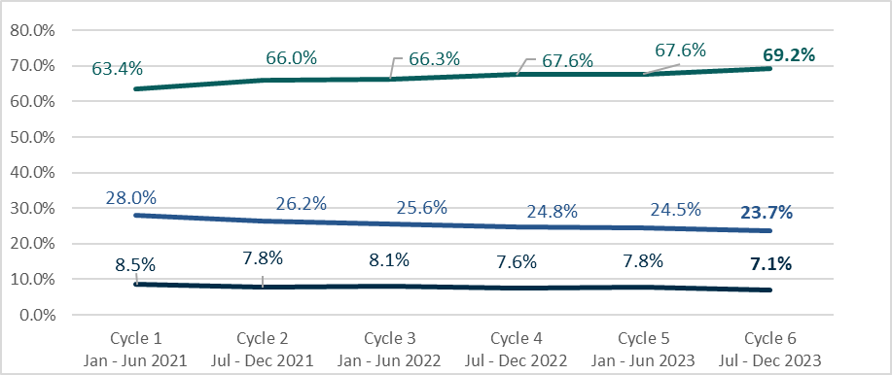

**60+ days**

**31-60 days**

**30 days or less**

***Figure 2****: Proportion of entities that make 95 per cent or more payments by day range, Reporting Cycles 1 to 6 (see data table 6)*

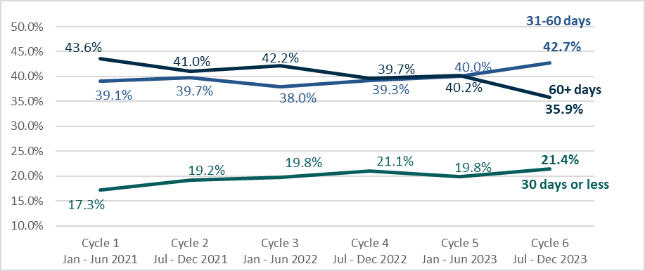

Payment terms

In Reporting Cycle 6, reporting entities improved their average payment terms offered to small businesses to 35.2 days, marking a reduction of 1.9 days from the 37.1 day average reported in Reporting Cycle 1.

Throughout all reporting cycles, the median payment term offered to small businesses has remained unchanged at 30 days.

**Figure 3** shows the average and median payment terms for reporting entities.

***Figure 3:*** *Standard payment terms, Reporting Cycles 1 to 6 (see data table 3)*

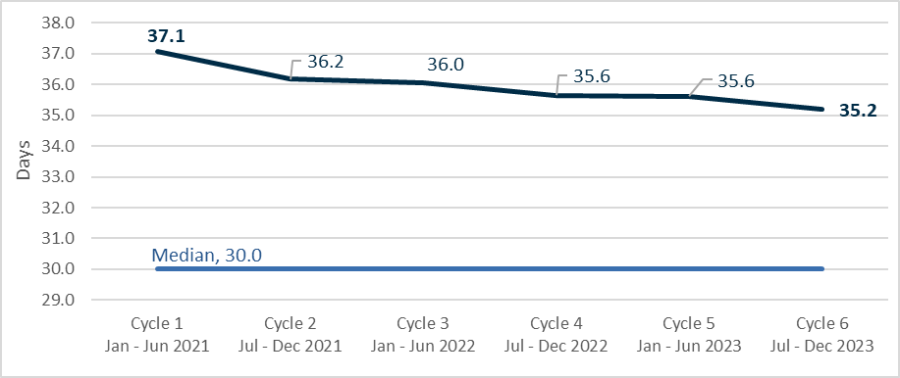

Average standard payment terms

## Procurement from small business

In Reporting Cycle 6, 72.7 per cent of reporting entities made payments to small business suppliers. This is consistent with previous reporting cycles which have ranged from 71.8 to 73.5 per cent.

Reporting entities that procure from small businesses report an average of 30.4 per cent of the total procurement value coming from small business suppliers. This figure remains stable across prior reporting cycles, which have ranged from 29.1 to 30.0 per cent.

**Table 1** below shows the proportion of entities reporting payments to small businesses and the average proportion of the procurement value from small business suppliers for these entities.

***Table 1:*** *Share of small business procurement, Reporting Cycles 1 to 6*

|  |  |  |  |  |  |  |
| --- | --- | --- | --- | --- | --- | --- |
|  | **Cycle 1 Jan - Jun 2021** | **Cycle 2 Jul - Dec 2021** | **Cycle 3 Jan - Jun 2022** | **Cycle 4 Jul - Dec 2022** | **Cycle 5 Jan - Jun 2023** | **Cycle 6 Jul - Dec 2023** |
| Proportion of entities with small business procurement (average) | 73.5% | 72.6% | 71.9% | 71.8% | 72.5% | 72.7% |
| Proportion of total procurement with small businesses (value) | 29.1% | 29.6% | 30.0% | 29.4% | 30.0% | 30.4% |

# Industry insights

## Reports by industry

In Reporting Cycle 6, 7,306 reporting entities made payments to small businesses across all 19 Australian and New Zealand Standard Industrial Classification (ANZSIC) Divisions (ANZSIC 2006 – ABS 2013).

The number of reporting entities in each industry has been broadly consistent through each reporting cycle.

**Figure 4** shows the number of selected reporting entities by ANZSIC Division. Data for all industries is provided in **Table 2** in Appendix B.

***Figure 4:*** *Number of reporting entities paying to small business by industry division, Reporting Cycle 6* *(see data table 2)*

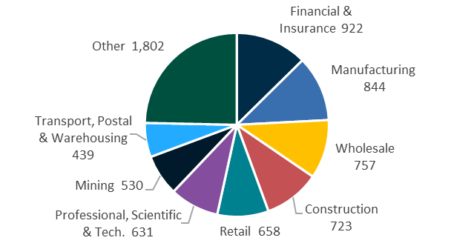

## 

## Payment times by industry

Improvements in the number of payments made within 30 days show a relatively consistent pattern across industries. Following a decline in Reporting Cycle 5 for some industries, there was a positive rebound in Reporting Cycle 6.

**Figure 5** shows the movements in the average proportion of small business payments made within 30 days across selected industries. Industries comprising less than 5 per cent of total reporting entities are grouped as ‘Other’ (for all industry data refer to **Table 2** at Appendix B).

***Figure 5:*** *Average proportion of payments within 30 days (by all industries) (see data table 2)*

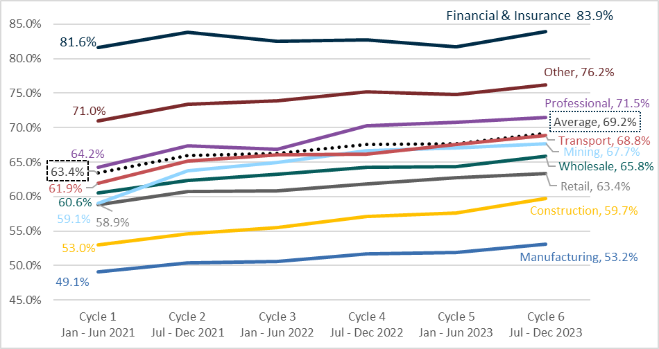

## Payment terms by industry

In Reporting Cycle 6, the average payment terms varied across industries, ranging from 26.6 days in the ‘Public Administration and Safety’ industry to 44.0 days in the ‘Manufacturing’ industry.

**Figure 6** shows the payment terms offered by industries that constitute more than 5 per cent of reporting entities (for all industry data refer to **Table 2** at Appendix B).

***Figure 6****: Average standard payment terms in days, Reporting Cycle 6 (see data table 2)*

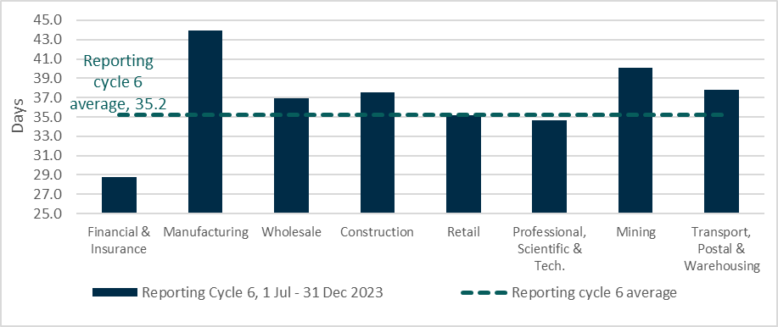

## Comparing payment times and terms

Industries with faster average payment terms typically make a higher proportion of payments within 30 days. Conversely, industries characterised by longer payment terms and a lower proportion of payments in 30 days tend to consist of larger industries with a greater number of reporting entities.

**Figure 7** visually represents this relationship, showing that industries with faster payment terms tend to have a higher proportion of payments within 30 days. The size of each bubble indicates the number of reporting entities for the industry.

***Figure 7****: Average payment terms and percentage of payments within 30 days by industry*, *Reporting Cycle 6 (see data table 2)*

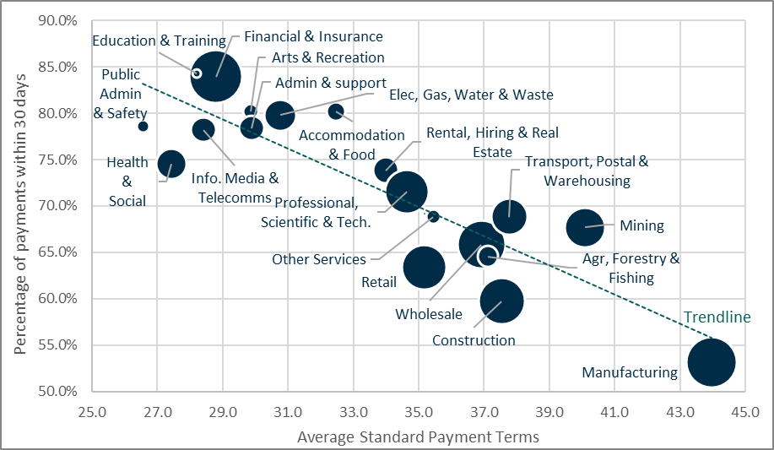

# Policy and Reforms update

## The *Payment Times Reporting Amendment Act 2024*

The Australian Parliament passed the *Payment Times Reporting Amendment Act 2024* (the Amendment Act) on 3 July 2024. It received Royal Assent on 9 July 2024.

The Amendment Act makes major changes to the *Payment Times Reporting Act 2020* (the Act) to implement the [Government’s response](https://treasury.gov.au/publication/p2023-469059) to the statutory review of the Payment Times Reporting Scheme (the Scheme) conducted by Dr Craig Emerson in 2023.

**The reforms in the Amendment Act commence on 7 September 2024. The reforms are significant and will impact all reporting entities.**

Entities are encouraged to engage early with new obligations, including how changes will impact the entities that must report and the transactions that must be reported.

To assist entities in navigating these reforms, the Regulator has prepared the following information sheets:

* [Information sheet 9: Transition to new Scheme](https://paymenttimes.gov.au/guidance/regulatory-resources/information-sheet-9), and
* [Information sheet 10: Reforms to payment times reporting.](https://paymenttimes.gov.au/guidance/regulatory-resources/information-sheet-10)

Additionally, the Regulator will be undertaking a fulsome review and replacement of existing guidance material to align with the reformed Scheme. The Regulator’s [news site](https://paymenttimes.gov.au/news-and-publications) will be updated with relevant information when we release draft guidance for consultation.

## Update to the Payment Times Reporting Rules

The Payment Times Reporting Rules (the Rules) are being overhauled to give effect to the reforms introduced by the Amendment Act.

Treasury opened a consultation process on an [exposure draft of the overhauled Rules](https://treasury.gov.au/consultation/c2024-537148) on 23 July 2024 which is open until 19 August 2024.

Entities are encouraged to review the proposed Rules, in particular, the simplified summary of new reporting content set out in Attachment B of the Explanatory Statement.

Details on how to provide submissions are set out on the Treasury [consultation page](https://treasury.gov.au/consultation/c2024-537148).

## Updating the SBI Tool

The [Government’s response](https://treasury.gov.au/publication/p2023-469059) to the statutory review included a commitment to update the Small Business Identification Tool (SBI Tool) within 28 days of receiving a valid update request from a reporting entity.

Between December 2023 and June 2024, 93.3 per cent of SBI Tool update requests were actioned within the 28-day commitment. On average, requests were actioned in 10.2 days.

The Regulator remains focused on refining processes to further improve the timeliness and accuracy of correcting SBI Tool errors. This effort includes ongoing system updates aimed at streamlining the process for entities to give notice of an error.

## Planned improvements to the submission portal and Register

In addition to streamlining and amending reporting content, the Government committed to improving the operation of the submission portal to lessen the regulatory burden of reporting and enhance the user experience with simplicity and efficiency in mind.

The Regulator is actively working on delivering improvements to the Payment Times Reports Register (the Register), alongside changes to align it with the legislative amendments.

These enhancements will introduce additional functionality and tools designed to improve accessibility and provide enhanced insights for Register users.

# Compliance and enforcement

The Regulator continues to monitor and enforce compliance with the Act.

All entities with obligations under the Act must take those obligations seriously. Reporting entities that fail to submit reports within the required period may face compliance and enforcement action by the Regulator.

## Update on compliance activities

The Regulator continues their compliance focus on entities that have failed to register to report and entities that did register but have failed to report.

Between 1 January and 30 June 2024, the Regulator’s compliance activities resulted in:

* the Regulator receiving 1,370 additional reports
* 120 entities reporting for the first time, and
* publishing 78 failure to comply notices for 26 entities that had failed to report.

As of 30 June 2024, these compliance activities have led to 465 entities submitting reports for the first time, and the publication of 99 records of non-compliance on the Register.

## Late payment times reports

The Regulator issued warning letters to entities that failed to give a report within 3 months for the reporting period ending 31 December 2023.

Entities need to be mindful of the need to report on time. When a report is given late, the Regulator may take compliance and enforcement action that could include publishing a notice of non-compliance on the Register.

# Applications

The Regulator received 346 applications and notices in Reporting Cycle 6.

|  |  |  |  |
| --- | --- | --- | --- |
| **153** | Extension of time to report | **119** | Revised report applications |
| **63** | Cease to be a reporting entity | **10** | Volunteer notices |
| **1** | Reconsider a reviewable decision | | |

## Extension of time applications

The number of applications for an extension of time to report that were made after a report is due, has decreased. Entities should remain mindful that the Regulator cannot grant an extension of time to report once a report is overdue.

With the upcoming reforms effective from 7 September 2024, there will be changes to extension of time applications. A new ‘short-term’ application type will be introduced for extensions of 28 days or less, and a ‘modifiable’ application type offering greater flexibility for longer extensions.

Entities should monitor the Regulator’s [news site](https://paymenttimes.gov.au/news-and-publications) for updates on guidance regarding new application types and requirements.

Until reforms commence on 7 September 2024, entities should continue using [Guidance Note 3: Applications and notifications](https://paymenttimes.gov.au/guidance/regulatory-resources/guidance-note-3) before making an application. **Table 1 of the Guidance Note** serves as a template to ensure that applications contain all necessary information for the Regulator to make a timely decision.

## Cease being a reporting entity applications

The Amendment Act simplifies the way the most reporting entities exit the Scheme and provides transitional provisions to remove entities that do not meet the new definition of a reporting entity.

For information on these transitional provisions, reporting entities should refer to [Information Sheet 9: Transition to new Scheme](https://paymenttimes.gov.au/guidance/regulatory-resources/information-sheet-9).

Reporting entities considering making an application for a determination to cease being a reporting entity before commencement of reforms should continue to use [Guidance note 3: Applications and notifications](https://paymenttimes.gov.au/guidance/regulatory-resources/guidance-note-3) and refer to **Table 2 of the Guidance Note** to determine their eligibility for a determination.

To avoid delays in processing, applications for a determination should include a cover letter plus all relevant content outlined in Table 3 of the Guidance Note.

# Appendix A – Insights: methodology and assumptions

## Reporting cycles

Insights reported refer to **reporting cycles**. A reporting cycle is a fixed period based on the commencement of the Act:

|  |  |  |  |  |
| --- | --- | --- | --- | --- |
| Reporting cycle 1 | Reporting cycle 2 | Reporting cycle 3 |  | Reporting cycle 10 |
| 1/01/2021 – 30/06/2021 | 1/07/2021 – 31/12/2021 | 1/01/2022 – 30/06/2022 |  | 1/07/2025 – 31/12/2025 |

Reports are assigned to a reporting cycle based on the **reporting period start date**. For example, a report with a reporting period start date of 15 March 2022 will be categorised as Reporting Cycle 3 for the purpose of payment times reporting.

For the purposes of assigning data to a reporting cycle, we assign other assumptions to several **reporting period start date** values which are either formatted as MM/DD/YYYY or occur prior to the commencement of the Scheme, i.e., 1 January 2021. For dates 07/01/YYYY with a reporting period end date of 31/12/YYYY or 12/31/YYYY, a reporting period start date of 1 July YYYY is assumed. Where a reporting period start date is prior to 1 January 2021, if any of the reporting period falls after the commencement of the Scheme, a date of 1 January 2021 is applied. If all the reporting period falls prior to the commencement of the Scheme, the report is excluded from reporting cycle analysis (4 reports result in being excluded).

Reporting instances (i.e., an entity’s first report, second report, etc.) and reporting cycles do not reconcile because of the timing of reports. For example, the first instance of reporting for an entity may occur in Reporting Cycle 2 or 3.

Historic report statistics will also change as entities continue to submit reports for prior reporting cycles and revisions are made to reports.

## Insights are at a point-in-time

Data is subject to revision and reports are received on a continuous basis, including for historical reporting cycles. Previous reports can also be updated by submissions of revised reports.

Insights provided in this Regulator’s Update are based on reports received by 30 June 2024 and subsequently registered. The insights are subject to change as additional reports received after this date are registered by the Regulator or revised by reporting entities.

## Analysis on payment times

The Regulator receives payment times data relating to 2 categories:

* The percentage of the **total number** of payments to small businesses
* The percentage of the **total value** of payments to small businesses.

Insights in this Regulator’s Update are based on the percentage (or proportion) of the total number of small business payments. Insights reporting the changes in the payment times for entities are based on a comparison between an entity’s first submitted report (containing small business payments) and their last submitted report (containing small business payments). Reports superseded by a revised report and ‘nil’ reports (refer to assumptions below) are excluded from analysis on payment times.

## Assumptions

Unless otherwise stated, the following assumptions apply.

* **Nil reports** are excluded from calculations for standard payment terms and payment times. Nil reports either:
  + contain zero payment terms and payment times because the entity does not procure from small business, or
  + report zero as the percentage of their total procurement with small business.
* **Superseded reports** are excluded from calculations. A superseded report is where an original or revised report has been replaced by a subsequent revised report. Only the most recent revised report is used.
* **Change in standard payment period** is the standard payment term reported at the end of a reporting period. It is the most contemporary standard payment term reported and used, unless otherwise stated, when calculating summary statistics such as averages and medians. This field can be incorrectly reported, so to address the inconsistencies, the following assumptions are applied:
  + If the change in standard payment period is a positive number, the reported figure is used.
  + If the change in standard payment period is a negative number, the absolute value is subtracted from the standard payment period (at the start of the reporting period). Where this calculation results in:
    - a positive number, the resulting figure is used, and
    - a negative number, the report is excluded from analysis.
  + If the change in standard payment period is zero, the standard payment period (at the start of the reporting period) is used.
* An entity is **reporting as part of a group** by applying the following assumptions:
  + classification is based on the most recent report received from an entity
  + if no ABN or ACN is provided for a head entity or controlling corporation, then it is treated as a null value for these fields
  + if multiple entities report the same head entity, all entities reporting the same head entity are made a single group
  + if an entity reports a controlling corporation and no head entity, that entity and the controlling corporation is a single group
  + if an entity reports a head entity with no controlling corporation, and is the only entity to report under that head entity, it is treated as an individual reporter, and
  + if an entity does not report a controlling corporation or head entity, it is treated as an individual reporter.

# Appendix B – Data tables

All data tables reflect payment times reports **received** by 30 June 2024, reflecting payment activity up to and including **Reporting Cycle 6**.

***Table 2:*** *Reporting entities making payments to small businesses by industry [1] in Reporting Cycle 6*

|  |  |  |  |  |  |
| --- | --- | --- | --- | --- | --- |
| Industry | Reporting entities[2] | | Average proportion of  procurement from small business (by value) | Average standard payment terms | Average payments in  30 days |
| Ranked by number of reporting entities | **No.** | **(%)** | **(%)** | **(days)** | **(%)** |
| Financial & Insurance Services | **922** | 12.6 | **28.5** | 28.8 | 83.9 |
| Manufacturing | **844** | 11.6 | **26.6** | 44.0 | 53.2 |
| Wholesale Trade | **757** | 10.4 | **23.5** | 36.9 | 65.8 |
| Construction | **723** | 9.9 | **42.4** | 37.5 | 59.7 |
| Retail Trade | **658** | 9.0 | **26.2** | 35.2 | 63.4 |
| Professional, Scientific & Technical Services | **631** | 8.6 | **34.5** | 34.6 | 71.5 |
| Mining | **530** | 7.3 | **23.3** | 40.1 | 67.7 |
| Transport, Postal & Warehousing | **439** | 6.0 | **27.9** | 37.8 | 68.8 |
| Electricity, Gas, Water & Waste Services | **333** | 4.6 | **26.7** | 30.8 | 79.8 |
| Health Care & Social Assistance | **311** | 4.3 | **35.4** | 27.4 | 74.6 |
| Rental, Hiring & Real Estate Services | **232** | 3.2 | **37.1** | 34.0 | 73.8 |
| Administrative & Support Services | **211** | 2.9 | **36.9** | 29.9 | 78.4 |
| Information Media & Telecommunications | **208** | 2.8 | **28.0** | 28.4 | 78.2 |
| Agriculture, Forestry & Fishing | **147** | 2.0 | **43.9** | 37.1 | 64.6 |
| Accommodation & Food Services | **117** | 1.6 | **34.0** | 32.5 | 80.2 |
| Arts & Recreation Services | **81** | 1.1 | **35.2** | 29.9 | 80.2 |
| Other Services | **74** | 1.0 | **37.2** | 35.4 | 68.9 |
| Public Administration & Safety | **59** | 0.8 | **33.3** | 26.6 | 78.6 |
| Education & Training | **29** | 0.4 | **33.6** | 28.2 | 84.3 |
| Total | **7,306** | **100.0** | **30.4** | **35.2** | **69.2** |

***Table 3:*** *Payment time reports received by 30 June 2024*

|  |  |  |  |  |  |  |
| --- | --- | --- | --- | --- | --- | --- |
| **Reporting Cycle** | **Cycle range** | **Payment time reports** | **Standard payment terms** | | **Average proportion of reports with small business procurement** | **Average proportion of procurement with small business (value)** |
| **Average** | **Median** |
|  | | no. | days | days | % | % |
| Cycle 1 | 1 Jan - 30 Jun 2021 | 9,274 | 37.1 | 30 | 73.5 | 29.1 |
| Cycle 2 | 1 Jul - 31 Dec 2021 | 9,616 | 36.2 | 30 | 72.6 | 29.6 |
| Cycle 3 | 1 Jan - 30 Jun 2022 | 10,060 | 36.0 | 30 | 71.9 | 30.0 |
| Cycle 4 | 1 Jul - 31 Dec 2022 | 10,222 | 35.6 | 30 | 71.8 | 29.4 |
| Cycle 5 | 1 Jan - 30 Jun 2023 | 10,338 | 35.6 | 30 | 72.5 | 30.0 |
| Cycle 6 | 1 Jul - 31 Dec 2023 | 10,047 | 35.2 | 30 | 72.7 | 30.4 |
| Cycle 7 | 1 Jan - 30 Jun 2024 | 14 | | |  | |
| **Total** | | **59,571** | | |  | |
| Superseded reports | | 1,980 | | |  | |
| **Total reports on the Register** | | **61,555** | | |  | |

***Table 4:*** *Payment time reports by reporting instance*

|  |  |
| --- | --- |
| **Reporting instance** | **Payment time reports** |
|  | no. |
| First report | 11,698 |
| Second report | 10,965 |
| Third report | 10,410 |
| Fourth report | 9,746 |
| Fifth report | 8,965 |
| Sixth report | 7,764 |
| Seventh report | 23 |
| **Total reports** | **59,548** |
| Superseded reports | 1,980 |
| **Total reports on the Register** | **61,555** |

***Table 5:*** *Payment times by day ranges, Reporting Cycles 1 to 6*

|  |  |  |  |  |  |  |
| --- | --- | --- | --- | --- | --- | --- |
| **Payment times** | **Cycle 1 1 Jan - 30 Jun 2021**  **%** | **Cycle 2 1 Jul - 31 Dec 2021**  **%** | **Cycle 3  1 Jan - 30 Jun 2022**  **%** | **Cycle 4 1 Jul - 31 Dec 2022**  **%** | **Cycle 5 1 Jan - 30 Jun 2023**  **%** | **Cycle 6 1 Jul - 31 Dec 2023**  **%** |
| Within 30 days | 63.4 | 66.0 | 66.3 | 67.6 | 67.6 | 69.2 |
| 31-60 days | 28.0 | 26.2 | 25.6 | 24.8 | 24.5 | 23.7 |
| More than 60 days | 8.5 | 7.8 | 8.1 | 7.6 | 7.8 | 7.1 |

***Table 6****: 95 per cent of payments to small business within day ranges, Reporting Cycles 1 to 6*

|  |  |  |  |  |  |  |
| --- | --- | --- | --- | --- | --- | --- |
| **95 per cent of Payment times** | **Cycle 1 1 Jan - 30 Jun 2021**  **%** | **Cycle 2 1 Jul - 31 Dec 2021**  **%** | **Cycle 3 1 Jan - 30 Jun 2022**  **%** | **Cycle 4 1 Jul - 31 Dec 2022**  **%** | **Cycle 5 1 Jan - 30 Jun 2023**  **%** | **Cycle 6 1 Jul - 31 Dec 2023**  **%** |
| Within 30 days | 17.3 | 19.2 | 19.8 | 21.1 | 19.8 | 21.4 |
| 31-60 days | 39.1 | 39.7 | 38.0 | 39.3 | 40.0 | 42.7 |
| More than 60 days | 43.6 | 41.0 | 42.2 | 39.7 | 40.2 | 35.9 |

***Table 7:*** *Average percentage of payments within 30 days by Industry, reporting cycles 1 to 6*

|  |  |  |  |  |  |  |  |  |
| --- | --- | --- | --- | --- | --- | --- | --- | --- |
| **Industry  (alphabetical)** | | | **Cycle 1**  **1 Jan 2021 to 30 Jun 2021** | **Cycle 2**  **1 Jul 2021 to 31 Dec 2021** | **Cycle 3**  **1 Jan 2022 to 30 Jun 2022** | **Cycle 4**  **1 Jul 2022 to 31 Dec 2022** | **Cycle 5**  **1 Jan 2023 to 30 Jun 2023** | **Cycle 6**  **1 Jul 2023**  **to**  **31 Dec 2023** |
|  | |  | % | % | % | % | % | % |
| 1 | Accommodation & Food Services | 71.7 | 77.0 | 78.7 | 80.5 | 81.5 | 80.2 |
| 2 | Administrative & Support Services | 77.3 | 75.8 | 79.6 | 78.8 | 78.5 | 78.4 |
| 3 | Agriculture, Forestry & Fishing | 57.8 | 59.4 | 60.9 | 60.8 | 60.5 | 64.6 |
| 4 | Arts & Recreation Services | 71.2 | 79.6 | 77.9 | 81.6 | 79.4 | 80.2 |
| 5 | Construction | 53.0 | 54.6 | 55.5 | 57.1 | 57.7 | 59.7 |
| 6 | Education & Training | 80.0 | 82.2 | 79.1 | 77.6 | 78.7 | 84.3 |
| 7 | Electricity, Gas, Water & Waste Services | 76.2 | 76.7 | 76.6 | 79.3 | 78.3 | 79.8 |
| 8 | Financial & Insurance Services | 81.6 | 83.9 | 82.5 | 82.7 | 81.7 | 83.9 |
| 9 | Health Care & Social Assistance | 71.6 | 73.6 | 72.8 | 74.7 | 73.7 | 74.6 |
| 10 | Information Media & Telecommunications | 71.5 | 75.4 | 75.9 | 76.9 | 76.0 | 78.2 |
| 11 | Manufacturing | 49.1 | 50.4 | 50.6 | 51.7 | 51.9 | 53.2 |
| 12 | Mining | 59.1 | 63.7 | 65.0 | 66.6 | 67.0 | 67.7 |
| 13 | Other Services | 56.5 | 59.7 | 59.2 | 63.2 | 64.8 | 68.9 |
| 14 | Professional, Scientific & Technical Services | 64.2 | 67.4 | 66.9 | 70.3 | 70.7 | 71.5 |
| 15 | Public Administration & Safety | 77.6 | 80.7 | 79.4 | 80.0 | 79.1 | 78.6 |
| 16 | Rental, Hiring & Real Estate Services | 67.2 | 72.2 | 72.6 | 73.9 | 73.3 | 73.8 |
| 17 | Retail Trade | 58.9 | 60.7 | 60.8 | 61.9 | 62.8 | 63.4 |
| 18 | Transport, Postal & Warehousing | 61.9 | 65.1 | 66.0 | 66.2 | 67.5 | 68.8 |
| 19 | Wholesale Trade | 60.6 | 62.3 | 63.3 | 64.3 | 64.4 | 65.8 |
| **Total** | | | **63.4** | **66.0** | **66.3** | **67.6** | **67.6** | **69.2** |

1. ANZSIC ([Australian Bureau of Statistics 2013](https://www.abs.gov.au/statistics/classifications/australian-and-new-zealand-standard-industrial-classification-anzsic/latest-release)).
2. Excludes reporting entities without small business procurement.