Regulator’s update

July 2023

© Commonwealth of Australia 2023

This publication is available for your use under a [Creative Commons Attribution 3.0 Australia](http://creativecommons.org/licenses/by/3.0/au/deed.en) licence, with the exception of the Commonwealth Coat of Arms, the Treasury logo, the Payment Times Reporting Regulator logo, photographs, images, signatures and where otherwise stated. The full licence terms are available from <http://creativecommons.org/licenses/by/3.0/au/legalcode>.

Creative Commons attribution licence 3.0 icon. 

Use of Treasury material under a [Creative Commons Attribution 3.0 Australia](http://creativecommons.org/licenses/by/3.0/au/deed.en) licence requires you to attribute the work (but not in any way that suggests that the Treasury endorses you or your use of the work).

*Treasury material used ‘as supplied’.*

Provided you have not modified or transformed Treasury material in any way including, for example, by changing the Treasury text; calculating percentage changes; graphing or charting data; or deriving new statistics from published Treasury statistics — then Treasury prefers the following attribution:

*Source: The Australian Government, The Treasury, Payment Times Reporting Regulator*.

**Derivative** **material**

If you have modified or transformed Treasury material, or derived new material from those of the Treasury in any way, then Treasury prefers the following attribution:

*Based on The Australian Government the Treasury, Payment Times Reporting Regulator data*.

**Use of the Coat of Arms**

The terms under which the Coat of Arms can be used are set out on the Department of the Prime Minister and Cabinet website (see [www.pmc.gov.au/government/commonwealth-coat-arm](http://www.pmc.gov.au/government/commonwealth-coat-arm)s).

**Other uses**

Enquiries regarding this licence and any other use of this document are welcome at:

Manager  
Media and Speeches Unit  
The Treasury  
Langton Crescent   
Parkes ACT 2600  
Email: [media@treasury.gov.au](mailto:media@treasury.gov.au)

Letter from the Regulator 4

Data and insights 5

Published reports 5

Payments to small business 5

Median and average payment terms 6

Payment times 6

Reports by industry 8

Applications, notices to volunteer and enquiries 9

Policy and resources update 10

Statutory Review of the *Payment Times Reporting Act 2020* 10

Changes to the portal 10

Register monthly updates 10

Regulatory resources and website changes 10

Compliance and enforcement 11

Ongoing compliance program 11

Failing to register 11

Failing to report 11

Regulator approach to non-compliance 11

Improving the quality of reporting 12

Applications 12

Revised report applications 12

Extension of time applications 12

Appendix A – Insights methodology and assumptions 13

Reporting cycles 13

Insights are at a point-in-time 13

Analysis on payment times 13

Assumptions 14

Appendix B – Data tables 15

# Letter from the Regulator

The Payment Times Reporting Scheme (the scheme) has been in operation for over two years and the Payment Times Reports Register (the register) now contains over 36,000 reports from more than 10,000 reporting entities.

It’s been a busy six months, and this issue of the Regulator’s update includes the latest data insights, information about compliance programs, tips for reporting entities to ensure reports comply with the *Payment Times Reporting Act 2020* (the Act) and updates on system upgrades and website updates, to make reporting easier. In summary:

* The most recent reporting cycle shows no material change in payment terms when compared to the last reporting cycle.
* However, when looking at actual payment times across the life of the scheme, there has been a small improvement in the percentage of small business invoices being paid within 30 days.
* The Hon Dr Craig Emerson completed an independent, statutory review of the Act by the end of June 2023. The Minister is due to table the report in each House of the Parliament within   
  15 sitting days.

On Friday 21 July 2023, the regulator published its Statement of Intent in response to the Minister for Small Business’s Statement of Expectation. The Statement of Intent sets out how the regulator will deliver its functions and meet the Government’s policy objectives. These statements are available on the Payment Times Reporting Regulator’s website.

The next liaison forum will be in September 2023. This virtual forum provides reporting entities and stakeholders an opportunity to discuss this update, provide feedback and ask questions directly with the regulator’s leadership team. Previous forum attendees will automatically receive an invitation to the virtual forum. If you have not previously attended and would like to be added to our mailing list, please email us at [support@paymenttimes.gov.au](mailto:support@paymenttimes.gov.au).

I thank you for your ongoing support of the Payment Times Reporting Scheme.

Kind regards,

**Mary Jeffries**

Payment Times Reporting Regulator (statutory position)

Assistant Secretary, Payment Performance Branch

The Treasury

# Data and insights

A total of 36,421 payment times reports were received to 30 June 2023. Reports have been received from 10,184 reporting entities, with 7,193 entities reporting as part of a group and 2,991 entities reporting individually.

A total of 9,152 reports have been received for the 4th reporting cycle (reports with an end date between 1 July 2022 and 31 December 2022) and 7,638 reporting entities have now submitted 4 reports. Details on reporting cycles, methodology and report calculations are provided in Appendix A.

## Published reports

Pictorial icons with numbers:
10,184 Reporting entities
7,193 Entities that reported as part of a group 1,531 Reporting groups
36,421 Payment times reports published on the register
9,235 3rd reporting cycle
9,152 4th reporting cycle

Based on reports as at 30 June 2023. For information on 'reporting cycles' see Appendix A.

## Payments to small business

Pictorial icons with figures:
72% Percentage of reporting entities that make payments to small business
30% Average percentage of total procurement that is with small businesses

Based on reports for the 4th reporting cycle. Average percentage of total procurement calculation excludes reports with nil small business procurement.

In the 4th reporting cycle, 72% of reporting entities made payments to small business suppliers with an average of 30% of total procurement with small businesses. This was a reduction of almost   
1 percentage point for both measures from the previous reporting cycle.

## Median and average payment terms

Pictorial icons with text:
30 days:  Median payment terms at the end of the 3rd reporting cycle
30 days:  Median payment terms at the end of the 4th reporting cycle
0 change in median payment terms across reporting periods
36.0 days: Average payment terms at the end of the 3rd reporting cycle
35.7 days: Average payment terms at the end of the 4th reporting cycle
-0.27 days: Change in average payment terms across reporting periods

Median and average payment terms offered to small business suppliers at the end of the reporting period in   
cycles 3 and 4.

The median and average payment terms offered by reporting entities to small businesses did not materially change between the 3rd reporting cycle and the 4th reporting cycle.

An analysis of entities that have submitted reports for all 4 reporting cycles and procure from small business indicate that since the 1st reporting cycle:

* 13% offer shorter payment terms
* 5% offer longer payment terms, and
* 82% offer the same payment terms.

## Payment times

There has been a small improvement in the percentage of small business invoices being paid within 30 days when comparing the first report submitted by a reporting entity to its last report.

The number of invoices being paid within 30 days has increased by approximately 3%. This improvement is driven by a reduction in the percentage of invoices being paid between 31-60 days (reduction of ~2.5%) with very little improvement (<1%) attributable to a reduction of invoices being paid in 61 days or more.

**Figure 1 – Change in the proportion of invoices paid within day ranges (data in Appendix B)**

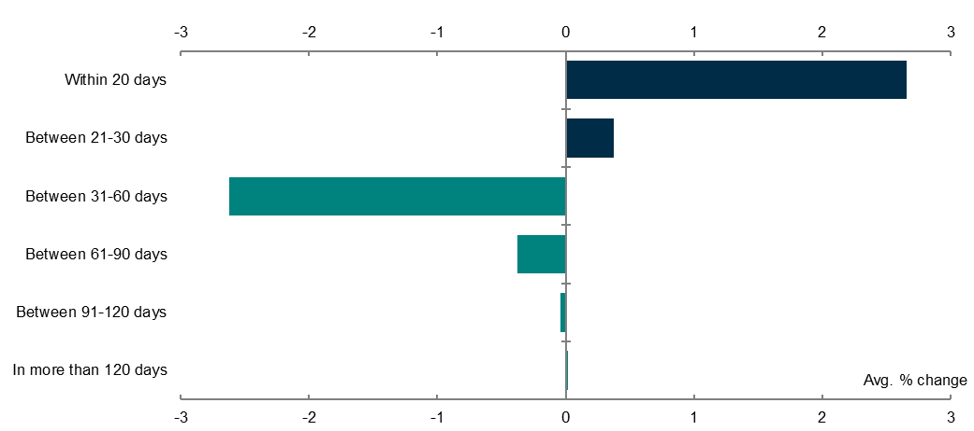

% change in average proportion of small business invoices paid between  
 first and last submitted reports.

The small improvement can also be seen when looking at the percentage of entities that pay within 30 days.

* In the first submitted report, 38% of entities paid at least 80% of their small business invoices within 30 days.
* In the last submitted report, 44% of entities paid at least 80% of their small business invoices within 30 days.

**Figure 2 – Percentage of reporting entities paying invoices within 30 days (data in Appendix B)**

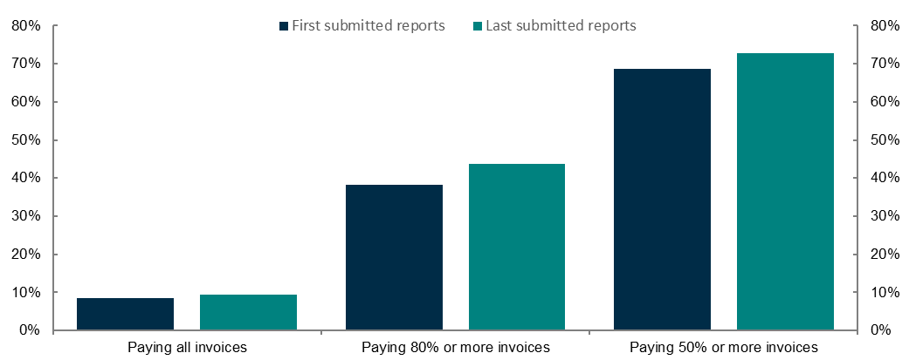

Percentage of entities that paid all, at least 80% and at least 50% of small business invoices within 30 days, first and last submitted reports.

## Reports by industry

**Figure 3 – Percentage of reports with small business procurement by ANZSIC division code (data in Appendix B)**

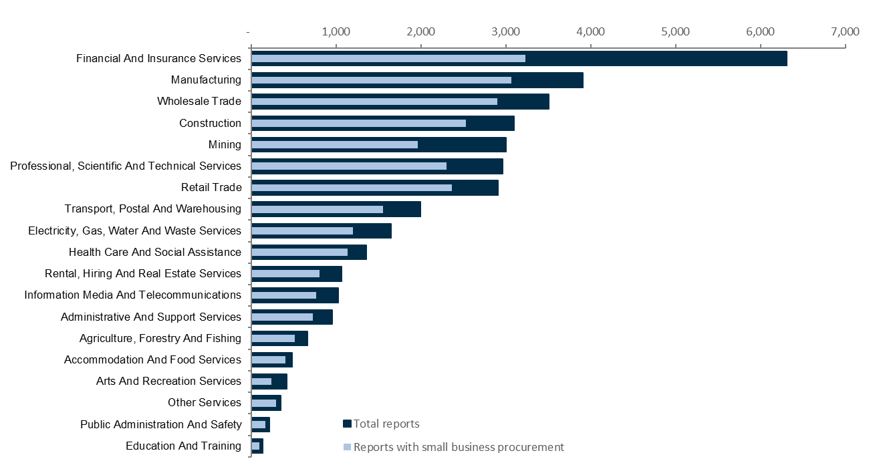

Total reports in the register and reports with small business procurement by ANZSIC division code.

The financial and insurance services industry has the highest number of reports published on the register, with a total of 6,310 reports. It is also the industry with the highest percentage of reports with nil small business procurement (49%). Accommodation and food services has the highest percentage of reports with small business procurement (85%) and has 481 reports on the register.

**Figure 4 – Reporting entities with small business procurement by ANZSIC division code (data in Appendix B)**

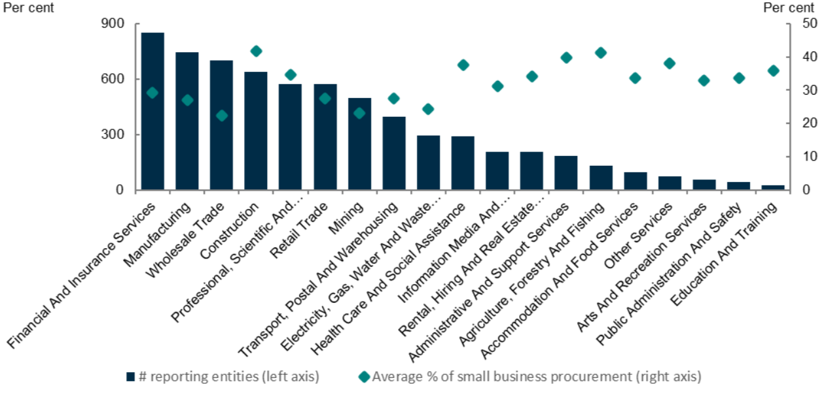

Number of reporting entities with small business procurement and average percentage of small business procurement - in 4th reporting cycle by ANZSIC division code.

In the 4th reporting cycle the industry with the highest percentage of procurement from small business suppliers was construction (42%) followed by the agriculture, forestry and fishing (41%). The industry with the lowest percentage of procurement from small business suppliers was wholesale trade (22%).

**Figure 5 – Percentage of invoices paid within 30 days by ANZSIC division code (data in Appendix B)**

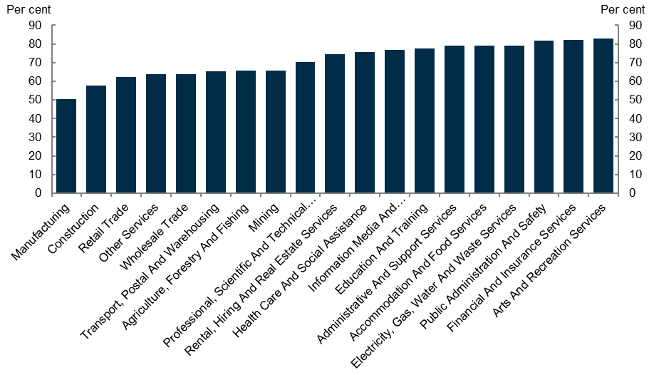

Average percentage of invoices paid within 30 days in 4th reporting cycle by ANZSIC division code.

When looking at the percentage of small business invoices paid within 30 days by industry:

* The manufacturing industry had the lowest percentage at 50%, followed by the construction industry at 58%.
* The arts and recreation services industry had the highest percentage at 83%, followed by the financial and insurance services industry at 82%.

## Applications, notices to volunteer and enquiries

Numbers with icons listed in proceeding text plus: 
148 Extension of time applications
16 Cease to be a reporting entity applications
1,032 Revised report applications  
  
Between 1 January 2023 and 30 June 2023, the regulator received 1,196 applications, 5 notifications from volunteering entities, and responded to 1,387 enquiries.

# Policy and resources update

## Statutory Review of the *Payment Times Reporting Act 2020*

The independent, statutory review of the *Payment Times Reporting Act 2020* commenced in December 2022 and finalised by 30 June 2023. The review included broad consultation and preparation of a written report with findings on the efficacy of the Act in meeting its objectives.

The written report will be published on the Treasury website after being tabled in Parliament by the Minister for Small Business. A news update will be published to the regulator’s website when the report is released.

## Changes to the portal

The Payment Times Reporting Portal (the portal) was upgraded in June 2023 to improve the user experience and make it easier to submit reports and applications.

The changes to the portal were designed to make the experience more intuitive, with clearer steps and system validation checks at the end to prompt users of potential errors. The new features will assist reporting entities to address potential errors prior to submitting a report and reduce the need to submit revised reports.

For more information on changes to the portal see the news article [*Changes to the portal now available*](https://paymenttimes.gov.au/news/changes-portal-now-available)(16 June 2023) on the regulator’s website.

## Register monthly updates

|  |
| --- |
| Register updates |
| 31 January 2023 |
| 21 February 2023 |
| 15 March 2023 |
| 18 May 2023 |
| 14 June 2023 |

As foreshadowed in the Regulator’s update in January 2023, the regulator has delivered monthly register updates (with the exception of April to allow for the processing of the peak volume of reports received in March).

The regulator will publish a statement on the [news section](https://paymenttimes.gov.au/news) of the regulator’s website each time the register is updated.

## Regulatory resources and website changes

The [regulator’s website](https://paymenttimes.gov.au/) was updated in June 2023, with a new structure and revised content to better assist users in finding information. There are new sections created for guidance materials, publications, legislation and small business.

Superseded guidance material has been removed from the website but is available as an archived version (accessible on the [Guidance page](https://paymenttimes.gov.au/guidance)).

Stakeholder feedback informed some of the changes to the website, and any further feedback regarding the website can be directed to [support@paymenttimes.gov.au](mailto:support@paymenttimes.gov.au).

# Compliance and enforcement

## Ongoing compliance program

Since the last Regulator’s update in January 2023, the regulator has commenced a compliance program focused on:

* reporting entities that have failed to register for the Payment Times Reporting Scheme; and
* reporting entities that are registered to report but failed to provide one or more reports.

## Failing to register

The regulator uses commercial and government data to identify entities that may meet the criteria of a reporting entity but have not registered to report.

Where an entity is suspected of being a reporting entity that has failed to register the regulator will contact the entity requesting information that confirms whether the entity is a reporting entity under the Act.

An entity that submits that it is not a reporting entity because it does not meet the financial thresholds will be requested to provide financial statements and other information in support of its submission.

## Failing to report

The regulator reviews the reporting history of entities and may commence compliance action where a reporting entity has previously reported and then fails to report in a subsequent period.

Once an entity becomes a reporting entity, they are required to give the regulator a payment times report for each reporting period until:

* they have been granted a cease to report determination by the regulator, or
* if the entity is a member entity, they have had two consecutive income years with total income below A$10 million (which must be disclosed as a notifiable event in a payment times report).

If a reporting entity has outstanding reports, they should be submitted immediately.

## Regulator approach to non-compliance

Reporting entities are reminded of the regulator’s approach to regulation, in particular that timely remediation is a relevant consideration when determining how non-compliance will be addressed.

The regulator may address non-compliance through a range of options including issuing a guidance letter, publishing details of non-compliance, issuing an infringement notice, and seeking civil penalties through court proceedings.

Further updates on the compliance program will be provided in the next Regulator’s update.

## Improving the quality of reporting

The regulator monitors the quality of reporting.

Where suspected errors in reporting are identified prior to registration, the regulator may contact the reporting entity and seek clarification or facilitate corrections through the return and re‑submission of the report in the portal. Where report contents do not align with guidance, feedback is provided to the reporting entity.

As the next major reporting deadline of 30 September 2023 approaches, entities are reminded that [Guidance Note 2 - Appendix 1 - Reporting template instructions](https://paymenttimes.gov.au/sites/ptrs.gov.au/files/regulatory-resource/GN2_Appendix1_instructions.pdf) provides detailed guidance on each field of the report to help entities prepare a best practice report.

Report fields that commonly attract feedback include Business Name, Principal Governing Body Name, and Principal Governing Body Description. In addition, reports are required to include any information that will provide context or explanation for information in a report and free text fields are generally underutilised.

# Applications

## Revised report applications

If a reporting entity needs to correct a registered report, it can apply through the portal to have a revised report registered. Guidance on making a revised report request is contained in [Guidance Note 3: Applications and Notifications](https://paymenttimes.gov.au/about/regulatory-resources/guidance-note-3-0).

When applying to have a revised report registered, entities must attach an updated responsible member declaration that reflects the dates of the revised report.

## Extension of time applications

Applications for an extension of time must provide a submission of the circumstances that have resulted in the need for further time and be supported by available evidence. Applications must also be made before a report has become overdue.

The regulator has recently refused applications that were made after a report had become overdue. Reporting entities are reminded the regulator cannot grant an extension of time if an application is made more than 3 months after the end of the relevant reporting period.

Reporting entities should review [Guidance Note 3: Applications and notifications](https://paymenttimes.gov.au/about/regulatory-resources/guidance-note-3-0) before making an application and use Table 1 of the guidance note as a template for application submissions. Following this guidance will ensure applications contain all required information and that a timely decision can be made.

# Appendix A – Insights methodology and assumptions

## Reporting cycles

Insights reported refer to **reporting cycles**. A reporting cycle is a fixed period based on the commencement of the Act:

|  |  |  |  |  |
| --- | --- | --- | --- | --- |
| Reporting cycle 1 | Reporting cycle 2 | Reporting cycle 3 |  | Reporting cycle 10 |
| 1/01/2021 – 30/06/2021 | 1/07/2021 – 31/12/2021 | 1/01/2022 – 30/06/2022 |  | 1/07/2025 – 31/12/2025 |

Reports are assigned to a reporting cycle based on the **reporting period start date**. For example, a report with a reporting period start date of 15 March 2022 will be categorised as reporting cycle 3 for the purpose of reporting.

For the purposes of assigning to a reporting cycle, other assumptions are applied to a number of **reporting period start date** values which are either formatted MM/DD/YYYY or occur prior to the commencement of the scheme, i.e. 1 January 2021. For dates 07/01/YYYY with a reporting period end date of 31/12/YYYY or 12/31/YYYY, a reporting period start date of 1 July YYYY is assumed. Where a reporting period start date is prior to 1 January 2021, if any of the reporting period falls after the commencement of the scheme, a date of 1 January 2021 is applied. If all of the reporting period falls prior to the commencement of the scheme, the report is excluded from reporting cycle analysis (4 reports result in being excluded).

Reporting instances (i.e. an entity’s first report, second report, etc.) and reporting cycles do not reconcile because of the timing of reports. For example, the first instance of reporting for an entity may occur in reporting cycle 2 or 3.

Historic report statistics will also change as entities continue to submit reports for prior reporting cycles and revisions are made to reports.

## Insights are at a point-in-time

Reports are received by the regulator on a continuous basis, including for historical reporting cycles. Previous reports can also be updated by submissions of revised reports.

Insights provided in this update are based on reports received by 30 June 2023 and subsequently registered. The insights are subject to change as additional reports received after 30 June 2023 are received by the regulator or revised by reporting entities.

## Analysis on payment times

Data received by the regulator on payment times relates to 2 categories:

* The percentage of **total number** of small business payments
* The percentage of **total value** of small business payments.

The insights reported in this update are based on the percentage (or proportion) of total number of small business payments. Insights reporting the changes in the payment times for entities are based on a comparison between an entities first report submitted (containing small business payments) and its last report submitted (containing small business payments). Reports that are superseded by the submission of a revised report and ‘nil’ reports (refer to assumptions below) are excluded from analysis on payment times.

## Assumptions

Unless otherwise stated, the following assumptions are adopted in preparation of insights:

* **Nil reports** are excluded from calculations regarding standard payment terms and payment times. Nil reports are reports that:
  + have zero payment terms and payment times because the entity does not procure from small business, or
  + report zero as the percentage of total procurement with small business.
* **Superseded reports** are excluded from calculations. A superseded report is where an original or revised report has been replaced by a subsequent revised report. Only the most recent revised report is used.
* **Change in standard payment period** is the standard payment term reported at the end of a reporting period. It is the most contemporary standard payment term reported and is used, unless otherwise stated, when calculating summary statistics such as averages and medians. This field can be incorrectly reported, so to address the inconsistencies the following assumptions are applied:
  + if the change in standard payment period is a positive number, the reported figure is used
  + if the change in standard payment period is a negative number, the absolute value is subtracted from the standard payment period (at the start of the reporting period). Where this calculation results in:
    - a positive number, the resulting figure is used
    - a negative number, the report is excluded from analysis
  + if the change in standard payment period is zero, the standard payment period (at the start of the reporting period) is used.
* An entity is **reporting as part of a group**, by applying the following assumptions:
  + classification is based on the most recent report received from an entity
  + if no ABN or ACN is provided for a head entity or controlling corporation, then it is treated as a null value for these fields
  + if multiple entities report the same head entity, all entities reporting the same head entity are treated as a single group
  + if an entity reports a controlling corporation and no head entity, that entity and the controlling corporation is treated as a single group
  + if an entity reports a head entity with no controlling corporation, and is the only entity to report under that head entity, it is treated as an individual reporter
  + if an entity does not report a controlling corporation or head entity, it is treated as an individual reporter.

# Appendix B – Data tables

Table 1: Status counts of reports received by 30 June 2023 and subsequently published to the register.

|  |  |  |  |  |  |  |  |
| --- | --- | --- | --- | --- | --- | --- | --- |
| Reporting cycle | Cycle range | | # of reports | Average standard payment terms (end of reporting period) | Median standard payment terms (end of reporting period) | % of reports with small business procurement | Average % of small business procurement (excl. nil reports) |
| Cycle 1 | 1/01/2021 - 30/06/2021 | | 8,730 | 36.8 | 30 | 74.1 | 29.9 |
| Cycle 2 | 1/07/2021 - 31/12/2021 | | 8,891 | 36.0 | 30 | 73.2 | 30.7 |
| Cycle 3 | 1/01/2022 - 30/06/2022 | | 9,235 | 36.0 | 30 | 72.5 | 31.1 |
| Cycle 4 | 1/07/2022 - 31/12/2022 | | 9,152 | 35.7 | 30 | 72.0 | 30.4 |
| Cycle 5 | 1/01/2023 - 30/06/2023 | | 1 | 30.0 | 30 | 100 | 14.5 |
| **Total** | | |  | **36,009** |  |  |  |  |
| Superseded reports[1] | | |  | 408 |  |  |  |  |
| **Total reports on register[2]** | | |  | **36,421** |  |  |  |  |

Table 2: Average standard payment terms by reporting cycle.

|  |  |  |  |  |
| --- | --- | --- | --- | --- |
| Reporting period | Cycle 1 | Cycle 2 | Cycle 3 | Cycle 4 |
| Start of reporting period | 37.4 | 36.5 | 36.4 | 35.9 |
| End of reporting period[3] | 36.8 | 36.0 | 36.0 | 35.7 |

|  |  |  |  |  |  |  |  |  |  |  |  |  |  |  |  |  |  |  |  |  |  |  |  |  |  |  |  |  |  |  |  |  |  |
| --- | --- | --- | --- | --- | --- | --- | --- | --- | --- | --- | --- | --- | --- | --- | --- | --- | --- | --- | --- | --- | --- | --- | --- | --- | --- | --- | --- | --- | --- | --- | --- | --- | --- |
| Table 3: Reports by reporting instance, received by 30 June 2023 and subsequently published to the register.   |  |  | | --- | --- | | Reporting instance | No. reports | | First report | 10,184 | | Second report | 9,458 | | Third report | 8,727 | | Fourth report | 7,638 | | Fifth report | 6 | | **Total reports** | **36,013** | | Superseded reports | 408 | | **Total reports on the register** | **36,421** | | Table 4: % change in average proportion of small business invoices paid between first and last submitted reports.   |  |  | | --- | --- | | Payment time range | Average % change | | Within 20 days | 2.7 | | Between 21-30 days | 0.4 | | Between 31-60 days | -2.6 | | Between 61-90 days | -0.4 | | Between 91-120 days | -0.0 | | In more than 120 days | 0.01 | |

Table 5: Percentage of entities that paid all, at least 80% and at least 50% of small business invoices within 30 days, first and last submitted reports.

|  |  |  |  |
| --- | --- | --- | --- |
|  | Small business invoices paid within 30 days | | |
| Report with small business payments | 100% of invoices paid | 80% or more of invoices paid | 50% or more of invoices paid |
| First report | 8.5% | 38.2% | 68.6% |
| Last report | 9.4% | 43.8% | 72.7% |

Table 6: Reports on the register by ANZSIC code (excluding reports superseded by a revised report).

| Industry | No. reporting entities | % of reporting entities | Total reports (excl. superseded reports) | Reports with small business procurement (% of total reports) | Average small business procurement (% of total value) |
| --- | --- | --- | --- | --- | --- |
| Accommodation And Food Services | 135 | 1.3 | 481 | 84.6 | 33.4 |
| Administrative And Support Services | 270 | 2.7 | 957 | 76.1 | 40.8 |
| Agriculture, Forestry And Fishing | 188 | 1.8 | 663 | 77.2 | 43.7 |
| Arts And Recreation Services | 114 | 1.1 | 418 | 56.9 | 33.0 |
| Construction | 959 | 9.4 | 3,099 | 81.7 | 41.7 |
| Education And Training | 40 | 0.4 | 134 | 73.9 | 36.5 |
| Electricity, Gas, Water And Waste Services | 445 | 4.4 | 1,648 | 72.7 | 26.7 |
| Financial And Insurance Services | 1,793 | 17.6 | 6,310 | 51.2 | 29.8 |
| Health Care And Social Assistance | 384 | 3.8 | 1,358 | 83.5 | 37.2 |
| Information Media And Telecommunications | 301 | 3.0 | 1,024 | 75.2 | 31.7 |
| Manufacturing | 1,082 | 10.6 | 3,911 | 78.4 | 26.9 |
| Mining | 836 | 8.2 | 3,000 | 65.5 | 22.2 |
| Other Services | 95 | 0.9 | 351 | 83.5 | 39.5 |
| Professional, Scientific And Technical Services | 831 | 8.2 | 2,963 | 77.7 | 34.5 |
| Public Administration And Safety | 56 | 0.5 | 213 | 80.3 | 31.0 |
| Rental, Hiring And Real Estate Services | 308 | 3.0 | 1,069 | 75.5 | 35.4 |
| Retail Trade | 832 | 8.2 | 2,912 | 81.1 | 26.3 |
| Transport, Postal And Warehousing | 542 | 5.3 | 1,995 | 77.8 | 28.4 |
| Wholesale Trade | 973 | 9.6 | 3,507 | 82.7 | 23.0 |
| **Total** | **10,184** | **100** | **36,013** | **73.0** | **30.5** |

Table 7: Number of reporting entities with small business procurement and average percentage of small business procurement in 4th reporting cycle by ANZSIC division code.

| Industry | Number of reporting entities (left axis) | Average % of small business procurement (right axis) |
| --- | --- | --- |
| Accommodation And Food Services | 98 | 33.7 |
| Administrative And Support Services | 183 | 39.7 |
| Agriculture, Forestry And Fishing | 131 | 41.2 |
| Arts And Recreation Services | 56 | 33.0 |
| Construction | 639 | 41.7 |
| Education And Training | 28 | 36.0 |
| Electricity, Gas, Water And Waste Services | 296 | 24.4 |
| Financial And Insurance Services | 849 | 29.3 |
| Health Care And Social Assistance | 292 | 37.5 |
| Information Media And Telecommunications | 207 | 31.2 |
| Manufacturing | 744 | 27.1 |
| Mining | 499 | 23.1 |
| Other Services | 74 | 37.9 |
| Professional, Scientific And Technical Services | 573 | 34.5 |
| Public Administration And Safety | 44 | 33.6 |
| Rental, Hiring And Real Estate Services | 207 | 34.2 |
| Retail Trade | 571 | 27.5 |
| Transport, Postal And Warehousing | 397 | 27.4 |
| Wholesale Trade | 699 | 22.4 |

Table 8: Average percentage of invoices paid within 30 days in 4th reporting cycle by ANZSIC division code.

| Industry | Average % invoices paid within 30 days |
| --- | --- |
| Accommodation And Food Services | 79.1 |
| Administrative And Support Services | 79.0 |
| Agriculture, Forestry And Fishing | 65.8 |
| Arts And Recreation Services | 82.8 |
| Construction | 57.7 |
| Education And Training | 77.7 |
| Electricity, Gas, Water And Waste Services | 79.2 |
| Financial And Insurance Services | 82.3 |
| Health Care And Social Assistance | 75.6 |
| Information Media And Telecommunications | 76.9 |
| Manufacturing | 50.4 |
| Mining | 65.9 |
| Other Services | 63.7 |
| Professional, Scientific And Technical Services | 70.3 |
| Public Administration And Safety | 81.9 |
| Rental, Hiring And Real Estate Services | 74.3 |
| Retail Trade | 62.2 |
| Transport, Postal And Warehousing | 65.4 |
| Wholesale Trade | 63.7 |

1. Superseded reports are reports that have been replaced by a revised report. Superseded reports are published to the register for transparency of reporting history but are excluded from calculations. Where there are multiple revised reports, only the most recent revised report is used for calculations.
2. Four reports, that cover reporting periods completed prior to the commencement of the scheme, i.e. 1 January 2021, are not used for calculations. These are published to the register for transparency of reporting history.
3. Assumptions are applied to the standard payment terms reported at the end of a reporting period, refer to Appendix A.