Regulator’s update

JANUARY 2023

© Commonwealth of Australia 2023

This publication is available for your use under a [Creative Commons Attribution 3.0 Australia](http://creativecommons.org/licenses/by/3.0/au/deed.en) licence, with the exception of the Commonwealth Coat of Arms, the Treasury logo, the Payment Times Reporting Regulator logo, photographs, images, signatures and where otherwise stated. The full licence terms are available from <http://creativecommons.org/licenses/by/3.0/au/legalcode>.

Creative Commons attribution licence 3.0 icon. 

Use of Treasury material under a [Creative Commons Attribution 3.0 Australia](http://creativecommons.org/licenses/by/3.0/au/deed.en) licence requires you to attribute the work (but not in any way that suggests that the Treasury endorses you or your use of the work).

*Treasury material used ‘as supplied’.*

Provided you have not modified or transformed Treasury material in any way including, for example, by changing the Treasury text; calculating percentage changes; graphing or charting data; or deriving new statistics from published Treasury statistics — then Treasury prefers the following attribution:

*Source: The Australian Government the Treasury, Payment Times Reporting Regulator*.

**Derivative** **material**

If you have modified or transformed Treasury material, or derived new material from those of the Treasury in any way, then Treasury prefers the following attribution:

*Based on The Australian Government the Treasury, Payment Times Reporting Regulator data*.

**Use of the Coat of Arms**

The terms under which the Coat of Arms can be used are set out on the Department of the Prime Minister and Cabinet website (see [www.pmc.gov.au/government/commonwealth-coat-arm](http://www.pmc.gov.au/government/commonwealth-coat-arm)s).

**Other uses**

Enquiries regarding this licence and any other use of this document are welcome at:

Manager  
Media and Speeches Unit  
The Treasury  
Langton Crescent   
Parkes ACT 2600  
Email: [media@treasury.gov.au](mailto:media@treasury.gov.au)

Letter from the Regulator 4

Insights 5

Published reports 5

Payments to small business 6

Median and average payment terms 6

Payment times 7

Applications, notices to volunteer and enquiries 7

Reports by Industry 8

Policy and resources update 8

Regulatory resources 8

Changes to the portal & register 9

Report types on the register 9

Compliance and enforcement 9

Compliance programs 9

Failing to report 10

Quality of reporting 10

Common reporting errors 11

Applications 11

Providing submissions and evidence 11

Appendix A – Insights methodology and assumptions 12

‘Reporting cycles’ 12

Insights are a point-in-time 12

Assumptions 12

Appendix B – Data tables 14

Report Statistics (as at 31 December 2022) 14

Reports by reporting instance (as at 31 December 2022) 14

Figure 1 – Change in number of invoices paid within day ranges 14

Figure 2 – Reports in register by ANZSIC division code 15

# Letter from the Regulator

I’m pleased to release the second issue of the Payment Times Reporting Regulator’s update.

This issue provides information about our activities including recent changes to our regulatory resources, portal and register updates, the focus of our compliance and enforcement activities and insights on the payment practices of reporting entities.

The Payment Times Reporting Register now contains over 25,000 reports from approximately 9,500 reporting entities, with more than 7,000 entities submitting 3 reports.

After 3 reporting cycles, it is concerning that register data indicates payment terms and payment performance have not materially improved since the commencement of the scheme.

This year, we will increase our engagement with reporting entities and stakeholders to help us better understand barriers to compliance. Because payment practices have not improved across recent reporting periods, we will also explore how the register can be used by small business suppliers, investors, advisers, supply chain managers and other stakeholders to incentivise improved payment performance by large businesses.

Entering a fourth reporting period we will pursue compliance and enforcement activities with a focus on identify instances of failure to report, such as where entities may have reported in the first reporting period, but not the third and improving the quality of reporting.

Late last year, the Australian Government [announced](https://treasury.gov.au/review/statutory-review-payment-times-reporting-act-2020) an independent, statutory review of the *Payment Times Reporting Act 2020* (the Act) and appointed the Hon Dr Craig Emerson as the Independent Reviewer.

The Independent Reviewer will deliver a report with findings and recommendations to the Minister for Small Business by 30 June 2023. The Minister will then table the report in Parliament.

A consultation paper will be released on the [Treasury website](https://treasury.gov.au/) shortly and interested parties are invited to make a written submission to the Review. You can find more information about the Review, including the [Terms of Reference](http://www.treasury.gov.au/review/statutory-review-payment-times-reporting-act-2020), on the Treasury website.

Finally, following the success of our stakeholder liaison forum in September 2022 we will host another forum in March 2023. This is an opportunity for stakeholders to discuss information within this report and provide feedback to our team. Those who attended the September forum can expect to receive a routine invitation. If you did not attend and would like to receive an invitation, please send your details to [support@paymenttimes.gov.au](mailto:support@paymenttimes.gov.au).

Thank you for your ongoing support of the Payment Times Reporting Scheme.

Kind regards,

**Mary Jeffries**

Payment Times Reporting Regulator (statutory position)

Assistant Secretary, Payment Performance Branch

The Treasury

# Insights

Since the Regulator’s update **–** July 2022, the [Payment Times Reports Register](https://register.paymenttimes.gov.au/) has been updated on 18 August 2022, 28 November 2022 and 31 January 2023. There are now 25,353 payment times reports across 3 cycles of reporting, as at 31 December 2022. Future register updates will occur monthly except for April and October when large volumes of reports require screening.

### Published reports

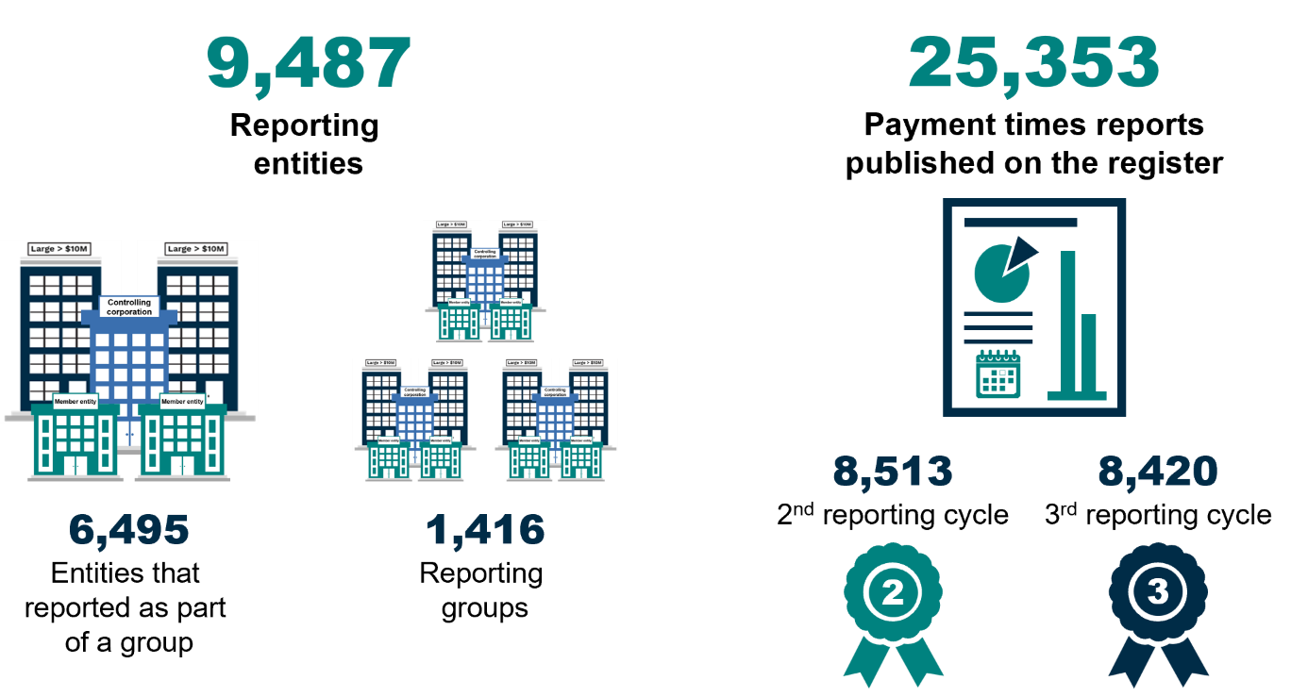

*Figures based on reports as at 31 December 2022. For information on ‘reporting cycles’ see Appendix A.*

Reports have been received from 9,487 reporting entities with 6,495 entities reporting as part of a group and 2,992 reporting individually. A total of 25,353 reports have been published, with 8,513 in reporting cycle 2 and 8,420 in reporting cycle 3, and 7,298 reporting entities have submitted 3 reports (see Appendix A and Appendix B for details on reporting cycles).

Although the number of reports per reporting cycle is comparable there is a variance between the expected number of reports based on reporting entities (9,487) and the number of reports received in each cycle (maximum 8,513 in reporting cycle 2). This demonstrates a potential failure to report by some entities that have previously reported.

### Payments to small business

*Pictorial icons.
73% of reporting entities that make payments to small business. 31% of average total procurement that is with small business. *

*Figures based on reports for the 3rd reporting cycle. Average total procurement excludes reports*

*with nil small business procurement.*

The number of reports showing payments to small business remained relatively unchanged at 73% (from 74% in in the 2nd reporting cycle) and for those reporting procurement from small business the average proportion of small business procurement remained unchanged at 31%.

### Median and average payment terms

Pictorial icons with text:
30 days:  Median payment terms at the end of the 2nd reporting cycle
30 days:  Median payment terms at the end of the 3rd reporting cycle
0 change in median payment terms across reporting periods
35.61 days: Average payment terms at the end of the 2nd reporting cycle
35.66 days: Average payment terms at the end of the 3rd reporting cycle
0.05 days: Change in average payment terms across reporting periods


The median and average payment terms offered by reporting entities to small businesses did not change across the second and third reporting cycles indicating no improvement to the terms offered to small business.

### Payment times

Figure 1 – Change in number of invoices paid within day ranges (data in Appendix B)

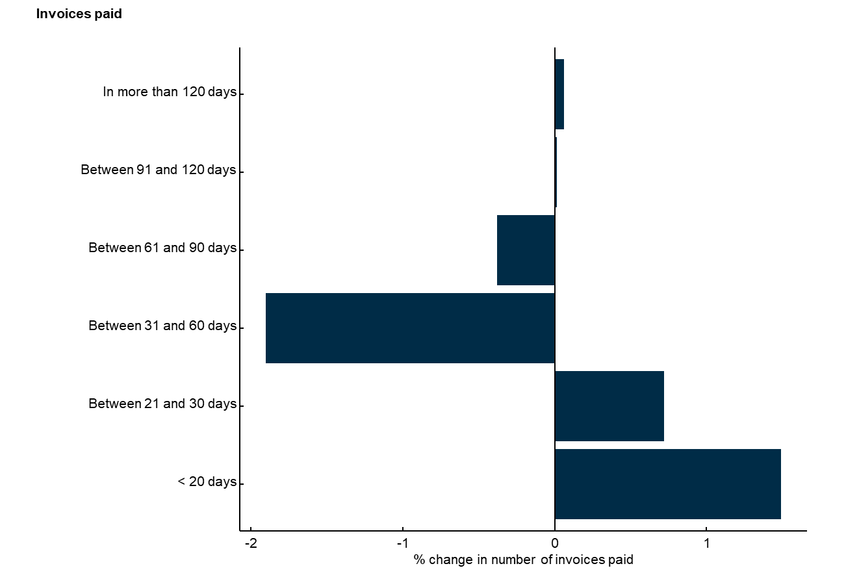

Analysis of actual payment times are similarly unchanged. For entities that have reported more than twice, a comparison of their first ever payment times report and their most recent report indicates only small changes in the average for any given payment times range. Changes identified indicate that while invoices previously paid between 31 and 90 days may now be getting paid in 30 days or less, the change is relatively small (<3% total change). Even less improvement was identified in the proportion of invoices paid in 91 days or more (<0.1% total change).

### Applications, notices to volunteer and enquiries

Numbers with icons listed in proceeding text plus: 
32 Cease to be a reporting entity applications
283 Revised report applications

In administering the Act, between 1 July 2022 and 31 December 2022 the Regulator received 818 applications, 10 notices from entities to volunteer to report and responded to 1,827 enquiries.

## Reports by Industry

The highest number of reports as at 31 December 2022, have been received from the Financial and Insurance Services industry with 4,462 reports. Agriculture, Forestry and Fishing reported the highest average proportion of its procurement with small business with 44.29% of total procurement (by value) being provided by small business.

Figure 2 – Reports in register by ANZSIC division code (data in Appendix B)

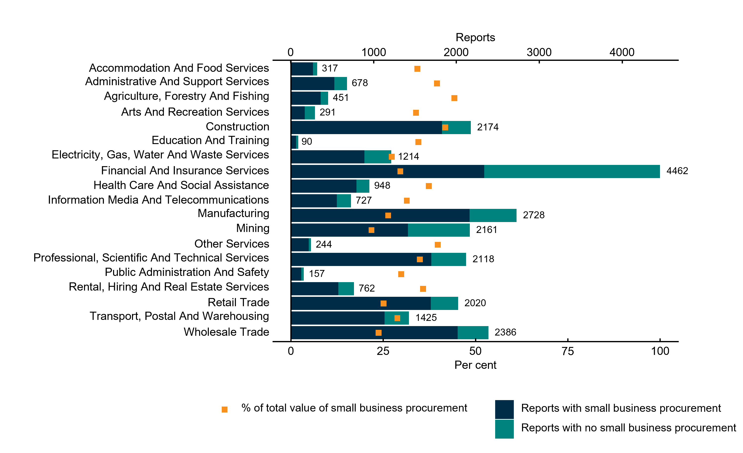

# Policy and resources update

## Regulatory resources

Following public consultation on the draft guidance materials, information sheets and guidance notes were published on the [regulatory resources](https://paymenttimes.gov.au/about/regulatory-resources) page on the Payment Times Reporting Scheme website in October 2022.

We continue to monitor feedback from reporting entities and will publish additional guidance to address common issues encountered.

## Changes to the portal & register

We are committed to continually improving the portal and register to make reporting payment times easier and ensure payment times data remains accessible and easy to use.

In response to feedback from our stakeholders, several improvements have been made to the portal and register since the July 2022 Regulator’s update.

In the coming months we will contact users of the portal for feedback on their experience which will be used to design further improvements. If you would like to provide feedback on the portal, please contact us at [support@paymenttimes.gov.au](mailto:support@paymenttimes.gov.au).

|  |
| --- |
| **Portal & register updates** |
| * Implementation of validation checks to the portal, to prevent submission of overlapping payment times reports. * Expanded the character limit for ‘Report comments’ in the portal from 1,000 characters to 5,000 characters, following feedback from reporting entities. * To provide full transparency of reporting, a report type field has been added to the register (see ‘Report types on the register’). * Addition of reporting period start date to the fields published on the register. * To improve accessibility and make analysis of the register easier, formatting, excel functions and password protection have been removed. |

### Report types on the register

The register now identifies reports as one of three report types: an Original Report, a Revised Report or a Redacted Report.

An **Original Report** is the first version of a report published to the register for a reporting entity for a reporting period.

A **Revised Report** is a report that replaces prior reports. Where a reporting period has multiple revised reports, the revisions are numbered (Revised Report – 01, Revised Report – 02 etc).

A **Redacted Report** is a report that withholds certain information from publication that the Regulator has decided would be contrary to the public interest under section 20 of the Act.

In addition to the report type field, the register now includes related report version information including original report date, revised report date and details of the changes from prior report.

The report type and version information has been published to the register to provide full transparency of the reporting history of a reporting entity.

# Compliance and enforcement

## Compliance programs

We conduct a range of compliance programs to ensure reporting entities are meeting their obligations under the Act.

The focus of our compliance programs for the first half of 2023 remains unchanged from 2022 and continues to be:

* reporting entities who have failed to provide a report, and
* quality assurance of the Payment Times Reports Register, including the accuracy and completeness of reports.

If you have queries on how to provide a report or remedy potential non-compliance, please contact us at support@paymenttimes.gov.au.

## Failing to report

Analysis over three reporting cycles indicates some entities that reported in previous cycles may have since stopped reporting. We remind entities that once they become a reporting entity they are required to continue to report:

* until they have been granted a cease to report determination by the Regulator, or
* if the entity is a member entity, they have had two consecutive income years below A$10 million (which must be disclosed as a notifiable event in a payment times report).

Our compliance activities will target entities that have previously submitted a payment times report and then failed to do so in subsequent periods.

We also use commercial and government data to target entities that meet the standard criteria of a reporting entity but have not registered to report. We may use compliance and enforcement powers if entities have missed multiple reports or their failure to report was due to indifference, unwillingness, or carelessness regarding their reporting obligations.

## Quality of reporting

We continue to monitor the quality of reporting on the register. Our activities are data driven and can involve interrogation of specific fields of reporting or focus on individual reports.

Where suspected errors in reporting are identified we will usually contact the reporting entity and provide an opportunity to clarify or remediate errors before using compliance or enforcement powers.

|  |
| --- |
| **Example – Quality Assurance Activity** |
| In the last period we contacted reporting entities with suspected errors in their payment times reports. Errors targeted in this activity were reports that:   * included business names that did not match the name recorded on the Australian Business Register * had incorrect reporting period start dates * showed discrepancies in the amount of small business procurement and invoice payment times reported.   Seventy-five percent of entities either submitted a revised payment times report or clarified that the suspected error was not an error. Entities that did not respond or take remedial action will continue to have reports monitored and non-compliance escalated for enforcement action.  We remind entities that we may use our compliance and enforcement powers if a report is misleading, and the reporting entity has intentionally not complied or has demonstrated indifference, unwillingness or carelessness with compliance (see [Information Sheet 1: Our approach to regulation)](https://paymenttimes.gov.au/about/regulatory-resources/information-sheet-1). |

### Common reporting errors

In this most recent reporting period, we expanded our regulatory resources and implemented updates to the portal to facilitate improved reporting. Our review of the portal user experience will assist us to make continuous improvements on reporting data accuracy and reliability.

Common errors identified in recent reporting cycles have been:

* business names that are inconsistent with the Australian Business Register
* reporting nil value or negative values for changes in standard payment terms
* insufficient details provided for the principal governing body.

Reviews of the register have also identified that free text fields are commonly underused or contain a limited amount of information. We remind entities there is an obligation to report any information that would provide context or explanation to a report, which may include details on the methodology used to compile the report (see [Guidance Note 2: Preparing a payment times report](https://paymenttimes.gov.au/sites/ptrs.gov.au/files/2022-10/Guidance%20note%202%20-%20Preparing%20a%20payment%20times%20report_0.pdf) paragraph 19).

We encourage entities to refer to [Guidance Note 2: Appendix 1](https://paymenttimes.gov.au/about/regulatory-resources/guidance-note-2-0) when reviewing their report prior to submission. Ensuring data is reported as set out in guidance may prevent the need to remediate a report at a later time.

# Applications

## Providing submissions and evidence

A large number of applications were made during the period where a decision could not be made in a timely manner because the application did not include sufficient details or supporting evidence.

We encourage entities making an application to consult [Guidance Note 3: Application & notifications](https://paymenttimes.gov.au/about/regulatory-resources/guidance-note-3-0). This guidance sets out the matters that must be addressed before we can exercise powers requested in an application.

We also recommend entities use the tables in Guidance Note 3 that set out application requirements as a template when preparing an application. Using the tables as a template will increase the likelihood we can make a decision on your application without requesting further information.

If we receive an application that does not contain sufficient supporting submissions and evidence we will request further information. Applications may be refused if insufficient information is available for a decision to be made.

# Appendix A – Insights methodology and assumptions

## ‘Reporting cycles’

Insights reported refer to **reporting cycles**. A reporting cycle is a fixed period based on the commencement of the Act:

|  |  |  |  |  |
| --- | --- | --- | --- | --- |
| **Reporting Cycle 1** | **Reporting Cycle 2** | **Reporting Cycle 3** |  | **Reporting Cycle 10** |
| 1 Jan 2021 –  30 Jun 2021 | 1 Jul 2021 –  31 Dec 2021 | 1 Jan 2022 –  30 Jun 2022 |  | 1 Jul 2025 –  31 Dec 2025 |

Reports are assigned to a reporting cycle based on the **reporting period start date**. For example, a report with a reporting period start date of 15 March 2022 will be categorised as Reporting Cycle 3 for the purpose of reporting.

*Note: Insights for the Regulator’s update published in July 2022 was based on instances of reporting: 1st report, 2nd report etc. Reporting instances and reporting cycles do not reconcile because the timing of reports (eg, first instance of reporting may occur in Reporting Cycle 2). Historic report statistics will also change as entities continue to submit reports for prior reporting cycles and revisions are made to reports.*

## Insights are a point-in-time

Reports are received by the Regulator continuously, including for historical reporting cycles. Previous reports can also be modified by submissions of revised reports.

Insights provided in this update are as of a point in time and subject to change as additional reports are received by the Regulator or revised by reporting entities.

## Assumptions

Unless otherwise stated, the following assumptions are adopted in preparation of insights data:

* **Nil reports** are excluded from calculations regarding standard payment terms and payment times. Nil reports are reports that have zero payment terms and payment times because the entity does not procure from small business.
* Superseded reports are excluded from calculations. Where an **original report** is replaced by a **revised report**, only the revised report is used. Where there are multiple revised reports, only the most recent revised report is used.
* **Change in standard payment period** can be incorrectly reported. To address inconsistencies the following assumptions are applied:
  + if the change in standard payment period is a positive number, the reported figure is used
  + if the change in standard payment periodis a negative number, it is subtracted from the **standard payment period**. If this calculation results in a negative payment period, the report is excluded from analysis
  + if the change in standard payment period is zero, the standard payment period is used.
* To identify whether an entity is **reporting as part of a group** the following assumptions are applied:
  + classification is based on the most recent report received from a reporting entity
  + entities that do not provide an ABN or ACN are excluded from classification
  + if multiple entities report the same head entity, all entities reporting the same head entity are treated as a single group
  + if a member entity reports a controlling corporation and no head entity, the member entities and controlling corporation are treated as a single group
  + if an entity reports a head entity but is the only entity to report under that head entity, it is treated as an individual reporter
  + if an entity does not report a controlling corporation or head entity, it is treated as an individual reporter.

# Appendix B – Data tables

### Report Statistics (as at 31 December 2022)

|  |  |  |  |  |  |  |
| --- | --- | --- | --- | --- | --- | --- |
| Reporting Cycle | Cycle Range | No. of Reports | Avg. Standard Payment Terms Period (End) | Median Standard Payment Terms Period (End) | % Reports with small business procurement | Avg. small business procurement % (excl entities with nil small business procurement) |
| Reporting Cycle 1 | 1/1/2021 – 30/6/2021 | 8,420 | 36.29 | 30 | 75.38% | 30.05 |
| Reporting Cycle 2 | 1/7/2021 – 31/12/2021 | 8,513 | 35.61 | 30 | 73.97% | 30.56 |
| Reporting Cycle 3 | 1/1/2022 – 30/6/2022 | 8,420 | 35.66 | 30 | 73.23% | 30.93 |
| **Total** |  | **25,353** |  | | | |
| *Superseded Reports[1]* |  | *195* |  | | | |
| **Total reports on register** |  | **25,548** |  | | | |

### Reports by reporting instance (as at 31 December 2022)

|  |  |
| --- | --- |
| Reporting instance | No. Reports |
| First reports from entities | 9,488[2] |
| Second reports from entities | 8,567 |
| Third reports from entities | 7,298 |
| **Total reports** | **25,353** |
| *Superseded reports* | *195* |
| **Total reports on register** | **25,548** |

### Figure 1 – Change in number of invoices paid within day ranges

|  |  |
| --- | --- |
| Payment time range | % Avg Change[3] |
| < 20 days | 1.49 |
| Between 21 and 30 days | 0.71 |
| Between 31 and 60 days | -1.90 |
| Between 61 and 90 days | -0.38 |
| Between 91 and 120 days | 0.01 |
| In more than 120 days | 0.06 |

### Figure 2 – Reports in register by ANZSIC division code

|  |  |  |  |  |  |
| --- | --- | --- | --- | --- | --- |
| **Industry** | **No. of reporting entities** | **% of reporting entities** | **Total reports** | **% Reports with payments to small business** | **% Avg. $ total small business procurement (% of value) [4]** |
| Accommodation and Food Services | 117 | 1.23 % | 317 | 84.54 % | 34.24 % |
| Administrative and Support Services | 247 | 2.6 % | 678 | 77.58 % | 39.57 % |
| Agriculture, Forestry and Fishing | 173 | 1.82 % | 451 | 80.04 % | 44.29 % |
| Arts and Recreation Services | 106 | 1.12 % | 291 | 57.39 % | 33.90 % |
| Construction | 903 | 9.52 % | 2,174 | 83.99 % | 41.81 % |
| Education and Training | 37 | 0.39 % | 90 | 71.11 % | 34.51 % |
| Electricity, Gas, Water and Waste Services | 432 | 4.55 % | 1,214 | 73.31 % | 27.35 % |
| Financial and Insurance Services | 1,667 | 17.57 % | 4,462 | 52.35 % | 29.66 % |
| Health Care and Social Assistance | 368 | 3.88 % | 948 | 83.54 % | 37.39 % |
| Information Media and Telecommunications | 274 | 2.89 % | 727 | 76.34 % | 31.41 % |
| Manufacturing | 999 | 10.53 % | 2,728 | 79.21 % | 26.36 % |
| Mining | 778 | 8.2 % | 2,161 | 65.43 % | 21.85 % |
| Other Services | 91 | 0.96 % | 244 | 88.93 % | 39.79 % |
| Professional, Scientific and Technical Services | 791 | 8.34 % | 2,118 | 80.17 % | 34.94 % |
| Public Administration and Safety | 56 | 0.59 % | 157 | 80.25 % | 29.88 % |
| Rental, Hiring and Real Estate Services | 291 | 3.07 % | 762 | 75.33 % | 35.83 % |
| Retail Trade | 749 | 7.9 % | 2,020 | 83.66 % | 25.10 % |
| Transport, Postal and Warehousing | 505 | 5.32 % | 1,425 | 79.37 % | 28.85 % |
| Wholesale Trade | 903 | 9.52 % | 2,386 | 84.49 % | 23.75 % |
| Total | 9,487 | 100 % | 25,353 | 74.19 % | 30.51 % |

1. *Superseded reports are reports that have been replaced by a revised report. Superseded reports are published to the register for transparency of reporting history but are excluded from calculations. Where there are multiple revised reports, only the most recent revised report is used for calculation.*
2. *There are more first instances of reporting (9,488) than reporting entities (9,487) because entities with no ABN or ACN are excluded from reporting entity classification: see Appendix A: Insights methodology and assumptions.*
3. *Avg Change is calculated by taking the variance of the averaging across payment time ranges from entities first reports and its most recent report. Entities with only one report were excluded from analysis.*
4. *Based on reports with procurement from small business. Reports with nil small business procurement are excluded from calculation.*