Regulator’s update

July 2022

© Commonwealth of Australia 2022

This publication is available for your use under a [Creative Commons Attribution 3.0 Australia](http://creativecommons.org/licenses/by/3.0/au/deed.en) licence, with the exception of the Commonwealth Coat of Arms, the Treasury logo, the Payment Times Reporting Regulator logo, photographs, images, signatures and where otherwise stated. The full licence terms are available from <http://creativecommons.org/licenses/by/3.0/au/legalcode>.

Creative Commons attribution licence 3.0 icon. 

Use of Treasury material under a [Creative Commons Attribution 3.0 Australia](http://creativecommons.org/licenses/by/3.0/au/deed.en) licence requires you to attribute the work (but not in any way that suggests that the Treasury endorses you or your use of the work).

*Treasury material used ‘as supplied’.*

Provided you have not modified or transformed Treasury material in any way including, for example, by changing the Treasury text; calculating percentage changes; graphing or charting data; or deriving new statistics from published Treasury statistics — then Treasury prefers the following attribution:

*Source: The Australian Government the Treasury, Payment Times Reporting Regulator*.

**Derivative** **material**

If you have modified or transformed Treasury material, or derived new material from those of the Treasury in any way, then Treasury prefers the following attribution:

*Based on The Australian Government the Treasury, Payment Times Reporting Regulator data*.

**Use of the Coat of Arms**

The terms under which the Coat of Arms can be used are set out on the Department of the Prime Minister and Cabinet website (see [www.pmc.gov.au/government/commonwealth-coat-arm](http://www.pmc.gov.au/government/commonwealth-coat-arm)s).

**Other uses**

Enquiries regarding this licence and any other use of this document are welcome at:

Manager  
Media and Speeches Unit  
The Treasury  
Langton Crescent   
Parkes ACT 2600  
Email: [media@treasury.gov.au](mailto:media@treasury.gov.au)

# Contents

Contents 2

Letter from the Regulator 3

Insights 4

Reports by Industry 6

Policy updates 7

Updates to legislation 7

Regulator publications 7

Updated guidance material 7

Consultation on guidance 7

Using the new guidance 8

Compliance and enforcement 8

Commencement of enforcement powers 8

Compliance programs 9

Appendix A – Reports by ANZSIC division code 10

# Letter from the Regulator

Welcome to the first issue of the Regulator’s update.

The [*Payment Times Reporting Act 2020*](https://www.legislation.gov.au/Series/C2020A00091) (the Act) has been in operation for over 12 months, with 8,885 reporting entities reporting under the scheme and 16,801 payment times reports received as at 30 June 2022.

Now that most reporting entities have reported twice, we will be publishing updates on payment times reporting activities twice per year.

Each update will include details of changes to legislation, rules or guidance, background to major policy activities, information about compliance and enforcement priorities and insights from payment times report data.

Following publication of each update we will hold a liaison forum for stakeholders to discuss the update and provide feedback on reporting. If you would like to participate in these forums, or would like further information, please send your details to [support@paymenttimes.gov.au](mailto:support@paymenttimes.gov.au).

To better support our reporting entities with their reporting obligations, we have recently drafted updated guidance materials. Before finalising guidance materials, they will be available for public consultation and feedback commencing in July 2022. We will email all reporting entities a link to the consultation materials once they are available on the Treasury [consultation web page](https://treasury.gov.au/consultation).

I encourage all organisations that prepare reports, or have an interest in the scheme, to review the materials closely and take advantage of the opportunity to provide feedback.

Thank you for your ongoing support of the Payment Times Reporting Scheme.

Kind regards,

**Mary Jeffries**

Payment Times Reporting Regulator (statutory position)

Assistant Secretary, Payment Performance Branch

The Treasury

# Insights

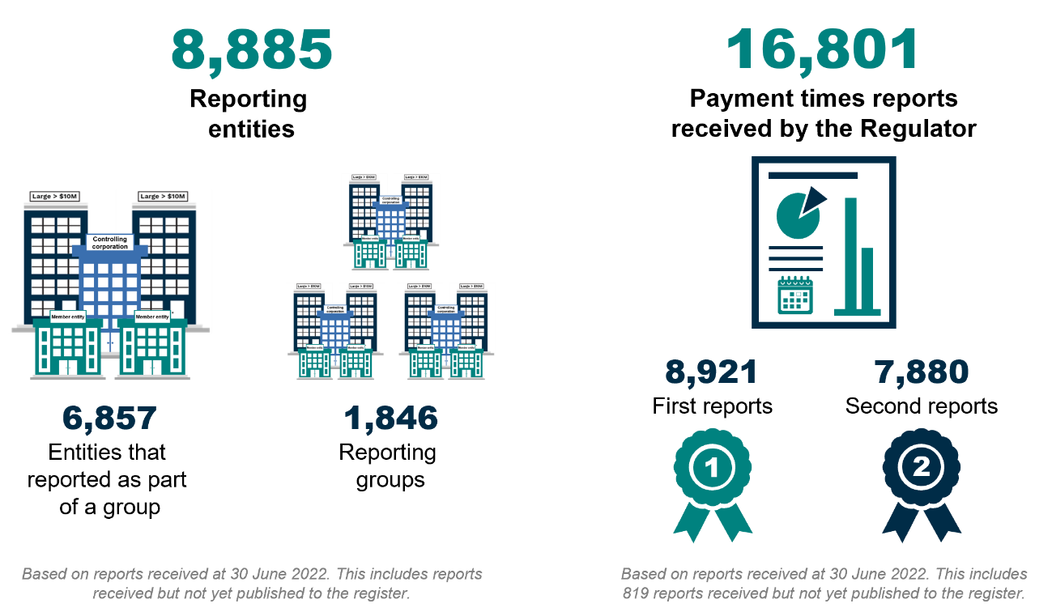The [Payment Times Reports Register](https://register.paymenttimes.gov.au/) (the register) was launched in November 2021 and provides both a downloadable Excel file and an interactive dashboard to search and view payment times information. Since its launch the register has been updated in December 2021, February 2022 and April 2022. The register’s latest release (July 2022) saw a 91% increase in the number of reports on the register, from 8,353 to 15,982.

As of 30 June 2022, the Payment Times Reporting Regulator has received 16,801 reports from 8,885 reporting entities of which 15,982 (95%) have been published to the register. Reports received by 30 June 2022 but not published in the current register will be included in the next register update. There were 7,139 reports received for a second reporting period allowing the public to identify early changes in payment practices.

Of the reports currently in the register, 77% of reporting entities make payments to small businesses. Across all sectors, reports for second reporting periods show a median payment term offered in contracts to small businesses of 30 calendar days, with an average of 36.2 calendar days.

The majority of reports submitted for a second reporting period indicate that entities were not meeting their own payment terms offered to small business. Using a benchmark of 80% of invoices (by number), only 47% of reports submitted for second reporting periods showed payment within the terms offered. Using the same benchmark only 31% of reports show payment within 30 days.

|  |  |  |
| --- | --- | --- |
| **Reports with more than:** | **1st Reports** | **2nd Reports** |
| 80% of invoices paid (by number) within payment terms | 45% | 47% |
| 80% of invoices paid (by number) within 30 days | 25% | 31% |

*\*Based on reports published to the register (excluding reports with nil small business procurement).*

In administering the Act, we have received 4,054 enquiries, 1,431 applications and 49 notices from entities to volunteer to report.

## Reports by Industry

The highest number of reports published on the register were received from the Financial and Insurance Services with 2,736 reports. Agriculture, Forestry and Fishing reported the highest average proportion of its procurement with small business with 40.64% of total procurement (by value) being undertaken by small business. Figure 1 sets out reports by ANZSIC division with additional information on the number of reporting entities by division available in Appendix A.

Figure 1 – Reports by ANZSIC division code (data table in Appendix A).

# Policy updates

## Updates to legislation

Technical amendments to the [*Payment Times Reporting Act 2020*](https://www.legislation.gov.au/Series/C2020A00091)(the Act) were passed by Parliament on 10 February 2022 through the [*Corporate Collective Investment Vehicle Framework and Other Measures Bill 2021*](http://www5.austlii.edu.au/au/legis/cth/bill/ccivfaomb2021688/)*.*

The changes allow entities that volunteer to report under the Act to start reporting in the first reporting period commencing after it gave notice to volunteer. Previously, entities that volunteered to report were required to wait until commencement of its next income year before it could report.

## Regulator publications

Since 1 January 2022 we have started publishing additional regulatory resources on our website to assist reporting entities to understand their obligations and how we administer the  
[*Payment Times Reporting Act 2020*](https://www.legislation.gov.au/Series/C2020A00091)*.*

Recent publications include:

* [Information Sheet 1: Our approach to regulation](https://paymenttimes.gov.au/about/regulatory-resources/information-sheet-1).
* [Information Sheet 2: Regulator decisions – Your rights](https://paymenttimes.gov.au/about/regulatory-resources/information-sheet-2).

We intend on adding to the regulatory resources during the remainder of 2022, including guidance notes and additional information sheets. There will also be periodic updates made to the resources as required.

We encourage you to provide feedback on the content of existing and new regulatory resources via our [contact form](https://paymenttimes.gov.au/contact).

## Updated guidance material

Following a review of enquiries and payment times reports received, we identified a need for updated guidance material.

To assist reporting entities to meet their obligations and understand the Regulator’s expectations, we have prepared 3 draft guidance notes:

* Guidance note 1: Key concepts
* Guidance note 2: Preparing a payment times report
* Guidance note 3: Applications and notifications

The draft guidance notes include information that may be new or more detailed than existing guidance available on our website.

### Consultation on guidance

The 3 draft guidance notes will be available in July for public consultation for a 6-week period. We encourage you to engage in the consultation process.

Information on how to access the draft guidance and provide feedback will be available on the Treasury website [consultation page](https://treasury.gov.au/consultation).

### Using the new guidance

During the consultation period, reporting entities may choose to use the draft guidance to prepare reports or applications. As consultation is during a reporting window for many entities, this may be an opportunity to test our guidance during report preparation and provide feedback.

Alternatively, reporting entities can continue to use the existing guidance on our website until guidance is finalised. The guidance used prior to finalisation will not affect compliance.

We plan to publish finalised guidance notes after the consultation in October 2022 in our new [Regulatory resources](https://paymenttimes.gov.au/about/regulatory-resources) section of the website. Information sheets are already available in this section with brief guidance on specific processes and functions.

# Compliance and enforcement

## Commencement of enforcement powers

Most reporting entities have now experienced 2 reporting cycles and submitted 2 payment times reports. These cycles have provided reporting entities with time to register to report, understand their obligations and implement the processes needed to prepare and submit their report.

The compliance and enforcement powers in the [*Payment Times Reporting Act 2020*](https://www.legislation.gov.au/Series/C2020A00091) commenced on 1 January 2022. Prior to commencement of these powers, we relied on reporting entities voluntarily complying with their obligations and our approach to non-compliance was focused on facilitation and providing assistance.

The Regulator has not used its compliance and enforcement powers under the [*Payment Times Reporting Act 2020*](https://www.legislation.gov.au/Series/C2020A00091) between 1 January 2022 and June 2022, however as entities have now had an opportunity to prepare to meet their obligations, we may now consider using the compliance and enforcement powers in the [*Payment Times Reporting Act 2020*](https://www.legislation.gov.au/Series/C2020A00091) to address non-compliance. This may include:

* publishing non-compliance on the [Payment Times Reports Register](https://register.paymenttimes.gov.au/) (the register)
* requiring a reporting entity to undergo a compliance audit
* undertaking monitoring or investigation activities under the [Regulatory Powers Act 2014](https://www.legislation.gov.au/Series/C2014A00093)
* issuing an infringement notice
* commencing Court action for civil penalties.

In the third quarter of the 2022 calendar year, we plan on publishing an information sheet with more information on our enforcement powers. This will be available for reference by reporting entities contacted during our compliance activities. The proposed information sheet will not describe when we may consider using specific powers – this information is already set out in [Information sheet 1: Our approach to regulation](https://paymenttimes.gov.au/about/regulatory-resources/information-sheet-1).

## Compliance programs

To ensure reporting entities are complying with their obligations under the [*Payment Times Reporting Act 2020*](https://www.legislation.gov.au/Series/C2020A00091), we have commenced and will continue to initiate both routine and targeted compliance programs.

The focus of our compliance programs for the remainder of 2022 are:

* quality assurance of the [Payment Times Reports Register](https://register.paymenttimes.gov.au/), including the accuracy and completeness of reports
* reporting entities that have failed submit a report.

Although these are current areas of focus, we also undertake targeted compliance action in response to intelligence and emerging trends of non-compliance.

If we contact you in relation to non-compliance, we encourage you to refer to our approach to non-compliance set out in [Information sheet 1: Our approach to regulation](https://paymenttimes.gov.au/about/regulatory-resources/information-sheet-1).

Note:

* the attitude of the reporting entity to its reporting obligations may inform our approach to addressing non-compliance
* our first action on identifying non-compliance when utilising the compliance and enforcement powers under the [*Payment Times Reporting Act 2020*](https://www.legislation.gov.au/Series/C2020A00091) may be to publish details of the non-compliance on the [register](https://register.paymenttimes.gov.au/).

In addition to publication of non-compliance on the register, we may also publish information about how we have used our compliance and enforcement powers in other publications, such as the Regulator’s Updates.

If you have concerns or queries on how to remediate or remedy potential non-compliance, we encourage you to contact us at [support@paymenttimes.gov.au](mailto:support@paymenttimes.gov.au).

# Appendix A – Reports by ANZSIC division code

|  |  |  |  |  |  |
| --- | --- | --- | --- | --- | --- |
| **Industry** | **Number of reporting entities** | | **Total reports** | **% Reports with payments to small business** | **% Avg. $ total small business procurement (value) excludes reports with nil payments to small business** |
| Accommodation and Food Services | 114 | 1.29% | 198 | 88.38% | 33.65% |
| Administrative and Support Services | 229 | 2.59% | 423 | 79.67% | 36.72% |
| Agriculture, Forestry and Fishing | 155 | 1.75% | 281 | 87.19% | 40.64% |
| Arts and Recreation Services | 103 | 1.16% | 187 | 59.89% | 36.76% |
| Construction | 838 | 9.48% | 1,416 | 88.49% | 39.64% |
| Education and Training | 35 | 0.40% | 55 | 70.91% | 35.44% |
| Electricity, Gas, Water and Waste Services | 418 | 4.73% | 799 | 74.47% | 27.46% |
| Financial and Insurance Services | 1,526 | 17.26% | 2,736 | 56.07% | 28.17% |
| Health Care and Social Assistance | 345 | 3.90% | 611 | 85.60% | 35.12% |
| Information Media and Telecommunications | 241 | 2.73% | 440 | 76.82% | 31.86% |
| Manufacturing | 962 | 10.88% | 1,738 | 80.78% | 25.59% |
| Mining | 760 | 8.60% | 1,391 | 66.79% | 21.04% |
| Other Services | 85 | 0.96% | 156 | 89.74% | 37.60% |
| Professional, Scientific and Technical Services | 736 | 8.32% | 1,304 | 83.28% | 32.98% |
| Public Administration and Safety | 57 | 0.64% | 102 | 88.24% | 25.20% |
| Rental, Hiring and Real Estate Services | 265 | 3.00% | 476 | 76.89% | 35.25% |
| Retail Trade | 699 | 7.91% | 1,285 | 88.40% | 22.56% |
| Transport, Postal and Warehousing | 480 | 5.43% | 892 | 81.50% | 28.28% |
| Wholesale Trade | 858 | 9.70% | 1,492 | 88.14% | 22.89% |
| **Grand Total** | **8,842** | **100%** | **15,982** | **77%** | **29%** |